About Blackboard Collaborate Ultra

(This document has been created from many existing sources. In most cases they are cited)

What is Blackboard Collaborate Ultra?

Collaborate Ultra is a platform built into Blackboard that allows faculty members to communicate with students live or allow the students to watch recorded sessions. It is browser-based and does not require users to download a separate program or launcher. It allows users to schedule and record a session right within Blackboard itself! (We recommend using Google Chrome or Mozilla Firefox for the best user experience.)
Participants can see others via webcam, hear and ask questions via voice or instant messaging, and share presentations and ideas using a common whiteboard or by sharing desktops. Sessions can be recorded and can be posted with other course materials in a Blackboard course or shared outside of Blackboard as a direct link. They can be uploaded to KSU’s Kaltura video site.

What Can I Do with Collaborate Ultra?
- Live Instruction
Using Collaborate Ultra, students can enter the “classroom,” watch and listen to lectures, ask questions, engage in discussions, make presentations, join smaller groups for group work. Instructors can share existing files (e.g., PowerPoint presentations, Spreadsheets, Videos, PDF files, etc.) and develop content in the session using a Whiteboard, which the instructor can allow students to access.
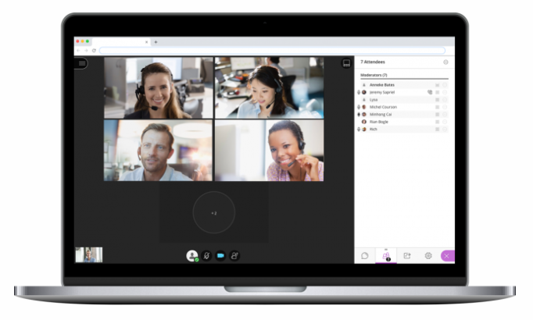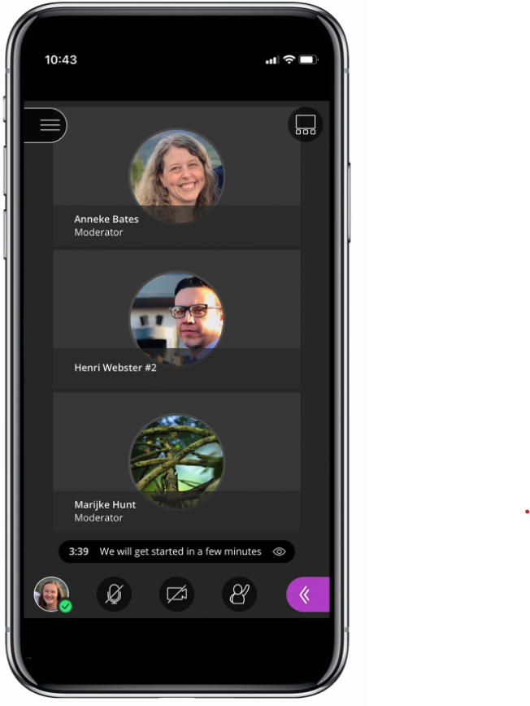
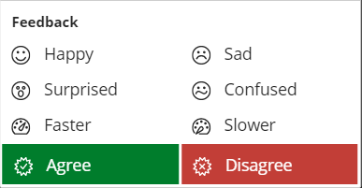
During the class, students can provide quick responses to questions posed:
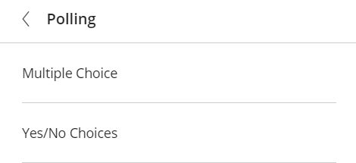
Or instructors can create a poll with “multiple choice” or “Yes/No” choice and have students respond to that:
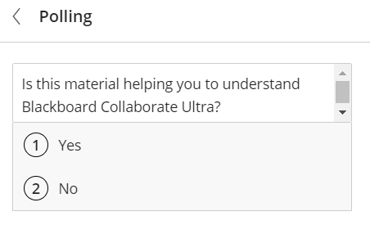
For example:

- Synchronous Delivery of an In-person Class
Used with the equipment in each KSU classroom, instructors can teach an in-person class and using Collaborate Ultra to simultaneously stream the class to students who cannot be in the classroom. The Lumens High-Definition camera can be used as a web cam to share video of the instructor lecturing or of the students in the in-person class room interacting, and it can be used as a document camera to show documents or objects to the class.
The Audio Technica microphone can pick up audio for 25 feet, allowing instructors to move around the room and allowing remote students to hear interactions from students in the room.
The projectors in the classrooms allow in-person students to view the Collaborate Ultra room, just as the remote students see it, including PowerPoint slides, Spreadsheets, PDF files, Videos, material shown via the document camera, etc.
- Asynchronous Content Delivery/Development
If the instructor uses the Collaborate Ultra option to record a live class (or an in-person class), then students can view the recording if they have missed the session or just to reinforce learning and help retain knowledge.
Also, with Blackboard Collaborate, instructors can create asynchronous content using the interactive record and playback functions. For example, recordings might be done for a student orientation session to the class, to record a welcome to the virtual classroom prior the first day of class, or to record part or all a lecture.
- Meetings
Blackboard Collaborate Ultra can be an effective way to host or attend meetings. Invitations can be sent to those who do not have a KSU UserID, so anyone, anywhere can be invited to a meeting, or to a class.
- Tutoring
Whether provided by instructors or peers, tutoring via Blackboard Collaborate Ultra offers students an opportunity to work one-on-one to get questions answered or receive help with homework or other assignments. Sessions can be scheduled in advance or students can drop into to an existing virtual room to connect with the tutor.
- Classroom Collaboration
Instructors can create Breakout Groups to allow students to interact during class in small groups. Student can be randomly assigned to groups, placed into groups by the instructor, or move among groups themselves. Instructors can “drop into” Breakout Groups to view the activity or comment.
- Virtual Office Hours
Instructors can use Collaborate Ultra to set up virtual office hours. They can meet with students one-on-one or in a group. If students come to office hours in a group and a one-on-one meeting is needed, a Breakout Group can be created with that student.
- Remote Guest Speakers/Virtual Field Trips
Because you can send an invitation to someone outside of KSU, you can have a remote guest speaker join in the class. They can be given all the permissions that the instructor has to share content, make use of the Whiteboard, etc.
The Collaborate Ultra classroom is accessible via virtually any device. So someone at a remote site could join the class on a mobile phone or with a notebook, etc. and do a tour of a site or facility for the class.
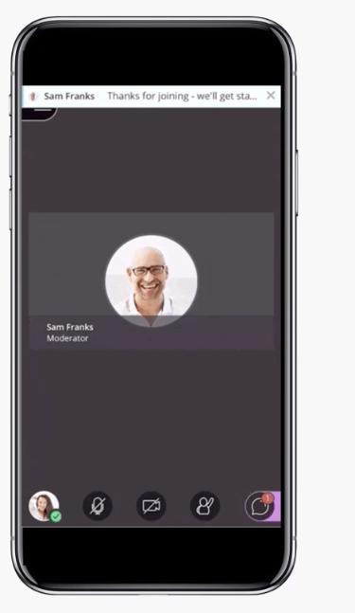

Source for much of the above: http://content.ctcd.edu/bb/docs/WaystouseBbCollaborate.pdf
Images from https://www.blackboard.com/teaching-learning/collaboration-web-conferencing/blackboard-collaborate

Getting Started with Blackboard Collaborate Ultra
Virtually all classes at KSU have a Blackboard site created for them. The Collaborate Ultra platform is a tool built into each Blackboard class site.
Assuming you have set up your class on Blackboard, you will have an entry point (e.g., Home, Announcements, Email) and several Folders (e.g., Start Here, Learning Materials, etc.). You can choose to place your Collaborate Ultra room anywhere you like.
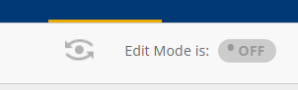
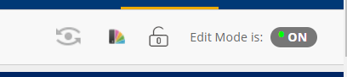
First, double check to be sure that Edit Mode is ON. (If it off, click to turn it ON).

- Creating the Collaborate Ultra Room
Now, browse to the place you want the Collaborate Ultra room to appear (e.g., the Home Page, in the Learning Materials Folder).
- At the top of the Folder, click on Tools > More Tools > Blackboard Collaborate Ultra.
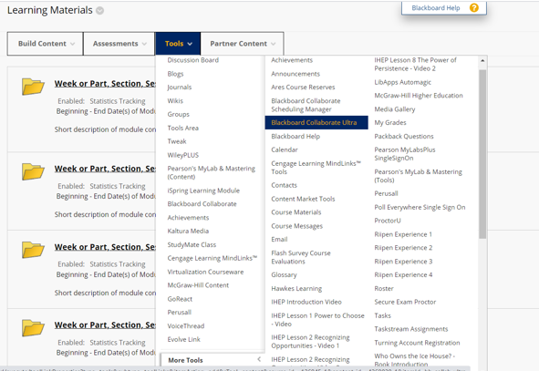
- This takes you to a Create Link page where you can Rename the Link (default is Blackboard Collaborate Ultra), enter a description, choose whether the link (the room) is available or not, chose to track the number of views, and set any date restrictions.
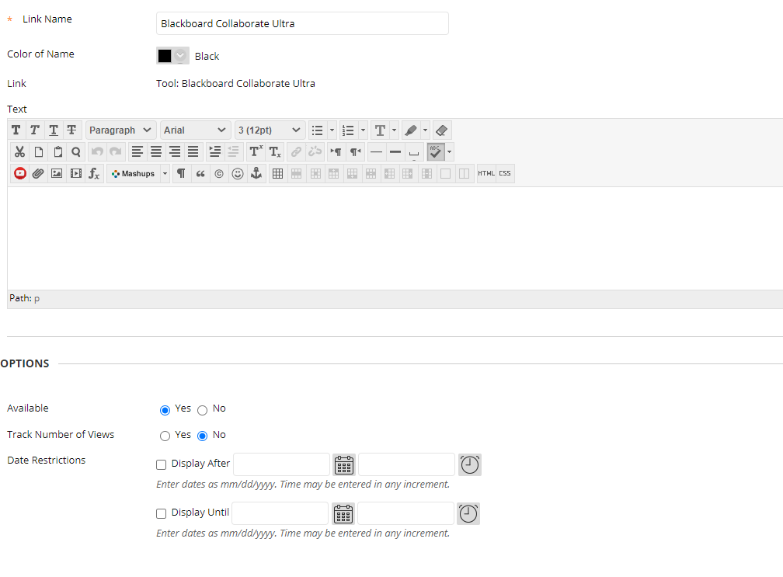
- When all is set, click “Submit” (at the bottom of the page).
- The Link to the room appears at the bottom of the page (Folder) you are in.
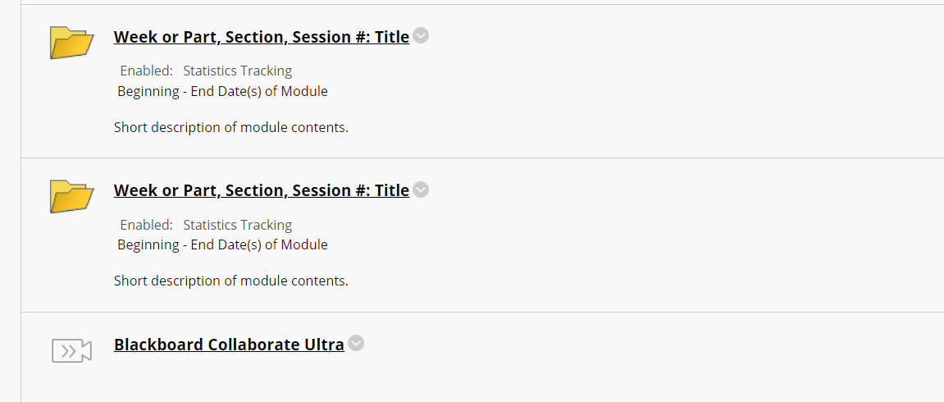
- This sets up the default room and makes it accessible for students.
  - As with most Blackboard content, you can move the room up on the page, if a different location is better for the class.
- You can also choose to add the room to the Course Menu (the left-hand pane of Blackboard). To add the room here:
  - Click on the “+” at the top of the Course Menu.
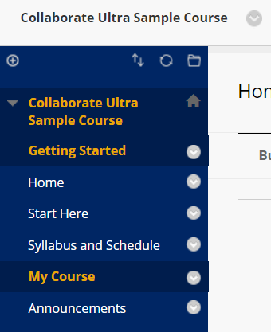
  - Click on Course Link, which brings up an Add Course Link window
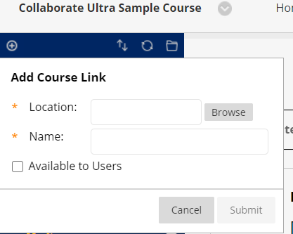

- In the Add Course Link window, click on Browse, and scroll down to find the link for Blackboard Collaborate Ultra (or whatever name you may have given to the room). Select that link and change the Name if you so desire. Then click on “Available to Users” to make it visible to students. Click on Submit.
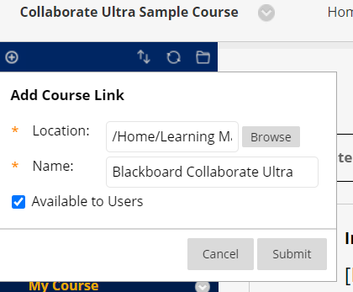
- The Link will appear at the bottom of the Course Menu. You can move it up in the menu by scrolling over the link, left clicking, and moving it to where it works best.
- Students can then get to the room by clicking on this menu item.

- Editing the Default Collaborate Ultra Room
You have now created a link to the default Collaborate Room area.
- This video gives a nice overview of the Collaborate Room features: https://www.youtube.com/watch?v=1W4sGpVmJaY&vl=en (2:14) or this one from a user https://youtu.be/zqA8OuOO0FY?t=52 (begins about a minute into the 13 minute presentation)
Click on the link to see the entry page. 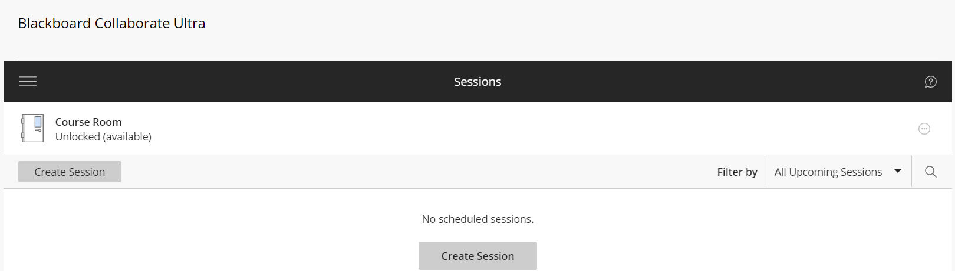

Annotated Entry Page:
Course Room Link
Session Help Icon
Session Options Icon
Collaborate “hamburger” menu icon
The default has an “Unlocked (available)” course room all set up for you. To get started, there is no need to Create a Session. For details on Scheduling Sessions see the Appendix.

- To see the settings for the room, or to edit them click on the Session Options icon on the right side of page across from the Course Room name.
- That click brings up the Session Options menu.
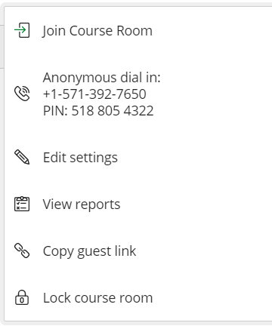
  - From this menu you can Enter (Join) the Course Room (which you could have done by clicking on the Course Room name earlier); Share a phone number which people can use to dial into the class anonymously (long distance rates may apply); Edit the room settings; View Reports (most likely to be used to see who attended a session, see the APPENDIX); Copy a Guest Link (which can allow anyone to join the class session, even if they do not have a KSUId. This can be turned on or off as you edit the Session Options); and you can Lock the course room.
    - By default, this initial Course Room is always open to students in the class. They can enter it from Blackboard whether or not you are holding a session and communicate via audio, video, chat, etc. That may be an option which works well for you class. However, if you do not want them in the room when there is not a session, you can Lock it. To unlock it when you want to allow entry, just click on the room name and select Unlock Course Room from the popup window.
  - If the Join session link is not clicked within 60 seconds it changes to “Get secure link.” Click that option, and then click it a second time to enter Course Room or session.
- EDIT SETTINGS – clicking on Edit Settings brings up a window with two tabs: Event Details and Session Settings.
  - The Event Details tab allows you to (a) Lock the Course Room, (b) Join the Course Room (or get a Secure Link if you did not click on this within 60 seconds, (c) See and copy the Anonymous dial in information, (d) Select Guest access.
    - Anonymous dial in refers to the fact that users who join sessions via telephone only do not have assigned identities or any way to identify themselves.
      - Collaborate gives each anonymous user a name consisting of “Caller,” followed by a sequential number, such as Caller-1001. Users on computing devices can see this identification in the Attendees pane of the Collaborate Panel, with a telephone icon appearing by their names.
      - Anonymous dial-in allows all users joining by phone to use the same PIN. This PIN can be sent to users via e-mail or included in an entry on the Course or Organization Calendar.
    - Clicking on Guest Access bring up a window that allows you to choose the Role for the Guest (Participant, Presenter, or Moderator).
    - Saving the Session then brings up the https address for the Guest(s) for the session.
- SESSION SETTINGS – clicking on the Session Settings tab bring up a window with several choices for the room.
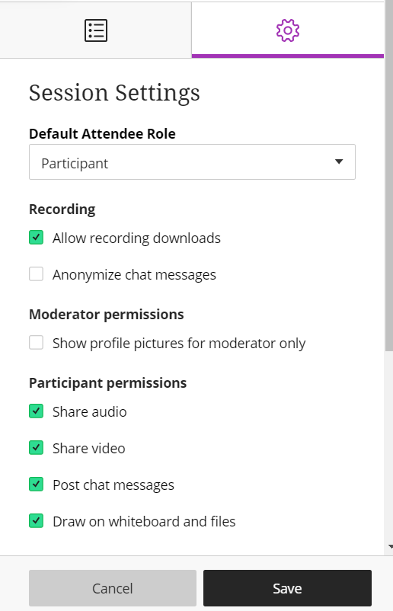
- As with the Guest role, you can choose the Default Role for Attendees, that is students, when the enter the room (Participant, Presenter, or Moderator).
  - With a large number of Students, it may be useful to turn off their ability to share audio, share video, or draw on shared content.
- If you plan to record the class and want it to be downloadable later, select that option now.
- When done with all options, click Save (or Cancel to exit without changes).

- The Collaborate Ultra Room
- To enter the Room, click on its name, or choose Join Course Room.
- This opens a new browser tab and takes you to the room. The first person into the room will see the empty room page:
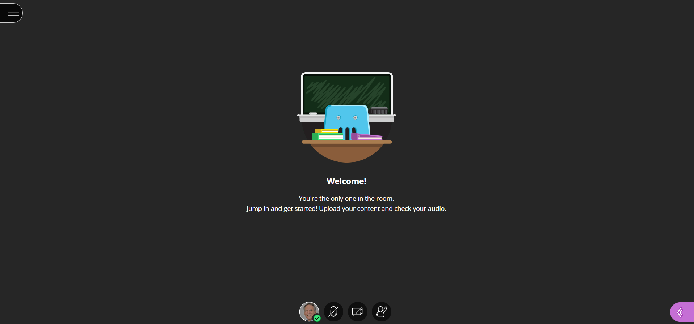
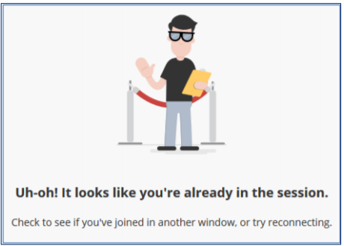
Each user account can be in the room in only one place: When users try to enter the room via a second browser or device, Collaborate Ultra informs them that they are already logged in.

If an instructor has a Test Student account, he or she may join the room using two different accounts on two different browsers or devices.
The Room Interface
The visual interface of the conference room consists of two main areas: The Participants area (the large black area seen in the image above), which takes up most of the screen space; and the Interaction Bar at the bottom. There are also icons at the top-left and bottom-right to open the Session Menu and the Collaborate Panel, respectively. If there are three or more users in the conference, an additional Follow the Speaker icon may appear in the top-right.
- Interaction Bar Buttons - The Interaction Bar is at the bottom of the room page and consists of icons for My Status and Settings, Share Audio, Share Video, and Raise Hand.
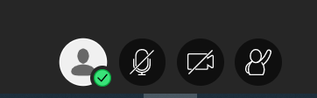
  - If the instructor changes the session settings in order not to permit Participant users to share audio and video the microphone and camera icons do not appear.
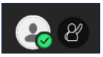
  - My Status and Settings - The My Status and Settings icon opens the Collaborate Ultra Control panel to display the user’s name, role, quality of the internet connection, and allows the user switch attendance status between Present and Away, or to provide Feedback to something.
    - Clicking “Away” creates a clock icon  letting others know your status. This goes away when you return.
    - Clicking a Feedback icon causes that reaction to appear for other users to see on the Attendees pane of the Collaborate Ultra panel.
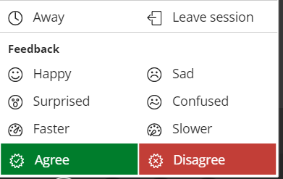
    - Here, the Test Student has clicked the Happy icon:
  - Share Audio – Users can control whether their microphones are live for conversations. This button toggles between Share Audio and Mute Audio. When audio is enabled, the icon also shows the relative volume level of the audio. If speaking into the microphone fills the icon consistently, a user may wish to turn his or her microphone volume down via Audio and Video Settings in the Collaborate Panel, discussed below.
  - If users have trouble communicating via microphone, they may be able to troubleshoot the problem:
    - Is the headset/microphone plugged in?
    - Is there a mute switch engaged on the headset/mic?
    - Is the computer’s audio muted or turned low?
    - Is the user using the audio input device that Collaborate is configured to recognize? (see the Audio and Video Settings in the Collaborate Panel, discussed below).
    - Is there an echo in the headphones? This may result from two or more users in close proximity in the same physical room; the user’s voice may be coming through two or more microphones.
  - Share Video - This button toggles between Share Video and Mute Video. By default, video sharing is turned off when you enter the room. When a user clicks Share Video, Collaborate provides a Video preview screen to verify that the camera is working. If it is, the user clicks on Share Video.
    - The Video appears to others in the room with the user’s name and role, and at the bottom of the user’s screen.
    - Multiple users may have video and audio turned on. Collaborate is set up to display the video image of the current active speaker; there is usually a short delay before the image switches.
  - Raise Hand - Users may raise a virtual hand via this icon to indicate a question or concern, and then lower it with the same icon.
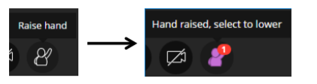
    - The instructor may also lower the hand via a notification that appears on his or her screen.
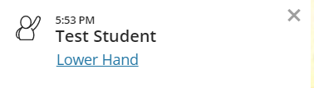
- Collaborate Panel - In the bottom-right corner of the screen, you will find an icon to open the Collaborate Panel. 
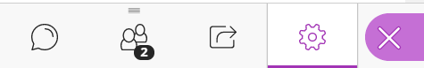
  - Clicking this icon provides access to the Chat, Attendees, Share Content, and Settings panes.
  - Chat - When a user first clicks the Collaborate Panel icon, the Chat pane opens by default, allowing a user to chat with all other users, Moderators only, or an individual attendee. After switching to a different pane and then closing the panel, the last pane used will appear when the panel is reopened.
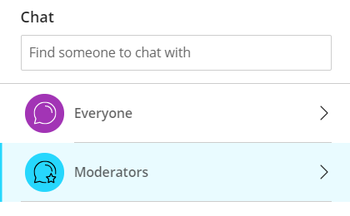
  - As users add text or images to the Chat pane, the contributions accumulate there. However, when a user leaves the session (voluntarily or not) and returns, the Chat pane will appear empty when he or she returns. Likewise, anyone entering the room “late” will not see any Chats that happen prior to their entry.
  - Users can type text into the box at the bottom of the pane or click the menu button display a limited library of emoticons. As with a typical chat application, pressing Enter or Return submits the text. For a wider array of images and emoji, users can keep the Twitter Symbols page open on a separate browser tab, click on a desired emoji, click on copy and then paste the emoji in the textbox: http://www.piliapp.com/twitter-symbols.
  - To start a conversation with another attendee, type that attendee’s name in the “Find someone to chat with” textbox. A filtered list of names containing the text you type appears immediately. Select the appropriate name from that list, and begin typing.
  - When users add text in the Chat pane, the other users receive visual or auditory notification if they do not have their Chat panes open.
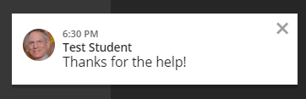
    - The small notification window disappears after a few seconds.
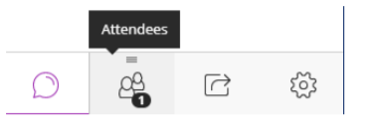
  - Attendees – Clicking this This icon displays the Attendees pane on the right side. Here you can see an alphabetized list of users, separated by role into Moderators, Presenters, and Participants. There is no separate section for the fourth role, Captioners; users whom a Moderator has designated as a Captioner receive a small “CC” icon next to their names.
    - The Attendees pane tracks which Participants have their audio input devices turned on via microphone or telephone icons. A darkened microphone icon indicates the current primary speaker, as selected by Collaborate’s audio algorithm (since multiple Participants may be speaking at once); an outlined microphone icon indicates others with audio turned on.
    - The Connection Indicator reveals a user’s network status when you point the mouse at it. Moderators can use this to check the network quality of all users.
    - Other icons and notifications in the Participants pane show the status of Participants, including whether they have stepped away from the session, are just joining, or are having trouble joining due to network problems.
    - At the top right of the Attendees panel there is an option button (three dots):
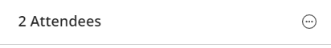
- Clicking the option button pops up three options:
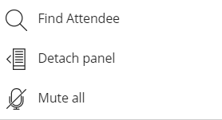
- If there are many participants (students) the user can click on the first option, type in the name of the attendee and see that person’s internet connection experience.
- If the user wants to keep the participant list visible, clicking on the Detach Panel option brings the list into the room. This does reduce the content area in the “Participants Space” for that user. Clicking on the options button on a Detached Panel enables the option to reattach it (giving back the screen space it was using) or Finding an Attendee.

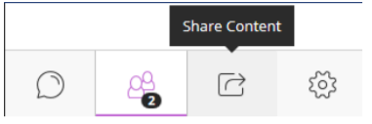
- Share Content - For Participant users, this pane primarily reveals the name of the file that a Moderator or Presenter is currently sharing with the conference.
  - For the instructor, the following choices are available:
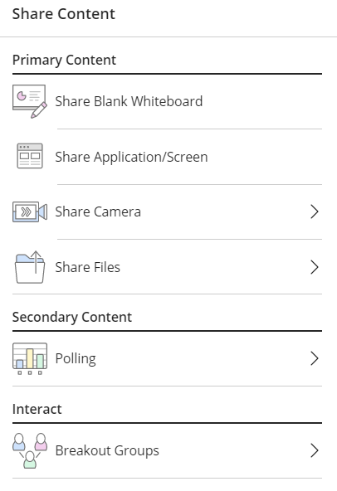
- Share Blank Whiteboard – clicking this option brings up and shares a Whiteboard with several basic tools available:
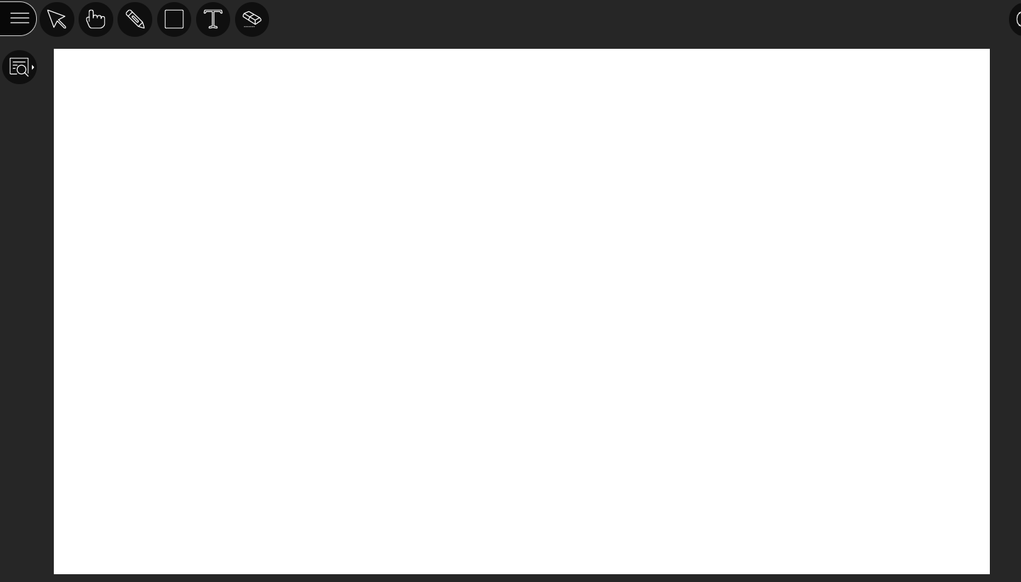
  - Clicking the Pencil tool pops up the selected color for the pencil. Clicking on the color circle shows the available choices.
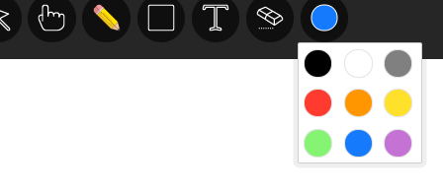
    - Select the color and use the pencil to draw on the Whiteboard. This is easier to do with some mobile devices/pads than with a mouse.
  - Clicking the Square “shapes” tool brings up the available shapes.
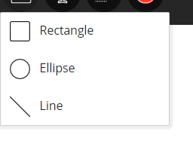
    - The same color pallet is available for the shapes tools.
  - Clicking the “T”ext tool allows text entry with the same colors. The font is fixed but you can “select” a textbox and resize, move, or delete it.
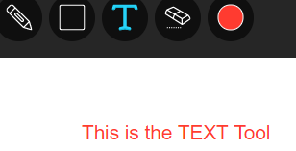
  - Clicking the hand/pointer tool lets you point out things on the Whiteboard.
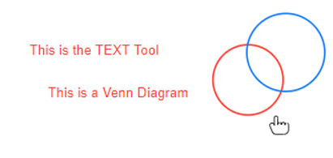
  - Clicking on the Eraser tool clears the Whiteboard. 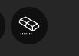
  - The instructor decides in Sessions Settings if participants can use the whiteboard and tools along with them during a session.
  - Also see https://help.blackboard.com/Collaborate/Ultra/Moderator/Moderate_Sessions/Share_Content#share-whiteboard_OTP-5
  - Clicking on the Select Tool (the blue arrow below) allows you to select an object
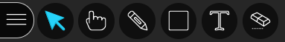
on the Whiteboard and resize, move, or delete it.
  - Here is a summary of those tools (from https://help.blackboard.com/Collaborate/Ultra/Moderator/Moderate_Sessions/Share_Content_)

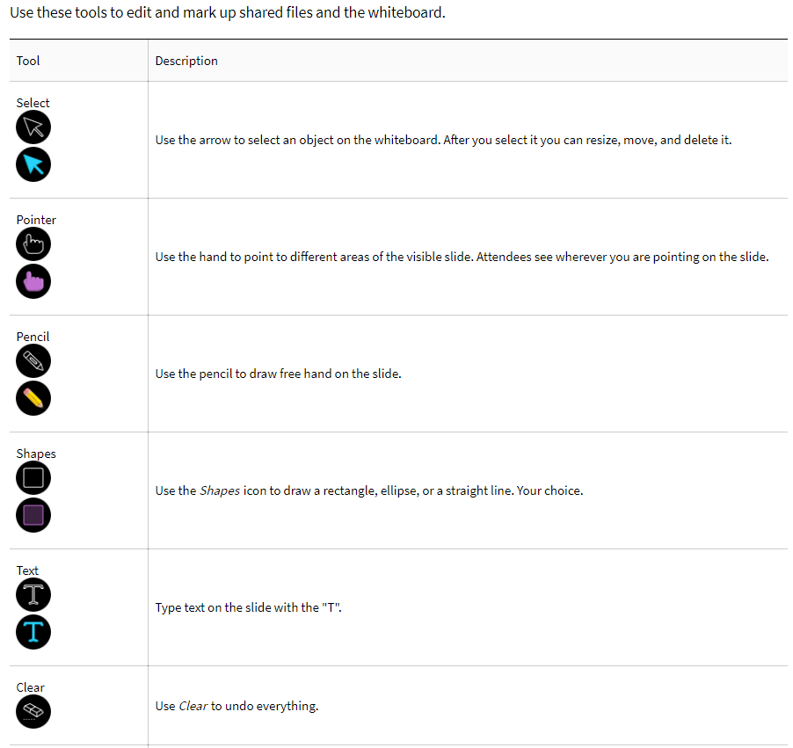
- STOP SHARING - At the top right of the Whiteboard screen (and all Sharing Screens) is a white square in a circle.  Click that to Stop Sharing the content.
  - Also when you share a pop-up at the bottom of the screen appears. 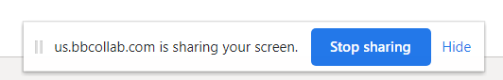 That pop-up can be moved or hidden or you can click on it to Stop Sharing content.
- Controlling the SIZE of the Shared content - When you share content a “View Control” button appears at the top right of the screen for BOTH the instructor and the students. 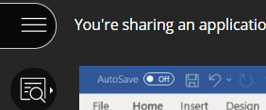
  - Once clicked, it “opens.” 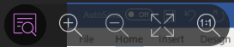 BOTH the instructor and the students have the option to use this “View Control.” Anyone can the use the controls to Zoom In, Zoom Out, Best Fit, or see the Actual Size of the Whiteboard or the shared content (see following section) ON THEIR SCREEN.
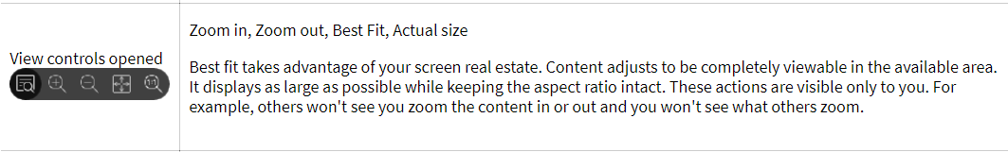
  - Changing the View on your screen does not change it on the students’ screens.
    - You can instruct the students to Zoom In (or whatever works best) OR you can “adjust” the size of the screen or application being shared (see following section).

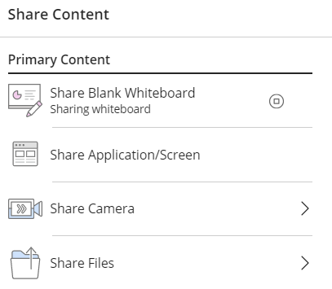
- Share Application/Screen
  - Clicking on the Share Application/Screen button brings up a pop-up window that allows you to share Your Entire Screen, an Application Window, or a Chrome Tab. If you have more than one monitor (as in the example below) Collaborate will ask which screen you want to share.
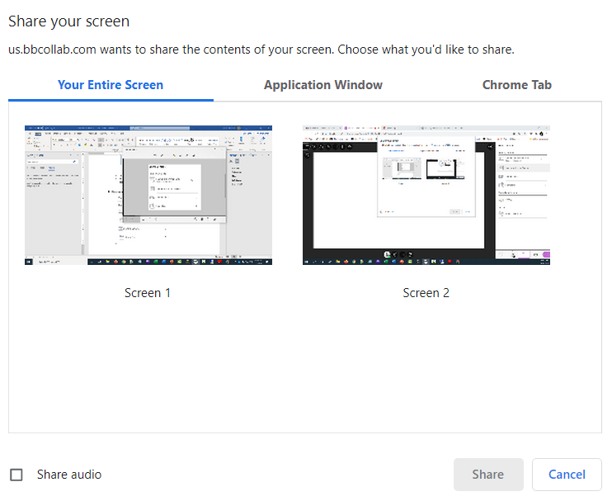
- Even if you only have one screen, you must Select (click) on the screen you want to share. Once you do that, the “Share” button will turn blue and you can select it.
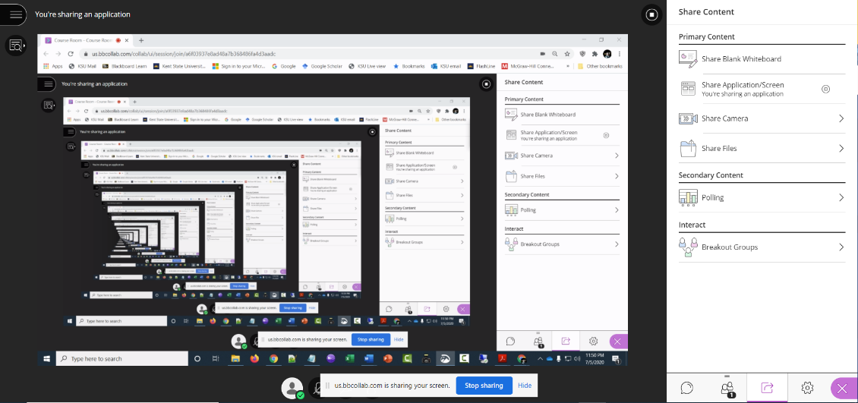
- If you share the screen that is showing the room, you get the “hall of mirrors” effect, showing the room over and over again. This is annoying, but normal.

- Next, simply select the application that you want to share, for example, a PowerPoint Slideshow, a document, a website, etc. Whenever you move through the application or desktop, your students automatically follow along.

  - When you share your desktop or application it is seen by everybody in the live session and anybody viewing the recording later. Make sure to close any windows and applications you do not want others to see before starting to share.

- It is important to note that if you want to share audio from your screen/application/tab (for example, a YouTube video) you must click on Share Audio in the initial pop-up window when you choose what screen/application/tab you want to share.

- Share Camera – Click this option to share a different camera if one is available.
- Share Files (from https://help.blackboard.com/Collaborate/Ultra/Moderator/Moderate_Sessions/Share_Content)
  - Upload GIF, JPEG and PNG images, PDF files, or PowerPoint presentations of 60MB or lower to your session. You can upload multiple presentations, however the total size allowed is 125 MB or lower for any particular session.
    - Limit PDFs and presentations to 500 pages or slides.
  - Screen reader users can access text from PowerPoint and PDF files shared in the session. This provides an easy way to follow along as slides change. Moderators and presenters must select Share Files and upload the files to Collaborate Ultra for screen readers to access the text.
  - Select Add Files Here or drag a file into the box to upload it. Select Share Now when you're ready for students to see the file.
  - You can prep for class at the beginning of the week, or even at the start of the semester. Join a session and load the files you want to share. These files stay in the session until deleted by a moderator. Load them once and reuse them as often as you want. If you can't join a session you want to upload files to, edit the session and change the time to start now. Upload the files. Don't forget to change the start time back to the original time! Attendees won't see the changes unless you send them another invitation.
  - You can choose to allow participants to mark up your shared file during a session in Session Settings. Open the Collaborate panel 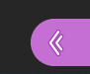and select My Settings. Go to Session Settings and make your choice.
    - If you are recording your session, allow 8 seconds for the recording to include your shared file before moving on.
  - For details on Sharing PowerPoint Slides see https://help.blackboard.com/Collaborate/Ultra/Moderator/Moderate_Sessions/Share_Content#ppt_files or watch a video about it here https://youtu.be/6H3R-E_pgEY
    - For many instructors, simply sharing the PowerPoint app will work well and is the way to go if your slides have animations. Animations do not show in an uploaded slide. The upload creates a static gif image of the slide.
    - If you only have one screen and want to both share PowerPoint slides and still see other parts of your screen (e.g., the students’ video images) you can view your show in a smaller window (see https://www.ellenfinkelstein.com/pptblog/view-slide-show-in-a-smaller-window-so-you-can-see-another-presentation-or-program/ )
      - In your presentation, click the Slide Show tab and choose Set Up Slide Show.
      - In the Set Up Show dialog box, in the Show Type section, choose Browsed by an Individual (Window).
      - Click OK.
      - Go into Slide Show view. Instead of taking up the entire screen, your presentation is in a resizable window. If it shows up in full screen you can resize it as you do any window. You can see other parts of your screen and can easily switch among other applications to share.
- Polling (https://help.blackboard.com/Collaborate/Ultra/Moderator/Moderate_Sessions/Polling )
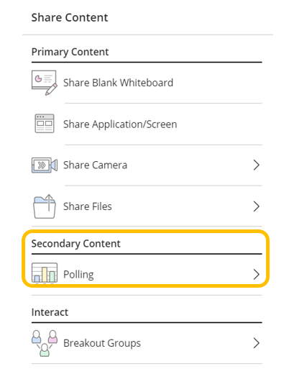
  - Polls can be a great to engage students and keep them interested. They have many uses. For example: Keep your attendees' attention by giving them opportunities to participate. Start a discussion by asking your attendees their opinion on something. Ask questions to see how well they understood what you presented. Or use reflective questions to help them retain what you presented.
  - You can select either a multiple-choice poll, where you can provide up to five choices (90 character limit per choice) or a Yes/No poll.
    - For both poll types, you can type a question (up to 100 characters).
    - You cannot create and save Polls in advance of a class. However, you can speed things up if you know what Questions and Answers you will be using.
      - Prepare the Questions and Answers in advance in a Word document (or text document) and then copy and paste your prepared Q&As into the poll. That will save time.
      - Alternatively, you might “gamify” Polls via something like kaboodle (see https://www.kaboodle.com/ ).
  - Select Polling.
  - Select Multiple Choice or Yes/No Choices.
  - Optionally, type the poll question, paste in the prepared question, or leave it blank. Poll questions have a 110-character limit.
  - If using Multiple Choice, give up to 5 answer choices. Type (or copy/paste) your answer choices or leave them blank. Answer choices have a 90-character limit. If you leave the choices blank, attendees see numbers for their choices.
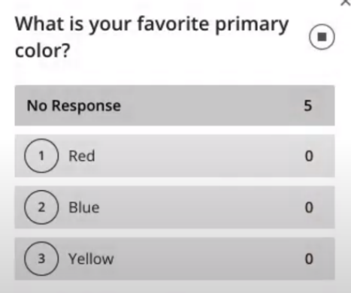
  - Two Examples:

  - When you are set, click “Start.”
  - Students respond to your poll by selecting one of up to five responses or choosing Yes or No.
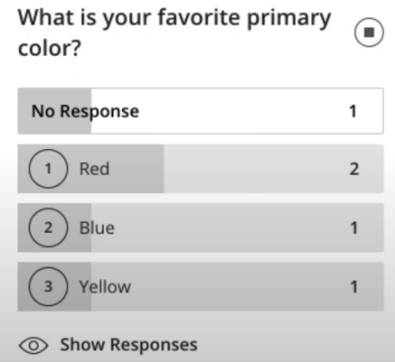
  - As students respond, you see a “response count:”
    - Instructors can also respond to the poll. For this reason, you are also counted in the No Response count.
  - Show responses to Students
    - Select Polling to open the poll overview. Select Show Responses to show the responses to all students. You can see what responses individual students gave, but when you share the results the students see the overview count of the responses only.
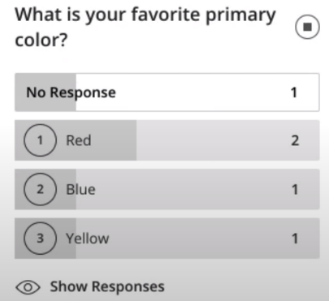
  - To END a poll, select Polling to open the poll overview. Then select “End polling” (black square in circle) to stop the poll.

  - To see this in action see a Blackboard video at https://youtu.be/mK7390n-VN0 (1:15) or a user created video at https://youtu.be/4bluYCZFGic?t=399 (this is in the middle of a presentation on groups, but shows the feature nicely).
  - Download poll results
    - Moderators, instructors, and administrators can download a session's Poll report. This report includes the poll question and how each attendee responded.
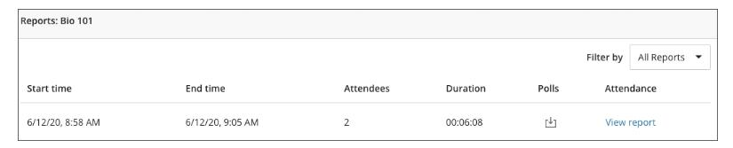
    - After you leave the session, open the Session options menu and select View reports.

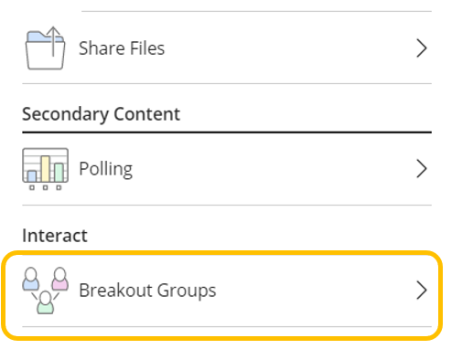
- Breakout Groups (https://help.blackboard.com/Collaborate/Ultra/Moderator/Moderate_Sessions/Breakout_groups)

- To facilitate small group collaboration, you can create breakout groups that are separate from the main room and assign attendees to them.
  - If your session has more than 250 attendees in it, breakout groups is turned off.
- Breakout groups have their own private audio, video, whiteboard, application sharing, and chat. Any collaboration that takes place in a group is independent of the Main room (and other groups).
  - What is said or viewed in a breakout room isn't captured in recordings.
Start breakout groups
- You can choose to have Collaborate create and randomly assign breakout groups for you. Or you can create the groups yourself. Breakout groups are assigned during the session. You can't create them ahead of time or save them.
- It takes a few seconds after you “start” Breakout Groups for them to be created (so let your students there may be a pause as the rooms are set up).
Begin by Clicking on Breakout Groups.
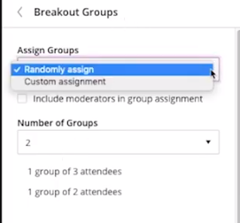
- Assign groups. Select Randomly assign or Custom assignment.

  - Randomly assign: Collaborate creates groups and randomly assigns attendees for you. Randomly assign is only available when there are four or more people are in the room.
  - If you want to be in a group, select Include moderators in group assignment.
    - You can change how many attendees are in each group. Select the number of groups from the Number of Groups menu.
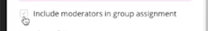
    - Optionally, you can choose to “Include moderators in group assignments.”
    - If you don't like how the attendees are grouped, select “Reassign attendees.” (or “shuffle attendees”).
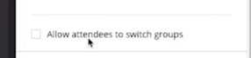
  - Optionally, select “Allow attendees to switch groups,” if you want attendees to be able to move to another group on their own.
    - Once the groups are set up, each student can click on the Attendees button and see all of the group members and all of the groups.
  - If you want, you can change the Group names.
  - Click on “Start.”
  - Custom assignment: Create your own groups.
    - Assign attendees to a group. You can select the attendee's options menu and select the group that you want them to be in. You can also select the attendee and “drag and drop” them to the desired group.
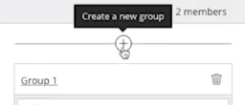
    - Select “Create a new group” to add more groups.

    - You can create up to 20 groups. Breakout groups is only available in sessions with 250 or fewer attendees. There is no limit to the number of attendees you can put in each group. However, we recommend spreading attendees out evenly over your groups.
  - As above, optionally, select “Allow attendees to switch groups,” if you want attendees to be able to move to another group on their own and choose to “Include moderators in group assignments” if you like.
  - If you want, you can change the Group names.
- Select “Start.”
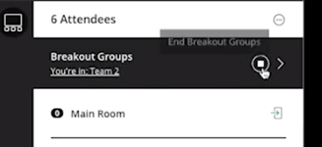
- Bring all students back into the main room by clicking on the “white square in a circle” to end the Breakout Groups session.
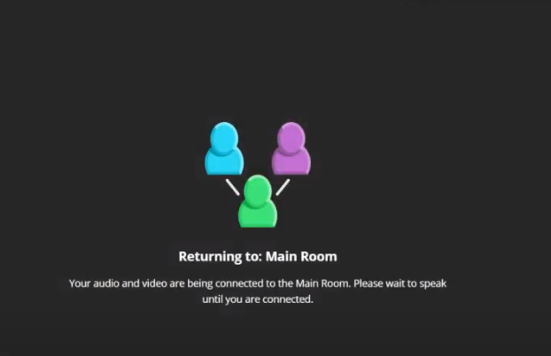
  - Everyone see that the sessions are ending (that takes some time too, let students know):

- Monitor groups - After breakout groups are started you can move between groups to monitor them. If you assigned yourself to a group, you see and hear what others in the group are doing. This includes any shared content, audio, video, and chat.
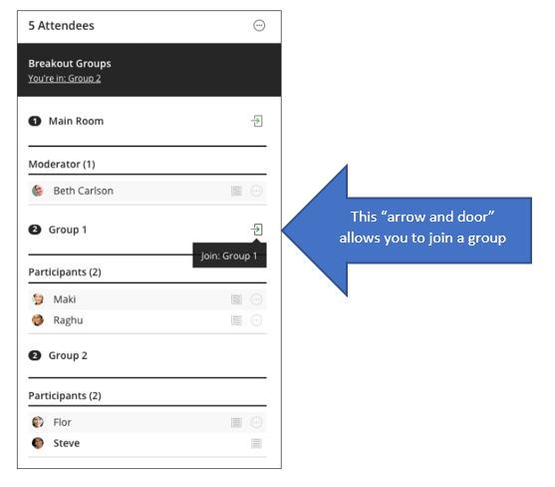
  - If you want to see how the other groups are doing, you need to join those groups. From the Attendees panel, select Join group.
  - NOTE that the STUDENTS would change groups in the same way (click on the “arrow and door” of the group they want to join) IF you have enabled that option for them.
- Share files to breakout groups
  - You can share files, with one or more breakout groups.
  - After starting breakout groups, select Share Files.
  - Open the File options menu of the file you want to share.
  - Select Share with groups.
  - Choose the groups you want to share the file with.
  - Select Share Now.
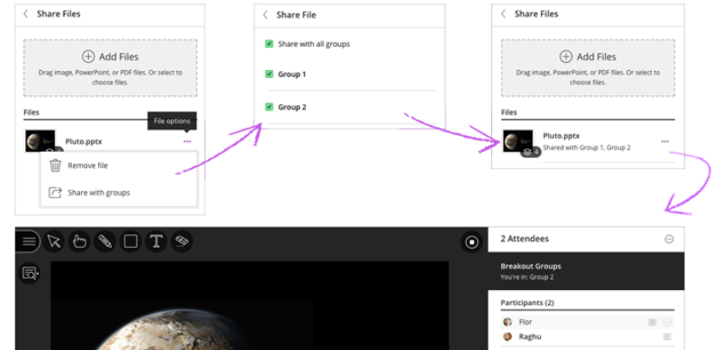
  - The first slide of the file displays in the breakout group.
    - In many cases it will be easier to share a screen/application/Chrome tab.
- To see this in action, watch a video about breakout groups at https://youtu.be/D4dudLGevhw (0:57) or https://youtu.be/0b7NXc0Rnrs for more detail (5:44).

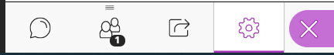
- My Settings -- When an instructor clicks on the My Settings icon the following window pops up.
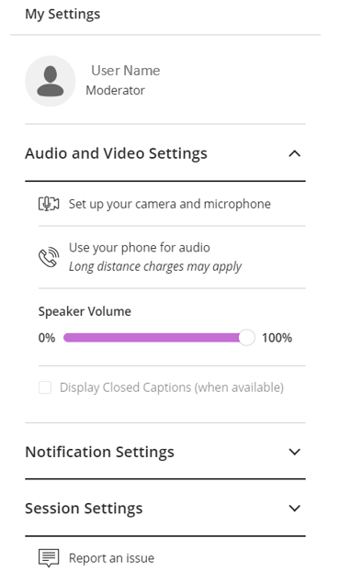
    - Students who click on the icon do not see the Session Settings option (they see the user name/icon, Audio and Video Settings, Notification Settings, and Report an issue.)
    - Upload or Change the Profile picture. Clicking on the image next to the User Name brings up the option to create or change your profile picture. This can be done with an upload of a picture or by capturing a photo from the camera.
    - Audio and Video Settings - An important element is the Set Up of the camera and microphone found in the Audio and Video Settings area.
      - Clicking on “Set up your camera and microphone” first brings up a window that allows you to choose your microphone from a drop-down list of available mics. Select the appropriate one and the audio test screen will show how loud the volume is. If the volume bar does not move, clicking on the “No. I need help.” button takes the user to a Blackboard Help screen. Clicking on “Yes. Audio is working.” Moves to the Video Test.
      - This window allows you to choose the camera you want to use for the session from a drop-down menu. The selected camera will show the video on this preview screen. As with the microphone, the user can click for help or indicate that the video is working.
      - Once the options are set, you are returned to the room with this pop-up:
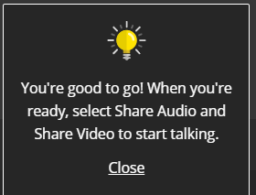

- Session Menu - In the top-left corner of the Collaborate screen, you will find the Session Menu icon. Click it to expand the Session Menu pane. The panel displays the name of the room at the top, above a list of command icons. There is also a Leave Session icon at the very bottom of the pane.
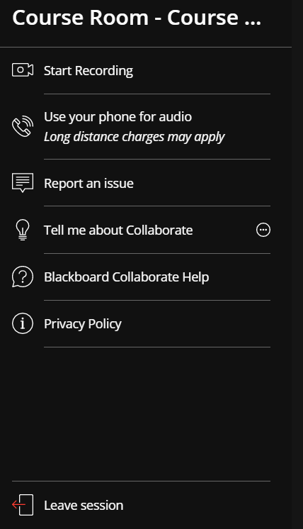
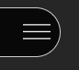

  - Start Recording – As noted earlier, the Instructor can choose to record the class session. It will be visible “live” and then a recording of the session will be available for later viewing.
    - Collaborate Ultra works best in an updated Chrome browser.
    - Record your sessions so that your students can access presentations whenever they need them. Stop and restart whenever you need to, and when finished, and share with your students.
    - Recorded sessions are compressed and saved as MP4s. Recordings include activity in the live session:
      - Audio
      - Any content shared or active speaker video. If both are shared during the session, only the content shared is recorded.
      - Captions entered during the live session or added later by a moderator. Only one caption track is available. If your session had more than one caption track, only the first available one is captured.
      - Chat messages in the Everyone channel. Private messages and chat messages in breakout groups are not recorded.
    - Only moderators can turn recording on in sessions.
    - Everyone with access to the class can view the recordings from any device as often as they want. There are no view limits.
    - Recordings are converted by Blackboard Collaborate Ultra into a playable format before viewing. This conversion can take quite a while and the recording cannot be viewed until it is completed.
      - If the recording is not yet ready, clicking on it will return the following message: No recordings found within the past 30 days.
      - Wait a while and try it again later.
    - You can have multiple recordings during one session. If you decide to continue recording a session after you have stopped, a new recording is saved and added to the list of recordings for that session.
    - To Start Recording open the Session menu and select Start Recording. The recording camera appears on with a red dot while recording is in progress.
    - To Finish Recording open the Session menu and select Stop Recording.
      - If you are sharing a file, allow 8 seconds for the recording to include the shared file before moving on.
    - You can view recordings in courses you are enrolled in. If the instructor has selected the session recording option for downloads then the recording will be available for download.
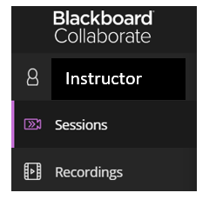
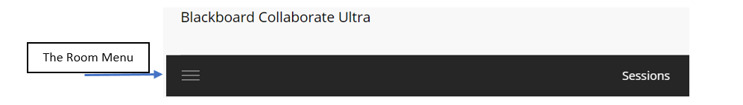
    - To see the recording, Go to the Collaborate Ultra room for the course, open the Menu, and select Recordings.
    - Click on Recordings to bring up all recordings for the class. If you don’t see the recording you want, click Recent Recordings and select Recordings In A Range. Enter a date range, or if it is a recent recording it may still be undergoing processing, so check back later.
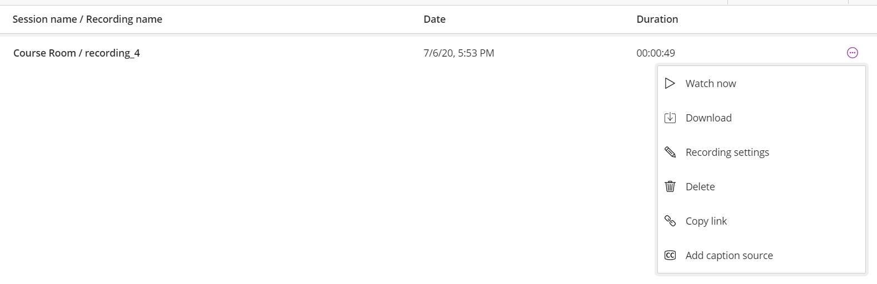
    - To the right of the recording you want, click the three dots in a circle icon Recording options icon which looks like a circle with three horizontal dots to access Recording options, and select the appropriate option (Watch now, Download, Recording settings, Delete, Copy link, Add caption source).
      - To share the video with those not in the course, select “Copy link,” copy the link that displays and paste that into an email, into your Blackboard course, or wherever you wish. Viewers can access this link from any browser without needing to be enrolled in the course or having to log into Blackboard.
    - The link to the recording will only be available as long as your course still exists on Blackboard. You may wish to download your recording to save for future courses (e.g., uploading to Kaltura or YouTube) if it is a recording you wish to reuse in the future.
    - So, you can download a recording (it is an .mp4 file) and then UPLOAD IT to Kaltura.
      - Go to https://video.kent.edu/
      - Click LOGIN and enter your KSU User ID and Password.
      - Click on + ADD NEW and then on Media Upload
      - Either Drag & Drop the file to the Upload Media window or click on +Choose a file to upload and select it from your computer.
      - While the file is uploading, you can complete the required and optional information (Title, description, Tags) as appropriate and click SAVE.
      - Click on “Go To Media” and on the “Share” tab to copy the link to this video.
    - This approach can also be used to Restrict Access to Collaborate Ultra Recorded Session (see https://www-s3-live.kent.edu/s3fs-root/s3fs-public/file/RestrictAccessCollaborateUltraRecordings.pdf for details)

  - Use your phone for audio - Click this icon to display the 10-digit number to call into the session, as well as the eight-digit PIN to enter when prompted. The number is not toll-free. Use this option when using a USB microphone is inconvenient or impossible. Each user receives his or her own PIN; entering a PIN received from another user currently in the conference will eject that user from the conference.
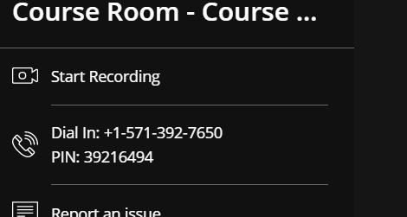
  - Report an Issue – Clicking this icon opens the Report an Issue pane on the right side of the screen. Check the appropriate checkboxes or type any useful information about a technical problem with Collaborate and click the Submit button at the bottom. Collaborate sends the report to the development team, with information about the session, as well as to KSU’s Blackboard Administrator.
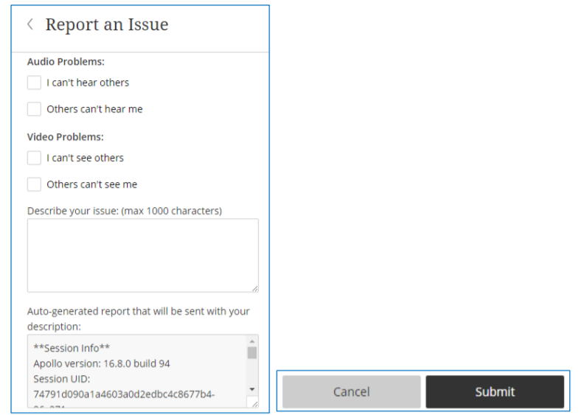
  - Tell me about Collaborate - This option provides a Details icon, which produces a two-item menu. Choose Introduction to Collaborate to step through the various interface elements. Choose Learn about private chat to learn about a how to allow Participants to type messages to other individual Participants. The Private Chat feature will be discussed in greater detail.
  - Blackboard Collaborate Help - Click this icon to navigate to Blackboard’s Collaborate Help website in a new tab. Depending on your role for the session, you may see the main page for a Moderator, Participant, Presenter, or Captioner.
  - Privacy Policy – takes you to a Blackboard Help page with a Privacy Statement.

Appendix
View Reports (source: https://www.stthom.edu/Public/getFile.asp?File_Content_ID=115307)
Every time the room is occupied, whether scheduled or not, generates a report and adds it to the list of reports for the room. Information in the report includes start date, start time, end time, number of attendees, calculated duration, the average time users spent in the session, and a unique Session ID.
The View Reports command displays a list of reports with the basic information for the session. By default, the list is filtered to sessions within the last 30 days. Click the icon in the far-right column to see more information, as well as a Session ID that you can copy and paste, and a link to export the report to a printable format (not PDF) in a new tab. Users are listed chronologically by when they joined the conference.
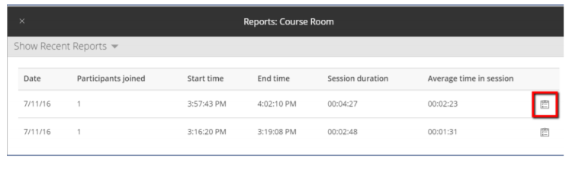
Instructors can export report data either in a printable format or to a .csv (comma-separated values) text file, which can be opened in Microsoft Excel.
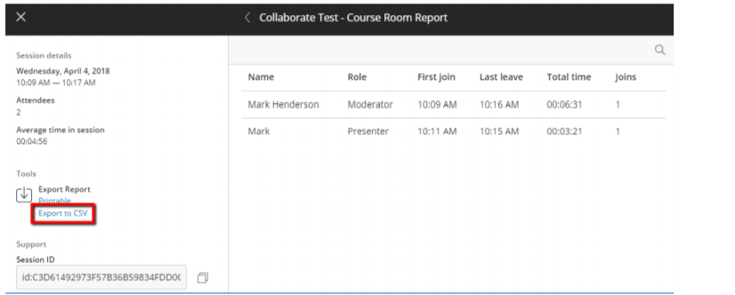
Click the Back (<) icon to return to the Reports page, or the X icon at the top-left to return to the main Collaborate Ultra page.

Scheduling Sessions
(source: https://www.stthom.edu/Public/getFile.asp?File_Content_ID=115307)
Blackboard Collaborate has the ability for Moderators (Instructors) to schedule sessions. These sessions can be scheduled for a fixed time period or set as an Open Session (with no end time). However, there is no requirement to schedule any sessions if a Moderator just wants to leave the Course Room open for the duration of a course.
If there are no upcoming sessions listed on the page, click the Create Session button to open the New Session pane.
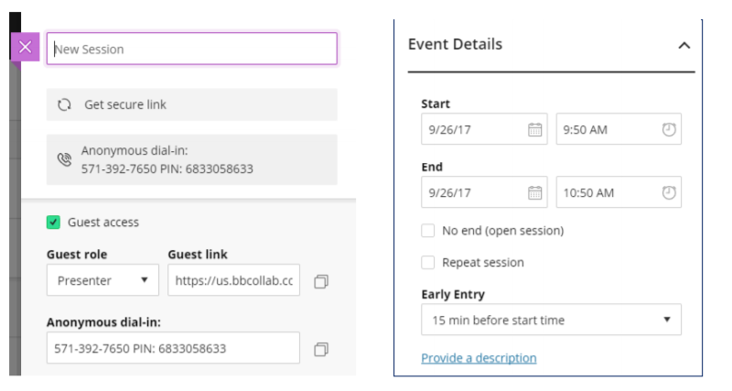

When the New Session pane appears, a Moderator can:
• Give the New Ssession a unique name (required), which may include the date and start time.
• Determine whether guest users (with no KSU Blackboard account) may join the session, and if so with what role.
• Set the Start and End dates and times, which must be in the future, or check No End.
• Check Repeat Session for any session that will occur at fixed intervals.
• Copy and share the dial-in information for attendees who need to join via telephone instead of a computing device.
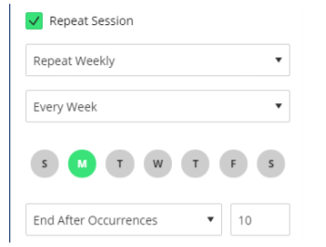
• Set how far in advance of the start time Participants may join the session.
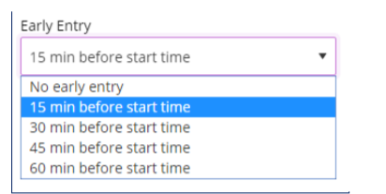
• Click Add a description to reveal a text box to type a description for the session.
• Scroll down and click Session Settings to expand that portion of the pane. A Moderator can also modify most of these settings during the live session.
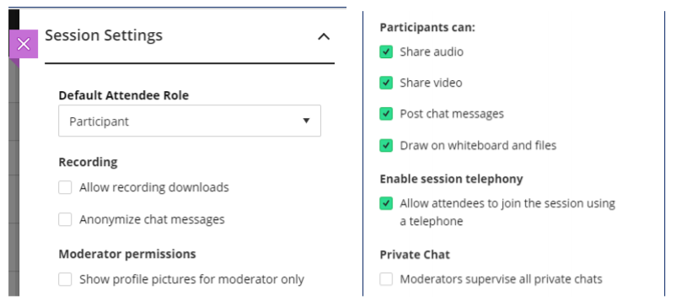
- The Session Settings portion of the New Session pane helps the Moderator control what privileges Participants have during the session. With a large number of Participants, it may be useful to turn off their ability to share audio, share video, or draw on shared content.
- When all the settings are in place, click the Save button to add the session to the current list; otherwise click Cancel or Delete. A few seconds after the beginning of the process, the caption of the Cancel button changes to Delete, because the session itself is automatically saved.
- To close the pane without saving any changes, click the X icon in its top-left corner.
- Each new occurrence of a session appears in the list on the Blackboard Collaborate Ultra page with its start and end times and a Session Options icon. The menus appear for single and repeated sessions, as appropriate.
- If the list contains more than ten upcoming sessions, navigational links appear below the list.

