LECTURE OUTLINE FOR

MKTG 25010

“Marketing”

Lecture Packet

Part 2

Spring 2009

DR. MARKS

Modified 1/14/09

Chapter 13 --Building the Price Foundation

- NATURE AND IMPORTANCE OF PRICE
  - Price -- the money or other considerations (including other goods and services) exchanged for the ownership or use of a
good or service.
  - Barter -- the practice of exchanging goods and services for other goods and services rather than for money.
    - Example:

  - Price Equation
Final Price = List Price – (Incentives + Allowances) + Extra Fees
  - The “price” a buyer pays can take different names depending on what is purchased
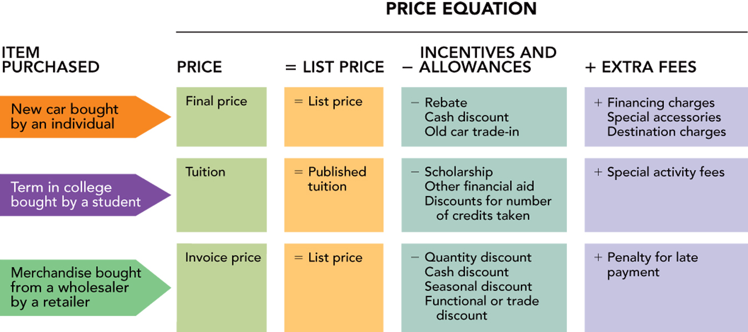
    - KSU Tuition Example:

      - The “price” for tuition at KSU
For a full-time in-state student at 15 credit hours
??

$5760 - $1545 - $1000 + ??

KENT CAMPUS SPECIAL COURSE FEES
FALL 2008 / SPRING 2009
PLUS ANY Miscellaneous Fees:

Legal Services Fee......................................$7
Admissions Application...........................$30
Matriculation Fee.....................................$100
Transient Application...............................$10
Reinstatement Application......................$25
Returned Check.........................................$30
Late Registration.....................................$100
Late Installment Payment........................$30

SO, The “price” for tuition at KSU is:

- PRICE AS AN INDICATOR OF VALUE
  - Value is the ratio of perceived benefits to price

VALUE = ------------------------------------------------

  - Value-Pricing -- the practice of simultaneously increasing product and service benefits while maintaining or decreasing price.
    - Examples
- PRICE IN THE MARKETING MIX
  - Profit Equation
Profit = Total Revenue – Total Cost
= (Unit price x Quantity sold) – (Fixed cost + Variable Cost)
- Six Steps in Setting Price
  - STEP 1: IDENTIFY PRICING OBJECTIVES AND CONSTRAINTS
    - IDENTIFYING PRICING OBJECTIVES -- Pricing Objectives specify the role of price in an organization’s marketing and strategic plans.
      - Profit Objectives
        - Managing for Long-Run Profits
        - Managing for Current Profit
        - Target Return (ROI)
      - Pricing Objectives
        - Sales Dollars
        - Market Share (Dollars or Units)
        - Unit Volume
        - Survival
        - Social Responsibility
    - Pricing Constraints -- factors that limit the range of prices a firm may set.
      - Constraints caused by DEMAND for the:
        - Product Class ( ),
        - Product ( ),
        - and Brand ( )
      - Constraints caused by Newness of the Product: Stage in the Product Life Cycle
        - Single Product vs. ______________
        - ___________ Producing and Marketing a Product
        - ___________ Changing Prices and Time Period They Apply
      - Constraints caused by the type of Competitive Environment
        - Pure Competition
        - Monopolistic Competition
        - Oligopoly
        - Pure Monopoly
        - Competitors’ Prices

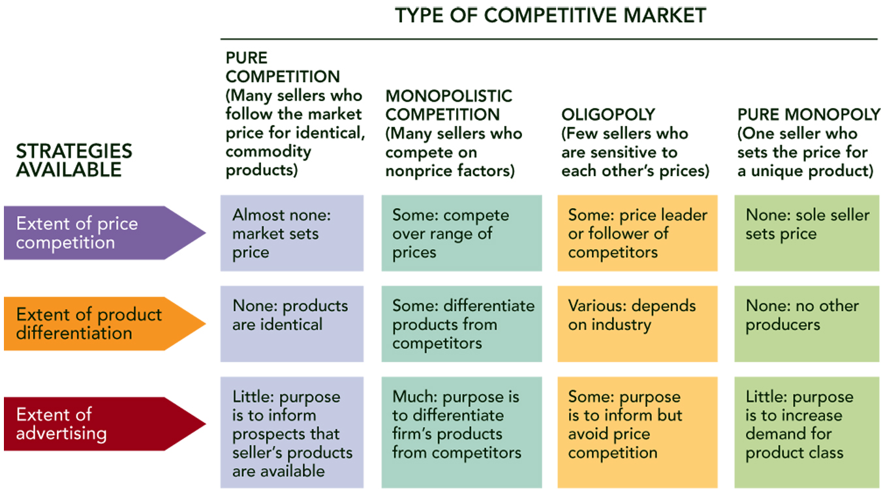
  - STEP 2: ESTIMATE DEMAND AND REVENUE
    - FUNDAMENTALS OF ESTIMATING DEMAND
      - The Demand Curve -- a graph relating the quantity sold and price, which shows the maximum number of units that will be sold at a given price.
        - Influenced by:
          - Consumer _________________
          - __________ and _____________ of Similar Products
          - ________________
          - _________________________
      - Demand Factors -- Factors that determine consumers’ willingness and ability to pay for goods and services.
      - Example:

FIGURE 13-5A Demand curve for Newsweek showing the effect on annual sales by a change in price caused by a movement along the demand curve
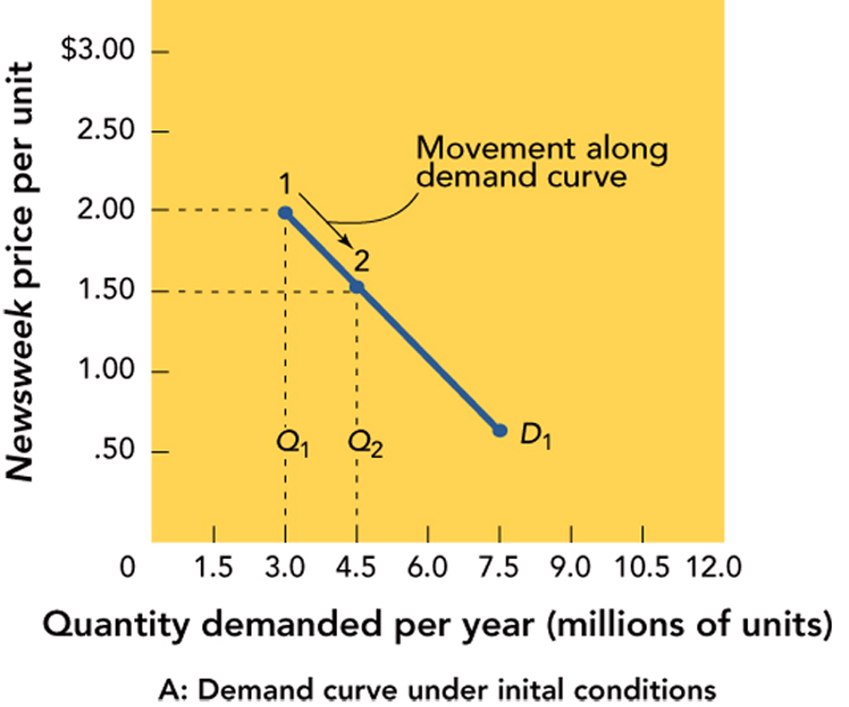

FIGURE 13-5B Demand curve for Newsweek showing the effect on annual sales by a change in price caused by a shift of the demand curve
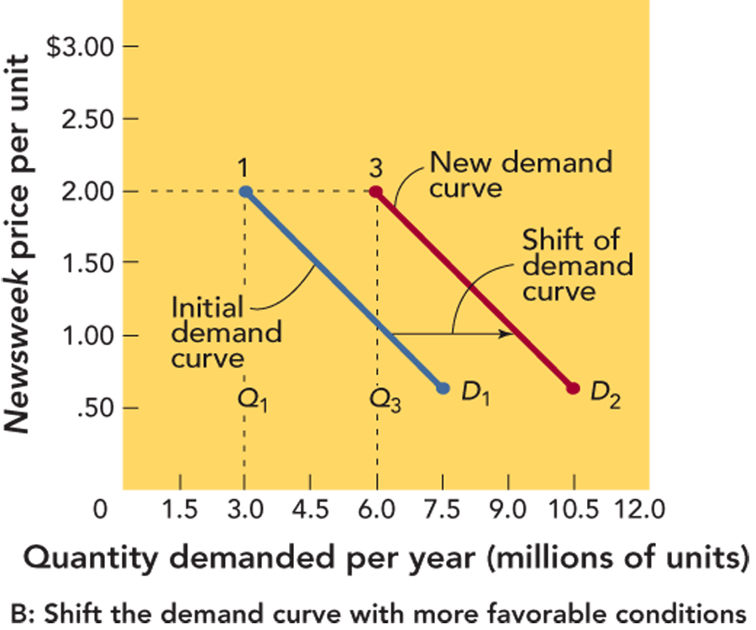
    - FUNDAMENTALS OF ESTIMATING REVENUE
      - Total Revenue (TR) -- the ______________ received from the sale of a product.
      - Average Revenue (AR) -- the average amount of money received for selling one unit of product, aka ___________ of that unit
      - Marginal Revenue (MR) -- the ________ in _______________ that results from producing and marketing one additional unit.
        - So, Total Revenue (TR) is the total money received from the sales of a product. Logically, if:
          - TR = Total revenue
          - P = Price, and
          - Q = Quantity sold, Tthen
          - Total Revenue = P x Q, and

          - Average Revenue = TR = P
Q
      - AND, if Marginal Revenue (MR) is the CHANGE in the total revenue that results from producing and selling on ADDITIONAL unit of a product:

      - ___Change in TR__
MR = 1 unit increase in Q = the SLOPE of the Total Revenue curve
      - See FIGURE 13-7 in textbook…HOWEVER
- For those who REALLY care:
- The Marginal Revenue formula shown in the text in Figure 13-7 is wrong
  - Try making the numbers work with this formula; they won’t
- The formula IS correct when the changes in quantity sold are small (essentially a change of 1 unit).
  - For larger changes (like 1.5 million!!) this formula shows the “average of the change” (more or less).
- To get the value for the changes in large quantities they use, one formula is:
  - Marginal Revenue= Price + (Quantity sold times the change in Price divided by the change in Quantity)
- Or
  - MR = P + (Q x Change in P/ Change in Q)
      - Price Elasticity of Demand -- the percentage change in quantity demanded relative to a percentage change in price.

Price Elasticity of Demand (E) = Percent Change in Quantity Demanded
Percent Change in Price
        - Elastic Demand, occurs when a 1% change in price results in a GREATER than a 1% change in sale (so, E>1)
          - So, a _________ decrease in price results in a _______ increase in sales
        - Inelastic Demand, occurs when a 1% change in price results in a LESS than a 1% change in sale (so, E<1)
          - So, a ___________ decrease in price results in ________ than a 1% increase in sales (SO, sales revenues ___________!)
        - Unitary Demand occurs when the percentage change in price is the ____________ as the percentage change in quantity
        - The Price Elasticity of Demand is Influenced by:

            - Example
          - The Price Elasticity of Demand is not _______________
  - Step 3: DETERMINE COST, VOLUME, AND PROFIT RELATIONSHIPS
    - Controlling COSTS – The basic concepts:
      - Total cost (TC) is the total expense incurred by a firm in producing and marketing a product.
        - Total cost is the sum of fixed cost and variable cost,
or TC = FC + VC
      - Fixed cost (FC) is the sum of the expenses of the firm that are ________________________________ with the quantity of a product that is produced and sold.
      - Fixed costs include things like:

        - These ____________________ as we sell more products.
      - Variable cost (VC) is the sum of the expenses of the firm that vary directly with the quantity of a product that is produced and sold.
        - Examples of variable costs include:
          - the _________ that is needed to make the product,
          - the _________ that are needed to make the product,
          - ______________ that are paid on each unit sold.
      - Unit variable cost (UVC) is __________ expressed on a per unit basis, so
UVC = VC / Q
      - Marginal cost (MC) is the ___________________ that results from producing and marketing one additional unit of a product.
        - Marginal cost (MC)
= Change in Total Cost
1 unit increase in Quantity
= Change in TC
Change in Q
= the slope of the Total Cost curve
      - Marginal analysis is a continuing, concise trade-off of incremental costs against incremental revenues.
    - Break-Even Analysis – is a technique that analyzes the relationship between _________________ and _______________ to determine __________________ at various levels of output.
      - A Break-Even Point (BEP) is the quantity at which total revenue and total cost are equal, SO…
Break Even Point (in units)
= ______Fixed Costs__________
Unit Price – Unit Variable Cost
= ______FC_______
P - UVC
      - Example -- FIGURE 13-10 Calculating a break-even point for the picture frame store

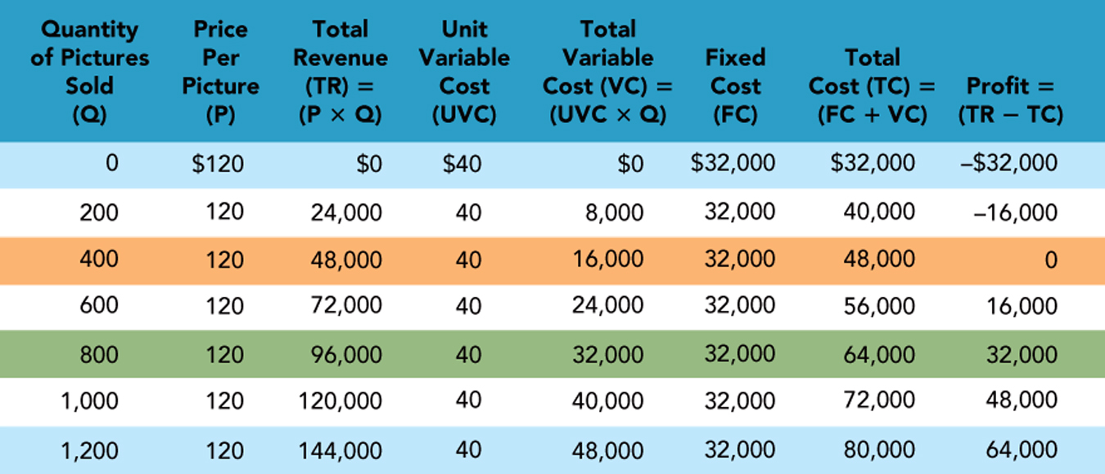
    - Break-Even Chart -- a graphic presentation of the break-even analysis that shows when ______________ and _________________ intersect to identify profit or loss for a given quantity sold.
      - Example Break-even analysis
Vari-able
Cost

      - Washburn Guitars: Using Break-even points to make pricing decisions
        - What factors are most likely to affect the demand for the lines
of Washburn guitars (a) bought by a first-time guitar buyer and
(b) bought by a sophisticated musician who wants a signature model?
        - For Washburn, what are examples of (a) shifting the demand curve to the right to get
a higher price for a guitar line (movement of the demand curve) and (b) pricing decisions involving moving along a demand curve?
        - In Washburn’s factory, what is
the break-even point for the new line of guitars if the retail price is (a) $349, (b) $389, and (c) $309? Also, (d) if Washburn achieves the sales target of 2,000 units at the $349 retail price, what will its profit be?

ANSWER:

The break-even is calculated as follows:

a. Price (P) = $ _____ ;

b. “Abel estimates one half of the FINAL RETAIL PRICE will be the price NETS when it sells it guitar to…its channel of distribution.”

SOOoooo, Retail markup = _________ %;

c. and Net Price = ______________/unit

d. Fixed Costs (FC) =

Rent and taxes _________

+Depreciation ________

+ Mgmt & control _________

= $

e. Unit Variable Costs (UVC) = [($____/unit + (___ hours/unit × $____/hour)]
= $_____ + $_____ = ______/unit

BEP = | Fixed Cost
BEP = | Unit Price – Unit Variable Cost

SO, if we charge a retail price of:
- $349, we get a break even of __________ units
- $389, we get a break even of __________ units
- $309, we get a break even of __________ units
- What will the profit be if Washburn sell its target of 2000 units?
  - For the $349 guitar?
  - For the $309 guitar?

Chapter 14 -- Arriving at the Final Price

- The Six Steps in Setting Price
  - Identify Pricing Objectives and Constraints
  - Estimate Demand and Revenue
  - Determine cost, volume, and profit relationships
  - Select a approximate price level
  - Set the list or quoted price
  - Make special adjustments to the list/quoted price
- STEP 4: How to Select an Approximate Price Level
  - What is the possible “range” of prices?

  - Demand-oriented Pricing Approaches
    - _________________
      - involves setting the highest initial price that customers really desiring the product are willing to pay.
      - used when introducing a new or innovative product; so it is seen in the early stage of the PLC

      - Used to rapidly recover investments in developing a new product
      - Works because:
        - consumers __________ the product,
        - there are ________________ (yet)
        - We have a protection on the product (copyright; patents; unique process)
      - And SO we have an ____________ demand curve.
      - Advantages of Price Skimming
        - Allows us to recover development costs quickly
        - IF the price is perceived as “too high” by the market, we can easily lower it (RAISING a price is much harder to do)
          - Example:

      - Disadvantage of Price Skimming
        - The major disadvantage is that the large profit margins will ATTRACT competition
    - __________________
      - involves setting a __________ price on a new product
      - It is used to appeal immediately to the ___________
      - And so to capture a large share of the market quickly
      - This is used when there are few barriers to competition entering the market,
      - When we expect the PLC to be long
      - When we expect demand to be ELASTIC (so there is a market response to our lower price).

Price/Cost
Price
Cost Curve
Time/Experience

      - Advantages of Penetration Pricing
        - The small margin is likely to ________________
        - Because we get a large share of the market quickly:
          - our volume is larger and our production costs (per unit) drop more quickly
          - And with high volume we still generate good profit
      - Disadvantages of Penetration Pricing
        - A risky strategy
          - We must be able to do a good job of forecasting the demand, because we will need to gear up FAST for mass production and distribution/marketing.
          - IF demand does not develop, our production costs stay high and we do not make a profit!
    - “_______________________________”
      - Involves starting with a Price Skimming approach and then REDUCING price as our costs decline
        - This is done to appeal to a wider market once the “premium price” buyers are satisfied or
        - To react to an influx of competitors

Time/Experience
Price/Cost
Price
Cost Curve

      - Advantages of “slide down the demand curve”
        - Allows us to recover __________________ early in the PLC
        - Helps to discourage competition as we drop price (note that OUR costs should be lower than those of the “late entrant” competitors).
        - assumes a reasonably LONG PLC
      - Disadvantages of “slide down the demand curve”
        - It is very hard to know just when to begin dropping prices
          - Drop too soon, and ___________________________
          - Drop too late and ________________________
    - __________________________
      - involves setting a high price
      - to attract quality- or status-conscious consumers
      - This should appeal to high-end consumers and limit it appeal to “others” (which ENHANCES the product’s image)
Price/Cost
Cost curve
Price
Time/Experience

      - Advantages and Disadvantages of Prestige Pricing
        - Because of the high price, we are ____________ to sell in large volume, however,
        - This is not a problem as __________ can be made with the large markup on each item sold
  - Demand-oriented Pricing Approaches
    - _______________
      - involves setting the price of a line of products at a number of different specific pricing points
      - even if customers don’t know much about a set of products, they may perceive difference based on price alone
      - If the differences in models are not readily apparent or not easily viewed, then price lining helps the customer recognize that differences do exist as (long as the prices are noticeably different).
      - Example:

      - Advantage of Price Lining
        - May increase profits if the ____________ of adding the additional features is not significant
          - Consumers “buy up” to a higher priced, more feature-rich model which is ALSO more profitable for the marketer
      - Disadvantages of Price Lining
        - A disadvantage to price lining is that by focusing too much on price, we may overlook issues of quality or consumer buying trends.
        - If it is used as a regular practice, it may limit our ability of the business to meet competitors' prices.
    - __________________ consists of
      - estimating the price that ultimate consumers would be willing to pay for a product,
      - working backward through markups taken by retailers and wholesalers to determine what price to charge wholesalers, and then
      - deliberately adjusting the composition and features of the product to achieve the target price to consumers.
      - SO, Target Price – Markups – Profit = Target COSTS
    - ___________________
      - involves setting prices a few dollars or cents under an even number
      - Use prices that end in 5, 7 and most often 9 for psychological reasons.
        - Consumers tend to round down a price of $39.95 to $39, rather than rounding it up to $40.
        - However, this is not considered to be as effective today as it was in the past as consumers have become “smarter” about price
    - Bundle pricing
      - involves setting prices for two or more products as a single price.
        - For buyers, the overall cost of the purchase shows a savings compared to purchasing each product individually.
        - For marketers this technique avoids making price adjustments on a EACH product if they fear doing so could affect the product’s perceived quality level
        - Example: “Buy our digital camera and you get the how-to photography DVD for 50% less.” With this approach we present a price adjustment without

    - Yield Management Pricing
      - Involves charging a different price for the same good/service in different markets
      - to maximize revenue for a set amount of capacity at any given time
        - Examples:

      - Requires:
        - That there is a ________________of resources available for sale.
        - That the resources sold are _________. This means that there is a time limit to selling the resources, after which they cease to be of value.
        - That different customers are willing to pay a different price for using the same amount of resources.
      - Two Approaches:
        - Airlines …
        - The fashion industry …

  - Cost-oriented Pricing Approaches
    - Standard Markup Pricing
      - adding a ______________ to the cost of all items in a specific product class; USUALLY refers to setting retail prices
      - Sometimes is used to refer to the manufacturer setting the wholesale selling price
        - SO, Retail price = cost + markup
      - Calculating markup percentages:
        - Percent Markup on SELLING PRICE
Markup on Selling Price (%)
= Markup dollars X 100
Selling Price $
        - Percent Markup on COST
Markup on COST (%)
= Markup dollars X 100
The Cost $
        - Example
          - The cost to me is $36 each for the product I want to sell.
          - I want to get the industry markup of 122.2% of cost, and we know
Markup on cost % =
Markup dollars X 100
The Cost $
Markup on cost % = Markup dollars X 100 (divide both The Cost $ sides by 100)

Markup on cost % = Markup Dollars
100 Cost
122.2% = Markup Dollars (Divide left by 100; eliminates %)
100 $36
1.222 = Markup Dollars / $36 (Multiply both sides by $36)
1.222 x $36 = Markup Dollars = $ __________
Selling price is $36 + $43.92 = $_________

        - Example
          - The cost to me is $36 each for the product I want to sell.
          - I am selling the product for $80, and I want to determine my markup on the selling price:
Markup on Selling Price (%)
= Markup dollars X 100
Selling Price $
            - Selling Price is $80
            - Cost to me is $36
            - So, mark up is $80 - $36 = $44
          - Markup on Selling Price (%) =
$44 X 100 OR _____%
$80

    - Cost Plus Pricing
      - Just as markup pricing arrives at price by adding a certain percentage to the product’s cost, cost-plus pricing also adds to the cost
        - by using a ______________ amount rather than percentage (cost-plus fixed-fee) OR
        - by adding a __________________ to the manufacturing cost.

    - Experience Curve Pricing
        - a pricing approach that we have already considered.
        - It is based on the “________________,” which says that the unit cost of many products and services declines by 10 percent to 30 percent each time a firm’s experience at producing and selling them doubles
        - This results in the possibility of rapid price reductions; and suggests advantages to market leaders
        - Example: Unit Costs drop by 15% with each doubling of Production

  - Profit-oriented Pricing Approaches
    - Target Profit Pricing
      - Set an annual _____________ in dollars
    - Target return-on-sales Pricing
      - Set prices to achieve a profit that is a _____________ of the units sold
    - Target return-on-investment Pricing
      - Set prices to achieve a specific annual return-on-investment (ROI).
  - Competition-Oriented Pricing
    - Customary Pricing
      - Set our price based on the _____________ in the channel of distribution or in our market
    - Above-, At-, or Below-market Pricing
      - Uses the competition’s price as a ______________ and prices relative to them.
    - Loss-leader Pricing
      - We set the price _____________ its usual (or profitable) price.
      - The goal is not to make money on that item, but to attract customers’ attention with the hope they will buy other, more profitable products as well.
- Step 5: Set the List or Quoted Price
  - One-price policy
    - involves setting one price for all buyers of product or service.
    - Also called _________________.
  - Flexible price policy
    - Involves setting ____________________ for products and services depending on individual buyers and purchase situations.
    - Also called dynamic pricing.

  - Factors Influencing the List or Quoted Price
    - Company Effects

    - What does our price convey to the consumer?
    - Competitive Effects
      - ______________, when we need to cut our price to increase or maintain unit sales or market share against competition, who does the same thing, forcing us to respond!!

- Step 6: Special Adjustments to the List or Quoted
  - Quantity Discounts
    - We offer reductions in unit costs for larger orders; the assumption is that we get “______________________” savings and we pass some on to our customers.
    - In non-cumulative quantity discounts, the price reduction is based on a _____________________. The larger order is expected to reduce our billing, order filling, shipping, and sales costs.
    - cumulative quantity discounts, the price reduction is based on the total quantity purchased over some period of time (often a year). The goal is to encourage the customers to ________________ for their reorders.

    - Seasonal Discounts
      - Reductions based on the time that the purchase is made.
      - Attempts to reduce time variations (seasonal variations) in sales.
      - The Travel Industry offer much lower off-season rates
      - These can also be based on the day of the week or the time of day.
        - For example,

    - Trade (Functional) Discounts
      - These are reduction in ____________ we offer to our distribution channel members for performing some function for us in the future.
        - Examples of these functions are warehousing and shelf stocking.
        - Trade discounts can be combined to include a series of functions for a channel member
        - For example 20/12/5 could indicate a 20% discount for warehousing the product, an additional 12% discount for shipping the product, and an additional 5% discount for keeping the shelves stocked.
The 20/12/5 example
$200.00 MSRP (manufacture's suggested retail price)
-20% less 20%
$ 40.00 profit to the retailer
$ 160.00 Retailer cost
-12% less 12 %
$ 19.20 profit to the wholesaler
$ 140.80 Wholesaler cost
- 5% less 5%
$ 7.04 profit to the jobber
$133.76 Jobber's cost = manufacturer's selling price

      - The text example is for a series of channel members.
        - In that example 20/12/5 would be based on the manufacturer’s suggest retail price.
        - It indicates a 20% discount for the retailer, an additional 12% discount the wholesaler, and an 5% discount for the jobber

      - Cash Discounts
      - Allowances
        - Trade-In Allowances
        - Promotional Allowances

      - Geographic Adjustments
        - FOB origin (Free on Board origin) –
          - The shipping cost from the ________________is paid by the _____________; so different buyers will pay different shipping costs.
          - _______________ of the goods is transferred to the buyer as soon as it leaves the point of origin. Either the buyer or seller arranges for the transportation.

      - Uniform Delivery Pricing – The shipping cost from the factory or warehouse is included in the selling price. Ownership of the goods is not transferred to the buyer until it is delivered. The seller arranges for the transportation.

        - Single Zone Pricing - The same price is charged to all buyers regardless of their location.

        - Multiple Zone Pricing –
          - Prices increase as shipping distances increase.
          - This is sometimes done by drawing concentric circles on a map with the plant or warehouse at the center and each circle defining the boundary of a price zone.
          - Instead of using circles, irregularly shaped price boundaries can be drawn that reflect geography, population density, transportation infrastructure, and shipping cost.
          - Map Example of Multiple-zone Pricing

        - Basing point pricing - Certain cities are designated as basing points. All goods shipped from a given basis point are charged the same amount.
          - Map revisited:

        - Freight-absorption pricing - The seller absorbs all (or part of the cost of transportation). This can be used as a promotional tactic.
      - How to get into LEGAL TROUBLE with your pricing:
        - Price Fixing
          - Agree with competitor what price everyone will charge
          - Enforce specific prices within the channel
        - Price Discrimination
          - Charge different prices to buyers when there are NO differences in the grade, quality, or cost of the goods, that results in substantial lessening of competition
        - Engage in Deceptive Pricing
          - Bait and switch
          - Bargains conditioned on purchased of overpriced products
          - Fake “sales” off of prices never really offered
        - Engage in Predatory pricing = low prices to drive out competition and then raise prices.

      - Pricing practices affected by legal restrictions
Price
discrimination
Vertical
price fixing
Deceptive
pricing
Consumer Goods
Pricing Act
Sherman
Act
Federal Trade
Commission Act
Robinson-Patman
Act
Horizontal
price fixing
Predatory
pricing
Geographical
pricing

Chapter 15: Managing Marketing Channels and Wholesaling

- Introduction Example – Toys “R” Us
  - Founded by Charles Lazarus
    - Create the world’s largest toy chain!
    - Founded in 1978, it average a growth rate of ________________
  - And, as we might expect it then attracted
    - Both
    - The result, Toys “R” Us Market share fell from 25% to 17%
  - Wal-Mart over took Toys “R” Us to become the largest volume seller of toys in the U.S.
  - Toys “R” Us reacted by renovating its stores, increasing it toy assortment, and changed its SUPPLY CHAIN arrangements to reduce inventory.
    - For the toy manufacturers this meant
    - To boost their profits, they reacted in two ways
      - Some reduced the flow of “hot toys” to
      - Others gave Toys “R” Us exclusive
- The Nature and Importance of Marketing Channels
  - Marketing Channel
    - Consists of Individuals and firms involved in the process of making a product or service available for use or consumption by consumers or industrial users.
  - Middlemen (aka ________________________)
    - A ________________ in a ____________ that renders services directly related to the sale/purchase of a product as it flow
      - Distribution’s role within a marketing mix is getting the product to its target market.
    - Middlemen can promote the product, store it, ship it and assume some of the financial risk during the distribution process
      - Merchant Middlemen & Agent Middlemen
        - Middlemen are commonly classified on the basis of whether or not they _____________ to the products being distributed.
        - Merchant middlemen take title to the products they help to market
    - As a “RULE” you can eliminate middlemen, but NOT

      - (well…that’s ALMOST always true; the RADIOHEAD experiment)

    - Middlemen Activities
      - Transactional Functions
      - Logistical Functions
      - Facilitating Functions
      - Example – A Sales specialist for producers can:
        - Provide market information
        - Interpret consumers’ wants
        - Promote producers’ products
        - Create assortments
        - Store products
        - Negotiate with customers
        - Provide financing
        - Own the product
        - Share the risks
      - Example – A Purchasing agent for buyers can:
        - Anticipate wants
        - Subdivide large quantities
        - Store the product
        - Transport the product
        - Create assortment
        - Provide financing
        - Make products readily available
        - Guarantee the product
        - Share the risks
      - Example – The Kent Stage
  - Distribution Channels
    - People and firms involved in the ________________ to a product as the product moves from a producer to the ultimate consumer or business user
    - Producers → Middlemen → Final Consumer or Business User
    - The channel for a product only extends to ____________________________ that buys it without making any significant change in its form
      - When the ____________is altered, another product emerges and a new channel is started.
    - Example

    - Other intermediaries include:
      - Banks
      - Insurance companies
      - Transportation companies

  - Consumer and Business Distribution Channels

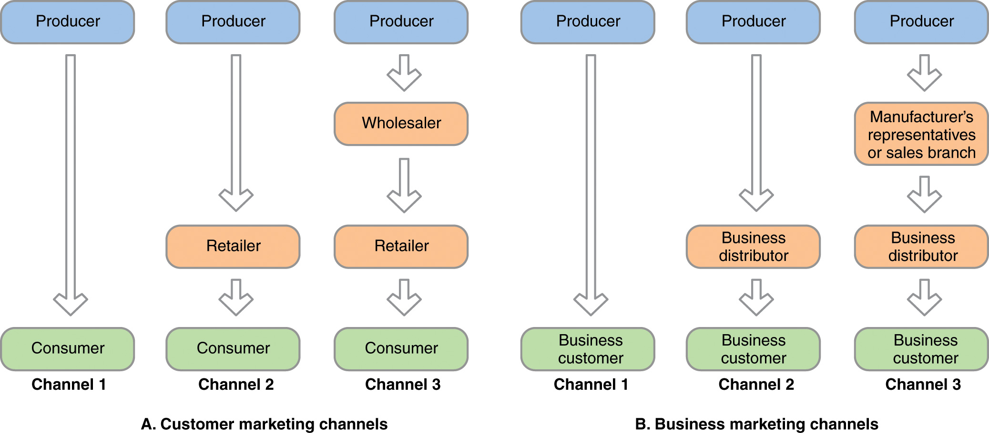

    - All of the institutions in the channel are connected by several types of flows, including the flow of:
      - ownership,
      - payment,
      - information and
      - promotion.
    - Channels MUST contain at least a __________ AND a __________. This would be a “direct channel” of distribution.
      - Consumer Marketing Example
      - Business Marketing Example
    - A channel of producer, final customer, and at least one _______________ is an indirect channel.
    - Customer Marketing Channels
      - Producer à Consumer
      - Producer à Retailer à Consumer
        - Example
      - Producer à Wholesaler à Retailer à Consumer
        - Small retailers and manufacturers find this channel the only economically feasible choice.
    - Business Marketing Channels
    - Producer à Business Customer
      - Accounts for a greater _______________ of business products than any other distribution structure
        - large installations such as jet engines, helicopters and elevators, are usually sold directly to users.
    - Producer à Business Distributor à Business Customer
      - Producers of operating supplies and small accessory equipment (e.g., building materials and air-conditioning equipment) frequently use industrial distributors to reach their markets).
    - Producer à Manufacturer’s Representative / Sales Branch à Business Distributor à Business Customer
      - Small manufacturers who cannot afford to call on customers directly may use this “more indirect” approach.
    - Multiple Distribution Channels
      - Used to reach two or more target markets or
      - avoid total dependence on a single arrangement.
  - Conventional and Vertical Marketing Systems
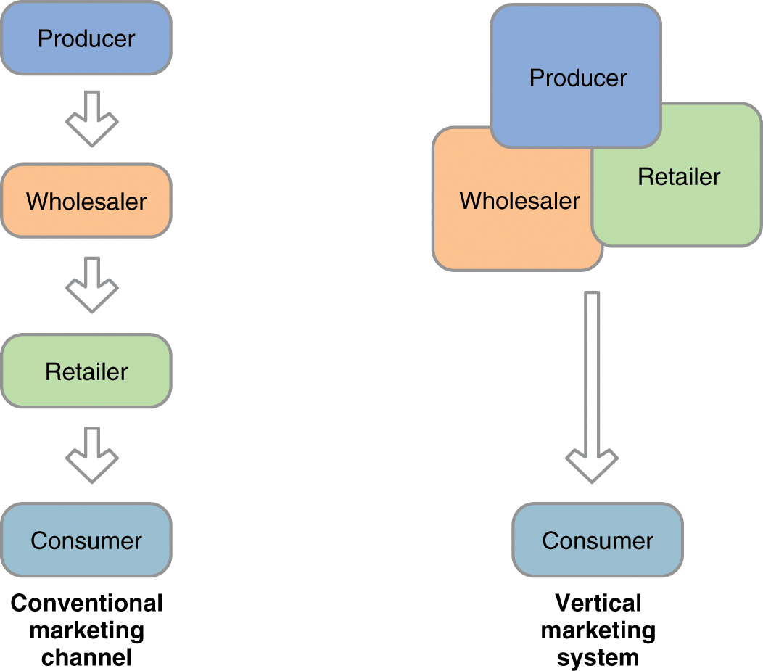

    - In conventional marketing channels, there was
      - __________________ for the individual channel members
      - with a focus on their ____________ needs and objectives
    - With Vertical Marketing Systems there is a _______________ of the members
      - The goal is to improve operating and marketing efficiencies.
    - Examples of Vertical Marketing Systems:
      - Corporate Ownership –

      - Contractual Vertical Marketing System –

      - Administered Vertical Marketing System –

  - Intensity of Distribution
    - We can choose to attempt to get
      - Intensive Distribution through __________________
      - Selective Distribution thorough _________________
      - Exclusive, though a ________ intermediary in an area
    - How MANY do we want? What is the “optimal intensity” for us?
      - And the answer is……
      - Because anything else is…..
    - While the decision is sometimes seen as a single one, often

      - Example
    - Reminders:
      - For convenience goods we want
      - For shopping goods
      - And for specialty products
  - Conflicts in Channels
    - Channel conflict exists when one channel member perceives another channel member to be acting in a way that prevent the first member from achieving its distribution objectives.
      - Examples:
    - Horizontal Conflict involves firms on the “same level” of distribution
      - Example:
      - It may occur:
        - middlemen of the same type

        - Different types of middlemen on the same level:

      - A primary source of horizontal conflict is “scrambled merchandising”
        - middlemen diversify by adding product lines not traditionally carried by their type of business
        - Example
    - Horizontal Conflict involve firms at different levels of the same channel.
      - Producer versus Wholesaler
        - Anheuser-Busch Example:
        - Conflict here occur because
      - A major conflict occurs when producers try to bypass wholesalers and deal directly with retailers or customers. To BYPASS producers might:
        - Sell directly to customers by establishing their own retail stores. This is often a supplemental rather than sole, form of distribution.
        - 2) Sell directly to retailers
          - Goodyear Example:

  - Disintermediation
    - The _______________________ in the supply chain, also referred to as "cutting out the middlemen."
      - Disintermediation creates __________________
      - Black & Decker Example:
  - Channel Control
    - _____________________ is the ability to influence or determine the behavior of a channel member.
    - Main sources of power in Distribution Channels
      - Expertise –
      - Rewards –
      - Sanctions—
    - Historically, manufacturers were viewed as controlling channels
      - Manufacturers feel they should assume the channel leader’s role because they create the new products and need greater sales volume to benefit from economies of scale.
        - This point of view is one-sided and outdated.
    - Retailers argue THEY should control the channel
      - They are closest to the customer
  - Channel as Partnership
    - For all to benefit, the channel needs to be viewed as a partnership aimed at satisfying end users’ needs rather than as something the members command or dominate.
      - Wal-Mart Example:
        - Benefits and Risks:
    - Category management (a type of partnering)
      - a retailer allows a large supplier to manage an entire product category.
        - Examples

    - Relationship marketing
      - Firms work closely together to better understand and satisfy their needs and develop long-term, mutually beneficial business practices.
    - Pricing and the Relationship with Channel Members
  - Recall that Gary Trinetti and his partner (graduates of KSU) set up a corporation, Garick, which markets a variety of lawn care products, composting, top soil, mulch, bark, turf, stone and aggregate for home and recreational areas.
    - Garick is doing line reviews with their retailers (Wal-Mart, Home Depot, and Lowe’s).
    - How do you price in advance these days?
    - Created a fuel surcharge for the first time
    - This creates a problem in planning for the retailer
    - Gary recalls there being 4P’s (which has NOT changed!)…AND he remembers them!!
    - Price was viewed as being “easy,” cost-plus pricing.
    - But it is more complicated when you think about your relationship with a retailer.
    - Will it be used as a loss leader, for a promotion, part of a two for one deal.
    - SO, pricing IS a marketing decision. What is our “appropriate price” for our customer, given OUR costs.
    - Then you need to consider YOUR strategy.
    - Do we want intensive and fast distribution? So we set a low price.
    - Do we have a competitive advantage, for a year or two or six months, so that we can set a high price and get a great profit margin until our competitors catch on?
    - OR do we need to consider how our customer wants to price it?

Chapter 16
Customer Driven Supply Chain and Logistics Management

- The P&G-Wal-Mart Example
  - Traditionally, the relationship between supplier and merchant has been “_____________________.”
  - Wal-Mart recognized that the traditional relationship had become outmoded and was often hurting BOTH parties!
  - Wal-Mart “invited” its major suppliers to jointly develop powerful supply chain partnerships
    - to increase product flow efficiency and, consequently, profitability for both firms
  - The Wal-Mart/Procter & Gamble alliance, incorporated vendor-managed inventory, category management, and other intercompany innovations
  - P&G had a dedicated account team…
  - The team members represented key P&G functions:
    - sales/marketing, distribution/supply chain management, IT, and finance.
    - Wal-Mart's CFO became a “key customer” as P&G's objective became maximizing Wal-Mart's internal profitability.

- Logistics
  - involves those activities that focus on getting the right amount of the right products to the right place at the right time at the lowest possible cost.

- Logistics Management
  - is the practice of organizing the _________________ of
    - raw materials,
    - in-process inventory,
    - finished goods, and
    - related information
    - from the point of origin to point of consumption to satisfy customer requirements.

- Supply Chain
  - is a sequence of firms that perform activities required to create and deliver a good or service to consumers or industrial users.
    - It includes suppliers that provide raw material inputs, the manufacturer, the wholesalers and retailers that deliver finished goods.

- Trinetti on Supply Chain Management
  - Supply Chain Management is a “new” term, working with __________ and ____________
  - Think about retailers like Home Depot and Wal-Mart and all the things that need to happen ____________________________________!
  - A truck has to deliver it to the store, of course.
  - But peel back the layers of what happened before that
  - The items all come from different raw materials with different manufacturing processes, coming from _____________________!
  - The opportunity for managing all of these processes is _____________.
  - Think of the opportunities from the time the material is grown, harvested, manufactured, all the way to _____________________!
  - There are opportunities for ____________, _______________, and firms to facilitate these.
  - Wal-Mart has developed expertise in _____________ and ___________
  - Supply chain crosses over from raw materials, to manufacturing production, to airplanes, barges, trucks and rails, to getting the item on the shelf!
- Significance of Supply Chain and Logistics Management
  - Supply Chain Management
    - the integration and organization of information and logistic activities across firms in a supply chain for the purpose of creating and delivering goods and services that provide value to consumers.
    - Requires the application of ________________ to allow companies to share and/or operate systems for order processing, transportation scheduling, and inventory and facility management.
  - Supply Chain management does NOT…..
    - A chain is
    - BEFORE attempting to deal with “supply chain issues,” the firm must be able to provide

  - SCM usually requires significant changes in the firm’s organizational structure,
    - because it cuts across functional areas and even across different firms
      - SO, the responsibility and authority for implementing SCM must be _____________________________
  - SCM requires firms to put in place information systems and metrics that focus on performance across the entire supply chain.
    - WHY? Because …

      - This can
  - SCM means that you not only need to do better than your competition to succeed, but you actually need to compete against…

  - SO, you need to not only work better among the functional areas of your firm, but think about …

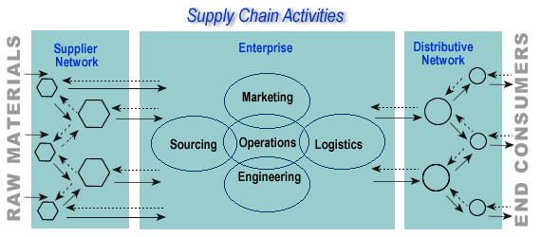
- Supply Chain Activities
  - Here we see that:

  - Relating logistics management and supply chain management

Suppliers
Producer
Consumers

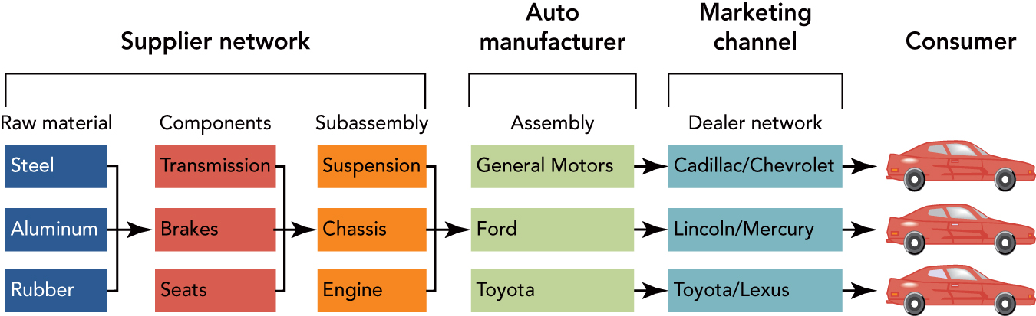

- Supply Chain Management and Marketing Strategy
  - Aligning a Supply Chain with Marketing Strategy
  - The PROBLEM:
    - In “real life” our supply chain team may focus on …

    - This focus does not produce
  - An Example of Non-Aligned SCM Objectives and Marketing Strategies
Customer Needs
Efficiency
Asset Utilization

  - An Example of Aligned SCM Objectives and Marketing Strategies
Customer Needs
Efficiency
Asset Utilization

  - Curing the PROBLEM:
    - Understand our customer’s needs
      - How important (and what VALUE) do our customers put on:
        - Lead Time
        - Quick Response
        - Efficient Consumer Response
        - Dependability
        - Communication
        - Convenience
    - Understand our supply chain and its strengths and weaknesses
    - Harmonize the supply chain strengths with our marketing strategies!
      - Redesign the supply chain if necessary
- Information’s Role in Supply Chain Responsiveness and Efficiency
  - Electronic Data Interchanges (EDIs)
    - combine proprietary computer and telecommunication technologies to exchange electronic invoices, payments, and information among suppliers, manufacturers, and retailers.
    - Easily said,……
  - The Need for Information in a Customer-Driven Supply Chain
  - We not only need information to Manage the Supply Chain, but to allow us to balance the ________________of our logistics efforts with the _________ we provide to our customers!
- Key Logistics Functions in a Supply Chain – Transportation
  - Third-Party Logistics Providers
    - firms that perform most or all of the logistics functions that manufacturers, suppliers, and distributors would normally perform themselves
      - http://outsourced-logistics.com/logistics_services/index.html
    - Outsourcing RISKS:
      - Outsourcing “_______________” functions, instead of the ones that give you the greatest competitive advantage
      - Not having clear goals and objective for the outsoucing
      - Not having an ______________ to measure outsoucing against
      - Underestimating the _______________
      - Inadequate planning for the Information Systems Interface
        - Source: The Supply Chain Handbook (Tompkins Press, 2004) edited by James A. Tompkins, Ph.D. and Dale Marmelink (www.tompkinsinc.com)
  - The Major Modes of Transportation
    - Rail
    - Water
    - Highway
    - Pipeline
    - Air
  - Intermodal Transportation
    - Piggyback, Trailer on a Flatcar
    - Containers
  - Freight Forwarders
    - Less than

  - Package Delivery
    - Due to
  - Advantages and disadvantages of five modes of transportation
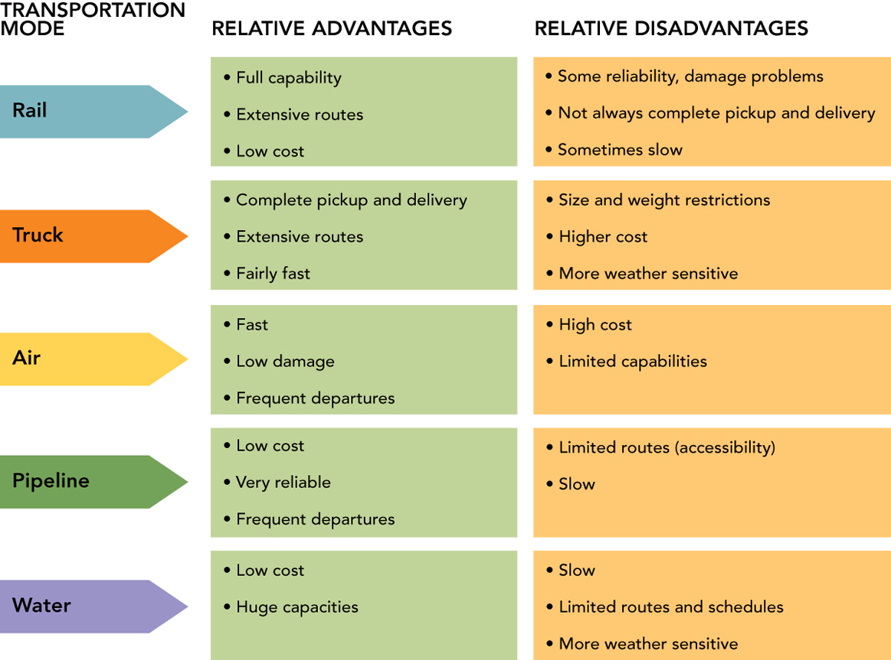

- Warehousing and Materials Handling
  - Storage Warehouses
  - Distribution Centers
  - Materials Handling
- Order Processing
  - Backorders
  - EDI/EFT

- Inventory Management
  - Reasons for Inventory
  - Inventory Costs
    - Capital Costs
    - Inventory Service Costs
    - Storage Costs
    - Risk Costs
- Supply Chain Inventory Strategies
  - The Just-in-Time (JIT) Concept
    - an inventory supply system that operates with __________ inventories and requires ________, on-time delivery.
  - Vendor-Managed Inventory (VMI)
    - an inventory-management system in which the _____________ determines the product amount and assortment a customer (such as a retailer) needs and automatically delivers the appropriate items.
      - Talk about TRUST!

- Reverse Logistics
  - a process of reclaiming recyclable and reusable materials, returns, and reworks from the point of consumption or use for repair, remanufacturing, redistribution, or disposal.
    - You may remember that we said this was a virtual impossibility today in some areas of the world (e.g., Russia).
Chapter 17
Retailing

- Introduction -- The First National Bank of Wal-Mart
  - Public opposition has all but killed Wal-Mart’s plans to open its own bank in the US
  - Wal-Mart's primary motivator in this effort was to reduce the cost of allowing customers to buy on credit with the use of Discover, MasterCard), and Visa -branded charge cards
  - BUT…US bankers did not like the idea of….
  - This story isn't over yet
    - Wal-Mart HAS 38 branch banks in….
    - And, NOW is turning to…..
- Retailing and Retailers
  - RETAILING
    - All activities related to the sale or rental of goods and services to the ultimate consumers for personal, non-business use
  - RETAILER
    - Lots of firms can sell to the final consumer, but a Retailer is a firm engaged primarily in retailing
  - Retailing -- Economic Justification and Realities
    - Retailers serve as Purchasing Agents for you and as Sales Specialists for their suppliers
      - They do this by:
        - anticipating ______________________,
        - developing _________________________,
        - acquiring ________________________, and
        - providing ________________________.
      - So, retailers offer the utilities of:

    - It is relatively easy to become a retailer
      - No large investment in ________________ is required,
      - merchandise can often be purchased __________, and
      - _____________ can be leased with no down payment, or
      - a simple _______________ can be set up at a modest costs.
    - BUT, success is hardly assured!
      - A successful retailer is a “merchant who sells goods that won’t come back to customers who will.”
      - Of course, a retail firm also must fulfill its other role of serving producers and wholesalers.
      - This dual role is both the justification for retailing and the key …

  - Operating Expenses and Profits
    - Retail Operating costs are about ___________________
    - This is _____________ than that for wholesalers, which is only about _______.
    - Retailers Costs are _________ Due to:
      - Dealing with ______________
      - Meeting their ________________!
    - Net Profits for retailers vary quite a bit.
      - Supermarkets have huge volume, but only earn _________
      - Specialized retailers can earn 10% or more.
      - An average net after tax profit for retailers would be __________ of sales.
      - Retail Pro: a retail point of sale software system
        - http://www.onestepretail.com/email/articles/article-09-13-07.php

  - Four Factors Related to Physical Facilities:
    - Location
      - Central Business District
      - Regional Shopping Centers
      - Anchor Stores
      - Community Shopping Center
      - Strip Location
      - Power Center
    - Size
    - Store Design
    - Product Layout
  - Classification of Retailers
    - Based on _________________________ and _____________________
      - Sears Example:

  - The four positioning strategies for retailers
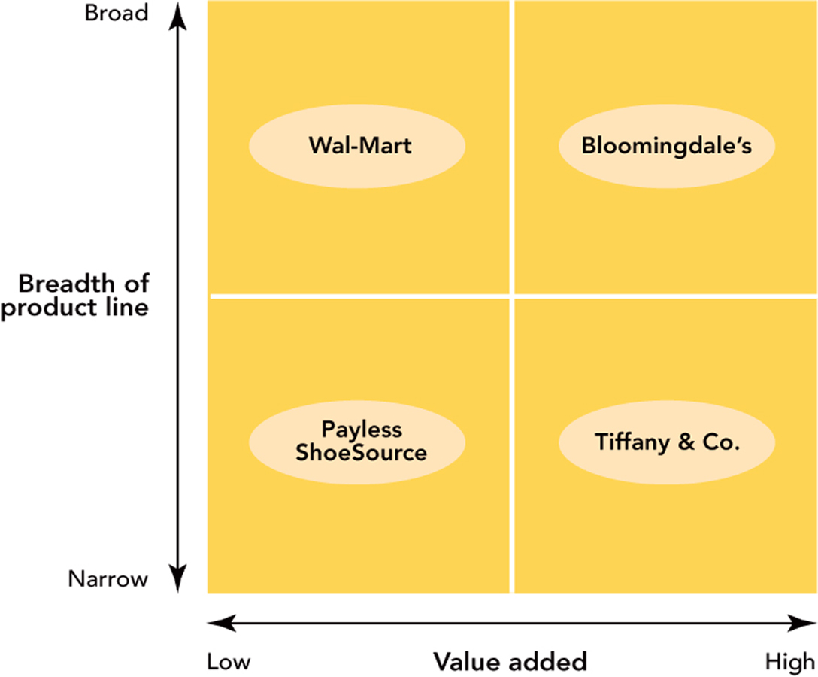
  - Retailers Classified by Ownership
    - Corporate Chains
      - organization of two or more centrally owned and centrally managed stores that generally handle the same lines of products.
      - Three factors differentiate a chain from an independent store and the contractual form of VMS:
        - Size
          - technically two or more stores constitute a chain (an independent retailer opening another store on the west side may think of themselves as owning a chain) but the US Bureau of the Census considers ___________to be the minimum size for a chain.
          - A corporate chain has _________________, and
          - Because of centralized management, individual units in a chain typically have little _________.
            - Corporate chains are tremendously significant in retailing, accounting for about _________of the total retail trade.
    - Independent Stores
      - A single store that is not affiliated
      - Most retailers are ______________, and
      - Most are __________________
      - May have higher prices than chain stores.
      - WHY? Their customers are willing to pay extra for __________________, such as
        - credit,
        - delivery,
        - alterations,
        - installation,
        - a liberal return policy, and
        - friendly, knowledgeable personal service.
    - Contractual Vertical Marketing Systems
      - Retailer Cooperatives
        - Formed by a group of small retailers
        - Who agree to establish and operate a __________________
      - Voluntary Chains
        - sponsored by a wholesaler that enters into a contract with interested retailers
        - Retailer coops and voluntary chains differ in terms of who organizes them.
        - But BOTH have been created for “defensive” reasons, to allow independent retailers to compete with larger, stronger chains
      - Franchise Systems
        - a _______________________
        - in which a parent company provides management assistance and the right to use its trademark
        - in return for _________________ of the individual business unit.
        - The_________________ is the parent company
        - The __________________is the owner of the business unit
        - and the “franchise system” is the combination of the franchisor and franchisee.
          - This type of contractual VMS generates 1 trillion in annual sales and accounts for as much as 2/5 of retail sales.
    - Top 5 Franchises for 2008
2008 Rank | Franchise | Type | Franchise Fee | Number of
1 | 7-Eleven | Convenience | Variable | 30,642
2 | Subway | Sandwich | $15,000 | 27,929
3 | Dunkin’ Donuts | Bakery | $40.000-$80,000 | 7,376
4 | Pizza Hut | Quick Service | $25,000 | 9,881
5 | McDonald’s | Fast Food | $45,000 | 23,099

http://www.entrepreneur.com/franchises/index.html
  - Non-store Retailing
    - Direct Selling
      - ___________________ between a sales person and a consumer away from a store that results in a sale
      - Drawbacks:
    - Telemarketing
      - sometimes called telephone selling refers to a sales person initiating contact with a prospective customer and closing a sale over the phone

    - Automatic Vending
      - sale of products through a machine with no personal contact between buyer and seller

    - Online retailing
      - firm uses a website to offer products for sale.
      - Find many new enterprises using this form of retailing, but more than __________ of brick-and-mortars have adopted it!
  - Direct Marketing
    - All “other” types of non-store retailing
      - Direct Mail
        - letter, brochures and even product samples to consumers and ask them to purchase by mail or telephone.
      - Catalog Sales
        - expanded at a rate of 10% in 1980s, flattened out in 1990s and is now taking off again
      - Televised Shopping
        - From 1 minute spots to Informercials (30 minutes are longer) often found on dedicated TV channels (e.g., Home Shopping Network).
      - Direct Marketing Drawbacks
        - Consumers must place orders without viewing or touching the actual product (can see picture of it though).
        - To offset this difficulty, Direct Marketers must offer liberal return policies.
        - Catalogs and some direct mail can be costly.
          - that they have to be prepared long in advance of their use and any adjustments to price or new product additions can be announced only through supplementary catalogs or brochures.
      - Direct Marketing Advantages
        - can provide shopping convenience in addition to low prices

  - The Wheel of Retailing
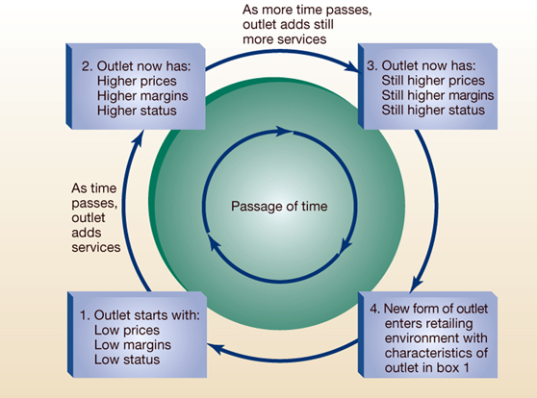
- Institutional Change in Retailing
  - VIDEO CASE: Shakeout from overbuilding (especially in THIS economic environment)
  - Adapting to Consumer Trends
  - “Bricks and Clicks”
    - Website
    - Kiosks
- MALL OF AMERICA: SHOPPING AND A WHOLE LOT MORE (time permitting)

  - Mall of America Facts
    - Contributes more than $1.8 billion in economic impact activity annually to the state of Minnesota
    - Gross leasable space - 2.5 million square feet
    - Gross building area - 4.2 million square feet
    - Number of stores - More than 520
    - Sit-down restaurants - 20
    - Fast food restaurants - 30
    - Specialty food stores - 36
    - Employees - 11,000 (year-round) 13,000 (holidays)
    - Parking spaces - 12,550 on-site
    - Walking distance around one level - .57 miles
    - Total store front footage - 4.3 miles
  - Questions:
    - Why has Mall of America been such a marketing success so far?
    - What (a) retail and (b) consumer trends have occurred since Mall of America was opened in 1992 that it should consider when making future plans?
    - What criteria should Mall of America use in adding new facilities to its complex?
      - Evaluate:
        - retail stores,
        - entertainment offerings, and
        - hotels on these criteria.

Chapter 18
Integrated Marketing Communications and Direct Marketing

- Introduction – Effective Promotion
  - The GEICO example
    - Founded
    - Targeted
    - Used “direct marketing” with no

    - Decided to

    - 1995 spent ____________ on national TV, radio, & print

    - 1996 ______________ bought the company

    - By 2006 the ad budget was more than

    - The Problem

    - The “Fix”

      - The original ad
      - The tag line continued “GIECO, a 15 minute call could save you 15% or more on car insurance”
    - The “next” campaign..using GIECO is so simple that…..

- What is Promotion?
  - Promotion is _______________
    - Recall that one criteria for a good market segment is that it is ____________
    - Promotion is one way that we reach the segment.
- The Promotional Mix
  - Promotion is one of the P’s in the Marketing Mix
    - We also use the term “mix” to refer to the elements used by marketers
    - The Promotional Mix consists of the tools marketers use to accomplish the organization’s communications objectives
  - The traditional roles of the promotion mix include:

  - ___________ goals include to:
    - Communicate customer value
    - Build a brand/company image
    - Explain how the product works
    - Suggest new uses for a product
    - Inform the market of a price change
    - Describe services and support
    - Correct false or misleading statements
      - Example
  - ___________ goals include to:
    - Build brand preference
    - Encourage switching to your brand
    - Change consumers’ perception of product value
    - Get consumer to purchase “now”
    - Convince consumers to tell others about the brand
      - Example
  - For “mature” products, _______ them – goals include:
    - Maintain customer relationships
    - Remind consumers they may need the product soon
    - Remind consumers where the product is available
    - Keep the brand in the consumers’ minds during the off-season
      - Example

- Tools in the Promotional Mix
  - advertising
  - public relations
  - sales promotion
  - personal selling
  - direct marketing
- Integrated Marketing Communications (IMC) -- the concept of designing marketing communications programs
that coordinate all promotional activities—advertising, personal selling, sales promotion, public relations, and direct marketing—to provide a consistent message across all audiences.
  - The “need” for Integrated Marketing Communications
    - Consumers are bombarded with commercial messages
    - To consumers, these become “one” message about the company
    - If not integrated, the various messages create a confusing and mixed image in the consumer’s mind
- Communication -- The process of conveying a message to others
  - Key elements of communication
    - The SOURCE of the communication
      - ______ ______ ________ with a meaning it intends to share with an audience.
      - Could be a __________ wanting to communicate with a customer, or
      - An ___________ wanting to communicate with thousands of people
  - The RECEIVER of the communication
    - The person, group, or organization which receives (and decodes) a communication.
    - It may be that the ____________ (audience) and the ____________one are not identical
    - That is, our message may NOT reach our ______________OR it may be received by our audience AND by others we _________________________!
  - ENCODING of the message
    - The coding of a message into ___________________that represent the ideas and concepts of the communication.
    - Uses sensory stimuli, including visual (words, symbols, images), sounds (spoken word, sound effects, music), and scents (e.g., fragrance) to convey the message.
  - THE MESSAGE
    - The message is what is sent (via a channel of communication) from a source to a receiver
  - The CHANNEL OF COMMUNICATION
    - This is the _________ used to convey the message from the source to the audience.
    - Examples include internet, television, radio, print in magazines and newspapers, mail, billboards, salespeople.
    - The “wrong” channel will _______________________
  - DECODING of the message
    - The decoding process is used by the _________________ the signs and symbols into concepts, ideas, and meaning.
    - Rarely does the audience _______________________ as the sender intended.
  - Field of Experience
    - Effective communication requires that the sender and the receiver have shared knowledge and understanding of words, symbols, culture, and their meaning
    - Without overlapping fields of experience, communication is likely to be ________________________________.
  - NOISE
    - Anything that reduces the clarity, accuracy, and effectiveness of the communication is considered noise.
    - There are MANY sources of noise:
      - Problems with the medium include--
        - Radio static
        - Internet or website down
        - Faulty printing of the ad
      - Problems with encoding
        - occur when the concept is not well understood by the _____________
        - when _______________________ are selected (wrong word, inappropriate music, poor choice of spokesperson, language that is too technical or too simple)
      - Problems with the receiver
        - occur if the message is _______________________ and so the receiver consciously or unconsciously blocks all or part of the message
  - RESPONSE
    - the impact the message has on the receiver’s
      - _____________,
      - ______________, or
      - ______________ (e.g., _____________________!)
  - FEEDBACK
    - the sender’s interpretation of the response, which indicates whether a message was decoded and understood by the receiver as intended.
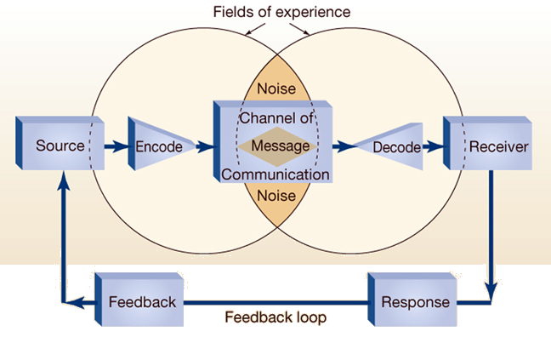

- Tools in the Promotional Mix Non-Personal vs. Personal (or Customized
  - Non-Personal forms of promotion or “ “

  - Personal or Customized forms of promotion

  - Promotional Tools -- Advertising
    - any paid form of nonpersonal communication about an organization, good, service, or idea by an identified sponsor.
      - Examples
    - Can be a very _______________ way to reach large numbers of people at a low cost per person.
      - TIME magazine example:
        - The 2008 cost of a 4 color, one-page ad in TIME magazine is $255,840
        - With a circulation of 3,250,000 the cost per thousand (cpm) readers is only $78.72
    - The message can be _________________, in various media
    - However, while the cost per person is relatively low, the actual cash outlay is ______________
    - The feedback from advertising is relatively __________
    - It may be less _______________ than more personal forms of promotion
    - Depending on the format, consumers may only be exposed to the ad for a ______________
  - Promotional Tools -- Publicity
    - A form of “public relations” that uses a nonpersonal, indirectly paid presentation of an organization, good, or service
    - Publicity can include news stories presented in radio, television, magazines, newspapers, or the internet.
    - Most often, in order to get publicity, the topic has to have a degree of ________________________
    - So, publicity is often about
    - To encourage media personnel to broadcast or print the item, marketers produce

    - SO, while there is not a direct cost to run the news item, there IS a cost to the marketing organization.
    - Publicity supports the other elements of the promotion mix.
    - It is very ____________
    - It can reach ____________ People
    - Social networking web sites and Blogs
      - Public Relations people now need to know about it, monitor it, report it, and, when appropriate, get involved in it!
    - The down-side
      - since we don’t actually control the message, it may _______________________________
  - Promotional Tools -- Sales Promotion
    - a short-term inducement of value offered to arouse interest in buying a good or service.
    - Can be used for

        - Discounts off of invoice, merchandise allowances, promotional allowances

    - Typical ____________ Sales Promotions include
      - Free Samples
      - Sweepstakes
      - Contests
      - Premiums
      - Coupons
    - Sales promotions can increase the effectiveness of other promotion mix tools
    - Important because:
      - Powerful _____________ “demand” them
      - Consumers are quite ___________
      - Price deals are very ______________
      - Advertising clutter requires “different” ways of getting ____________________
      - Pressure on businesses for short-term results
    - They are used on an occasional bases; otherwise consumers come to “expect” the deal
    - They are often used in “off-peak” seasons to generate sales
      - Examples

  - Promotional Tools -- Personal Selling
    - A two-way flow of communication between a buyer and seller, often in a face-to-face encounter, designed to influence a person’s or group’s purchase decision.
      - “Customizable”
    - Because it is personal, customers get a high degree of ____________________
    - The sales message can be _______________ to the customers needs
    - Questions and concerns can be __________________ and _________________
    - It is good for large amounts of information and for technical information
    - It is easy to demonstrate the product and its benefits to the consumer
    - It gives an opportunity to build long-term customer relations.
    - BUT
      - It is very _____________
        - Basic pay,
        - Commission
        - Equipment and money to engage in travel
        - Can only reach one customer at a time (not very ____________________)
  - Promotional Tools -- Direct Marketing
    - a promotion alternative that uses direct communication with consumers to generate a response in the form of an order, a request for further information, or a visit to a retail outlet.
    - Direct marketing is
      - Non-public (directed to a _________________)
      - Immediate (can be prepared ______________)
      - Customized (____________ to a specific customer)
      - Interactive (allows a __________________)
    - Direct marketing is usually done through:
      - Telephone
      - Direct Mail (catalogs, flyers)
      - Direct response ads (tv or radio)
      - Online computer shopping
    - For Consumers:
      - Can be convenient
      - Can be done privately (e.g., via a computer)
      - Can allow for comparison shopping
      - Can allow for customization of the order
      - Can be immediate
    - For Marketers
      - Builds customer relationship
      - Can gather information about customers
      - To create valued new products and service
      - Can minimize other costs (e.g., retail space)
- Developing the Promotion Mix
  - The _____________ you have will influence the promotional mix.
    - A limited budget suggests ______________
      - Easier to measure effectiveness
      - Less cost than a major ad campaign
    - A sizable budget means you need to decide which tools are “best” for your situation
  - OBJECTIVES will influence the mix:
    - Creating mass awareness for a breakfast cereal likely requires:
      - Advertising
      - Sales Promotions
      - Publicity
    - Educating consumers about a new mobile phone
      - Moderate advertising
      - Some sales promotion
      - Significant personal selling
    - Produce Immediate sales
      - Advertising
      - Sales Promotions
  - Target Audience will influence the mix
    - Size?
      - Bigger suggests ______________ and ____________________ to reach masses
      - More limited (for example industrial) suggests __________________
    - Geographic Distribution?
      - Concentrated = Personal Selling
      - Dispersed = Advertising
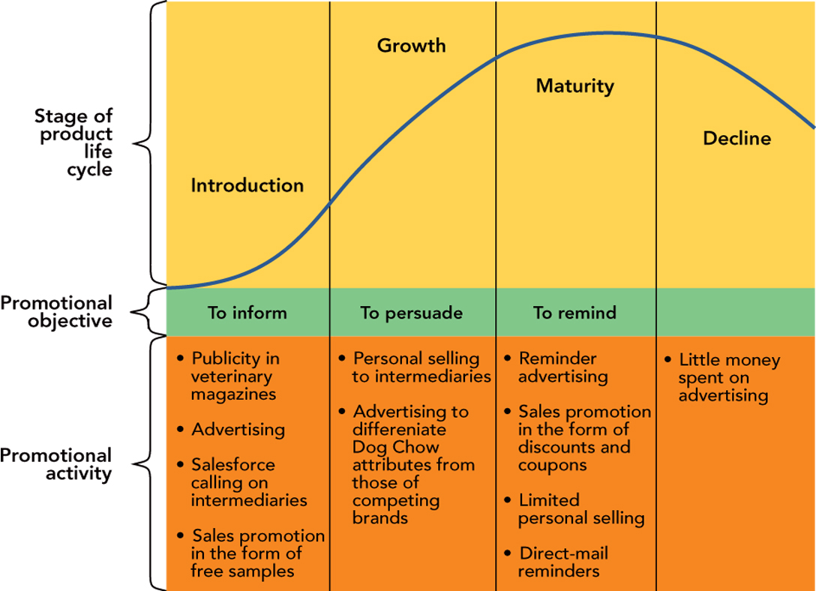
  - Stage of the Product Life Cycle (PLC)

  - The Product will influence the mix
    - Industrial products tend to use personal selling, with support from ads and some sales promotions
    - Consumer products will vary depending on their complexity
      - Durable goods tend to use _________________
      - Convenience goods tend to use ______________ and ________________
    - Both types use public relations
    - Seasonal products use advertising and sale promotion
    - Higher priced products usually need personal selling because of the RISK consumers associate with the purchase
  - Push and Pull Channel Strategies
    - A pull strategy involves directing the promotional mix at ultimate consumers to encourage them
to ask the retailer for a product.
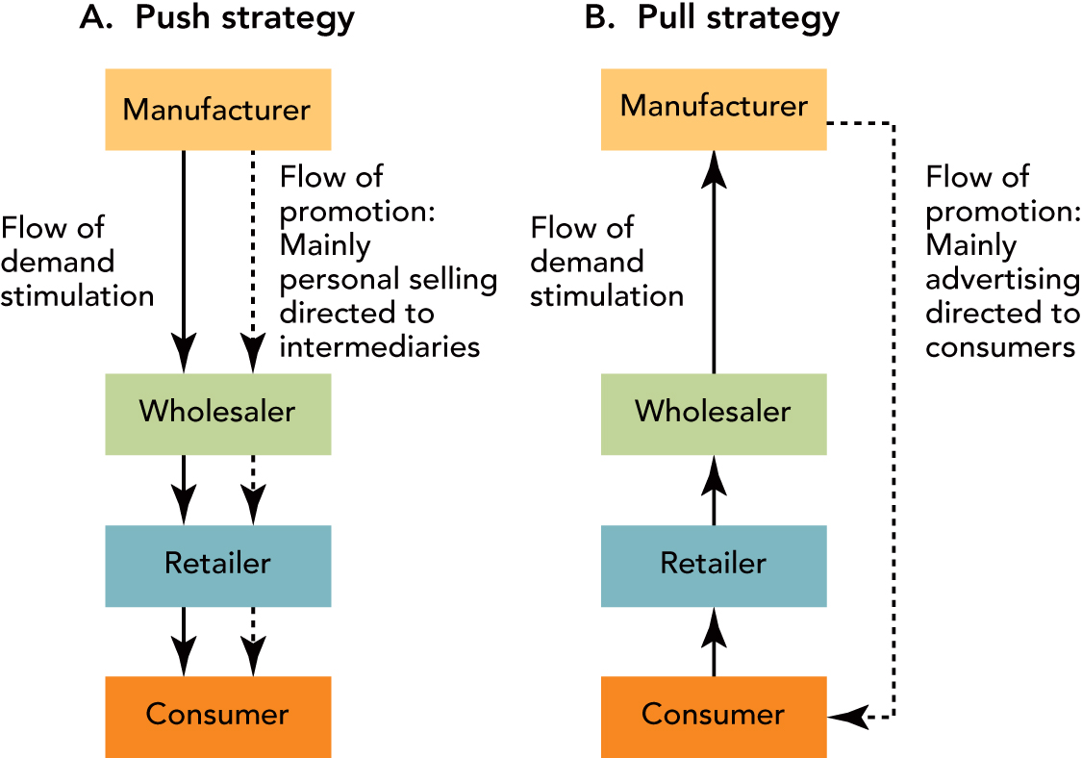
    - A push strategy involves directing the promotional mix to channel members to gain their cooperation in ordering and stocking the product.
- Developing an Integrated Marketing Communications Program
  - Identify the Target Audience
  - Specify the Promotion Objectives
    - The hierarchy of effects is the sequence of stages a prospective buyer goes through from initial awareness of a product to eventual action (either trial or adoption of the product).
      - The stages include awareness, interest, evaluation, trial, and adoption.
  - Set The Promotion Budget
    - Percentage of Sales Budgeting – allocate the budget as a percent of past sales or as a percent of forecasted sales
    - Competitive Parity Budgeting – allocate funds based on the competition. Either by matching their actual promotion dollars or by setting your budget to be the same proportion of market share. So, also called:

    - All-You-Can-Afford Budgeting – allocate as much as you can, once all other budget items are covered
    - Objective and Task Budgeting allocate funds to
promotion by:
      - determining the promotion objectives;
      - deciding on the tasks to accomplish these objectives; and
      - determining the promotion cost of performing these tasks.

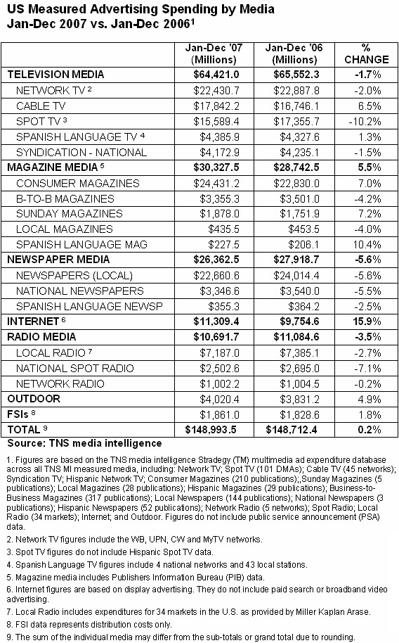
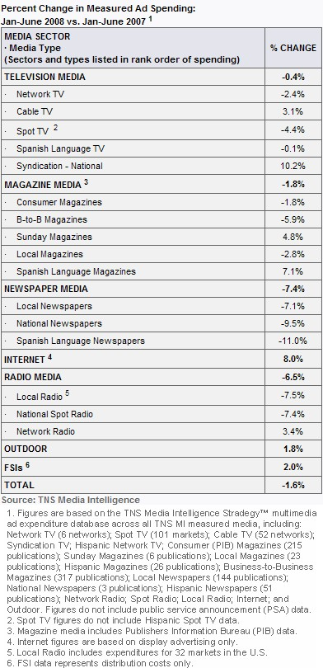

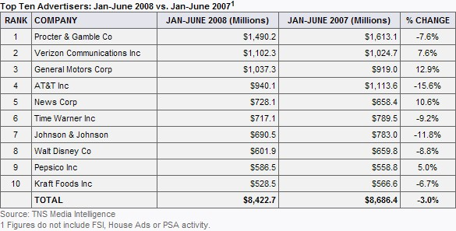
8
9
4
2
3
5
1

  - How Much Should You Spend on IMC?
    - The Promotion-to-sales Ratio
Total Promotion Expenditures ($)
Promotion-to-Sales Ratio (%) = x 100
Total Sales ($)

      - Compare your ratio result to …….
      - The ___________ the ratio the _________ you are doing

- Developing an Integrated Marketing Communications Program
  - Select the appropriate mix of Advertising, Personal Selling, Sales Promotion, Public Relations, and Direct Marketing
  - How you integrate these elements depends on what you're promoting, the expectations and preferences of your potential customers, general market conditions, and your promotional budget.
    - There is no one “best” way to do it
  - Design and Schedule the Promotion
  - Execute and Assess the Program
- Example Promotional Mix
http://www.esmalloffice.com/SBR_template.cfm?DocNumber=PL12_3600.htm#whatknow
Company:
“Pampered Pets Pet Sitting Service” -- Employees go into people's homes to feed pets, take them for walks, change litter boxes
Target Market:
  - People who work long hours and don't have enough time to take care of their pets
  - People who are going on vacation and don't want to put their pets in a kennel and don't have anyone who could stay at their house
  - Elderly people who are unable to care for their pets but want to keep them
Communication Objectives:
We need to:
  - introduce our service to the public
  - create awareness of our service
  - get people to use our service, not our competitor's
  - get veterinarians to recommend our service
  - have at least one veterinarian agree to treat our clients' pets on an emergency basis, a feature that competitors don't offer
- Design Message Content: “If you care about your pet's welfare when you aren't home, then you will use our services. It's so convenient and reasonably priced that you can't afford not to use our services.“
- Format: Fliers, brochure, ads in local newspapers and Yellow Pages
Promotional Tools:
Advertising
Yellow Pages, local newspapers
Sales Promotions
Coupons that can be punched out 1 punch per day, after 20 punches, get one day free or at discounted rate
Public Relations
Not applicable at this time. As business grows, we plan to offer to contribute part of customers' payments to an animal shelter.
Direct Marketing
Fliers in mailboxes throughout local neighborhoods, to veterinarians, apartment complexes where elderly live, to pet shops. As business grows, we will send a newsletter to customers.
Personal Selling
To veterinarians, pet shop owners, travel agents, apartment/condominium management to refer people to our services. This only requires existing personnel time, no added budget cost incurred here.
Promotion Budget:
Five hundred brochures for display in pet shops and veterinarian offices will cost $150. As business grows, we will expand to two-color pieces.
Fliers can also be created inexpensively. Two hundred fliers will cost $20 to copy on colored paper (distribute in spring and summer).
Yellow Pages ad will be limited to an informational in-column listing, 1 inch for $300 for the year in the local book. This book is sufficient.
Small ads in the local newspaper will cost $300 for two placements.
Rolodex cards will cost $160 for 500.
Five hundred punch-out cards will cost $27.
Total promotional budget: $977
Promotional Mix:
- Advertising 61% $600
- Sales Promotions 3% $27
- Public Relations 0% $0
- Direct Marketing 36% $350
- Personal Selling 0% $0

Measuring Results It's now one year later and Pampered Pets is evaluating its promotional mix:
Communication Objectives:
- We successfully introduced our service to the target markets and have a steady base of customers.
- We have the support of several veterinarians and were able to form an emergency services agreement with two in the area.
- This year, we will expand into certain areas of the neighboring county while enlarging the current customer base.
The New Plan Based on our Evaluation
Advertising:
- Yellow Pages: Response is slow but steady. We will renew as is ($350).
- Local Newspapers: Steady advertising will be put on hold as word-of-mouth referrals are fairly strong. We will place two small ads before the summer and Christmas holiday seasons ($425).
Sales Promotions: Punch-out Cards: These have proven a success. This year we will add a special discount coupon to attract new customers and to thank customers for their referrals (one free day for every five referrals who become customers) to replace last year's 21st day free program. ($55)
Public Relations: When a pet we cared for died, a small donation was sent to the local branch of the ASPCA. The owners were touched and sent a thank-you note. They also told their friends, which resulted in more referrals. We will continue to do this and also send cards when client's pets have surgery. During the holidays, food and supplies were donated to the ASPCA, and our picture was in the newspaper, which generated more referrals for the holiday season ($100).
Direct Marketing: The fliers were successful, so we will continue to use them and increase the number of mailings from two to four. The Rolodex cards and letters were successful; but because we ordered such a large quantity last year, we don't need to order more. We also have brochures left from last year, so we don't need more. We plan to launch a newsletter on our Web site in six months ($180).
Personal Selling: no added cost
Total Budget: $1,110

- Direct Marketing --Reminder:
  - Direct marketing is a promotion alternative that uses direct communication with consumers to generate a response in the form of an order, a request for further information, or a visit to a retail outlet.
    - The a key element of this approach is the call for a ___________(or a “_____________”) that is trackable and _____________.
  - The Growth of Direct Marketing
  - According to the Direct Marketing Association’s “The Power Of Direct Marketing,” in 2008 and in 2009 direct marketing expenditures will OUTPACE general advertising, representing about 53% of total U.S. advertising expenditures!
    - 2007 actual expenditure on direct marketing was $171.7 Billion;
    - expected in 2008 is to be 176.9 Billion (+3%)
  - Direct Marketing Response Rates

 | Average | Cost | Revenue | Cost | Average | Promo
 | Response | Per | Per | Per | Order | Cost
Medium | Rate | Thousand | Thousand | Order | Value | Percent
Direct Mail | 2.15% | $428 | $ 4,157 | $ 19.90 | $ 256 | 10.3%
Catalogs | 2.24% | $633 | $ 2,358 | $ 28.27 | $ 105 | 26.8%
Email | 0.48% | $19 | $ 408 | $ 3.88 | $ 85 | 4.7%
Telephone | 2.53% | $1,107 | $ 5,742 | $ 43.70 | $ 244 | 19.3%
Inserts | 0.11% | $29 | $ 171 | $ 26.62 | $ 155 | 17.0%
Newspaper/Magazine | 0.13% | $32 | $ 586 | $ 25.18 | $ 462 | 5.5%
source: http://www.opubco.com/direct/pdf/TheDMA_ResponseRateTrends2007.pdf

    - Direct Marketing Response Rates –Take Aways
      - Direct Media’s Average Promotional Cost is less than 27%
      - Email marketing provides significant profits for many marketers, despite it low response rates.
    - Direct Marketing can result in:
      - Actual Orders (“direct orders”)
      - Lead Generation
        - Email is the “winner” for lead generation. It produces the highest response rate at a fraction of the cost.
        - Inserts and direct mail have the lowest rate of conversion of leads to sales.
      - Traffic Generation
        - Direct mail is best at generating traffic.
For those who want to know more:
David Ogilvy, was born in England, and in 1948 founded an agency in New York that led the world of advertising with his scientific research on the market and consumers, says in a forceful way:
“In the advertising community today, there are two worlds; the Direct Response Advertising (the Direct Marketing), and the world of General Advertising. These two worlds are on a collision course. The general advertisers and their agencies know almost nothing for sure. In Direct Response Advertising, I see knowledge and reality. In General Advertising, I see ignorance“.
http://www.youtube.com/watch?v=Br2KSsaTzUc
and The Direct Marketing Association
http://www.the-dma.org/
Chapter 19
Advertising, Sales Promotion, and Public Relations

- Advertising -- Recap
  - Advertising is any paid form of nonpersonal communication about an organization, good, service, or idea by an identified sponsor.
- Product Advertisements
  - used to promote a product or service’s uses, features, and/or benefits.
  - Pioneering (or Informational) Advertising
    - Used in the __________________of the PLC
    - “Informs” the target market about:
      - The existence of a new brand
      - What it is
      - What it does
      - Where it can be found
    - Examples
  - Competitive Advertising
    - Points out a brand’s special features, advantages, and benefits relative to competing brands
      - Example
    - Comparison Advertising is a common form of competitive advertising.
      - The ad shows a brand’s strengths relative to another brand.
        - e.g., the MAC vs. PC ads
        - Or the Coke vs. Pepsi battle
        - Example
  - Reminder Advertising
    - Used to remind consumers about an established brand’s uses, characteristics, benefits
    - Common in the ____________ stage of the PLC
  - Reinforcement Advertising
    - Consumers often have “__________________” about their purchases or “post-purchase dissonance”
    - This advertising assures them they have made the right choice and tells them how get the most satisfaction from it
    - Example
- Institutional Advertisements
  - Advocacy
  - Pioneering Institutional
  - Competitive Institutional
  - Reminder Institutional
    - Example
- Developing the Advertising Program
  - Identifying the Target Audience
    - To communicate effectively, we must have overlapping __________________ with the target audience
    - To be SURE we understand the audience, we must know who they are and what their values, attitudes, beliefs, and lifestyles are.
    - SO, understanding the consumer is___________to developing a successful ad program
  - Specifying Advertising Objectives
    - Two main schools of thought:
      - The Sales School
      - The objective of advertising is to sell products or services. SO, the objective is to prompt direct action.
    - The Communications School
      - There are other objectives for advertising, including enhancing the image or reputation of a product or organization.
      - General Advertising Objectives from the Communications School
        - To encourage information search
        - To relate product benefits to consumer’s needs
        - To encourage recall of past satisfaction
        - To modify attitudes
        - To reinforce attitudes
  - Setting the Advertising Budget -- recap
    - Percentage of Sales Budgeting
    - Competitive Parity Budgeting
    - Matching Competitors
    - Share of Market
    - All-You-Can-Afford Budgeting
    - Objective and Task Budgeting
  - Designing the Advertisement
    - Elements must get target’s audience’s attention

      - Be ___________ with brand image, objectives, and target audience
    - Types of Appeals
      - Fear
      - Sex
      - Humor
      - Examples

  - Create the Actual Message
    - General Message Factors
      - Characteristics of the Target Audience
      - Type of Media Used
      - Product Factors
        - How complex?
        - How familiar to target audience?
      - Overall Promotion/Advertising Objectives
        - Inform? Persuade? Remind?
    - Message Structure
      - The Appeal –The underlying idea that captures the attention of a message receiver
        - Emotional, Fear, humorous, sexual
      - The Value Proposition
        - The reason for customers to be interested in the product
        - Often an emphasis on the benefits obtained
- Selecting the Right Media
  - Television
    - Advantages
      - Combines sight, sound, and motion
      - So, it appeals to multiple senses
      - It offers mass audience coverage
      - It has the potential of grabbing viewers’ attention
    - Disadvantages
      - It is not very selective (wasted coverage)
      - The impressions are fleeting
      - It has a short life (viewed and then gone)
      - Its overall cost is high
  - Radio
    - Advantages
      - It is widely used (over 25 million radios are sold annually)
      - Low cost (per unit of time)
      - Geographic flexibility
      - There is audience selectivity via station format

Station | Format | Gender | Age | Race | Children | Income | Education
WDOK | Adult Contemporary | Female | Older | Caucasian | No children | Middle income | No College
WGAR | Country | Female | Middle Aged | Caucasian | No Children | Middle Income | College Graduates
WKSU | KSU NPR | Female | Middle Aged | Other Ethnicities | No Children | Less Affluent | Grads & Post Grads
WTAM | News Radio | Male | Older | Caucasian | No Children | More Affluent | No College
WONE | Rock & Roll | Male | Young Adults | Other Ethnicities | No Children | Middle Income | College Grads
WSTB | Alternative | Female | Middle Aged | Asian | Has Children | Less Affluent | No College
WHFM | Christian Contemporary | Female | Middle Aged | African American | No Children | Middle Income | College Grades
http://www.quantcast.com/

    - Disadvantages
      - Audio only
      - Less attention than TV
      - Nonstandarized rate structure
      - Message has a short life
  - Magazines
    - Advantages
      - High Geographic and Demographic Selectivity
      - Has the psychology of attention
      - Excellent quality of reproduction
      - Pass-along readership
    - Disadvantages
      - Long lead time (6 to 8 weeks before publication)
      - Some waste circulation
      - No guarantee of position in the magazine (unless a premium is paid)
  - Newspapers
    - Advantages
      - Flexible and Timely
      - Intense coverage of local markets
      - Broadly accepted and used
      - High believability (printed word)
    - Disadvantages
      - Short life
      - It is often read quickly
      - Not much “pass along” audience
  - Yellow Pages
    - Advantages
      - Excellent geographic coverage
      - Long use period
      - Always available
    - Disadvantages
      - Many other directories compete for attention
      - Hard to keep up to date
  - Internet
    - Advantages
      - Interactive
      - Low cost per exposure
      - Ads can be targeted to interest sections
      - Timely
      - High information content possible
      - Positive attitudes as a new medium
    - Disadvantages
      - Does not “grab” attention
      - Short message life
      - Reader selects exposure
      - May be viewed as intrusive
      - Affected by download speeds
  - Outdoor
    - Advantages
      - Flexible
      - Relative absence of competing ads
      - Repeat exposure
      - Relatively inexpensive
    - Disadvantages
      - Creative Limitations
      - Many distractions for viewers
      - Not in favor with some environmentalists
      - No audience selectivity
      - Examples
  - Direct Mail
    - Advantages
      - Audience Selectivity
      - Flexible
      - No competition from another ad
      - Personalized
    - Disadvantages
      - Relatively high cost
      - Consumer attention – often it just gets tossed out!
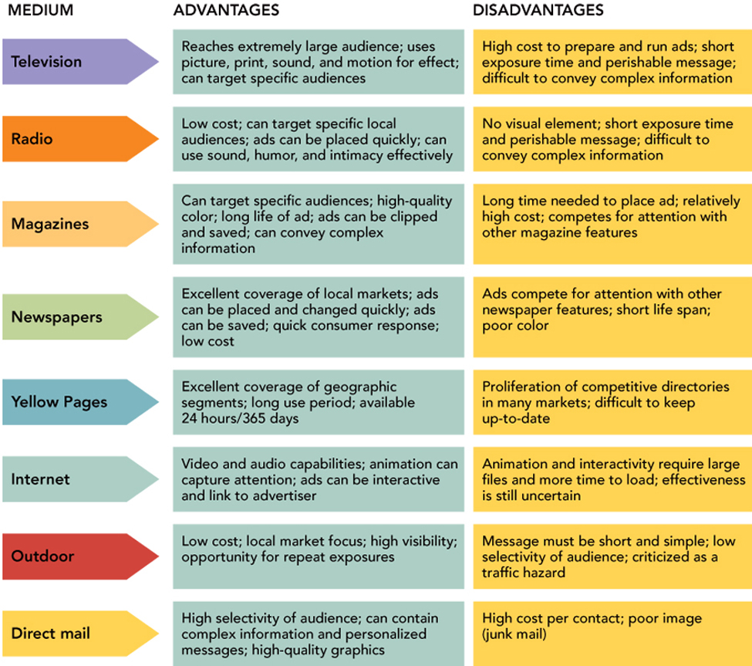

- Scheduling the Advertising
  - Factors to Consider
    - What is your objective?
      - Reach 60% of our target audience during the next 6 months with the message KSU is listed in the Best Business Schools by The Princeton Review?
        - Disperse ads in various media over the months
      - H&R Block’s ads on electronic tax filing?
        - 3 months prior to deadline, building frequency
      - Pizza Hut?
        - Weekly newspaper ads
        - Local cable ads and inserts during special promotions
And book factors of buyer turnover, purchase frequency, and forgetting
  - Approaches
    - Continuous (steady) Schedule
    - Flighting (intermittent) Schedule
    - Pulse (burst) Schedule
- Pretesting the Advertising
- Pretests

- Before running an ad, it would be good to pretest it to understand:
    - The ad’s _____________________________
    - The _____________ obtained by the viewer of the brand and the product
    - The _______________________ associations triggered by viewing the ad
    - Whether the viewer understands the _________________
- Pretest Techniques
    - Textbook techniques (portfolio, jury, and theatre tests),
    - Other, such as Eye Tracking
(e.g., http://www.konzept-und-markt.com/Docs/ad_score_EN.pdf)

      - Can provide:
        - Recall analysis
        - Spontaneous brand and product recall
        - Recall for our ad (unprompted and prompted)
        - Likes and dislikes for the ad
        - Impact on the brand image
      - Comparisons to “ideal ad” on:
        - Perceptions
        - Emotional attachment
        - Cognitive performance
        - Persuasiveness
      - And allow us to _______________ the ad before it runs
- Structures of advertising agencies used to Carry Out the Advertising Program
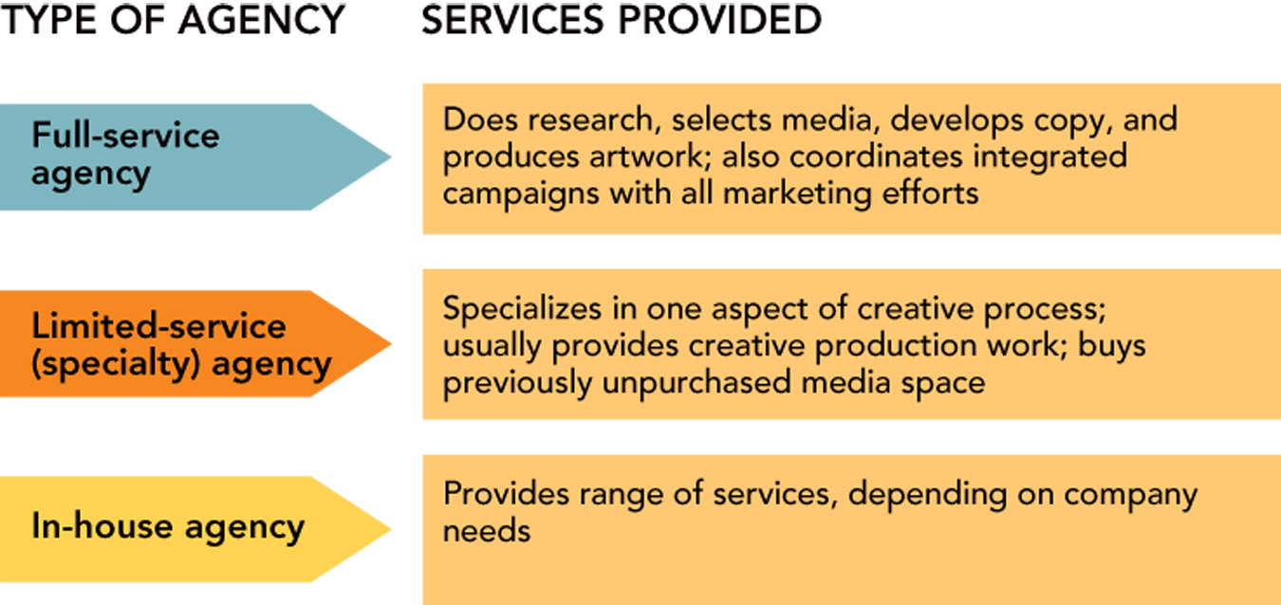
- Post testing the Advertising
  - Post testing measures how _____________________
    - Conditions of exposure and purchase are
    - This makes post testing more accurate, less difficult and less expensive than pretesting (which asks a narrower range of questions).
  - Post testing is capable of answering a broad range of questions:
    - "Does the advertising have attention getting power? Did people notice it or ignore it?"
    - "Will it get the name across?" (Most pretesting does not answer either of these.)
    - "Did the campaign as a whole work? Was there synergy between the elements?"
    - "What were the strong spots and the weak spots in the campaign?"
    - "Was it cost efficient? How many were reached and affected per dollar invested?"
    - "What was the most cost efficient? TV, radio, print, web advertising, store displays?"
    - "What happened when the competition started their big campaign?"
    - "What approaches usually work best in this market?"
    - "In the future, what should we do more of? What should we avoid?"
- Sales Promotions
  - Sales promotions are short-term inducements of value, offered to arouse interest in buying a good or service.
    - They are offered to both end users and intermediaries.
  - Sales promotions can be used to achieve many objectives for both the ultimate consumer and for channel members
  - Consumer-oriented Sales Promotions

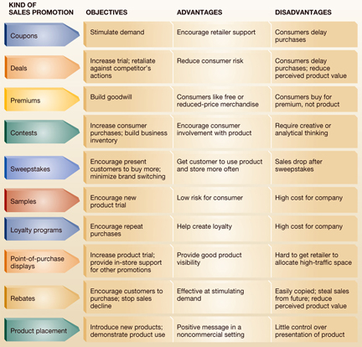

  - Trade-Oriented Sales Promotion
    - Allowances and Discounts
      - Merchandise Allowance
      - Case Allowance
      - Finance Allowance
    - Cooperative Advertising
    - Training of the Distributor’s Salesforce
- Public Relations
  - Public Relations (recap) --a form of communication management that seeks to influence the feelings, opinions, or beliefs held by customers, prospective customers, stockholders, suppliers, employees, and other publics about a company and its products or services.
  - Publicity Tools
    - News Releases
    - News Conferences
    - Public Service Announcements (PSAs)
- AdAge Top Slogans of the Century
  - Diamonds are forever
  - Just do it
  - The pause that refreshes
  - Tastes great, less filling
  - We try harder
  - Good to the last drop
  - Breakfast of champions
  - Does she…or doesn’t she?
  - When it rains, it pours
  - Where’s the beef
  - Look Ma, no cavities!
  - Let your fingers do the walking
  - Loose lips sink ships
  - M&M melt in you mouth, not in your hand
  - We bring good things to life
Personal Selling and Sales Management -- Chapter 20
- Scope And Significance Of Personal Selling And Sales Management
  - Personal selling is
    - A_____________ method
    - in which one party (the salesperson)
    - uses skills and techniques for building personal relationships with another party (those involved in a purchase decision)
    - that results in ____________________________.
  - Personal selling is the two-way flow of communication between
a buyer and seller, often in a face-to-face encounter, designed to influence a person’s or group’s purchase decision.
  - In the U.S. alone, the U.S. Department of Labor estimates that over 14 million of the overall labor force are directly involved in selling and sales-related positions
    - Examples
      - All Sales
      - Sales Representatives, Wholesale and Manufacturing, Technical and Scientific Products
      - Sales Representatives, Wholesale and Manufacturing, Except Technical and Scientific Products
  - Sales management consists of planning the selling program and implementing and controlling the personal selling effort of the firm.
- Salespeople create customer value
  - Identify Customers’ Problems and Creative Solutions to them
  - Assist the Customer with the Buying Process
  - Provided follow-up after the sale is made
  - Build long term customer relations
    - Relationship selling is the practice of building ties to customers based on a salesperson’s attention and commitment to customer needs over time.
    - Partnership selling (or enterprise selling) occurs when salespeople work with customers to combine their expertise and resources to create customized solutions, commit to joint planning, and share customer, competitive, and company information for their mutual benefit, and ultimately provide value for the customer.
  - Major types of Sales Roles
  - Order Takers
    - Primarily assist customers with a purchase
    - The greatest number of people engaged in selling
    - Compensation for order takers is generally lower
      - Retail Clerks
      - Industrial Distributor Clerks
      - Some Customer Service
  - Order Getters
    - a position in which the salesperson is actively engaged in using skills to obtain orders from customers.
    - New Business Development
      - Highly _____________
      - Potentially _____________ sales position
      - Main objective is to find _____________.
      - Sales jobs in this category are often in fields that are very competitive, but offer high rewards for those that are successful.
    - Business Equipment Sales
      - Used in industries where a company’s main profits come from the sale of supplies and services that come after an initial equipment purchase
      - The goal is to get buyers to purchase the main piece of equipment for which supplies and service are needed in order for the equipment to function.
    - Done right by Xerox
    - Outgoing Telemarketing –
      - Product sales over the phone, either to businesses or consumers.
      - US laws restrict unsolicited phone selling to consumers
      - The practice is still widely used in the business market.
    - Consumer Selling -- Some companies use salespeople to build new consumer business. These include:
      - retailers selling certain high priced consumer products including furniture, electronics and clothing;
      - housing products including real estate, security services, building replacement products (e.g., windows);
      - and in-home product sellers including those selling door-to-door and products sold at “home party” events such as cosmetics, kitchenware and decorative products.
    - Account Management
      - building customer relationships from initial sale to follow-up account servicing
      - Business-to-Business Selling
        - These salespeople sell products for business use with an emphasis on follow-up sales
        - May have many different items available for sale (i.e., broad and/or deep product line)
        - After the initial sale, the potential exists for the buyer to purchase many other products as the buyer-seller relationship grows.
      - Trade Selling (A “push” approach)
        - Sales professionals working for consumer products companies normally do not sell to the final consumer.
        - Their role is focused on first getting distributors, such wholesalers and retailers, to handle their products
        - Then they help distributors sell their product by offering ideas for product advertising, in-store display and sales promotions.
  - Sales Support Personnel
    - Order Influencers (Missionary Sales)
      - Do not engage in direct selling activities
      - Concentrate on selling activity that targets those who influence purchases made by the final customer
        - Examples:
        - pharmaceuticals, where salespeople (known as product detailers) discuss products with doctors (influencers) who then write prescriptions for their patients (final customer)
        - higher education, where salespeople call on college professors (influencers) who make requirements to students (final customer) for specific textbooks.
    - Technical Specialists
      - Used for sale of technical products, particularly in business markets
      - Salespeople may need to draw on the expertise of others to assist with the process.
      - This is particularly the case when the buying party consists of a buying center.
    - Office Support
      - Salespeople receive assistance from their company’s office staff in the form of
        - creating promotional materials,
        - setting up sales appointments,
        - finding sales leads,
        - arranging meeting space
        - organizing trade shows exhibits.
- Trends in Personal Selling
  - Controlled Word-of-Mouth Promotion
    - A version of Buzz Marketing
    - Individuals are hired to spread positive information about a product but in a way that does not make it obvious to others that they are being paid to do so.
    - useful when building awareness of new products
    - Some concern that paying people to “act” as if they are interested in a product without any indication of their relationship with the product breaches ethical standards.
  - Customer Relationship Management (CRM)
    - need for all customer contact points (e.g., salespeople, customer service, websites) to gather information so that this can be shared with others in the company
    - BUT, salespeople must share their information.
    - Salespeople are good at developing relationships and learning about customers,
    - Salespeople do not like sharing since this information is what makes them important.
    - For some salespeople, letting go of the information reduces their importance to the company.
    - It is NOT going away!
  - Mobile Technology and Web-Based Computing
    - Wireless internet (WiFi) and cellular Internet access allow salespeople to retrieve needed information at any time.
      - At a lunch, the salesperson can quickly access company material to respond to questions such as how long it may take to receive product if an order is placed.
    - Web-based CRM systems
      - Salespeople enter and retrieve CRM information using a browser
  - Electronic Sales Presentations
    - Online Video Conferencing
    - Web/Phone Conferencing
    - Online Text Chat
- The Personal Selling Process
  - The personal selling process consists of sales activities that occur before and after the sale itself, consisting of six stages:
    - prospecting,
    - preapproach,
    - approach,
    - presentation,
    - close, and
    - follow-up.
  - Prospecting
    - Prospecting involves identifying and developing a list of potential clients.
    - Sources include:
      - Trade shows, commercially-available databases or mail lists, company sales records and in-house databases, website registrations, public records, referrals, directories and a wide variety of other sources.
      - Prospecting activities should be structured so that they identify only potential clients who fit the profile and are able, willing and authorized to buy the product or service.
  - Preapproach
    - Analysis of all the information about a prospect
    - To understand as much about the prospect as possible:
      - understand the prospect's current needs,
      - current use of brands and feelings about all available brands,
      - identify key decision makers,
      - review account histories, and
      - assess product needs
    - This should provide good information to create and plan a sales presentation to address the identified and likely concerns of the prospect, and set call objectives.
    - The Preapproach process results in a preliminary overall strategy for the sales process
    - The strategy may have to be refined as more is learned more about the prospect.
  - Approach
    - The Approach is the actual contact the sales professional has with the prospect.
    - This is the point of the selling process where the sales professional meets and greets the prospect, provides an introduction, establishes rapport that sets the foundation of the relationship, and asks open-ended questions to learn more about the prospect and his or her needs.
  - Presentation
    - In the Presentation, the salesperson tells the product "story" in a way that speaks directly to the identified needs and wants of the prospect.
    - A highly customized presentation is the key component of this step.
    - At this point in the process, prospects are often allowed to hold and/or inspect the product.
    - The sales professional may also actually demonstrate the product.
    - Audio visual presentations and/or slide presentations may be incorporated at this stage and this is usually when sales brochures or booklets are presented to the prospect.
    - Sales professionals should strive to let the prospect do most of the talking during the presentation and address the needs of the prospect as fully as possible by showing that he or she truly understands and cares about the needs of the prospect.
    - Handling Objections
      - Salespeople MUST seek out prospects' objections in order to try to address and overcome them.
      - When prospects offer objections, it often signals that they need and want to hear more in order to make a fully-informed decision.
      - If objections are not uncovered and identified, then sales professionals cannot effectively manage them.
      - Uncovering objections, asking clarifying questions, and overcoming objections is a critical part of training for professional sellers
      - It is a skill area that must be continually developed because there will always be objections.
    - Methods of Handling Objections
      - Acknowledge and Convert
      - Postpone
      - Agree and Neutralize
      - Acceptance
      - Denial
      - Ignore
  - Close
    - Closing is asking for the order and adequately addressing any final objections or obstacles.
    - There are many closing techniques as well as many ways to ask trial closing questions
      - Trial Close
        - e.g., "Now that I've addressed your concerns, what other questions do you have that might impact your decision to purchase?"
      - Assumptive Close
        - Closing does not always mean literally asking for the order. Using the assumptive close, ask the prospect how many they would like, what color they would prefer, when they would like to take delivery, etc.
      - Urgency Close
      - Final Close
    - NOTE: Sales professions can be either weak or too aggressive when it comes to closing. If you are closing a sale, be sure to ask for the order. If the prospect gives an answer other than "yes", it may be a good opportunity to identify new objections and continue selling.
  - Follow-up
    - After the sale, follow-up with the prospect to make sure:
      - the product was received in the proper condition,
      - at the right time,
      - installed properly,
      - proper training delivered, and
      - that the entire process was acceptable to the customer.
    - A critical step in creating customer satisfaction and building long-term relationships with customers.
    - If the customer experienced any problems, the sales professional can intervene and become a customer advocate to ensure 100% satisfaction.
    - Diligent follow-up can also lead to uncovering new needs, additional purchases, and referrals and testimonials which can be used as sales tools.
- How to Sell in a Down Economy
By Geoffrey James, November 20th, 2008; http://blogs.bnet.com/salesmachine/?p=616&tag=nl.e808
1. Go on the offensive. This isn’t the time to hunker down. If you get on the defensive you’re dead. Get aggressive, set aggressive goals.
2. Select better targets. Improve your methodology so that you don’t waste time on customers who aren’t going to buy.
3. Don’t lower prices. Find new and innovative ways to lower the risk of purchase. Make it an easy entry and a better customer experience.
4. Focus on the customer. If sales people get nervous, they’re cooked. Don’t go into high-pressure mode. Ask the customers how can we help YOU to win?
5. Send the CEO out to sell. If the CEO hasn’t spoken with ten customers in the past week, he isn’t doing his job.
6. Improve everything. You can’t sell the way you sold two month ago. You need to improve people, process, and technology.
….and a “real world” response:
Excellent tips. We provide car sharing services to large corporations and councils. Although we are not lowering prices of existing products, we are about to launch a new entry level product to make our services easily feasible for smaller organizations, who we currently don't deal with directly. No barriers for them to upgrade in the future. Shall also be taking on board some of the other points.
- What We Can Learn from “Sales Gods” By Geoffrey James
http://blogs.bnet.com/salesmachine/?p=611&tag=nl.e808

  - They make other people feel important.
  - They are all unbelievably upbeat. Talk about positive.
  - They obviously love their customers. Not just like them. Love them. Think of them as friend and family. Cared if they were happy. Cared about their lives. Cared about how the product or service fit into their customer’s life goals. Really.
  - They all have fabulous product knowledge. They know what they are selling up, down and sideways. They know everything there is to know about their products. And they aren’t afraid to point out what their product won’t do. No exaggeration or lying here.
  - They KNOW they are changing the world. All of these “sales gods” felt they were in the business of making people happy.
  - More than technique, more than skills, more than business acumen, more than brand, and more than anything else…it’s your professionalism and how you see the world that determines whether you’ll reach the pinnacle of sales success.
- The Sales Management Process
  - Sales management consists of planning the selling program and implementing and controlling the personal selling effort of the firm.
    - Managing the sales process is typically the job of the Sales Manager.
    - Good sales managers usually exhibit the characteristics of: organization, a good personal sales record, enthusiasm, ambition, product knowledge, trustworthiness, mentoring skills, and is somebody who is respected by others.
  - Sales Plan Formulation
    - A sales plan is a statement describing what is to be achieved and where and how the selling effort of salespeople is to be deployed.
    - The questions you should answer in your sales plan are:
      - What are you going to focus on?
      - What are you going to change?
      - In practical terms, what steps are involved?
      - What territories and targets are you going to give each salesperson or team?
    - The sales plan will start with some strategic objectives.
      - For example:
        - break into the local market by adapting your product for this market
        - open a store in an area that you believe has the potential for generating lots of sales
        - boost the average dollar or unit sales per customer
    - Use objectives which are SMART - Specific, Measurable, Achievable, Realistic, Time-bound.
      - Using the example of breaking into the local authority market, the stepping stones might be to:
        - hire a sales person with experience of the local market on a salary of $43,000 by the beginning of February
        - fully train the sales person by mid April
        - ensure that any changes the product development team has agreed to make are ready to pilot by the beginning of April
    - As well as planning for new products and new markets, explain how you're going to improve sales and profit margins for your existing products and markets.
    - It is often helpful to identify how you will remove barriers to sales:
      - Can you increase the activity levels of the sales team - more telephone calls per day, or more customer visits per week?
      - Can you increase the conversion rate of calls into sales - through better sales training, better sales support materials or improved sales incentives?
  - Structure of the Sales Force
    - Based on Geography (or territory)
      - Could be based on cities (for a Regional company), on states (for a National company), or by country (for an International company)
      - Advantage—Simplicity
        - The salesperson or sales team sells the products to all consumers in the territory
      - Disadvantage – Potential Lack of Product Knowledge
        - If the firm carries many product lines.
    - Based on Customers
      - Different salespeople call on different types of customers, often based on industry
        - For example, consumer goods, high tech, manufacturing, services
        - OR, by other characteristics, such as growth potential, high net worth, product usage
      - Advantages – Sales people can be “experts” on the customers’ special needs
      - Disadvantage – Duplication of coverage; multiple people call on the same customer account
    - Based on Product
      - Each person or sales team specialized in a product or product line.
        - An office supply company might have one team focused on general office equipment, another on office furniture, and a third on computers.
      - Advantages – Sales people can be “experts” on the products being sold.
      - Disadvantage – Duplication of coverage; multiple people call on the same customer account

    - Size of the Salesforce
      - A “top-down” approach
        - Considers the total salesforce budget in terms of the ____________________
        - Attempts to constrain the salesforce budget to a certain “cost-of-sales” percentage.
        - Often set at 7% or less of total sales
        - Advantage: _________________
        - Disadvantage: Ignores that salesforce actually can _____________________
      - A “Bottom-up” approach (the textbook’s “workload method”)
        - Considers the workload needed to make a sale to each “type” of customer.
        - Considers the “reach” desired for each segment (how many of each type of customers should be called on)
        - Determines the “frequency” of calls for each segment
        - Uses these to decide how large the salesforce should be
  - Account Management Policies (Step 3)
    - Account management policies specify whom salespeople should contact, what kinds of selling and customer service activities should be engaged in, and how these activities should be carried out.

      - An Account Management Policy Grid
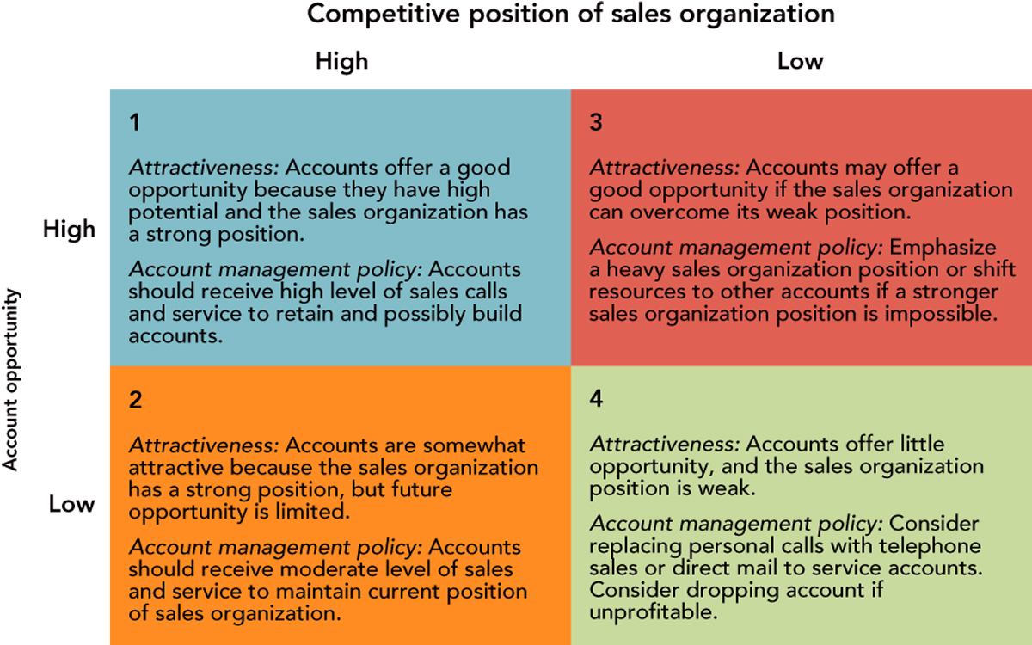

- Sales Plan Implementation
- Salesforce Recruitment and Selection
    - Problems associated with inadequate recruitment and selection:
      - Inadequate sales coverage and lack of customer follow-up
      - Increased training costs to overcome deficiencies
      - More supervisory issues
      - Difficulty in establishing enduring relationships with customers

  - The Recruitment and Selection Process
Step 1  Planning for Recruitment & Selection | Step 2  Recruitment: Locating Prospective Candidates | Step 3  Selection:  Evaluation and Hiring
- Job Analysis  - Job Qualifications  - Job Description  - Recruitment & Selection Objectives  - Recruitment & Selection Strategy | - Internal Sources  - External Sources | - Screening Resumes and Applications  - Initial Interview  - Intensive Interview  - Testing  - Assessment Centers  - Background Invest.  - Physical Exam  - Selection Decision and Job Offer

  - The Recruitment and Selection Process – Step 1, Planning for Recruitment & Selection
    - Job Analysis -- an investigation of the tasks, duties, and responsibilities of the job.
    - Job Qualifications -- Refers to the aptitude, skills, knowledge, personal traits, and willingness to accept occupational conditions necessary to perform the job.
      - An effective method to use in determining job qualifications
        - PROFILING THE SUCCESSFUL CANDIDATE
          - Success in a company may include the following:
            - Intelligence
            - Prospecting ability
            - Ability to create a follow-up system
            - Ability to influence people’s decisions and opinions
            - Ability to cultivate long-term client relationships
            - Ability to negotiate contracts and prices
            - Ability to determine prospects’/customers’ needs (hot buttons).
            - Computer skills.
            - Selling ability.
            - Conceptual ability.

    - Job Description -- A written summary of the job containing the job title, duties, administrative relationships, types of products sold, customer types, and other significant requirements.
      - EXAMPLE of a Formal Job Description for a Sales Rep
Position: Sales Rep. AUTOMOTIVE SUPPLY CORPORATION  Reports to: District Manager |  | Organizational Unit: replacement Parts  Date: (When Job Was Described)
NATURE OF JOB
Responsible for developing new accounts and reaching profitable sales goals in assigned territory.
PRINCIPAL RESPONSIBILITIES
Meeting total sales goals for product lines and individual products.
Maintaining an average of six daily sales calls.
Maintaining an average of one monthly product presentation to wholesalers.
DIMENSIONS
Develop strong promotional support from retail and wholesale customers.
Plan effective territorial coverage resulting in high sales/call ratio.
Inform management of activities by submitting daily and weekly call and sales reports to district manager.
SUPERVISION RECEIVED
General and specific tasks are assigned for each sales period. Every two months work with supervisor for a minimum of one day.
SUPERVISION EXERCISED
None

    - Recruitment and Selection Objectives -- What the organization hopes to accomplish as a result of the recruitment and selection process. The objectives should be specifically stated for a given period.
    - Recruitment and Selection Strategy -- The game plan the company will implement to accomplish the recruitment and selection objectives. The sales managers should consider the scope and timing of recruitment and selection.
      - Ratio And Days From Sales Job Announcement To Reporting To Work
Recruitment Pyramid
Ratio
Days
Report to Work
Offers→Hires
Interviews→Offers
Leads→Interviews
2:2
3:2
10:1
4:1
21
14
21
30

  - The Recruitment and Selection Process – Step 2, Locating Prospective Candidates
    - Internal Sources

    - External Sources

      - ______________ agencies

      - Professional societies

      - Computer rosters

  - The Recruitment and Selection Process – Step 3, Selection: Evaluation and Hiring
    - Screening Resumes and Applications
    - Initial Interview
    - Intensive Interview
    - Testing
    - Assessment Centers
    - Background Investigation
    - Physical Exam
    - Selection Decision and Job Offer
      - Major Steps In Sales Personnel Selection Process
If No

  - Managing the Sales Training Process
    - Assess the Sales Training Needs
    - Set Training Objectives
    - Evaluate Training Alternatives
    - Design the Sales Training Program
    - Perform Sales Training
    - Conduct Follow-up and Evaluation
  - Salesforce Motivation And Compensation
    - Four Questions Salespeople Ask To Determine How Much Effort They Will Devote To Their Jobs

Motivation
to work
“What Is
the Probability
of Success?”
Performance
Level
“Will I Be
Rewarded
for Success?”
Rewards
Intrinsic
Extrinsic
“Are the
Rewards
Worth It?”
Equity
Determination
Inputs vs. Outputs
“Are the
Rewards
Fair?”
Satisfaction
Intrinsic
Extrinsic
Feedback

    - Major Types of Sales Force Compensation
      - Straight Salary
        - Paying salespeople a specific amount per time period
        - Most useful when compensating new salesperson, moving into new territories or customers, sales requiring many services for customers
        - Salary remains the same until pay increase
        - Provides salespeople with more security but less incentive
      - Straight Commission
        - Paying salespeople according to the amount of their sales in given time period
        - Commission may be based on percentage of sales or on a sliding scale
        - Requires highly aggressive selling and minimal nonselling tasks
        - Provides salespeople with maximum incentive but little financial security
      - Combination
        - Paying salespeople a fixed salary plus a commission based on sales volume
        - Most popular compensation method
        - Provides level of security and some incentive
        - Can require that salesperson exceeds a certain sales level before earning a commission
      - Straight Salary
        - Advantages
          - Salaries are simple to administer
          - Planned earnings are easy to project
          - Salaries can provide control over salespeople’s activities, and reassignments are less of a problem.
          - Salaries are useful when substantial development work is required.
        - Disadvantages
          - Salaries offer little incentive for better performance.
          - Salary compression could cause perceptions of inequity among experiences salespeople.
          - Salaries represent fixed overhead.
      - Straight Commission
        - Advantages
          - Income is linked directly to desired results.
          - Straight commission plans offer cost-control benefits.
        - Disadvantages
          - Straight commission plans contribute little to company loyalty.
          - Problems may also arise if commissions are not limited by an earnings cap.
      - Combination Plans
        - Advantages
          - Combination pay plans are flexible.
          - They are also useful when the skill levels of the salesforce vary.
          - Combination pay plans are attractive to high-potential but unproven candidates for sales jobs.
        - Disadvantages
          - Combination pay plans are more complex and difficult to administer.
          - A common criticism of combination pay plans is that they tend to produce too many salesforce objectives.
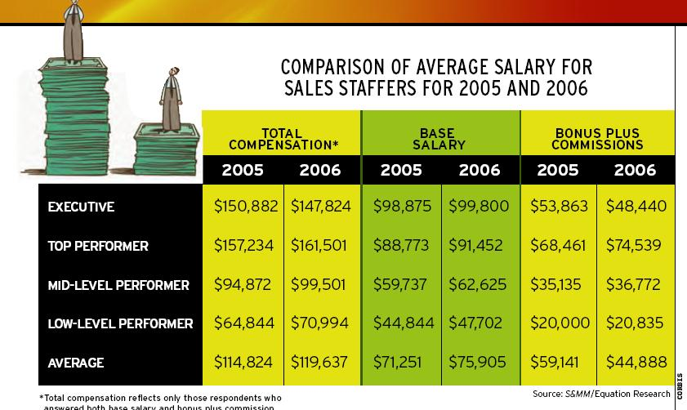

    - Nonmonetary rewards
      - Plaques 30%
      - Dinners 26%
      - Trips 26%
      - Merchandise 24%

- Salesforce Evaluation
  - Behavioral Evaluation -- Consists of criteria related to activities performed by individual salespeople, for example:

    - Required reports ___________
    - Training meetings attended
    - Letters and calls completed
    - Should not only address activities related to ____________ generation but should also include ________________ needed to ensure long-term customer satisfaction.
  - Professional Development Performance Evaluation
    - Assess improvements in certain characteristics of salespeople that are related to successful performance in the sales job
    - Characteristics include - Attitude, product knowledge, initiative and aggressiveness, communication skills, ethical behavior

  - Results-based Performance Evaluation

    - Salespeople measured objectively based on results such as – sales, market share, and accounts
    - A sales quota represents a reasonable sales objective for a territory, district, region, or zone
    - Some research shows that rewards for achieving results have a negative effect on performance and satisfaction
    - Quantitative Performance Criteria
      - Sales volume
      - Percentage of increase
      - Market share
      - Quotas obtained
      - Average sales calls per day
      - New customers obtained
      - Gross profit by product, customer, and order size
      - Ratio of selling costs to sales
      - Sales orders
      - Daily number of orders
      - Total
      - By size, customer classification, and product
      - Order to sales-call ratio
      - Goods returned

    - Profit Performance Evaluation
      - Salespeople have an impact on gross profits through the specific products they sell and/or through the prices they negotiate for final sale.
      - Salespeople affect net profits by the expenses they incur in generating sales.
      - Criteria Examples
        - Net profit dollars
        - Gross margin per sale
        - Return on investment
        - Selling expenses versus budget

- Recap: “MARKETING”
Competition
Regulatory
Economic
Technology
Social
PROMOTION
PRODUCT
PRICE
PLACE
CONSUMER

The GOAL:

Satisfaction of consumers’ needs, wants, and desires,

at a profit (or to attain organizational goals),

through an integrated effort within the firm.

