LECTURE OUTLINE FOR

MKTG 25010

“Marketing”

Lecture Packet

Part 1

2012 SPRING

DR. MARKS

12/31/2011

Class Schedule – Spring 2012
MKTG 25010 Sections 001 & 002 (CRN: 15287 & 15288)
Meeting 12:30 to 1:45 p.m. Tuesday and Thursday In 133 Bowman Hall

Week | Date | Topic | Readings  (this schedule is tentative and will need to adjust to what we cover in class each week)
Week 1 | Tues 1/10 | Lecture 1 – Introduction and Customer Value & Marketing | Chapter 1
 | Thurs 1/12 | Lecture 2
Week 2 | Tues 1/17 | Lecture 3 – Marketing/Organizational Strategies | Chapter 2
 | Thurs 1/19 | Lecture 4 – The Marketing Environment | Chapter 3  Add/drop ends January 22
Week 3 | Tues 1/24 | Lecture 5 – Ethical and Social Responsibility | Chapter 4
 | Thurs 1/26 | Lecture 6 – Consumer Behavior 1 | Chapter 5
Week 4 | Tues 1/31 | Lecture 7 – Consumer Behavior 2 | Chapter 5
 | Thurs 2/2 | Lecture 8 – Organizational Buying | Chapter 6
Week 5 | Tues 2/7 | Lecture 9 – Global Consumers & Markets | Chapter 7
 | Thurs 2/9 | Lecture 10 – Marketing Research | Chapter 8
Week 6 | Tues 2/14 | Lecture 11 –
 | Thurs 2/16 | Lecture 12 – Segmentation | Chapter 9
Week 7 | Tues 2/21 | Lecture 13 – New Products | Chapter 10
 | Thurs 2/23 | Lecture 14 – Managing Products and Brand | Chapter 11
Week 8 | Tues 2/28 | Lecture 15 – | Chapter 11
 | Thurs 3/1 | Lecture 16 – Managing Services | Chapter 12
Week 9 | Tues 3/6 | Lecture 17 –Building the Price Foundation | Chapter 13
 | Thurs 3/8 | Lecture 18 – Arriving at the Final Price | Chapter 14
Week 10 | Tues 3/13 | Lecture 19 – Managing Marketing Channels and Wholesaling | Chapter 15
 | Thurs 3/15 | Lecture 20 -- | Chapter 16
 |  | Spring Recess March 19 – March 25 | NO CLASSES  Course withdrawal deadline is March 18; a “W”  grade is assigned
Week 11 | Tues 3/27 | Lecture 21 – Customer Driven Supply Chains
 | Thurs 3/30 | Lecture 22
Week 12 | Tues 4/4 | Lecture 23 – Retailing | Chapter 17
 | Thurs 4/6 | Lecture 24
Week 13 | Tues 4/11 | Lecture 25 – Integrated Communications | Chapter 18
 | Thurs 4/13 | Lecture 26 –
Week 14 | Tues 4/18 | Lecture 27 – Advertising, Sales, & PR | Chapter 19
 | Thurs 4/20 | Lecture 28 –
Week 15 | Tues 4/25 | Lecture 29 -- Personal Selling & Sales Management | Chapter 20
 | Thurs 4/27 | Lecture 30
Finals Week | 4/30 to 5/4 | Take the exam in the College computer labs or other approved testing center. Bring your KSU ID, text book, and lecture notes with you. | Comprehensive Final  Chapters 1-20 and Lecture Materials

For the final exam, you can use a hard copy of the textbook, a hard copy of the lecture notes, and a calculator. International students can make use of a standard hard copy translation dictionary. You cannot use any other electronic devices (not your computer, or your cell phone, or an electronic translation device). You cannot have any windows open on your computer other than the final exam window.
Preliminary Mini test Schedule

Mini Test | Opens not later than 5 p.m. | CLOSES at  11 p.m. | Covers Lectures
1 | Saturday 1/21 | Sunday 1/29* | 1, 2, 3, 4
2 | Saturday 1/28 | Sunday 2/5 | 5, 6
3 | Saturday 2/4 | Sunday 2/12 | 7, 8
4 | Saturday 2/11 | Sunday 2/19 | 9, 10
5 | Saturday 2/18 | Sunday 2/26 | 11, 12
6 | Saturday 2/25 | Sunday 3/4 | 13, 14
7 | Saturday 3/3 | Sunday 3/11 | 15, 16
8 | Saturday 3/10 | Sunday 3/18 | 17, 18
 | 3/19 to 3/25 Spring Break
9 | Saturday 3/17 | Sunday 4/1 | 19, 20
10 | Saturday 3/31 | Sunday 4/8 | 21, 22
11 | Saturday 4/7 | Sunday 4/15 | 23, 24
12 | Saturday 4/14 | Sunday 4/22 | 25,26
13 | Saturday 4/21 | Sunday 4/29 | 27,28
14 Review only | Saturday 4/27 | Friday 5/4 | 29,30
Please note that this refers to the LECTURES covered by the exams. The Preliminary Class Schedule shows the CHAPTERS which are targeted for each lecture (subject to modification as needed.
Mini tests are normally available the Saturday after the material is covered in class (by 5 p.m.) for a minimum of eight days. The expiration deadline is listed in the description for each mini-test. Should a change in this preliminary schedule be necessary there will be an announcement on the class website and the revised deadline will be included in the test description.

*No mini tests will expire until after the 2nd week drop/add deadline (January 22). This allows students who add the class an opportunity to catch up and gives students who are having problems accessing the tests time to work out the bugs.

ACKNOWLEDGEMENTS: The concept for the way in which this course is offered, the approach to testing, and portions of the syllabus are based on the Principles of Marketing class offered by Dr. Bruce Robertson, San Francisco State University (http://online.sfsu.edu/~robertbc/). Many thanks to Dr. Robertson for pioneering this method of delivery.

Preliminary ELEC Schedule

ELEC | Opens not later than 5 p.m. | CLOSES at  11 p.m. | Opens in:
1 | Wednesday 2/1 | Tuesday 2/7 | Week 4
2 | Wednesday 2/8 | Tuesday 2/14 | Week 5
3 | Wednesday 2/15 | Tuesday 2/21 | Week 6
4 | Wednesday 2/22 | Tuesday 2/28 | Week 7
5 | Wednesday 2/29 | Tuesday 3/6 | Week 8
6 | Wednesday 3/7 | Tuesday 3/13 | Week 9
7 | Wednesday 3/14 | Tuesday 3/27* | Week 10
8 | Wednesday 3/28 | Tuesday 4/3 | Week 11
9 | Wednesday 4/4 | Tuesday 4/10 | Week 12
10 | Wednesday 4/11 | Tuesday 4/17 | Week 13
*Spring Break
- Three attempts for each ELEC. Each is worth up to .3% added to your final course grade.
- Unlike the mini-tests, for the ELEC’s I will record your best grade (for the mini-tests, I record the grade on you LAST attempt).
- You can earn partial credit for less than 100% on the assignment.
  - If you earn an 80% on your best attempt, you get .8 x .3 or .24% added to your Final Course Grade
- Earning a 100% on an ELEC will add .3% TO YOUR FINAL GRADE.
- For the 10 assignments you can earn up to a total of a 3% INCREASE in your course grade!!
- Available at http://connect.mcgraw-hill.com/class/l_marks_2012_spring_semester

Introduction to Marketing 25010

- Initial Background information (this is based on the syllabus, available from the class web site. You should be sure to print and read that document).

  - The Professor and his contact information:

Name
E-mail
Office
Phone
Office Hours:

Instructor’s personal website: http://www.personal.kent.edu/~lmarks

  - The REQUIRED TEXTBOOK
Marketing, 10th edition, Roger A. Kerin, Steven W. Hartley, and William Rudelius, McGraw-Hill 2011. It is available packaged with ConnectPlus access at no additional charge in a special Kent State soft cover edition (ISBN: 0077533534), or a standard Hard Copy (ISBN: 0077398254) or in a Loose Leaf edition (ISBN: 0078011795).

  - McGraw-Hill Connect Plus (a web-based assignment and assessment site that we will use for Enhanced Learning Extra Credit Assignments)
http://connect.mcgraw-hill.com/class/l_marks_2012_spring_semester

  - Lecture Notes
    - Why?
    - Where they are available

- The Prerequisite for this class is:

- Course Objectives

  - A working knowledge of marketing terminology, concepts, activities, and strategies;
  - An understanding of marketing functions within the organization and in the context of external environments;
  - Knowledge of the ways in which marketing contributes to attainment of the organization’s objectives and goals;
  - Developed quantitative and qualitative analytical skills to apply marketing concepts, theories, and tools to solve marketing problems;
  - An appreciation for the global and ethical aspects of marketing.

- Content Delivery
  - Delivered both …
  - Testing during the semester:
  - Final Exam:

- Class Website (http://learn.kent.edu),

  - Important Items to Check Regularly
    - Syllabus
    - Course Information
    - Lectures
    - E-mail
    - Discussions
    - Announcements
    - Calendar
    - Grades
    - The Point:
  - The discussion boards
    - Marketing Tech Talk
    - Marketing In Action
    - Textbook Issues
    - Mini-test Issues
    - Extra Credit and CONNECT ELEC Issues
  - Blackboard Learn Folders
    - Information about the 2012 Spring Class
    - 2012 Spring Class MKTG 25010 Syllabus
    - Lectures and Lecture Notes
    - Testing Folder
    - Review Tests

- The Course Grade is based on
  - 13 “mini” exams ( ________ % of your final grade), and
  - a comprehensive final examination ( _______ % of your final grade).
  - PLUS any __________________
Letter grades
Course Avg. | Course  Grade | Univ.  GPA | Course Avg. | Course  Grade | Univ.  GPA
92.6+% | A | 4.0 | 76.6-79.5% | C+ | 2.3
89.6-92.5% | A- | 3.7 | 72.6-76.5% | C | 2.0
86.6-89.5% | B+ | 3.3 | 69.6-72.5% | C- | 1.7
82.6-86.5% | B | 3.0 | 66.6-69.5% | D+ | 1.3
79.6-82.5% | B- | 2.7 | 59.6-66.5% | D | 1.0
 |  |  | 59.5 and below | F | 0.0

Students who want to become Marketing Majors must earn a “C” (2.0) or better in this course. A “C-“ (1.7) does not meet this College of Business requirement.

The class DOES use the plus/minus grading system.

IMPORTANT NOTE: Once the grades are in, students get what they have earned. I DO NOT make adjustments:
(a) because you “really, really” need a better grade,
(b) because your are “only” .3, .2, or .1 away from the next grade, or for
(c) any reason other than an error in the calculation.
When it comes to changing the grade which you have earned, asking, pleading, crying, and/or offering bribes DO NOT WORK (sorry).

- Policies
A. Students attending the course who do not have the proper prerequisite risk being deregistered from the class.

B. Students have responsibility to ensure they are properly enrolled in classes. You are advised to review your official class schedule (using Student Tools on FlashLine) during the first two weeks of the semester to ensure you are properly enrolled in this class and section. Should you find an error in your class schedule, you have until Sunday, January 22, 2012 to make corrections (UPO offices close FRIDAY at 5 p.m.). If registration errors are not corrected by this date and you continue to attend and participate in classes for which you are not officially enrolled, you are advised now that you will not receive a grade at the conclusion of the semester for any class in which you are not properly registered.

C. Academic Honesty: Cheating means to misrepresent the source, nature, or other conditions of your academic work (e.g., tests, papers, projects, assignments) so as to get undeserved credit. The use of the intellectual property of others without giving them appropriate credit is a serious academic offense. It is the University's policy that cheating or plagiarism result in receiving a failing grade (0 points) for the work or course. Repeat offenses may result in dismissal from the University.
For an excellent review of the topic, browse http://ec.hku.hk/plagiarism/introduction.htm, For a PowerPoint presentation that reviews the topic of cheating and plagiarism (and which reflects my views), browse http://www.personal.kent.edu/~lmarks/ethics/Plagiarism.ppt. NOTE The questions for the mini tests are copyrighted and unauthorized reproduction is prohibited.
D. Course Withdrawal Deadline: For Spring 2012, the course withdrawal deadline is Sunday, March 18, 2012. If you need advising assistance, you will need to contact an advisor before Friday, March 16, as our advising offices are not open on the weekend.
E. University policy 3342-3-01.3 requires that students with disabilities be provided reasonable accommodations to ensure their equal access to course content. If you have a documented disability and require accommodations, please contact the instructor at the beginning of the semester to make arrangements for necessary classroom adjustments. Please note, you must first verify your eligibility for these through Student Accessibility Services (contact 330-672-3391 or visit http://www.kent.edu/sas for more information on registration procedures).

F. Application for Graduation
It is your responsibility to apply for graduation before the set deadline. If you apply after the deadline you will be assessed a $200 late fee. Please see your academic advisor as soon as possible if you are uncertain as to your progress toward graduation.

- Calculating your final grade --
[(Total of all Mini test scores/13) x .5] + (Final exam score x .5) + extra credit = Final Course Grade
Or,
.5 times mini-test average + .5 times (final exam score) + extra credit = Final Course Grade

Note: Adding your total points up and dividing by 14 is NOT the correct calculation.

The Grade Calculator at
http://www.personal.kent.edu/~lmarks/MKTG25010/gradecalculator.xls or available from Blackboard Learn as a click in the Testing Folder (http://learn.kent.edu),.

IMPORTANT NOTES about course grades. YOU need to watch for deadlines for mini-tests and extra credit assignments. Once an assignment closes, it is very rare for it to be re-opened. And, once we get to finals week, all mini-tests and extra credit opportunities will have been closed. So, do them before their weekly deadlines.

Once the final is taken, your Final Course Grade is calculated using the above formula.

THERE ARE NO CHANGES to final course grades made for “being close” to the next higher grade, nor for “only being .1 away” from the next higher grade, nor for “really, really needing” the next higher grade. If there is an error in posting, then II will change a grade. If there is a curve necessary, then I will change ALL grades (this does not happen very often).

- About the Mini Tests
  - Type of exam:
  - Source of questions:
  - Coverage:

  - Number of mini-tests:
  - Available:
  - Number of Questions:
  - Time Limit:
  - Number of Attempts:
  - Which score COUNTS for your grade? The score from the last test taken is the one that counts for your grade.
  - First mini-test available until:
  - Make up policy:
  - Do not wait until
  - Do not forget to

- Is this guy for real??? Comments from others…

- Cautions and Warnings:

  - About the mini test scores
  - About convenience
  - About the work required
  - About the course grade
  - MORE about the work required
  - About getting behind

- Final Exam
  - What it covers and what you can use:
The final exam is OPEN BOOK and OPEN NOTES and you can use a calculator (international students can use a standard, hard copy translation dictionary). You cannot use other electronic devices. (no cell phones, no other computers, no electronic translators).
    - This means you cannot make use of an “e-book” for the final.
    - If you have taken notes on your computer during the semester, you will need to print those out for the final (you cannot access your computer during the final).
    - You cannot have mini-test questions and answers in your possession (which is prohibited anyway).

  - What it is
  - When and where it is taken
- MUST be taken in the College of Business computer labs during finals period, (or at an approved testing center) during Monday through Friday of finals week.
  - About your identification at the final
  - Make up policy:

- “Who does better?”

- To Succeed in the class:
  - Mini tests:
  - Practice tests:
  - If you do this, by the time of the final:

- Classroom Policies
  - Attendance
  - Classroom Expectations
  - Participation
  - Distractions and Electronics
  - Harassment
  - Check the Blackboard Learn site multiple times during the week.
  - Ask questions when you don’t understand something
  - Be polite in class and on-line
  - International Students for whom English is a second language, contact me for extra time on the test (Blackboard Learn email or lmarks@kent.edu)
  - University Closings

- Communications Policy
  - How to communicate “officially”: Blackboard Learn e-mail or to lmarks@kent.edu
IMPORTANT NOTES: BEGIN YOUR SUBJECT WITH “MKTG 25010”, then include the SUBJECT of your message (e.g., MKTG 25010 – Question about Mini-test 1).

  - About phone messages

- Extra Credit Opportunities
  - CONNECT Enhanced Learning Extra Credit (ELECs) http://connect.mcgraw-hill.com/class/l_marks_2012_spring_semester

  - Research as Extra Credit

- The Class Schedule, the Mini Test Schedule, and the ELEC schedule are in the class syllabus available on Blackboard Learn and were at the front of this packet.

- Our Guest Faculty
  - Who
  - To show:
  - And to provide:

- Guest Faculty -- Their names, titles, and organizations

 | NAME | Title | “Type of Organization”
1. | Valerie Thwing |  | Business to Business (B2B)—Service; Government
2. | Tim Apel |  | Family Entrepreneur--Product
3. | Don Kosec |  | Business to Business (B2B)--Service
4. | Rob Felber |  | Entrepreneur--Service
5. | Fred Hunt |  | Business to Business--Product
6. | Dan Muller |  | Business to Business—Industrial Product
7. | Michele Skinn |  | Not for Profit Foundation--Service
8. | Gary Trinetti |  | Entrepreneur—Product
9. | Jim Wise |  | Retail Franchise--Product
Chapter 1: Creating Customer Relationships and Value Through Marketing

- What IS Marketing?

- Marketing Defined
  - The American Marketing Association Definition:
“Marketing is the activity, set of institutions, and processes for creating, communicating, delivering, and exchanging offerings that have value for customers, clients, partners, and society at large.”

http://www.marketingpower.com/ResourceLibrary/MarketingNews/Pages/2008/42/1/MN1

  - Some controversy about the definition:

http://www.btobonline.com/apps/pbcs.dll/article?AID=/20080211/FREE/482594234/1155/ISSUEBEYOND

Kosec…Importance of Marketing to Time Warner Business Services
- Collect
- Helps to
- Use research and tools to
- Through

  - Marketing seeks to:
    - Discover
    - Satisfy
    - At a
    - Through an

  - It involves the idea of ____________________ which is the trade of things of value between buyer and seller so that each is better off after the trade.

- Factors Influencing Marketing

  - The Organization

    - Mission
      - Goals and Objectives
    - Management and people skills

    - Resources

  - Society
  - Environmental Factors
(See text, page 6, Figure 1-2, A marketing department relates to many people, organizations, and environmental forces)

  - Ways to Satisfy Needs (example, a funny birthday card):

  - The Point…only

- Requirements for Marketing to Occur
  - Two or more

  - Each must have

  - They need to

  - Each party must

- What DO people want?
To satisfy consumers’ needs, wants and desires (at a profit, through an integrated effort of the organization), we need to understand ______________

____________________________________________________.

  - BUT,

- Needs and Wants
  - Consumer NEEDS come from

    - These are

  - Consumer WANTS are ways to

- What is a Market?
  - The MARKET is the

  - Implications of the definition (MAD)

- Marketing seeks to discover then satisfy consumer needs through research and a marketing program (see text, page 10, Figure 1-3, Marketing seeks to discover then satisfy consumer needs through research and a marketing program).

Organization’s marketing department

- How Marketing Satisfies Consumer Needs, Wants, and Desires

  - We cannot be “all things to all people” so

- The Marketing Mix
  - The Marketing Mix represents

  - This consists of the 4 P’s of the Marketing Mix

  - Most of a firm’s marketing efforts involve

- Important Factors in the Marketing Environment

- Satisfaction through Value
  - Customer Value is unique combination of benefits received by targeted buyers that includes quality, convenience, on-time delivery, and both before-sale and after-sale service at a specific price.

Tim Apel – AAA Mobile Homes on “Creating Value”

  - Example of “Satisfaction through Value”

- Value Strategies
  - Best
  - Best

  - Best

  - What is “BEST?”

EXAMPLE: Douglas Conant, Pres. & CEO Campbell’s Soup Co.

Fred Hunt…Delivering VALUE to the customer at Sherwin Williams
- Value IS
- the way to
- The PRODUCTS may be

- Get it done ____________
- Deliver on
- Relationship Marketing
  - Relationship marketing links the organization to its individual customers, employees, suppliers, and other partners for their mutual long-term benefits.

Rob Felber -- Felber & Felber Marketing Services -- Creating Value for Customers

- Be a
- Be an
- Be there
- Provide them

- The Evolution of the Market Orientation – Marketing Management Philosophies

  - Production concept
    - Assumes
    - Implies
    - Useful when

  - Product Concept
    - Assumes
    - Implies
    - Places the focus on
  - Selling Concept
    - Assumes

    - Useful for

  - The Marketing Concept

    - Assumes that achieving the organization’s goals depends on

    - An organization should seek to make a profit by

Muller..how we create value for our customers at Timken

      - Our Vision =
      - For example,
      - Using our
      - BEYOND just

    - The Marketing Concept -- Three parts to the concept:

MICHELLE SKINN – What is Marketing?

      - Understanding
      - It is not about
      - How can you

    - NOTES:

      - Firms must identify and satisfy
      - Competition FORCES sellers to
      - Consumers must be seen in the context of
  - The Societal Marketing Concept

    - Assumes that customer satisfaction should be delivered in a way that

    - Relates to the Ethics of doing business

  - The Customer Relationship Era

- Marketing and:
  - Synergy
    - Managers must create marketing tactics that
    - They must

  - Hypercompetition
    - Competitive Advantages
    - Changes

  - Cross Functional Decision Making Teams

- The Breadth and Depth of Marketing

  - Who Markets?
    - Manufactures
    - Retailers
    - Service Providers
    - Nonprofit Organizations
    - Government
    - And YOU!

  - What is Marketed?
    - Products
    - Services
    - Ideas
    - Places
    - People

VIDEO Commercial EXAMPLES – Who is Marketing? What is being Marketed?

  - Who Buys?
    - Organizations
    - Ultimate Consumers

  - Why buy? How consumers benefit:
Marketing creates UTILITY; Utility is the satisfaction, value, or usefulness a user receives from a good or a service.

(Additional Information)
- The role of the Chief Marketing Officer

- http://www.marketingprofs.com/8/for-whom-the-bell-tolls-the-cmo-patterson.asp?adref=znnpbsc418

Chapter 2: Developing Successful Marketing and Organizational Strategies

HP example:

- Strategic Planning

- Corporate Strategy
- Corporate strategy is used by ALL firms, whether profit or non-profit, manufacturer or service, entrepreneurship or a global corporation.

- Marketing Strategy

  - Selecting and analyzing a
  - Creating and maintaining an
  - Deliver a
  - While Achieving
  - Whether you are a profit or a nonprofit organization,

- Three levels of Strategy in Organizations
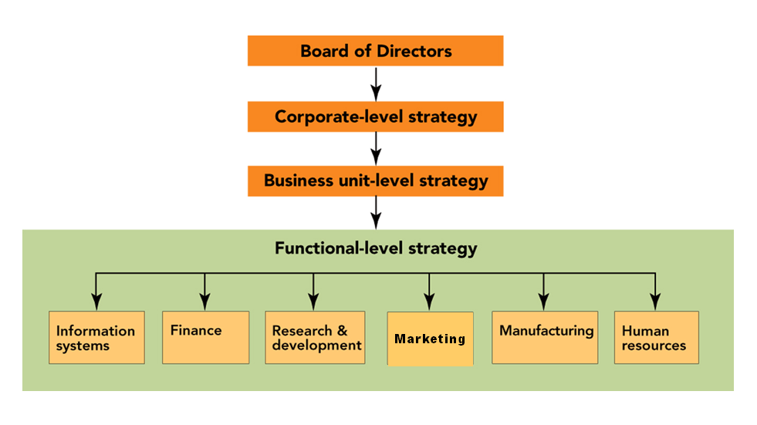
(see text page 27, Figure 2-1, The board of directors oversees the three levels of strategy in organizations: corporate, business unit, and functional)
  - The “ “ level
  - The “ “ level
  - The Functional or Departmental level

- Organizational Structure
  - Corporate
    - The “C” level;
    - Top management sets and
  - Strategic Business Units ( SBU’s )

    - Selling a distinct set of
    - Operate in markets that
    - So, planners must be

- Functional/Department Level – Strategy can be made at 3 different level:
  - The Corporate Level
  - The Strategic Business Unit level
  - The functional or department level
    - Department input and role:

- Levels of Strategic Market Planning

Your CORE VALUES must DRIVE your mission and your goals and your plans!!

- Mission Statement
  - The mission statement should be a clear and succinct representation of the enterprise's purpose for existence. It should incorporate criteria addressing concepts such as the moral/ethical position of the enterprise, public image, the target market, products/services, the geographic domain and expectations of growth and profitability.
  - The intent of the Mission Statement should be the first consideration for any employee who is evaluating a strategic decision.

  - Example – Mission/Vision at Timken

    - WAS the
    - BUT that put them
    - NEW:
    - For customers who are
    - REMEMBER:
  - Time-Warner Example

    - Our Mission
Time Warner Cable is committed to making itself the company people choose for in-home entertainment, communications and information, because we deliver superior customer care and quality products that create the best possible customer experience.
    - Our Values
Creativity -- We thrive on initiative and originality - encouraging risk-taking and divergent voices.
Customer Focus -- We value each of our customers - putting their needs and interests at the center of everything we do.
Agility -- We move quickly - embracing change and seizing new opportunities.
Teamwork -- We treat each other with respect - creating value by working together within and across our businesses.
Diversity -- We attract and develop the world's best people and talent - seeking to include the broadest range of people and perspectives.
Integrity -- We rigorously uphold editorial independence and artistic expression - earning the trust of our readers, viewers, listeners, members and subscribers.
Responsibility -- We work to improve our communities - taking pride in serving the public interest as well as the interest of our shareholders.

  - Valerie on Mission
Our ___________ GUIDES our business activities and what ______________ we will take on.

- Goals or Objectives—Be “S.M.A.R.T.”

      - Time Warner Business Services Goal is to

- Types of Goals
  - Profit
  - Sales Targets
    - In Dollars
    - In Unit Sales
  - Market Share (our percent of the market)
  - Quality
    - High? Acceptable?
  - Customer Satisfaction
  - Efficiency
  - Employee Welfare
  - Social Responsibility
    - Example—Portage County Health Services:

- Setting Strategic Directions
  - Understanding where we are NOW (“Three and ½ C’s”)
    - Our _____________

    - Our _____________
    - Our _________________
  - Where do we want to go? Do we want to:

    - Use Portfolio Analysis to help figure it out

- Product Portfolio Models – The Boston Consulting Group

Market Growth Rate
Market Dominance

  - Cash Cows
    - Dominant in Low Growth Market
      - Low
      - Strong
      - Generate
      - Do NOT require
      - Profits flow to
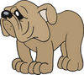
  - Dogs
    - Low Market Share in Low Growth Market
      - Low
      - Weak
      - Typically, generate
      - Not a good candidate for

  - Problem Children
    - Low Market Share in High Growth Market
      - High
      - Weak
      - Typically, require


  - Star
    - Dominant in High Growth Market
      - High
      - Profitable, but
      - Requires
      - Will be

Example -- The BCG MODEL and Coca-Cola

- Product Portfolio Models – The Directional Policy Matrix

Market Attractiveness | Competitive Position
Market Attractiveness |  | STRONG | Medium | weak
Market Attractiveness | HIGH | Maintain Leadership | Challenge the Leader | Overcome, Niche, or Quit
Market Attractiveness | Medium | Challenge the Leader | Manage for Earnings | Harvest
Market Attractiveness | low | Cash Generator | Harvest | Divest

- Tracking Strategic Directions with Marketing Dashboards
  - What are they?
    - the visual display on a single computer screen of the essential information related to achieving a marketing objective.

Example – Jim Wise -- Marketing Dashboards at Don Joseph Toyota
    - We can actually get
    - But,
    - How many
    - Where
    - Did they
    - Did we
    - Dashboards make it

  - iDashboards – Driving Business Decisions (http://www.idashboards.com/)

Example – Using Dashboards at Don Joseph Toyota for Media Effectiveness

  - Using data to

- The Strategic Marketing Process
  - Situation Analysis with _________________
    - Internal Factors

    - External Factors

Example: Fred Hunt on the Importance of SWOT
    - Few techniques
    - When you talk strategy,
    - From the analysis you can

  - ACTIONS based on SWOT:

 | Type of Factor
Location of Factor | FAVORABLE | UNFAVORABLE
Internal | Strength | Weakness
External | Opportunity | Threat

  - Market-Product Focus and Goal Setting
    - Market Segmentation
      - IDENTIFY groups of buyers who (a) have common needs and (b) will respond differently to a marketing effort
    - Target Marketing
      - SELECTION of one or more segments and developing a marketing plan to serve them

    - Jumbo Shrimp Marketing Example (the video)
Most Big Businesses began small; Nike, Dell, Starbucks,
Is Bigger Always Better?
Get Bigger by ACTING smaller!

Marketing Rules for How to get BIG by acting smaller!

#1 Be the
#2 LOVE
#3 Passion
#4 Treat
#5 Redefine

View “Jumbo Shrimp Marketing” at http://www.youtube.com/watch?v=UApCcRqu_Xo
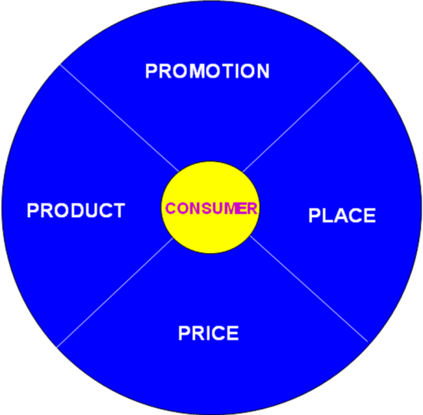
  - The Marketing Program (the 4 P’s of the _____________________)

    - Product Strategy
    - Price Strategy
    - Promotion Strategy
    - Place (Distribution) Strategy

  - See Text page 42, Figure 2-8 The Elements of the Marketing Mix MUST be blended to produce a COHESIVE marketing program!

- Implementing the Marketing Plan
  - Obtain Resources
  - Design the Marketing Organization
  - Develop the Schedules
  - Execute the Marketing Program

- Evaluating the Results – Muller at Timken
- SharePoint is used to create
- Available
- Reviewed in
- Everyone goes through
- People pay attention to

Chapter 3: Scanning the Marketing Environment

- Environmental Scanning
  - The process of continually acquiring information on events occurring outside the organization to identify and interpret potential trends.

- Environmental Factors Affecting the Organization

PROMOTION

PLACE
PRODUCT

PRICE

- Social Forces
  - Factors in a society that bring about changes in attitudes, beliefs, norms, customs and lifestyles.
    - These affect how

- Demographics
  - A population’s characteristics such as age, gender, ethnicity, income, and occupation.
    - World POPClock http://www.census.gov/population/popclockworld.html
    - U.S. Population http://www.census.gov/population/www/popclockus.html

  - Generational Cohorts (from the text)
    - Baby Boomers: 1946-1964
    - Generation X: 1965-1976
    - Generation Y: 1977-1994
    - Millennials: 1995+
    - Generational Marketing

- Social Forces
  - Marital Status
  - Cohabitation
  - Blended Family
  - All Brought together in…..The Lifestage Analytic Matrix
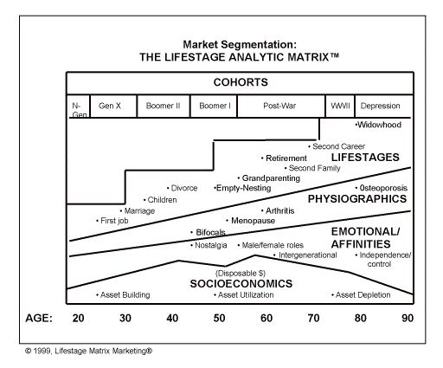
http://www.lifestagemarketing.com/

- The Seven American Cohorts

  - Depression Cohort -- Aged 91-100 in 2012.

  - World War II Cohort -- Aged 85-90 in 2012.

  - Post-War Cohort -- Aged 67-84 in 2012.

  - Leading-Edge Baby-Boomer Cohort -- Aged 58-66 in 2012.

  - Trailing-Edge Baby Boomer Cohort -- Aged 47-57 in 2012.

--Engage Boomers

  - Generation X Cohort -- Aged 35-46 in 2012.

  - The N Generation Cohort (Gen Y) -- Aged 27-34 in 2012.

Video: Don Kosec – The Impact of Generation Preferences (and Technology)

  - PLUS the newest cohort – Generation Z --Aged new born to 26 in 2012.

- Racial and Ethnic Diversity

- Cultural Trends
  - Green Marketing!
  - And…

- Economic Forces
  - Economy
    - The factors relating to income, expenditures, and resources that affect the cost of running a business and a household
  - Macroeconomic Conditions
  - Consumer Income
    - Gross Income (amount earned in a year)
    - Disposable Income (after taxes)
    - Discretionary Income (after necessities)
    - Marketing use of the data…ESRI Communities http://www.esri.com/data/community_data/index.html

  - Audio Example: The response of FORD to the economic slowdown

Video: Rob Felber, Felber & Felber’s Response to Economic Forces

- We have
- This one
- We learn
- And we need

- Technological Forces
  - Technology’s Impact on Customer Choices and Their Views of “Value”
    - Reduced costs = customers focus on other attributes
    - Introduction of new products
    - Changes to production (e.g. increased use of recycling)
  - Time Warner – Consistent Leader in Innovation
  - Electronic Business Technology
    - Marketspace
an information and communication based electronic exchange environment, where physical boundaries no longer interfere with buy/sell decisions.
In a marketspace, information and/or physical goods are exchanged, and transactions take place through computers and networks
    - Electronic Commerce
    - Intranet
    - Extranets

Video Example: An expert manager’s reaction to the impact of technological changes on a traditional business

  - How have
  - Recognize
  - …and then
  - Teaching Point:

- Competitive Forces
  - Competition
Other firms/organizations/people that want to take your customers/clients from you by providing better need satisfaction than you do, can, or care to.

NOTE: YOUR success comes from

  - Alternative Forms of Competition
    - Pure Competition
      - Large number of sellers
      - Similar Products
      - Distribution is very important
    - Monopolistic Competition
      - Large number of sellers
      - Products are unique, but substitution can occur
      - Pricing is important
    - Oligopoly
      - A few large competitors
      - Products are relatively similar
      - Promotion is the key to demonstrate product differences
    - Pure Monopoly
      - A single producer
      - A unique and unsubstitutable product
      - The marketing mix is not an important factor

  - Types of Competition
- Consumers have ___________________________________
- Companies compete for _____________________________

    - At the Brand level -- Brand Competition
Selling the same type of product that you do (e.g., Colgate or Crest?)

    - At the Product level -- Substitute Product Competition
Offers consumers a choice of how to spend their dollars within a broad product category (Football or Concert?)

    - At the Company level -- Every Company/Spending Opportunity
Given limited discretionary income, consumers must decide whether to save, donate, or spend on a variety of possible products/services

    - HOW does a firm successfully compete?
      - YOUR goal is to find a ________________________
___________________________________

      - Having gained it, ________________________________

  - Response to Competitive Trend
Audio Example -- Italy “allows” wine in boxes!! What changed their minds?

      - Realization that
      - Boxed wine is
      - NOT for the
      - Northern Europe is
      - In the U.S.
      - It is ____________________ to produce

- Political and Legal Forces
  - Monetary and Fiscal Policies
    - e.g., Government Spending
  - Social Legislation and Regulation
    - e.g., Antipollution Laws
  - To Regulate Competition
    - e.g., Rules on monopolies and restraint of trade
  - To Protect Consumer
    - e.g., Regulation of Food and Drug Labels

Chapter 4: Ethical and Social Responsibility in Marketing

- Ethics
  - The Moral Principles and Values the guide the actions and decisions of an individual or a group
- Business Ethics
  - involves what is right and wrong in the workplace...and doing right.
- Business Ethics: WHO NEEDS IT?
  - “NO ONE” Because:
    - It’s religion, not business.
    - Our people ARE ethical.
    - It’s for philosophers.
    - It’s Obvious--”Do Good”
    - It’s preaching
    - It’s just a recent fad.
    - Ethics can’t be managed.
    - It’s the same as “social responsibility.”
    - If a firm is not in legal trouble, it’s ethical.
    - Managing ethics has little practical relevance.
  - Well, maybe….BUT
    - Nestle’s -- Infant formula
    - Beech-Nut -- watered apple juice
    - Manville -- asbestos & employees
    - E.F. Hutton -- kiting scheme
    - Union Carbide -- Bhopal, India
    - Enron – Conflicts of Interest
    - Worldcom/MCI – Inflated Accounting Reports
    - Martha Steward – Insider Trading
    - Bernie Madoff -- First Jail, Then Bankruptcy for Madoff
    - Nike – Questionable Hiring Practices
      - The Background

      - Corrective Behavior

- Figure 4-1 (text page 92) Four ways to classify marketing decisions according to ethical and legal relationships
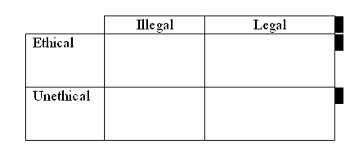
  - Unethical AND Illegal – DUH!
  - Ethical AND Legal – Okay to consider

  - Ethical but Illegal?
  - Unethical but Legal?
- Criticism of Marketing
  - High prices
  - Deceptive practices
  - High-pressure selling
  - Shoddy, harmful, or unsafe products
  - Planned obsolescence
  - Poor service to disadvantaged consumers
  - WHEN THESE OCCUR, they have impact on

- High Prices
  - Causes:
    - High costs of ________________________ and ________________

    - High _______________________ and _____________________ Costs

  - Generic vs. Branded? Why such a difference between generic and branded product prices?

  - SO, markups that result in high prices often reflect services that customers WANT and are willing to pay for:
    - Convenience
    - Image
    - Safety
    - Service
    - Return privileges, warranties

- Deceptive Practices
  - Deceptive Pricing

  - Deceptive Promotions

  - Deceptive Packaging

  - Deceptive Practices lead to:
    - Legislation
  - Is Puffery Deception?

  - Harm Business / Buyer Beware

- High-Pressure Selling
  - Some people are trained to deliver
    - High-pressure selling persuades people to
    - High-pressure selling can occur because
  - It DOES happen
  - BUT, it is not “standard business practice”
    - High-pressure selling

- Unsafe Products
  - Products that are not made well or services that are not performed well.
  - Products that deliver little benefit or that may be harmful
  - Unsafe products come from:

    - Manufacturer ______________
    - Increased _________________________________
    - Poorly trained __________
    - Poor quality _________________________, and
    - Outright __________________________.

Example -- Wal-Mart Pulling Children's Jewelry With Toxic Metals
Example – Lead Paint on Toys made in China
Example – Salmonella problems in the food supply

  - Consumer Product Safety Commission provides HELP for consumers
    - Mission
“To protect consumers against unreasonable risk of injury by developing voluntary and mandatory standards, banning dangerous consumer products, issuing recalls of products already on the market, and researching potential hazards associated with consumer products.”
http://www.cpsc.gov/
  - Video: Apel on Safe/Quality Products
    - Fix
    - Get
    - The result is a
- Planned Obsolescence
  - Products needing replacement before they should because they are obsolete
  - Producers who influence consumer concepts of acceptable styles
  - Intentionally holding back attractive functional features, then introducing them later to make old model obsolete.
  - The case of the Apple iPhone

- Poor Service to Disadvantaged Consumers
  - Poor are forced to shop in smaller stores where they _____________ for ________________ goods.
  - “Redlining” by national chain stores occurs in disadvantaged neighborhoods.
    - Redlining charges have also been leveled against insurers, banking, health care providers and others.
  - Poor are targeted for “rapid refunds.”

- Cultural Pollution
  - Mass communication media is ________________ and reaches outside target segment,
  - But, advertising keeps the cost of radio and television free and magazines/newspaper down, and
  - Consumers can opt for technologies or media that reduce or eliminate ads

- Questionable Judgments in Advertising
  - Provocative ads for Clearasil have parents upset.
  - Are such ads:
    - Over the top?
    - Unethical?
    - Humorous? Funny?
  - Should they be:
    - ?
    - ?
    - Or should _____________________________ be the main influence?

  - Clearasil’s Response

  - GoDaddy.com
    - Do you like their Super Bowl ads?
      - Rated on Artistic content __________________
      - Based on personal moral views ____________________
      - But if you’re a marketer ____________________________
      - The bottom line is __________________________________
      - Example results:

- Management’s Response to the need to be ethical
  - Corporate Culture
  - Codes of Ethics
  - Behavior of Top Management
    - Ombudsman for Ethics
  - MANAGING the ethical environment of your firm and its employees!
  - Video: Kosec – Ethics begins at the top!
    - If you are not
    - We want
    - MCI
    - Sarbanse-Oxley
    - Ethics starts
  - Video: Hunt on Ethics – It all starts at the top
    - Based on my experience
    - At Sherwin-Williams
    - As a result,
- Good ethics IS Good Business
  - For shareholders
  - For Employees
  - For business partners
  - For Customers/Clients
  - And for Society!

- AMA Ethics Statement
http://www.marketingpower.com/AboutAMA/Pages/Statement%20of%20Ethics.aspx

http://www.marketingpower.com/AboutAMA/Pages/Statement%20of%20Ethics.aspx

PREAMBLE
The American Marketing Association commits itself to promoting the highest standard of professional ethical norms and values for its members
(practitioners, academics and students). Norms are established standards of conduct that are expected and maintained by society and/or professional
organizations. Values represent the collective conception of what communities find desirable, important and morally proper. Values also serve as the criteria for evaluating our own personal actions and the actions of others. As marketers, we recognize that we not only serve our organizations but also act as stewards of society in creating, facilitating and executing the transactions that are part of the greater economy. In this role, marketers are expected to embrace the highest professional ethical norms and the ethical values implied by our responsibility toward multiple stakeholders (e.g., customers, employees, investors, peers, channel members, regulators and the host community).

ETHICAL NORMS – As Marketers, we must:
1. Do no harm. This means consciously avoiding harmful actions or omissions by embodying high ethical standards and adhering to all applicable
laws and regulations in the choices we make.
2. Foster trust in the marketing system. This means striving for good faith and fair dealing so as to contribute toward the efficacy of the exchange
process as well as avoiding deception in product design, pricing, communication, and delivery of distribution.
3. Embrace ethical values. This means building relationships and enhancing consumer confidence in the integrity of marketing by affirming these
core values: honesty, responsibility, fairness, respect, transparency and citizenship.

ETHICAL VALUES
Honesty – to be forthright in dealings with customers and stakeholders. To this end, we will:

~Strive to be truthful in all situations and at all times.
~Offer products of value that do what we claim in our communications.
~Stand behind our products if they fail to deliver their claimed benefits.
~Honor our explicit and implicit commitments and promises.

Responsibility – to accept the consequences of our marketing decisions and strategies. To this end, we will:

~Strive to serve the needs of customers.
~Avoid using coercion with all stakeholders.
~Acknowledge the social obligations to stakeholders that come with increased marketing and economic power.
~Recognize our special commitments to vulnerable market segments such as children, seniors, the economically impoverished, market illiterates
and others who may be substantially disadvantaged.
~Consider environmental stewardship in our decision-making.

Fairness – to balance justly the needs of the buyer with the interests of the seller. To this end, we will:
~Represent products in a clear way in selling, advertising and other forms of communication; this includes the avoidance of false, misleading and
deceptive promotion.
~Reject manipulations and sales tactics that harm customer trust.
Refuse to engage in price fixing, predatory pricing, price gouging or “bait-and-switch” tactics.
~Avoid knowing participation in conflicts of interest.
Seek to protect the private information of customers, employees and partners.

Respect – to acknowledge the basic human dignity of all stakeholders. To this end, we will:

~Value individual differences and avoid stereotyping customers or depicting demographic groups (e.g., gender, race, sexual orientation) in a
negative or dehumanizing way.
~Listen to the needs of customers and make all reasonable efforts to monitor and improve their satisfaction on an ongoing basis.
~Make every effort to understand and respectfully treat buyers, suppliers, intermediaries and distributors from all cultures.
~Acknowledge the contributions of others, such as consultants, employees and coworkers, to marketing endeavors.
~Treat everyone, including our competitors, as we would wish to be treated.

Transparency – to create a spirit of openness in marketing operations. To this end, we will:

~Strive to communicate clearly with all constituencies.
~Accept constructive criticism from customers and other stakeholders.
~Explain and take appropriate action regarding significant product or service risks, component substitutions or other foreseeable eventualities that
could affect customers or their perception of the purchase decision.
~Disclose list prices and terms of financing as well as available price deals and adjustments.

Citizenship – to fulfill the economic, legal, philanthropic and societal responsibilities that serve stakeholders. To this end, we will:

~Strive to protect the ecological environment in the execution of marketing campaigns.
~Give back to the community through volunteerism and charitable donations.
Contribute to the overall betterment of marketing and its reputation.
~Urge supply chain members to ensure that trade is fair for all participants, including producers in developing countries.

IMPLEMENTATION
We expect AMA members to be courageous and proactive in leading and/or aiding their organizations in the fulfillment of the explicit and implicit promises made to those stakeholders. We recognize that every industry sector and marketing sub-discipline (e.g., marketing research, e-commerce, Internet selling, direct marketing, and advertising) has its own specific ethical issues that require policies and commentary. An array of such codes can be accessed through links on the AMA Web site. Consistent with the principle of subsidiarity (solving issues at the level where the expertise resides), we encourage all such groups to develop and/or refine their industry and discipline-specific codes of ethics to supplement these guiding ethical norms and values.

Chapter 5: Understanding Consumer Behavior

- Video: Michele Skinn, on the importance of understanding consumers’ motivations
  - Learning the motivation is ________________________________
  - Understand WHY the consumer _____________________________
  - or your _____________________________________
  - Understand their motivation and then _________________________

- A Model of Consumer Behavior, Adapted from Engle, Kollat, and Blackwell

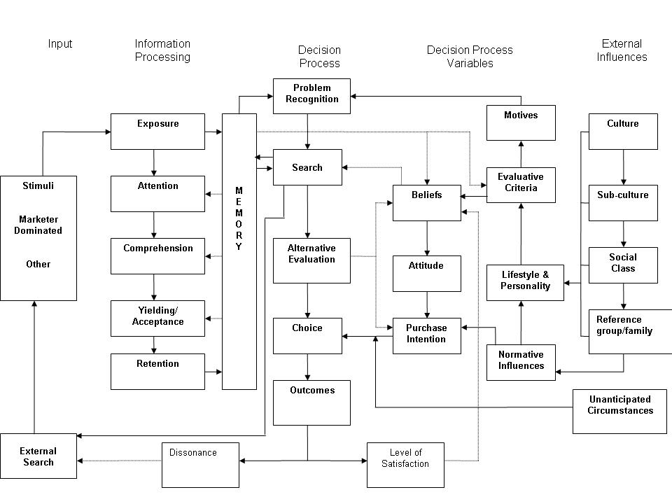

Comments:
- The Purchase Decision Process Consists of Five Stages

  - Problem Recognition _________________
  - Search _________________
  - Alternative Evaluation _________________
  - Choice _________________
  - Outcomes _________________
- Purchase Decision Process Stages – Problem Recognition
  - A perception that there is a difference between the
  - Influenced by:
    - Internal needs and _____________, and by
    - ____________, which can activate Problem Recognition through marketing communications which highlight

- Purchase Decision Process Stages – Information Search
  - First, we search ____________________________
    - What types of things do we recall?

  - Then, we may search _______________________ , including:

- Purchase Decision Process Stages – Alternative Evaluation
  - HOW will the consumer _____________________________________
  - __________________________________________are the Factors that represent the brand’s characteristics (as perceived by the consumer). They are used to compare the possible brand choices.
  - Marketers attempt to _________________________________ ________________________________
Video Example:
  - Consumers use their ____________________ to compare the alternatives in their CONSIDERATION SET (also called the __________________ )
  - Understanding the CONSIDERATION SET of brands
    - Consumers’ information search should result in a __________________________
    - Brands that consumers actually CONSIDER before making a purchase decision are known as ________________________ or __________________ (___________________________________)
All Brands
Unknown
Brands
Unacceptable Brands
Overlooked Brands

- Purchase Decision Process Stages – Alternative Evaluation – Belief, Attitudes, and Purchase Intention
  - As they evaluate the brand choices, consumers form ______________ and _______________________.
  - The result is ____________________ including which Brand to buy, where to buy, when to buy, how to pay, etc.

- Purchase Decision Process Stages – Post-Purchase Behavior
  - Consumers make the purchase (choice) based on their evaluations and their purchase intentions….and then they
  - Consumers’ Level of Satisfaction is based on their _______________ and their _______________________
    - If Perceived Performance is BELOW Expectations then consumers are _____________________
    - If Perceived Performance EQUALS Expectations then consumers are ______________________
    - If Perceived Performance EXCEEDS Expectations then consumers are _____________________
    - SO, Marketers should promise what ________________________
    - Some marketers will _____________________________

  - __________________________ is the feeling of anxiety consumers often experience when they must choose between attractive alternatives
    - It can occur REGARDLESS of the _________________________
Example:
  - Marketers help MINIMIZE dissonance by:
    - Reassuring consumers they made the right choice and minimizing product misuse through _______________________________
    - Offering ways for _____________________________________
    - Being RESPONSIVE to _______________________________
- Consumers’ Decision Making is Influenced by how INVOLVED they are with the decision (the following details are from the chart shown in the lecture):
  - When consumers’ involvement is _________, they engaged in Routine decision making.
    - Typically, such decisions take a _______________ time to make
    - The cost of the product is usually ______________
    - Consumers will only search _________________
    - And they consider ______________ brand or alternative
  - When consumers’ involvement is MODERATE, they engage in _________________ decision making.
    - Typically, such decisions take a ________________ time to make
    - The cost of the product is usually _________________
    - Consumers will search mostly ___________________
    - And they consider _______________ brands or alternatives
  - When consumers’ involvement is HIGH, they engage in _________ decision making.
    - Typically, such decisions take a ___________ time to make
    - The cost of the product is usually __________________
    - Consumers will search _________________
    - And they consider _______________ brands or alternatives
  - Examples:
- Psychological Influences on Consumers’ Purchase Decisions
  - Motivation – the energizing force that stimulates behavior to satisfy a need
  - Personality–A person’s tendency to respond in a consistent way to situations
  - Perception– the processes by which people select, organize, and interpret information
  - Learning–behaviors resulting from repeated experiences and from reasoning
  - Values, Beliefs, and Attitudes
  - Lifestyle–A person’s “mode of living”
- Psychological Influences Consumer Decision Making – Motivation
- Link to our model of Consumer Behavior
  - Maslow’s Hierarch of Needs (see Figure 5-5, text page 123)
    - Physiological Needs: Food, water, oxygen
Ad Example:
    - Safety Needs: Freedom from physical harm; financial security
Ad Example:
    - Social Needs: Friendship, belonging, love
Ad Example:
    - Personal Needs: Status, respect, prestige
Ad Example:
    - Self-actualization needs: Self-fulfillment
Ad Example:
- Psychological Influences Consumer Decision Making – Personality
  - Personality is a person’s ______________________ that influence their behaviors
    - If a person is confident, dependent, fearful, or sexual in their everyday life, these same traits likely will influence them in their style of __________________________________________
- Psychological Influences Consumer Decision Making – Perception
  - ________________________ is the process of receiving, organizing, and giving meaning to stimuli detected by one of our five senses.
  - However, not everyone gets the same meaning from the same stimuli due, in part, to:
    - Selective Perception
    - Selective Exposure
    - Selective Comprehension
    - Selective Retention
    - Subliminal Perception???
  - Selective Perception
    - Is the process which we use to determine “________________” to perceive.
    - Due to this selective process, we may omit items, add, or even change what we see, feel, or hear.
    - Selective perception doesn’t happen all at once but occurs in various stages including exposure, comprehension, and retention
  - Selective Exposure
    - From the variety of communication available to them, people _________________________________________________
    - They tend to view communication (e.g., ads) that reaffirm preexisting ideas and attitudes, thereby bolstering their image of themselves and what they "know“.
    - Marketers need to find ways to “____________________” barriers to perception!
    - Examples:
    - People rarely read Web pages, instead they _______________________
  - Selective Comprehension
    - This involves interpreting discrepant information so that it is ___________ with beliefs and attitudes.
      - It was once reported in a study that ________________ of non-smokers believed the link between smoking and lung cancer was proven;
      - yet only _______________ of heavy smokers accepted the link!!
- Example
  - Selective Retention
    - People remember more accurately messages that are favorable to their ____________ than messages that are unfavorable.
    - People remember the good things and forget the bad. Selective retention thus reinforces one’s _____________.
  - Subliminal Perception???

  - SO, consumers perceive marketing stimuli _____________because each individual is unique in the combination of his or her needs, attitudes, experiences, and personal characteristics.
    - AND, identical advertisements, packages, or products may be perceived __________________ by consumers
- Psychological Influences Consumer Decision Making – Perceived Risk
  - Perceived risk involves the perceptions of the riskiness of the purchase. There are several types that marketers must understand, including:
    - _____________________ Risk
    - _____________________ Risk
    - _____________________ Risk
    - _____________________ Risk
  - Marketers must understand their consumers’ perceptions of risk and address them
  - Video Example – Reducing Financial Risk

- Psychological Influences Consumer Decision Making – Learning
  - Learning involves changes in behavior resulting from observation and experience.
    - ______________Conditioning
    - ______________ Conditioning
    - ______________ Learning
    - ______________ Learning
  - Brand Loyalty
    - Consumers can

- Psychological Influences Consumer Decision Making – Attitudes and Beliefs
  - Based on what they have learned from processing information, evaluating alternatives, making a choice, and evaluating the choice consumers
  - form ____________ about the stores, products, decision processes, and
  - form attitudes ( _________________________ ) about these
  - When attitudes are POSITIVE they ____________________________
  - When attitudes don’t exist (e.g., for a new or for an unknown brand) or when they are NEGATIVE they _______________________________
  - Marketers attempt to Change Unfavorable Attitudes (using _____________________________) by:
    - Changing Beliefs About a Brand’s _________________
    - Changing the Consumer’s Perception of the Importance of the Brand’s ________________
    - Adding New Product ________________
- Body Wash example:

- Psychological Influences Consumer Decision Making – Lifestyles
  - __________________ -- Individual patterns of living as reflected by interests, opinions, spending habits, and activities.
  - _______________ -- A technique of measuring lifestyle and VALS

http://www.strategicbusinessinsights.com/vals/ustypes.shtml
- Influences on Consumers’ Purchase Decisions – Sociocultural
High Resources
High Innovation
  - Sociocultural Influences (link to our model of Consumer Behavior)
    - Personal Influence
    - Reference Groups
    - Family
    - Social Class
    - Subculture
    - Culture
  - Personal Influence
    - Product Trial, Brand Evaluation, Purchase Decisions, and Satisfaction can be influenced by the attitudes of “others.”
      - Opinion Leaders
      - Word of Mouth
        - Buzz
- The IMPACT of WOM “buzz” -- Philips Sonicare Essence Example:
    - Sent a $70 Sonicare Essence toothbrush to
    - The 30,000 agents each told
    - THOSE
    - Representing a
- Example: You Lookin’ at Me?

  - Family Influence
    - Consumer Socialization
      - The process by which people acquire the skills, knowledge, and attitudes necessary to function as consumers
      - The _____________ is a key factor in consumer socialization of children
        - Marketers are aware of this and create commercials to target this family influence
        - Ad Example:

    - Family Decision Making
      - Family can BE ______________________
      - Often involves ___________________ and __________________
    - Family Life Cycle (see Figure 5-6 from the textbook page 129).
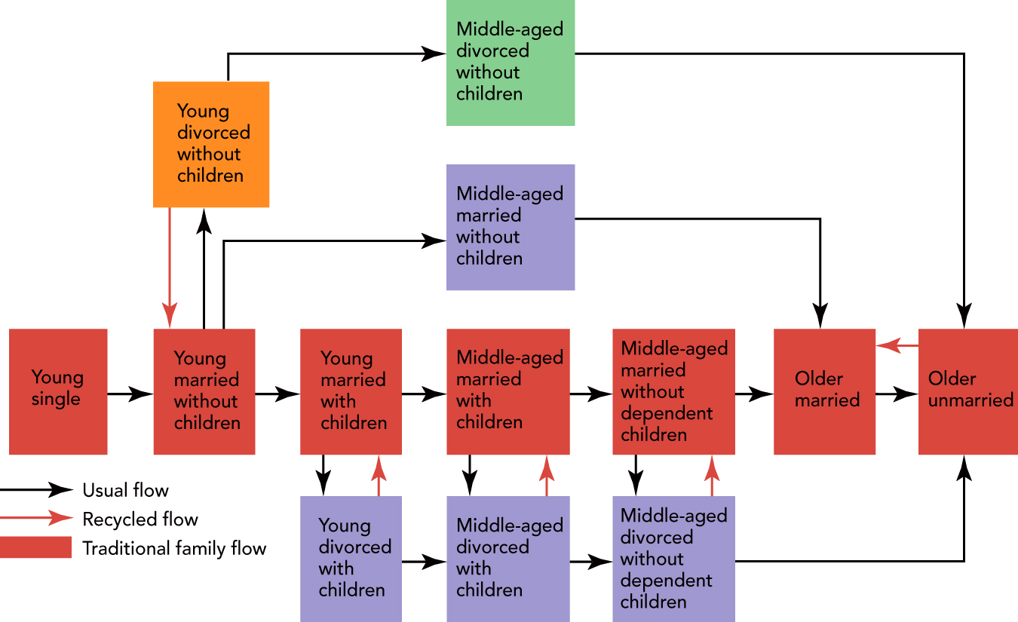
      - Roles in Family Decision Making
        - _________________
        - _________________
        - _________________
        - __________________
        - __________________
    - Marketers must know ___________ plays these roles for their products and whether/how to reach them!
NOTE AN ERROR in the textbook (10th edition). PAGE 130 says that Teenagers influence another $650 billion and spend $200 million of their own money annually. THAT SHOULD BE $200 BILLION.
  - Social Class
      - Social Class
      - Upper Class
      - Middle Class
      - Worker/Lower Class
    - A very strong influence on ________________________, attitudes, activities, social interactions, AND your consumer behavior (e.g., where you shop, what you buy, how you save/invest)
  - Subculture -- the subgroups within the larger, or national, culture with unique values, ideas, and attitudes
    - Hispanic
    - African American
    - Asian American
    - And more
  - Culture
  - Video example:
- Other influences
  - Situational Influences = five aspects of the purchase situation that impacts the consumer:
    - Purchase task
    - Social Surroundings
    - Physical Surroundings
    - Time (temporal) Effects
    - Antecedent (pre-existing) States
- IN CONCLUSION
Understanding what influences consumers to buy or not buy your product is
  - EXTREMELY ___________________________, and
  - EXTREMELY ____________________________!
Chapter 6: Understanding Organizations as Customers

- The Nature and Size of Organizational Markets
  - ___________________________________ involves the marketing of goods and services to companies, governments, or not-for-profit organizations for use in the creation of goods and services that they can produce and market to others.
  - Business Markets include ___________________ that buy goods and services to:
    - Make
    - RESELL
    - Conduct
    - In the past, business markets were called ____________________.
  - Six Components of the Business Market
    - Agriculture
    - Resellers who buy and sell products in essentially the same form. However, they create various utilities for other businesses, including:

    - Services, which are GROWING rapidly
    - The Government
      - Unique:
    - International Trade
http://www.census.gov/foreign-trade/statistics/highlights/top/top0912yr.html
Total Trade – Jan to Dec -- Data are goods only, in billions of dollars.
Total, All Countries | Exports (Year-to-Date) | Imports (Year-to-Date) | Total Trade (Year-to-Date)
Jan-Dec 2009 | 1,056.9 | 1,558.1 | 2,615.0
Jan-Dec 2010 | 1,278.1 | 1,912.1 | 3,190.2
http://www.census.gov/foreign-trade/statistics/highlights/top/top0912yr.html
http://www.census.gov/foreign-trade/statistics/highlights/top/top1012yr.html

    - “Non-business” Not-for-profit Organizations

  - Video: Muller on the Industries Timken serves
    - Growth for Timken
    - Focused on Heavy Industries

    - Where they can deliver value…and which are growing. For example:

    - Compared to Automotive, which may NOT be a good industry for them in the future.
- Type and Number of Organization Establishments in the U.S.
  - Industrial (business) markets -- Total Number =
  - Reseller markets – Total Number =
  - Government markets – Total Number =
--and Timken...

- Measuring Domestic And Global Industrial, Reseller, And Government Markets
North American Industry Classification System (NAICS) -- The North American Industry Classification System (NAICS) is the standard used by Federal statistical agencies in classifying business establishments for the purpose of collecting, analyzing, and publishing statistical data related to the U.S. business economy.
http://www.census.gov/eos/www/naics/
  - North American Product Classification System (NAPCS)
A joint multi-phase initiative to develop a comprehensive demand-oriented product classification from the statistical agencies of Canada, Mexico, and the United States. Work to date has focused on the products produced by service industries in 12 NAICS sectors 48-49 through 81. With that work nearing completion, this web page provides an overview of and progress report on the NAPCS initiative and presents the final versions of the product lists developed so far for the service industries included in those 12 sectors.
http://www.census.gov/eos/www/napcs/index.html

- Characteristics Of Organizational Buying
  - Demand Characteristics
    - Derived Demand -- the demand for industrial products and services is driven by, or “derived from,” demand for consumer products and services.
Example:

      - The Implications of Derived Demand:

Intel Example:

    - Elasticity of Demand
      - The total demand for all of the producers of the product responds very little to changes in its prices Demand does not change much if price changes.
        - Occurs when Cost is a small percent of the finished product, and
        - When there are no close substitutes
Example

      - Demand is more elastic when
        - A Price Change occurs in a ________________________
        - When demand is viewed from a ________________________
        - If the cost of the business product is a SIGNIFICANT portion of the cost of the finished good

  - Size of the Order or Purchase and the Number of Buying Units
    - Number of Business users =
    - Number of Ultimate Consumers =
    - However, while there are a smaller number of organizations they are ____________________________________________
    - Plus, they are _________________________________
--Goodyear
--Regional Concentration
  - Organizational Buying Objectives
    - Businesses buy from other businesses to help them achieve their objectives, such as:
      - Reduce ______________________
      - Increase _____________________
      - _____________________________________
  - Organizational Buying Criteria (like Consumer’s Evaluative Criteria)
    - In deciding among suppliers, buyers must consider a variety of factors, such as:
      - Price
      - Delivery Schedules
      - Past Performance
      - Production Facilities/Capacity
      - Warranty/Claim Policies
      - Technical Capability
      - Quality Specifications
        - ISO 9000 – standards for registration and certification of a manufacturer’s quality management and assurance system based on an on-site audit of practices and procedures developed by the International Standards Organization (ISO).
    - Why is all of this SO important in B2B Buying?
      - Firms MUST ___________________________________________
________________________________________________________ because:
        - Companies are making less and buying more from suppliers
        - Firms cannot tolerate ___________________________________

        - SO, firms need to work with fewer suppliers and develop long term relationships with them
          - Work together to develop new products, share information on inventories, production and costs.
  - Buyer-Seller Relationships and Supply Partnerships
    - Supplier development is the deliberate effort by organizational buyers to build relationships that shape suppliers’ products, services, and capabilities to fit a buyer’s needs and those of its customers.

  - The __________________________________________ -- consists of a group of people in an organization who participate in the buying process and share common goals, risks, and knowledge important to a purchase decision.
    - It is a “Cross-Functional” Group
    - People in the Buying Center
    - Roles in the Buying Center
      - Gatekeepers --
      - Influencers --
      - Users --
      - Buyers --
      - Deciders --
  - Buy Classes represent the “type” of buying situation (see Text Figure 6-3):
    - Straight Rebuy
    - Modified Rebuy
    - New Buy
    - See Figure 6-3, text page 149, for the ways in which the buying situation affects the buying center

    - Stages in the Organizational Purchase Decision Process (See Figure 6-4, text page 151),
      - Problem Recognition
      - Information Search
      - Alternative Evaluation
      - Purchase Decision
      - Postpurchase Behavior
    - The Hershey’s Example:
      - Problem Recognition
      - Information Search
      - Evaluation of Alternatives
      - Purchase Decision
      - Post-purchase evaluation

- ONLINE BUYING IN ORGANIZATIONAL MARKETS
    - Prominence of Online Buying in Organizational Markets
    - E-marketplaces
      - Online Auctions in Organizational Markets
a) Traditional Auctions
      - A Seller puts an item up for sale
      - Various Buyers ______________________.
      - As bidders increase, there is ________________ on price.
      - The Auction ends when ___________________________
b) Reverse Auction
- A Buyer communicates a need for a product or service
- Various ________________ bid in competition
- As the number of suppliers increase there is ___________________ on price
- The Auction ends when _____________________________
Chapter 7: Understanding and Reaching Global Consumers and Markets

- The Nature and Size of Organizational Markets
  - Why International Trade?
    - To get access to materials, products, and services which are___________________________________________

    - To get access to markets which______________________

    - Because of the nature of Comparative Advantage
      - Some countries have unique national or human resources that give them ______________________, internationally

    - Market Saturation ________________
    - Potential Demand
    - Customer Expectations
  - What does it mean to US?
    - Balance of Trade
      - The difference between the monetary value of a nation’s exports and imports
      - US Balance of Trade….

    - Impact of the DHL (Germany) decision for Ohio
    - Desire to HAVE foreign investment locally

- Dynamics of World Trade – The Competitive Advantage of Nations
  - Porter’s “Diamond” -- WHY do some industries and firms become world leaders and others lose ground or fail?

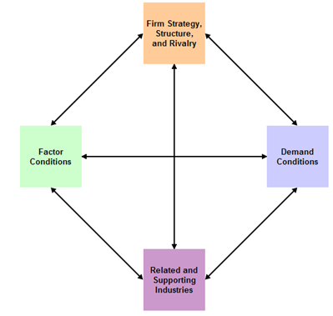
    - Factor Conditions
      - Natural Resources
      - Education and skill levels
      - Wage Rates
        - Examples:
      - AND, the question for OUR FIRM – Can we __________ ______________________________________
    - Demand Conditions
      - Size of Market
      - Sophistication of Consumers
      - Media Exposure of Products
        - Example

      - AND, the question for OUR FIRM – Is there ____________ ________________________________

    - Related and Supporting Industries
      - Existence of Supplier Clusters
        - Examples
      - AND, the question for OUR FIRM – Can we ____________ ________________________________
    - Company Strategy, Structure, and Rivalry
      - Number of Companies in an Industry
      - Intensity of Competition
      - Public or Private Ownership
        - Example
      - AND, the question for OUR FIRM --Can we ____________ ________________________________
  - CONCLUSION:
Firms that succeed in global markets have succeeded first in intense domestic competition through:

- Marketing In A Borderless Economic World
  - Trend 1—Decline of Economic Protectionism
    - Today we have an

    - Should Congress create more Protectionism?
      - Some argue that the benefits of today’s free trade systems go unfairly and primarily to low-wage countries, which take jobs away from Americans.
      - These arguments are not supported by the facts.
    - Reagan said:
      - “A creative, competitive America is the answer to a changing world, not trade wars that would close doors, create greater barriers, and destroy millions of jobs. We should always remember: Protectionism is destructionism.”
    - America's economy, over the past few decades, has proved that __________________________ flexibility makes the economic pie much bigger and that the benefits can be widely shared.
    - Over the past 10 years, open trade has boosted job growth by more than 13 percent and has helped to raise U.S. GDP by nearly __________________________.
    - Protectionism in World Trade (see textbook Figure 7-3)

PROTECTIONISM

    - General Agreement on Tariffs and Trade (GATT)
      - A treaty, NOT
      - Focus:
      - NO _______________________________
    - World Trade Organization (WTO) Goals:
      - Trade Without _______________________
(Exceptions: e.g., Regional Trade Agreements)
      - Predictable and Growing Access to _________________ (Example: binding tariffs)
      - Promoting ___________________________
      - Encouraging Development and Economic Reform (Over 3/4 of its members are developing countries)
      - Patrick Low – Chief Economist WTO
        - The WTO is an
        - Including ______________ nations.
        - The WTO needs to get
        - Regional Trade Agreements have exploded and the are a challenge to trade without

        - The WTO agreements create an environment of

        - They seek to create in trade.

      - An aside…how many countries ARE there in the world today?
  - Trend 2 – A Rise of Economic Integration
    - European Union
      - Consisting of
    - North American Free Trade Agreement (NAFTA), Canada, U.S., Mexico
      - Consisting of ________________________________
    - Asian Free Trade Agreements
      - South Asian Free Trade Area-
        - a framework for the creation of a free trade zone covering 1.4 billion people in India, Pakistan, Nepal, Sri Lanka, Bangladesh, Bhutan and the Maldives.
      - East Asian Free Trade Agreement on Services
  - TREND 3 — Global Competition—Who are we up against? How might we compete?
    - __________________________________________-- agreements among two or more independent firms to cooperate for the purpose of achieving common goals.
      - Example

    - _______________________________________ – International marketing done in the same way as domestic marketing
      - Example

    - __________________________________________ – Varies its Marketing Strategy for each country

      - Example

    - ____________________________________ – Use a “Global Marketing Strategy” to keep the mix the same where there are similarities and CHANGE the mix when cultures differ.
      - A goal of _________________ is to create and maintain a balanced portfolio of global AND local brands, to:
- Take advantages of ____________________ where possible, by sharing R&D, technical features, manufacturing, etc. across brands
- Grow _______________________ where possible
- Obtain __________________________ though ______ _________________________ locally, when necessary

Henkel Example
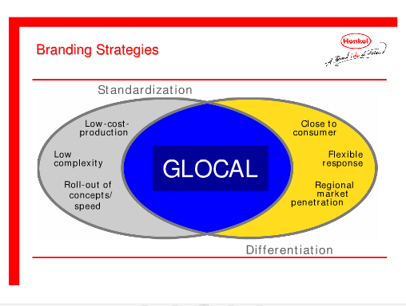

Global Marketing and G.M. (Video)
- _______________ to play a bigger role in G.M.’s future
- It is G.M.’s _________________________________
- ___________ new cars in the next 2 year.

- In 2010 GM sold _____________________ than in the U.S.!!!

- A Global Environmental Scan – What do we need to “know before we go?”
  - Cultural Diversity
    - Social and Cultural Environment
      - Family
      - Customs and Behavior
      - Education
      - Language
      - Impediments to understanding foreign markets:
        - ______________________________________ -- an unconscious reference to one’s own values, experiences and knowledge as a basis for making certain decisions
          - Can result in a __________________ an open attitude and a cultural sensitivity enabling managers to look carefully at the foreign market and understand the _______________needs there (and not simply transfer the needs of the domestic market)
        - Ethnocentrism -- The belief that one's culture is ________________________________
        - Examples

    - Economic Environment
      - _______________________ – can the country provide communications, transportation, energy, etc.?
      - Level of Economic Development
        - A general indicator of the market’s attractiveness
        - Indicator of the types of products that will be in demand
        - Gross National Income (GNI) Per Capita
      - Competition
        - The __________________ is often overlooked
        - You MUST have a ____________________
_______________________________________
      - Political Stability -- when the country is not politically stable, business risks losses!
        - Examples:

- Global Market Entry Strategies
  - Exporting
    - _______________ Exporting
    - _______________ Exporting
  - Licensing
    - _________________ Manufacturing
    - _________________ Assembly
    - Franchising
  - Joint Venture
  - Direct Investment
  - Global Market Entry Strategies

Exporting Directly, or through Import-Export Middlemen | Company Sales Branches | Licensing Foreign Producers | Contract Manufacturing by Foreign Producers | Joint Ventures and Strategic Alliances | Wholly Owned Subsidiaries | Multinational Corporations

    - Examples
      - Coca Cola ( __________________________)

      - Goodyear Tire & Rubber (_____________________)

      - Saint-Gobain (______________________________)

- Product Strategies
  - Product Extension -- No change
  - Product Adaptation -- Modification
  - Product Invention – Entirely NEW
- Promotion Strategies
  - Same Promotion Globally
  - Adapt Promotions to Local Tastes
  - Create Entirely NEW promotions
- Bringing together Product and Promotion Strategies for Global Marketing
(Figure 7-7, textbook page 186)
 |  | Product Emphasis
Promotion emphasis |  | SAME Product | ADAPT Product | Create NEW Product
Promotion emphasis | Same Promotion as Domestically | Product extension strategy | Product adaptation strategy | Product Invention Strategy
Promotion emphasis | Adapt Promotion to Foreign Culture | Communication adaptation strategy | DUAL adaption strategy | Product Invention Strategy

- Distribution and Pricing
  - Channels Usually Long and Complex
  - Countries May Impose Pricing Constraints
- Muller – Understanding Cultural Difference in Pricing
    - Timken tends to
    - But, in pricing
    - They had more
    - So, they felt they need to
    - In China,
    - They needed to
Chapter 8 -- Marketing Research: From Customer Insights to Actions

- The Role of Marketing Research
  - Important Factors that Marketers NEED information about:

- What is Marketing Research?
  - It is the process of defining a marketing problem and opportunity, systematically collecting and analyzing information, and recommending actions.
  - Implications
    - Marketing Research is used for
      - Planning ______________________________________
      - In the Implementation ____________________________
      - In their _______________________________________

    - Marketing Researchers are responsible for collecting and interpreting data that supports decision making

- Marketing Research/Program Failures
  - Apple Newton
  - Sega Dreamcast
  - Sony
    - Betamax lost to
    - Digital Audio Tape (DAT)
  - Microsoft
    - Webtv
    - iRex Digital Reader
- The Five-step Marketing Research approach for better Actions
  - Step 1: ________________________________
    - Set Objectives
      - The specific, measureable goals for the research (and for the decision maker)
    - Possible Objectives:
      - To ____________________ the issues better (Exploratory Research)
      - To understand the ___________________ better (Descriptive Research)
      - To determine how to ________________ an element of interest (Causal Research)

  - Step 2: ______________________________________
    - Specify Constraints
      - Financial, Time
    - Identify _____________________ needed for Marketing Actions
      - What do we NEED to know to?

    - Determine _______________________________________
      - Sampling
        - Probability Sampling (i.e., Random Sampling)
        - Nonprobability Sampling
        - The difference? The ability to make _________________

  - Step 3: Collect Relevant Information

    - Types of Data
      - Secondary Data

      - Primary Data

Figure 8-3, Types of Marketing Information (text page, 204)

Data
Facts and figures pertinent to the problem
_____________
Facts and figures already recorded prior to the project
_____________
Facts and figures collected for the project
______________
Many internal resources

Many organizations
______________
Mechanical
Personal
______________
Interviews and focus groups
Survey

- Video: Muller on Marketing Research at Timken
- Timken does Marketing Research “both ways” (using internal marketing managers and outside firms)
- They use research to understand their market and find
- Outside firms for really big jobs
  - e.g. Wind Energy Market
- Faster, Global
- Results suggest future role for Timken

- Secondary Data
  - Advantages
    - _______________
    - Inexpensive
    - May provide a “________________________________” solution
    - May point the direction for primary research
  - Disadvantages
    - ____________________________________________
    - Sample/Definitions/Categories not appropriate
    - __________________________________________
- Primary Data
  - Advantages
    - Focuses on the specific problem at hand
    - Is under control of the current researchers
  - Disadvantages
    - __________________________________________
    - _________________________________________

- Syndicated Services – A source of Secondary Data
  - Companies that collect and sell common pools of data of known commercial value designed to serve a number of clients.
  - Syndicated sources can be classified based on the unit of measurement (households/consumers or institutions).
  - Household/consumer data can be obtained from surveys, diary panels, or electronic scanner services.
  - Institutional data is obtained from retailers, wholesalers, or industrial firms.
    - Syndicated Services: Consumer Data

    - Syndicated Services: Institutional Data

http://www.productscan.com/
….and some internet databases useful to marketers
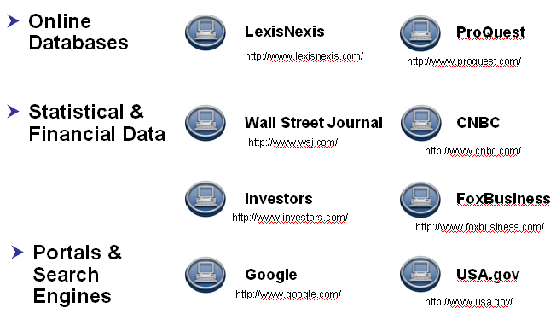
- Primary Data
  - ______________________________
    - Observational Data
      - Nielsen
      - TIVO
      - Web Cookies
  - _____________________________
    - Mystery Shopper
    - Videotaping
    - Ethnographic Research
      - MTV visits teens in “The Merchants of Cool”
  - Questionnaire/Survey Data (Questioning Consumers)
    - __________________________________
      - Individual Interviews
      - In-depth Interviews
      - Focus Groups
      - Fuzzy Front End techniques
        - “Unusual” ways to identify new, cool trends
    - __________________________________:
      - Personal Interview Surveys
      - Telephone Surveys
      - Mail/Fax Surveys
      - E-Mail/Internet Surveys
      - Mall Intercept Surveys
  - Question Formats
    - Open-ended
    - Closed-ended or Fixed Alternative
    - Dichotomous
    - Semantic Differential
    - Likert Scale
    - All can be useful; the format needs to match the goal.
    - Writing the question can be an “art” that critically influences the result!!
See http://knowledge-base.supersurvey.com/glossary.htm#loaded_question
  - Collecting Primary Data
    - ________________________________
      - An ongoing group of consumers or stores who agree to provide information
    - _________________________
      - Carefully control the “cause” (the “stimulus”, e.g., the ad, the price, the packaging, etc.) and measure the important “results” (the “dependent variable,” e.g., attention, beliefs, attitude, sales).
    - __________________________

  - Using information for ACTION – issues
    - Navigating information overload
      - New ways to ____________________, ______________________ and ___________________________ in the extended enterprise
      - Information Systems…On-going, organized procedure to generate, analyze, disseminate, store, and retrieve information for use in making marketing decisions.
    - Data Mining
      - Data warehouses can be analyzed the same way as databases (looking for predetermined patterns).
      - However, its size, it would be a slow and cumbersome process
      - More advanced statistical and artificial intelligence techniques (called data mining) allow marketers to identify patterns and meaningful relationships!
      - Example

- Step 4: Develop Findings
  - Analyze the Data
    - Using the appropriate techniques
  - Present the Finding
    - Communicated in a clear manner for ACTION

- Step 5: Take Marketing Action
  - Make Action Recommendations
  - Implement the Actions Recommended
  - Evaluate the Results

Video EXAMPLE – Frontline from PBS
MTV Using Marketing Research for Action!
- VIACOM’s crown jewel is MTV earning _____________________ in profits
- MTV’s Problem – _____________________________
  - No longer seen as cool or creative
- MTV’s Objectives:
  - How to get closer to the audience
  - How to learn what kids want and get closer to them
- The “data plan”-- Immerse themselves in ___________________________
- Learn what the consumer wants and deliver it to them!
  - To ensure the bond, MTV depends on Market Research!
  - Research to understand ___________________________________
- Collect RELEVANT INFORMATION --TECHNIQUES:
  - Ethnography study (Collection of Primary Data with Personal Observation)
    - Visit the fan in his home
      - Gain insight into the teenaged male
      - What issues are important them?
      - Dating
      - Parents
      - Stressors?
- Develop and Present the findings.
  - Captured on video and shown to the MTV insiders
- What happens with the research? What portrait emerges?
  - The _________________________..???!!!!
  - He is crude, loud, obnoxious, and in your face.
- And the ACTION…he influences a great deal of programming!
  - Tom Green
  - Daredevils
  - Spring Break
  - Comedy Central South Park
  - The Man Show
- Criticism -- Are we capturing the “person?”
  - Revenues depend on being ahead of the curve!
  - Professional Wrestling
- Huge with the audience

Example:

Chapter 9 -- Segmenting, Positioning, and Forecasting Markets

- Hewlett Packard – Printers (and more)
  - HP's Imaging and Printing Group (IPG) is "the leading imaging and printing systems provider in the world for printer hardware, printing supplies and scanning devices, providing solutions across ____________________ from individual consumers to small and medium businesses to large enterprises.“
  - How has it obtained this position?
  - History
    - The 1980’s
    - The 1990’s
    - The 2000’s
  - HP has been successful by finding _____________________________ them with appropriate products and services!!

- Markets
  - _______________________________________ -- Groups of customers with different wants, buying preferences or product-use behavior
    - For example, what do YOU look for in a vacation?

  - _______________________________________ – A market segment for which the seller chooses to design a marketing mix
  - Market Segmentation – The PROCESS of identifying and describing POTENTIAL target markets
    - Market Segmentation involves ______________________________ _____________ into groups, or segments, that:
      - Have common needs, and
      - Will respond similarly to a marketing action.
    - We need to target our market segment by “positioning” our offer; BUT first we need to define and describe the target market in detail.
- Market Segmentation (another view)
  - The process of dividing the total market for a good or service into several smaller, internally homogenous (i.e., similar) groups.
    - Members of each group are similar with respect to the factors that influence demand
      - For example:

  - Segmentation Benefits and Challenges
    - More efficient use of marketing resources
      - Example
    - Can help to create rapid growth
      - Example
    - Challenges – Be Careful
      - Too much complexity can frustrate consumers
        - Example:
- Process of Market Segmentation
  - Identify _____________________________________________
    - Market research is used to explore this with CURRENT and POTENTIAL consumers.

    - Cell phone Example -- What do people want in a cell phone?
      - Texting?

      - Web access
      - Gaming Apps
      - Camera (or video?)
      - Music
      - Fashion
      - Simple, low-tech
      - “Don’t Care”
      - Business Users
Examples:

  - Identify the Characteristics that define the segment (what do prospective segments share that make them different from other segments with different needs/wants/desires?)
Example:

  - Determine the ____________________ of the segment and how well they are being ________________________ by current offerings
    - How large is the segment in terms of numbers, demand, and dollars (i.e., potential sales)?
    - How _________________ is their need (how dissatisfied are they with their current options)?
    - How __________________ is the existing competition?
    - FORECASTS can help to determine which segments are worth pursuing!
    - Note: See the textbook for “sales forecasting techniques” that may be very valuable here.
  - This should allow us to determine the size of the segment, the urgency of the need, and the strength of the competition…so, ____________ _________________ help determine whether or not this segment seems to be appealing for us
- Market Segmentation Conditions that indicate a useful segment
  - The segment is Measurable and we can ____________________ data about the segment
Example:

  - Is the segment ______________________________?
e.g., The Cleveland Plain Dealer:
  - Is the segment _______________________ to be profitable for us?

    - Creating a new product/service, advertising it, distributing it, facing down competition is all ______________________________.
    - Is there enough size, demand, and sales to provide the ________________ we will need?
    - Mass Customization – Treat each customer as a __________ _________________________________
Examples:

- Market Segmentation – Grouping Buyers into Segments
  - Based on the Customer’s reason for __________________________?
    - _______________________ -- For personal use = Final Consumer
    - _________________________________ -- To use in the organization, to resell, or to make other products
--Black and Decker and DeWalt Example:

Video: Felber on Market Segmentation at Felber & Felber
        - Felber & Felber has focused on the _____________ segment
        - There are many manufacturing companies doing well
        - Felber & Felber only needs a few of these to FOCUS on with their specialties
        - Green Marketing and Early Stage Clients
        - They apply what they learned from other clients to this segment
    - However, while useful, this is too broad
  - Bases for Segmenting Consumer Markets
    - Geographics (Region, Size, Urban-rural, Climate)
    - Demographic (Income, age, gender, family life cycle, social class, education, occupation, ethic background)
    - Psychographics (e.g., VALS)
    - Behavioral segmentation (Benefits desired, usage rates)
    - Usage Rate
    - Examples:
      - ___________________________________________ (by Age )

      - Psychographic Segmentation
        - As the American population becomes more diverse and affluent, demographic researchers are changing the way they define segments of American society.
        - The marketing research firm _____________________ has defined 14 distinct groups of consumers based on recent Census and consumer data that emphasize income, age, and lifestyles. Segments of each group buy the same types of cars, read the same magazines, and watch the same television shows.

L I F E S T Y L E

URBAN  I  N  C  O  M  E | SUBURBAN | SECOND CITY | TOWN & COUNTRY
Urban Uptown | Elite Suburbs | Second City Society | Landed Gentry
Midtown Mix | The Affluentials | City Centers | Country Comfort
Midtown Mix | Middle-burbs | City Centers | Middle America
Urban Cores | Inner Suburbs | Micro-City Blues | Rustic Living

- Claritas’ 14 segments are divided into 66 smaller clusters.

USA Today – Who We Are: Redefining our demographics
http://www.usatoday.com/news/graphics/whoweare/flash.htm
http://www.claritas.com/MyBestSegments/Default.jsp

        - Useful for direct-mail promotions, retail outlet selection, decisions about the mix of products/brands to offer in the area.

      - Behavioral Segmentation
        - An “ideal” approach, but often hard to measure
          - Example: What are the benefits of wearing clothing that has label on the outside?
          - Citicard example:

      - Usage Rate
        - Non-users
        - Light users, medium users, heavy users
          - Example:

- “Traditional” Target Market Strategies
  - ___________________________________________ (mass-market, undifferentiated market, one size fits all)
    - Use a ___________________________________ for everyone – A “shotgun” approach…. VERY UNCOMMON; perhaps some _________ ___________
    - Potential Advantages;
      - Lower ______________________________________
      - Easy to _________________________________________
  - ________________________________
    - Product differentiation involves using different elements of the marketing mix to help consumers see the product as being different from the competition, and “better” for the consumer
    - Apple example:

  - Single-Segment Strategy (_____________________________)
    - Create a single marketing mix which targets a single, well defined group
    - Can be a good way to __________________ in the broader market
      - Examples

    - The marketer can earn a reputation as an _________________ or a _________________________ in this ____________________ market
    - Niche markets are often (though not always) relatively ________________________________

        - Example:

    - So, this is one way for a firm with ______________________ ___________________ to be competitive!

    - CAUTION: A danger of this approach is that you are ______________ __________________ ______________________
      - Example
  - _____________________________________
    - Identify MULTIPLE segments, and develop, market, and manage MULTIPLE marketing mix offering attempting to satisfy the needs, wants, and desires of EACH segment with a “_______________” marketing mix.
e.g., Bayer HealthCare Products
    - Advantages:
      - Eliminate or reduce _______________________________
      - Become _________________________________________
_____________________________________________________
    - Disadvantages:
      - Higher ____________________________________________
      - Higher ___________________________________________
      - Higher __________________________________________
      - SO,
For example:
Examples: Clothing and Jeans segmentation

  - Example: Muller on Segmentation at Timken
    - Primarily by industry
      - Primary metals
      - Wind energy
      - Power generation
      - Cement
      - Automotive
      - Off highway construction vehicles
    - And then further with micro segmentation
      - Short lead time
      - Longer life
      - More productivity
    - Challenge to discover the segment’s needs and to create a mix for each
- Example: Bayer Consumer Products Example (http://www.consumercare.bayer.com/index_en.html)
    - Background
        - Employees: 6,600
        - Activities in more than 100 countries
        - Sales: Over EUR 2 billion
        - More than 170 brands worldwide
        - Global Headquarters: Morristown, NJ
        - Bayer HealthCare's OTC brands are manufactured around the globe in Europe, North America and Latin America, as well as in Asia.
      - _______________Major Segments
        - Analgesics: Bayer Aspirin, Aleve, Aktren, and Midol
        - Gastrointestinal: Alka-Seltzer, Lefax, Phillips Milk of Magnesia, Rennie, and Talcid
        - Dermatological: Bepanthen, Bepanthol, Canesten
        - Cough and cold remedies: Alka-Seltzer Plus, Aleve Cold & Sinus, and Tabcin
        - Multivitamins and dietary supplements: Berocca, One-A-Day, Flintstones (complete, gummies, plus, my first Flintstones)
http://www.bayerhealthcare.com/scripts/pages/en/company/profile/divisions/consumer_care/index.php
      - 2 Segments ___________________________________
        - Aspirin Regimen
        - Aspirin for Pain Relief
http://www.bayeraspirin.com/products/products.htm
        - Multiple offerings within each segment
- Selecting a Target Market – Guidelines
  - BEFORE selecting a segmentation strategy, determine the __________________ of the segments.
  - Is the segment’s needs ____________________ with the company’s goals
    - Example:
  - A good ______________ with the company’s resources
    - Example:
  - Expected ___________________ that justify the investment
    - The segment must be _____________________________
    - The segments should be expected to ________________________
    - We can reach the segment at a ___________________________
      - Example:

  - Competitors are _____________________________________

- Positioning the Product
  - Creating and maintaining in the minds of target market consumers a particular image relative to competing products
    - Example:

  - Consumers often form mental “____________________”for brands that will simplify their decision making – OUR “____________________” in their mind is of critical importance!
  - Three steps to Positioning a product
    - Select a ____________________________________
    - Design the ______________________________ that conveys the position
    - Coordinate ALL ___________________________ to convey the position to the target consumers
Example:

  - The Perceptual Map as a product positioning tool
    - Step 1 -- Analyze the Map and select the ______________________
    - Step 2 -- Design the dimension or the product feature that most effectively conveys the ____________
    - Step 3 -- Coordinate the marketing mix components to convey a consistent position to the target audience
    - Of course, this can only work if it is a “good” segment and all the segmentation criteria are met!
- Positioning Errors
  - __________________________
    - Failing to position the brand very well.
      - Examples:
  - _____________________________
    - Giving buyers too narrow a picture of the company.
      - Example
  - _____________________________
      - Claiming two or more contradicting benefits OR changing positions often
      - Leaving buyers with a confused image of a company.
        - Example
- Basic Positioning Platforms (and examples)
  - Premium Positioning or status symbol
  - Value for money
  - Friend / family values /warmth
  - Problem Solver
  - “Fun”
  - Trendy / stylish
  - Role model/ user imagery (reliability, trust, quality, premium); Celebrity endorsements
  - Anti-establishment / rebel
  - Technology leader / Innovation
  - Service Leader
    - NOTE: It would be simplistic to look at these platforms as independent and exclusive. Many brands can (and do) span more than one platform.

Chapter 10 -- Developing New Products and Services

- New Products? Who needs ‘em?
Examples:

- Great New Ideas are the cornerstone of business success
  - Price Waterhouse Coopers
    - 50% or more of plausible business ideas come from customers, competitors, and suppliers.
    - The rest? ____________________________________
    - The Challenge!

  - Imaginatik – Idea Central

- Understanding the terms
  - What is a “product”?
    - A set of ____________________________________________
    - May be a __________________________________________
    - Which provide satisfaction of ______________________________ in the form of ___________________________ .
    - And is exchanged for ______________________________________
  - The “Total Product”
    - A Broad spectrum [bundle] of tangible and intangible benefits
    - Primary Characteristics:
      - Basic features of the ________________________
    - Auxiliary Dimensions ________________________
      - Example: Ultrabrite Advanced Whitening Toothpaste

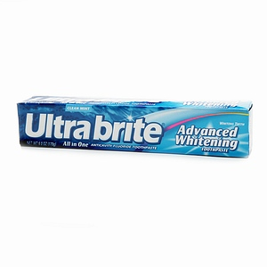
Core Product – Ultrabrite Toothpaste

- Understanding the terms
  - Product Line
    - A group of closely related products that ______________
      - a class of needs,
      - are used together,
      - are sold to the same customer group,
      - are distributed through the same type of outlets,
      - or fall within a given price
    - EXAMPLE: Product Lines at Church & Dwight Co. Inc.
      - Consumer Product Lines:
        - Household Deodorizers
        - Household Cleaners
        - Oral Care Products
        - Laundry Products
        - Pet Care Products
        - Personal Care Products
        - Arm & Hammer Baking Soda
        - Deodorant & Anti-Perspirants
  - Product Mix
    - The number of product lines offered by a company.
  - Width of Product Mix
    - The number of product lines carried (Church & Dwight is broad; Spyder Paintball is narrower)
  - Depth of Product Mix
    - Average Number of Products in each line
  - Consistency of Product Mix
    - How similar are our product lines?
    - PRODUCT MIX EXAMPLE:

Hair Care | Salty Snacks | Dental Care | Soft Drinks
Shampoo | Chips | Toothbrush | Colas
Conditioner | Nuts | Toothpaste | Ginger Ale
Hair Spray | Crackers | Dental Floss | Root Beer
Comb

- Classifying Products
  - Consumer Goods
    - products purchased by the ultimate consumer.
    - Based on Durability/Tangibility Classification (goods-services continuum)

    - Based on CONSUMER’S Interest
Willingness to Expend Effort for the Product
LOW
HIGH

    - CONVENIENCE PRODUCTS
      - Characteristics:
        - Relatively Inexpensive
        - Purchase is regular and recurring
        - Little Thinking Involved
        - Minimal Shopping Effort
        - Bought a most convenient location
        - “Staple” products, like groceries, and
        - Impulse purchases (candy bar?)
      - STRATEGY:
        - Make available in every possible place
        - Must be visible inside the store
        - Distribution is a major marketing mix factor
        - Easy substitution by similar brands (consumer will accept another brand)
        - Extensive advertising is used
    - Shopping Products
      - CHARACTERISTICS:
        - Product comparisons occur
        - Consumer seek information
        - Decisions are based on thought
        - Relatively higher prices
        - Often technology or fashion oriented
        - Monetary & social risks
        - Brand loyalty may be found
      - STRATEGY:
        - Selective distribution
        - Consumers will seek products in less visible locations
        - Product attributes and Quality are important
        - Product differentiation is possible
    - Specialty Products
      - CHARACTERISTICS:
        - Substitutes are not accepted
        - Infrequently purchased
        - Extensive Search
        - Brand loyalty may be strong
        - Loyalty to retailer may be as important as brand selection
        - May travel great distances to acquire
      - STRATEGY:
        - Limited distribution
        - Consumers will seek products regardless of location
        - Extensive product and price differentiation
        - Strong brand image
    - Unsought Products
      - CHARACTERISTICS:
        - Consumer does not know about or does not want the product (initially)
        - Interest is likely caused by a “sudden or unexpected problem” (rain = umbrella; death = funeral plot)
        - The consumer is not likely to be loyal and will accept substitutes
      - STRATEGY:
        - Limited distribution
        - Need to advertise so consumers are aware when the need arises
        - May require persistent and aggressive advertising and selling approach
Example: Fortune Brands Segmented based on Consumer Markets

  - _______________________________
    - Products that assist directly or indirectly in providing products for resale. Also called B2B goods, industrial goods, or organizational goods.
      - Manufactured materials and component parts: (electrical resistors, screws, electric motors, computer chips, spark plug)
      - Process materials (raw materials): used in production, become part of finished product (chemicals, wood, wheat, cotton)
      - Installations: primary production equipment and major capital items (buildings, computer hardware, assembly lines, oil drilling rig)
      - Accessory equipment: (Copiers, office equipment, cell phone, hand tools)
      - Maintenance, Repair, and Operating Supplies: facilitate routine operations (writing paper, staples, tape, Post-it notes)
      - Services: intangible product provided by others to facilitate the firm’s production and operation (maintenance, repairs, trucking, security service, legal advice, consulting)
- Product Development
  - The development of _______________________
  - The continuous improvement of ___________________________
  - WHY bother?
    - Any company that does not innovate will eventually be crushed by competition or abandoned by its consumers
    - “____________________________________________________!”
    - EXAMPLE: Innovation at two very different companies
      - GOOGLE
        - Ideas come from everyone in the company – even the finance team.
        - Open information on every project – every idea, every deadline.
        - Favor intelligence over experience.
        - Employees get a free day each week to innovate – 50 percent of new products come from this time.
        - Don't politic for your idea, use data – eliminate ‘I like' for real data.
        - Give people a vision, rules how to get there and deadlines – creativity loves constraints.
        - Simple to use and easy to love – the money will follow this.
      - Whirlpool
        - Stick with it – it can take up to six years to attain a big payback.
        - Innovation alone is not enough – need operational excellence as well.
        - Be highly practical – inventions have to be something someone will buy.
        - At Whirlpool, sales from new product ideas less than 5 years old were less than $30 million; today they are more than $1.2 billion!!
- Differing Perspectives of New Products
  - Newness Compared with Existing Products – “_______________________________________”
  - Newness in Legal Terms—for ____________________________ ________after “regular distribution”
  - Management perspective:
    - New-to-the-world products (true innovation)
      - High Risk
    - Product category extensions
      - Diversification into an established market for an existing product--BUT, ____________________________________ _______________________________________
    - Product line extensions
      - Additions to _________________________
  - Consumer Perspective:
    - ______________________ innovations
      - Variations of existing products
      - No behavior changes or new learning
    - ___________________ innovations
      - Improvement of existing products
      - Minor behavior changes, some new learning
    - _____________________ innovations
      - New function
      - Major behavior changes and education needed

- What it takes to launch ONE commercially successful new product
One Successful New Product
Cumulative Time (percent)
100
100

- Characteristics of Success for a New Product
Screening
Business Analysis
Development
Testing
Commercialization
Number of New Ideas
5
10
15
20
55
60
0
0
10
20
30
40
50
60
70
80
90
Adapted from Booze, Allen, and Hamilton 1965
Cumulative Time (percent)
  - _______________________________
    - An enhanced bundle of benefits
  - __________________________
    - Similar usage or consumption, patterns, and values
  - _______________________
    - Opportunity for buyer testing through sampling or divisibility
  - ________________________
    - Buyers see the newness
  - ____________________________________
    - Complexity is a disadvantage which slows diffusion
  - A good marketing mix, well executed

- Stages in the New-Product Development Process

Salespeople
Dealers
Customers
Engineers
R&D
Competitors
Trade Shows
Ad agencies
Market Research
U.S. Dept of
Commerce
Patent Office
Licenses
Private Labs
Independent
Inventors
University Labs
Stage 1

Search for
New Product
Ideas
(idea generation)

To Stage 2

Video: Fred Hunt on a New Product Idea for at Sherman-Williams
  - Marketing is very much focused on the ______________________
  - At Sherwin-Willams we ___________________________________
  - How the conversation resulted in _____________________________
  - We know that our “do-it-yourself consumer is mostly _________________
  - She knows what she wants and she makes _____________________________
  - She was doing the actual ___________________________________________
  - BUT, she has a few things that she was __________________________________
  - SO, we did some ___________________________________ to watch what she was doing when she got the product home.
  - We found that she had problems with (a) ________________________________ (b) _________________________________ and (c) _______________________
  - We thought about the innovative idea of making the process ___________________.
  - From this came the _________________________________ paint can.
  - It has a Wide handle, a Twist Off Top, and a Spout!!
  - A Classic Story of
INTERNAL

- Initial Evaluation of Market Potential
- Initial Evaluation of Market Potential
- Check product fit in company mission and competencies
- Consider Effects on other products
INTERNAL

- Raw materials supply
- Patent position

EXTERNAL
- Concept Tests

Screening and Evaluation

Stage 2
To Stage 3
INTERNAL

- Check against customer needs
- Establish target market
- Check competition’s position
- Develop target position

- Develop initial product specifications
- Perform economic analysis
- Revise and refine as needed

Business Analysis

Stage 3
To Stage 4

Supply chain process
Manufacturing process
Manufacturing Control system process
Marketing programs

Update costs and financial plans
Ensure target costs are met

Development

Stage 4

To Stage 5

Create Prototype
Lab Testing
Customer Use Tests
Customer reaction to planned marketing mix

Feedback and Revision
Re-test by customers
Re-evaluation against competition

Development
&
Testing

Stage 5
To Stage 6a
Test Market
To Stage 6
Commercialization

Test promotion methods
Check repurchase rate
Test media mix
Measure Trade Acceptance
Test prices

Build product inventories
Develop additional distribution channels
Revise as needed
OR
Simulated Test Marketing

Market
Testing

Stage 6z
To Stage 6

Ramp up Production
Ramp up purchasing
Activate Quality focused control systems

Mass training of sales or service personnel
Dealer meetings
Trade and customer ads
Press conference

Launch
(Commercial-iziation)

Stage 6
To Stage 7

Analyze sales data
Analyze profits
Revise promotion mix

Adjust product specs
Reallocate sales force
Phase out weak items

Evaluation

Stage 7
Continuous Improvement

- Why New Products Fail
  - No Competitive ___________________
  - ________________________ Reaction
  - Badly ________________
  - Poor Quality
  - Does Not Deliver Promised ___________________
  - Too Little Marketing Support (SYNERGY!)
  - Low Perceived _____________________
  - Bad Estimates of Market Potential (or other marketing research errors)
    - --Forecasts are dangerous, especially those about the future!!!
  - Poor estimates of Production &/or Marketing Costs
  - Poor Selection of Marketing Channels
  - Rapid Change in the Marketing Environment
- ..so Research, Research, RESEARCH!!
- Thinking about research and sample size…
  - http://www.robertniles.com/stats/sample.shtml

Chapter 11 -- Managing Products and Brands

- Introduction – Starbucks
  - The Early Years
  - Growth
  - Managing the product and brand extensions.
  - Logos
  - Starbucks Competition

- The POINT:

- Product Life Cycle
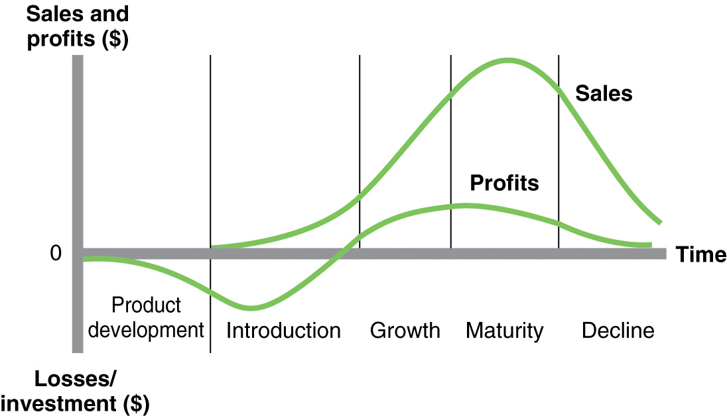
  - The PLC shows the ___________________________ over an extended period of time for all brands comprising a generic product category.
  - PLC and profit curves varies from product category to another, but above is the __________________________ that we often see.
  - Note the ________________ profits. Sales are needed to offset product development costs
  - As we move through the PLC, we must increase advertising and selling efforts and cut prices in face of __________________________.
  - Deciding when to enter a market can IMPACT __________________.

- PLC Characteristics and Implications

  - Characteristics Introduction Growth
  - Customers Innovators To the masses
  - Competition Little Increasing
  - Sales Low Rapid Growth
  - Profits None Strong & then peak

  - Marketing Implications
  - Overall Strategy Market
Development Penetration
  - Costs High per unit Declining
  - Product Strategy Undifferentiated Improved features
  - Pricing Strategy High Lower over time
  - Distribution Strategy Scattered Intensive
  - Promotional Strategy Awareness Brand Preference

  - Characteristics Maturity Decline
  - Customers Mass market Loyal Customers
  - Competition Intense Decreasing
  - Sales Slow Declining
  - Profits Declining Low/none

  - Marketing Implications
Overall Strategy Defensive Efficient or exit
  - Costs Stable Low
  - Product Strategy Differentiated Pruned line
  - Pricing Strategy Lowest Increasing
  - Distribution Strategy Intensive Selective
  - Promotional Strategy Brand Loyalty Reinforcement

  - WHY do brands decline?

    - Better or ______________________________________
    - The need ______________________________________
    - Most competitors abandon the market, BUT
    - Some can develop small successful niche businesses.

- Length of Product Life-Cycle
  - The PLC diagram suggests that stages are of _____________ length (this may not be accurate)…certainly ______________________________
    - Examples

  - Extended introduction stage
  - Fad
  - Indefinite Maturity stage

  - The Product Life Cycle is getting shorter for most products due to:
    - ________________ (“me-too”)
    - Technology advances
  - The Product Life Cycle can be affected by
    - The Product Category and __________________
      - Example

    - Differences in _________________________________________
      - Example
- Product Life-Cycle Management
Successful marketers need to do well at:
  - ________________________the PLC for their product, and
  - Recognize what stage they are in and ________________________ to it.
    - ISSUES: When to enter?
  - Entry Strategies
    - When is there a Pioneering Advantage?
    - An imitation strategy may be better!
  - Managing on the Rise

  - Managing During Maturity

  - Surviving the Decline

      - During the decline stage firms may:
        - Ensure that marketing and production programs are _____________________ as possible,
        - Prune _____________________ sizes and models which decreases sales but increases profits,
        - Run out the product to squeeze out final profits, or
        - _________________________ (best and toughest route)
- Brands
  - The word “brand” is comprehensive
  - Brands are used both to _________________ the seller and to __________________ the product from competition.
  - Brand Name --Words, letters, numbers that can be vocalized
    - Examples
  - Brand Mark – Symbol, design, color, lettering
    - Examples

  - Trade Mark – The Legal Protection of a brand
Companies Protect their Brands
    - Example
  - Leading Brands
    - Examples
--Why Brand?
  - Reason for Branding from the consumer perspective
    - Brands make it easy to ___________ goods or service
    - Brands help assure consumers of __________________.
    - Brand make shopping ____________________________.
  - Reason for Branding from the marketer’s (seller’s) perspective
    - Brands provide a ________________ for promotion.
    - Brands allow for recognition and ___________________
    - Brands help to reduce the importance of _________________
  - Are the benefits worth it??
      - Example
  - BusinessWeek’s -- Top Global Brands
(also see Best Global Brands Summit 2009 http://www.youtube.com/watch?v=8f2crqqTglI )

Business Week’s Top Global Brands 2009 | Top Global Brands 2010
1.Coca Cola | 1. Coca Cola
2.IBM | 2. IBM
3.Microsoft | 3. Microsoft
4.GE | 4. Google
5.Nokia | 5. GE

Top Global Brands 2011
1. Coca Cola
2. IBM
3. Microsoft
4. Google
5. GE

  - Reasons for NOT branding
    - Branding brings responsibilities that some companies do not want:
      - Expensive _____________________
      - Maintaining _______________________
      - The product ________________easily be physically differentiated
- Selecting a Brand Name
  - Good Brand name
    - Contributes to the product’s success
  - The Challenge

    - Many dictionaries only have 50,00 words
  - Solutions?
    - Combine _________________________________
    - Use ______________________________________________
  - A Good Brand name should suggest the _______________ or use of the product
      - Example:
    - Should be ____________ to pronounce, spell, and remember
      - Example:
    - Should be _________________
      - Example:
    - Should be adaptable to product line _________________
      - Example
    - Can be registered and legally protected
- Protecting a Brand Name
  - Product counterfeiting
    - Intellectual Property Theft costs companies ____________________ and costs 750,000 jobs in the U.S.
Examples:

    - Product Counterfeit Example:

  - Generic Use of the name
    - Becoming generic
Examples

      - No simple __________________________________, and

    - Protect by:
      - Indicate _________________________
      - Use brand with ________________________, and
      - ___________________________
  - Online Brand Monitoring

    - Warning signs of Brand Counterfeiting behavior:
      - _______________below acceptable levels
      - Lack of good contact information
      - ______________ service and warranty information
      - Inaccurate product descriptions
      - Products sold on sites not registered to the seller
      - Sites with unsecured transactions

- Producer’s Branding Strategies
  - Producer’s Own Brand
    - Done by large, well financed, and well managed firms
Examples:
  - Branding of Fabricating Parts and Materials
    - The producer attempts to develop a market preference for its branded parts or materials
      - Works when the product is also a _____________________________ that is bought for replacement.
      - OR when the part is ______________________________
  - Producing for Middlemen (Private Label)
    - A widespread practice
    - The strategy is that the manufacturer’s brands will appeal to __________________________ while the Middlemen’s brands will appeal to ______________________________________
- Middlemen’s Branding Strategies
    - The middleman may choose to only carry only the _____________ Brands
      - Avoids the Branding Responsibilities
    - Carry BOTH the Producer and ___________________________ brands.
Example:
      - Can create store loyalty and better profits
      - _______________ say the plan to place more emphasis on private label brands.
    - Manufacturer Responses:
      - Cutting prices
      - Convincing consumers of their brand superiority
      - Pruning product lines
      - This sets up the “Battle of the Brands”
- Strategies Used by both Producers and Middlemen
  - Branding within a product mix
    - A _____________________________ for each product
    - ______________________________ The company name combined with a product .
  - Branding for Market Saturation

  - Co-branding
    - Two or more brand names on _______________________
    - Dangers
      - Overexposure
      - Risk to both brands if ___________________________
- Brand Equity
  - The value a brand adds to a product over __________________________________________________
    - Examples:
  - Brand Equity Benefits:
    - It provides a _______________________to buy
    - It is a ______________________ to competition
    - Facilitates international _______________________
    - Helps product survive a crises
  - Brand Equity does have limits
Example:
- Brand Licensing
  - Owner grants permission to other firm to use the brand name and brand mark on products
    - Benefits to owner
      - ___________________ and
      - Brand _____________________
    - Benefits to Licensee
      - Improved likelihood of new product success
      - Reduced marketing costs
- Packaging – CNBC “The Entrepreneurs” example
  - Jason Osborn and Jason Wright
    - “If the next guy can do it, I can do it better!”
  - The “back story”
  - The product needs a name
    - They came up with 20 or 25 names
    - They pick “FEED.”
      - It describes the product.
      - It is simple.
      - It stands out from the 1000’s of other products.
  - The beginnings of a new brand are born
  - The product gets “rave reviews.”
  - Now, growing their business involves several steps:
    - Writing a business plan,
    - Getting a loan,
    - Incorporating
    - AND
    - More sophisticated packaging
  - Now it is time to give the brand a STRONGER IDENTITY
    - You have 1 second to get the customer’s attention
    - You want your brand BIG and MEMORABLE.
    - Goal: To SIMPLIFY the packaging
  - Consult a “Branding and Identity Expert”
    - What is working and what is not?
    - Problems:
      - Hard to read
      - Busy
      - Image is vague
    - It IS legible
  - The NEW package:
    - Simple.
    - Keeps true to the product idea.
    - It showcases the product well.
  - NOMINATED FOR AN AWARD FOR THE PACKAGING!
  - And the WHOLE FOODS chain becomes interested!!

Chapter 12 -- Managing Services

Introduction

“Ruby Tuesday Blows up Wrong Restaurant”

The Point
In SERVICES marketing, the “casual dining segment” HAS become a “sea of sameness!”

The industry is not longer providing customers with “Value.”

- Services are a Major Factor in the U.S. economy in dollars and in jobs Over $5.5 Trillion and 116 million jobs!
See Figure 12-1 page 298.
- SERVICES Defined
  - Services are the intangible activities or benefits that an organization provides to consumers in exchange money or something else of value.
- Increase in Services Influenced by:
  - Organizations’ focus on productivity and profits

  - Consumers’ poverty of time
    - Personal Shoppers
    - Take out food
    - House and lawn care
- Affecting virtually all industries:
  - Location--ATMs, branch outlets, branch warehouses, JIT delivery
  - Longer Business Hours
  - Better trained sales and service people
  - One-stop shopping
  - Improved customer service systems (personal, phone, on-line)
  - More information available--before, during, and after the sale
  - ADDS VALUE beyond issues of price and product quality
- THE UNIQUENESS OF SERVICES
  - Four I’s of Services
    - _____________________
      - Services cannot be
      - SO it is harder to
      - Communications must make these
      - Setting Price can be hard
    - _______________________
      - Lack of standardization;
      - inconsistent delivery and quality depending
      - Minimize by employee selection, training, and
      - service performance standards.

    - ______________________
      - Simultaneous production and consumption means
        - consumers are a part of the service process;
        - We must manage the interaction for customer satisfaction;
        - educate consumers about the service process and their role in it.
    - ________________________
      - Services cannot be inventoried, so it is hard to balance capacity and demand;
      - cannot return service for credit or exchange;
      - need to manage demand in peak periods; use capacity in off-periods
      - Idle production capacity

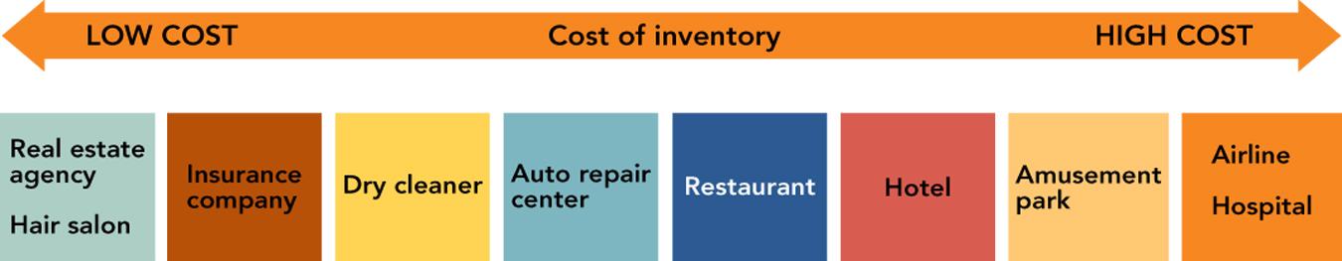
- Inventory carrying costs of services depend on the cost of employees and equipment

- Levels of Service
  - Core/Primary Services
    - The major activity of a business (or nonprofit organization).
      - Example: Investment Services provide the use of a brokerage account to buy and sell stocks

  - Ancillary Services
    - Expected or optional supplements to the primary purchase.

    - Ancillary Services expected in B2B marketing

- Service as Value
  - Consumers & Organizational Buyers want:
    - Quality products
    - Right price
    - Qualified Sales/Service personnel
    - Maximum benefits
    - Minimum effort
    - Low wait times
    - They demand _____________________!
      - Example: The Casual Dining Industry is NOT providing “value” any longer
        - Casual Dining restaurants provide full-service, alcoholic beverages, and CHECK AVERAGES from $10 to $23 per person.
        - COMPETITION from “fast-casual” chains are stealing customers
        - Fast-casual chains have no waiters and higher quality food than fast food chains.

- VALUE...
  - …an intangible concept often defined in terms of
    - exceptional _______________________________
    - exceptional ______________________________
    - value-based ________________________
      - Example: Some casual chains are returning to a value service proposition
        - MOST casual dining chains raise menu prices 1% to 3%every six months
          - To keep up with rising commodity and labor costs
        - SOME try temporary discounts
          - $9.99 dinner deals and $5.99 lunch specials
        - Others are making it a new marketing tactic
          - TGI Friday’s “Right Portion, Right Price” dinner menu with smaller entrees starting at $6.99
          - Cheesecake Factory rolled back cheese-cake prices to $1.50 and had LONG lines. They are now rolling out a “customer loyalty card” with incentives to return
- Competitive Positioning
  - Service Image is conveyed by the firm’s “service products.”
    - The dimensions used should be those valued by the customers.
      - Example: What DO consumers want in Casual Dining?
        - Stand for something UNIQUE
          - Cheesecake Factory

          - Outback

          - Olive Garden

        - Lower Prices
        - BETTER FOOD
          - Casual dining was initially successful because it provided better food quality than fast food, at a very reasonable price
          - Recently, fast food’s quality has gone UP with prices rising only slowly
          - BUT, casual dining’s price have risen while food quality and innovation has stagnated!
          - RUBY TUESDAY is upgrading its food, but it prices are still pretty high.
        - IMPROVED SERVICE
            - Slow service
            - Discourteous staff
            - Are NOT what consumers are looking for!!
              - Chili’s is trying to cut 15 minutes from its 45-minute lunch by testing BlackBerry’s that connect directly from the server to the kitchen.
              - Chili’s is also improving its employee hiring practices
              - And the staff is wearing more professional looking aprons
        - Better looking stores
            - Most stores are 20-years old!
              - Ruby Tuesday has redesigned all of its company-owned stores with contemporary designs and lighter colors.
              - Lone Star is replacing concrete floor with wood and is installing oak tables.
            - Get kid-friendly
              - Families are a big part of the casual dining industry’s market
              - Could restaurants have kid playgrounds? Loaner hand held video games?

- Service Leadership or Follow the Leader?
  - Will you set the service standard or wait for competitors to set the standard and then follow their lead?
    - Example:
- Benefits of Exceptional Customer Service
  - Exceptional Customer Service can _______________________ from Competitors
    - Services attract & keep customers
    - Services and recover lost sales
    - Service quality is related to customer satisfaction
    - Customer Service usually leads to a profitable ROI in the long term
- HOW CONSUMERS PURCHASE/EVALUATE SERVICES
  - The Purchase Process
    - ________________ Properties
      - What consumers can judge prior to the purchase
        - Price, location, appearance of physical facilities, paperwork, interactions with the service provider’s staff
    - __________________ Properties
      - Attributes discernable only during or after the service experience
        - Physical comfort; staff concern
    - _________________ Properties
      - Attributes inferred from a subjective evaluation of the entire process.
- Consumers use search, experience, and credence properties to evaluate services (Figure 12-5)
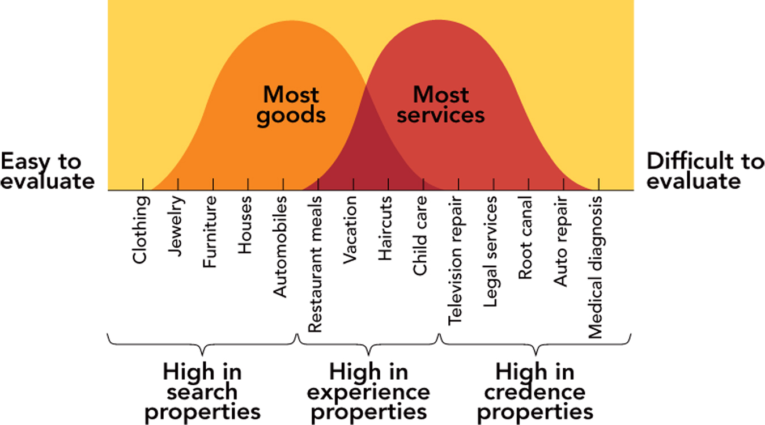

- The Service Design Process
  - Customer Targets
    - What do they want?
  - Nature of the Service
    - Complex (medicine, investments) = substantial support services and highly qualified customer contact people
  - Pricing?
    - Who is the target?
      - How much and how often do they buy?
    - What is the type of service?
    - Can a fee be “justified?”
  - Pricing--Costs
    - Wages
    - Physical facilities
    - Technology & Equipment
    - Honoring warranties and guarantees
  - Degree of Complexity/Uncertainty
    - When complex, customers may need extensive sales assistance, demonstrations, service guarantees, after sale assistance, pre-purchase information
  - Marketer’s Resources
    - Smaller marketers may need to outsource some customer services to save costs (pros and cons to this).
    - When to use customer service outsourcing (http://www.buyerzone.com/marketing/call_center/tmm-customer-service-outsourcing.html)
      - Significant growth
      - Save money
      - Testing and learning
      - Variable volume
      - Business model shifts
  - Number of Services
    - Focus on services which make a difference in consumers’ purchase decisions
    - Remember, customers may be willing to pay some or all of the cost of desired services
  - Level of Service
    - Full service to self-serve?
      - What does your market/target customer call for?
      - What can you support?
- Service Delivery
  - Top-management commitment
  - Treat EMPLOYEES as Internal Customers
  - View Service as a “Performance”
  - Ensure Service Recovery
    - When errors occur---fix ‘em!
- Successful Service Recovery
  - Know the costs of losing a customer
    - For every customer who bothers to complain, there are
    - The average “wronged” customer will tell
    - 91% of unhappy customers will never purchase services from you again.
    - It costs about __________________________ as much to attract a new customer as it costs to keep an old one.
    - Each one of your customers has a circle of influence of 250 people or potential customers who hear bad things about you!
      - Example: Two Outback Steakhouse EX-customers have not been back since a server and a manager argued with them very publically about how a steak was cooked!!
  - Listen to the customer--get them to talk
  - Anticipate potential failures
  - Act fast
  - Train employees
  - Empower the front line
  - Close the Loop--get back to the customer
Video: Chef Ramsey’s Cardinal Rule
- Chef Ramsey helps a restaurant by revamping the menu and the layout.
- The owners book TWO seatings for mother’s day.
  - A table of 19, 15, 14 all coming at the same time!
  - The Kitchen is overwhelmed!
- The owner’s must learn a “______________________________:”
- Put the ________________________________, make them feel really special, and build a sense of _________________________!
- These customers have waited 1.5 hours!
- Remember, “Unhappy customers ________________________________!!”
- An excellent lesson whether selling a Service OR a product!!

