LECTURE OUTLINE FOR

MKTG 25010

Principles of Marketing

Lecture Packet

Part 1 (of 2)

2014 SPRING

DR. LAWRENCE MARKS
OFFICE -- 516 BSA (College of Business)
Office Phone -- 330-672-1266
lmarks@kent.edu
Course website on Blackboard Learn (http://learn.kent.edu)

1/3/2014
Class Schedule – 2014 SPRING
MKTG 25010 Sections 001 & 002 (CRN: 15166 & 15167)
Meeting 3:45 to 5:00 p.m. Monday and Wednesday in 133 Bowman Hall

Week | Date | Topic | Readings  NOTE: This schedule is tentative and will need to adjust to what we actually cover in class each week.
Week 1 | Monday 1/13 | Lecture 1 – Introduction and Customer Value & Marketing | Chapter 1
 | Wed 1/15 | Lecture 2
Week 2 | Monday 1/20 | MLK Day – no classes, offices closed
 | Wed 1/22 | Lecture 3 – Marketing/Organizational Strategies | Chapter 2  Add/drop ends Jan. 26
Week 3 | Monday 1/27 | Lecture 4 – The Marketing Environment | Chapter 3
 | Wed 1/29 | Lecture 5 – Ethical and Social Responsibility | Chapter 4
Week 4 | Monday 2/3 | Lecture 6 – Consumer Behavior 1 | Chapter 5
 | Wed 2/5 | Lecture 7 – Consumer Behavior 2 | Chapter 5
Week 5 | Monday 2/10 | Lecture 8 – Organizational Buying | Chapter 6
 | Wed 2/12 | Lecture 9 – Global Consumers & Markets | Chapter 7
Week 6 | Monday 2/17 | Lecture 10 – Marketing Research | Chapter 8
 | Wed 2/19 | Lecture 11 – Market Segmentation (STP) | Chapter 9
Week 7 | Monday 2/24 | Lecture 12 – New Products & Services | Chapter 10
 | Wed 2/26 | Lecture 13 – Managing Products and Brand  [END OF MATERIAL FOR MIDTERM] | Chapter 11
Week 8 | Monday 3/3 | Lecture 14 – Services Marketing | Chapter 12
 | Wed 3/5 | Lecture 15 – Building the Price Foundation | Chapter 13
Week 9 | Monday 3/10 | Lecture 16 –
 | Wed 3/12 | Lecture 17 – Arriving at the Final Price | Chapter 14
Week 10 | Monday 3/17 | Lecture 18 – Managing Marketing Channels and Supply Chains | Chapter 15
 | Wed 3/19 | Lecture 19 – Retailing & Wholesaling | Chapter 16  Course withdrawal deadline is March 23; a “W”  grade is assigned
 |  | Happy Spring Recess March 24 – March 30 | NO CLASSES
Week 11 | Monday 3/31 | Lecture 20 –
 | Wed 4/2 | Lecture 21 – Integrated Marketing &DM | Chapter 17
Week 12 | Monday 4/7 | Lecture 22—
 | Wed 4/9 | Lecture 23 – Advertising, Sales Promo, & PR | Chapter 18
Week 13 | Monday 4/14 | Lecture 24--
 | Wed 4/16 | Lecture 25 – Using Social Media | Chapter 19
Week 14 | Monday 4/21 | Lecture 26 –
 | Wed 4/23 | Lecture 27- Personal Selling & Sales Management | Chapter 20
Week 15 | Monday 12/2 | Lecture 28 –
 | Wed 12/4 | Lecture 29 –
Finals Week | Sunday 5/4 to Friday 5/9 at 5 pm | Take the exam in the College computer labs or other approved testing center. Bring your KSU ID, text book, and lecture notes with you. | Final Exam  All Textbook & Lecture Content after the Midterm  (except for Marketing in the News)

For the midterm and the final exam, you can use a hard copy of the textbook, a hard copy of the lecture notes, and a calculator for the final. International students can make use of a standard hard copy translation dictionary. You cannot use any other electronic devices (not your computer, or your cell phone, or an electronic translation device). You cannot have any windows open on your computer other than the final exam window. You cannot have or use mini-test questions and answers during the tests.
Preliminary Mini-test Schedule
Available from http://learn.kent.edu

Mini Test | Opens not later than 5 p.m. | CLOSES at  11 p.m. | ¹Covers Lectures:
1 | Saturday 1/25 | Sunday 2/2* | 1, 2, 3,
2 | Saturday 2/1 | Sunday 2/9 | 4, 5
3 | Saturday 2/8 | Sunday 2/16 | 6, 7
4 | Saturday 2/15 | Sunday 2/23 | 8, 9
5 | Saturday 2/22 | Sunday 3/2 | 10 11
6 | Saturday 3/1 | Sunday 3/9 | 12, 13
Midterm | Sunday 3/3 | Sunday 3/9 | Lectures 1-13 & associated text material
7 | Saturday 3/8 | Sunday 3/16 | 14, 15
8 | Saturday 3/15 | Monday 3/31 | 16,17
9 | Saturday 3/22 | Sunday 4/6 | 18,19
10 | Saturday 4/5 | Sunday 4/13 | 20, 21
11 | Saturday 4/12 | Sunday 4/20 | 22, 23
12 | Saturday 4/19 | Sunday 4/27 | 24, 25
13 | Saturday 4/26 | Sunday 5/4 | 26, 27
14 Review only | Saturday 5/3 | Friday 5/9 | 28,29
Final Exam | Sunday May 4 | Friday May 9 at noon | Lectures 14-27& associated text material
¹Please note that this refers to the LECTURES covered by the exams (Not the chapters). The Class Schedule shows the CHAPTERS which are targeted for each lecture (subject to modification as needed).
Mini tests are normally available the Saturday after the material is covered in class (by 5 p.m.) for a minimum of eight days. The deadline is listed in the description for each mini-test. Should a change in this preliminary schedule be necessary there will be an announcement on the class website and the revised deadline will be included in the test description.
*No mini tests will expire until after the 2nd week drop/add deadline listed above. This allows students who add the class “late” an opportunity to catch up (and gives students who are having problems accessing the tests time to work out the bugs).

ACKNOWLEDGEMENTS: The concept for the way in which this course is offered, the approach to testing, and portions of the syllabus are based on the Principles of Marketing class offered by Dr. Bruce Robertson, San Francisco State University (http://online.sfsu.edu/~robertbc/). Many thanks to Dr. Robertson for pioneering this method of delivery.
Preliminary Enhanced Learning Extra Credit (ELEC) Schedule

ELEC | Opens not later than 5 p.m. | CLOSES at  11 p.m. | Opens in:
1 | Thursday 2/6 | Wednesday 2/12 | Week 4
2 | Thursday 2/13 | Wednesday 2/19 | Week 5
3 | Thursday 2/20 | Wednesday 2/16 | Week 6
4 | Thursday 2/27 | Wednesday 3/5 | Week 7
5 | Thursday 3/6 | Wednesday 3/12 | Week 8
6 | Thursday 3/13 | Wednesday 3/19 | Week 9
7 | Thursday 3/20 | Wednesday 4/2 | Week 10
8 | Thursday 4/3 | Wednesday 4/9 | Week 11
9 | Thursday 4/10 | Wednesday 4/16 | Week 12
10 | Thursday 4/17 | Wednesday 4/23 | Week 13
- Three attempts for each ELEC. Each is worth up to .3% added to your final course grade.
- Unlike the mini-tests, for the ELEC’s I will record your best ELEC grade (for the mini-tests, I record the grade on you LAST attempt).
- You can earn partial credit for less than 100% on the assignment.
  - If you earn an 80% on your best attempt, you get .8 x .3 or .24% added to your Final Course Grade
- Earning a 100% on one ELEC will add .3% TO YOUR FINAL GRADE.
- So, for the 10 assignments you can earn up to a total of a 3% INCREASE in your course grade!!

These are available from the class website Extra Credit Folder on Blackboard Learn (http://learn.kent.edu).

Introduction to Marketing 25010

- Initial Background information: This is based on the syllabus, available from the class web site on Blackboard Learn. You should print and read that document.

  - The Professor and his contact information:

Name: Dr. Lawrence J. Marks
E-mail: lmarks@kent.edu
Office:
Phone: 330-672-1266
Office Hours:

Instructor’s personal website: http://www.personal.kent.edu/~lmarks

  - Required Text: The required text for the class is Marketing, 11th edition, Roger A. Kerin, Steven W. Hartley, and William Rudelius, McGraw-Hill 2011. It is available packaged with ConnectPlus access at no additional charge in a special Kent State loose leaf edition (ISBN: 1259152456). The “standard” edition’s ISBN is 0078028892.

  - McGraw-Hill ConnectPlus is a web-based assignment and assessment site that we will use for Enhanced Learning Extra Credit Assignments (ELECs). THIS IS INCLUDED WITH THE KSU EDITION OF THE REQUIRED TEXTBOOK.

  - Cost/Purchase:

  - Printed Lecture Notes
    - Why?
    - Where they are available:

- The Prerequisite for this class is: __________________________________

- Course Objectives

  - A working knowledge of marketing terminology, concepts, activities, and strategies;
  - An understanding of marketing functions within the organization and in the context of external environments;
  - Knowledge of the ways in which marketing contributes to attainment of the organization’s objectives and goals;
  - Developed quantitative and qualitative analytical skills to apply marketing concepts, theories, and tools to solve marketing problems;
  - An appreciation for the global and ethical aspects of marketing.

- Policies

A. Students attending the course who do not have the proper prerequisite risk being deregistered from the class.

B. Students have responsibility to ensure they are properly enrolled in classes. You are advised to review your official class schedule (using Student Tools on FlashLine) during the first two weeks of the semester to ensure you are properly enrolled in this class and section. Should you find an error in your class schedule, you have until Sunday, January 26, 2014 to correct the error. If registration errors are not corrected by this date and you continue to attend and participate in classes for which you are not officially enrolled, you are advised now that you will not receive a grade at the conclusion of the semester for any class in which you are not properly registered.

C. Academic Honesty: Cheating means to misrepresent the source, nature, or other conditions of your academic work (e.g., tests, papers, projects, assignments) so as to get undeserved credit. The use of the intellectual property of others without giving them appropriate credit is a serious academic offense. It is the University's policy that cheating or plagiarism result in receiving a failing grade (0 points) for the work or course. Repeat offenses may result in dismissal from the University.
For an excellent review of the topic, browse http://ec.hku.hk/plagiarism/introduction.htm. For a PowerPoint presentation that reviews the topic of cheating and plagiarism (and which reflects my views), browse http://www.personal.kent.edu/~lmarks/ethics/Plagiarism.ppt.
NOTE: The questions for the mini tests are copyrighted and unauthorized reproduction is prohibited. You CANNOT have these at the tests.
D. Course Withdrawal Deadline: For Spring 2014, the course withdrawal deadline is Sunday, March 23, 2014. If you need advising assistance, you will need to contact an advisor before Friday, March 21, as our advising offices are not open on the weekend.
E. Students with disabilities: University policy 3 -01.3 requires that students with disabilities be provided reasonable accommodations to ensure their equal access to course content. If you have a documented disability and require accommodations, please contact the instructor at the beginning of the semester to make arrangements for necessary classroom adjustments. Please note, you must first verify your eligibility for these through Student Accessibility Services (contact 330-672-3391 or visit http://www.kent.edu/sas for more information on registration procedures). INTERNATIONAL students for whom English is a second language, send me an email. Once I verify that, I will give you access to the Extended Time mini-tests, midterm and final.

F. Application for Graduation
It is your responsibility to apply for graduation before the set deadline. If you apply after the deadline you will be assessed a $200 late fee. Please see your academic advisor as soon as possible if you are uncertain as to your progress toward graduation. The graduation application deadlines are follows:

Graduation Application Deadlines:
May Graduation: Apply before September 15th
August Graduation: Apply before December 15th
December Graduation: Apply before March 15th

To apply for graduation complete the following steps:
- Log onto your Flashline account
- Click on the Student Tools tab
- Look in the Graduation Planning Tool Box
- Click on Application for Graduation
If an error message appears, you must contact your advisor.

- Content Delivery
  - This is NOT an “independent learning” class. Content is delivered both_____________________________________
  - Testing during the semester:
  - Midterm and Final Exam: In-class students
Web-based students

- Class Website (http://learn.kent.edu)

  - Important Items to Check Regularly
    - Course Information
    - Syllabus
    - Lecture Notes and Online Lectures and Housekeeping Slides
    - E-mail
    - Testing Folders for Mini-tests
    - Review Tests
    - Extra Credit
    - Discussion Forums
      - Marketing 25010 Tech Talk
      - Mini-test Issues
      - Extra Credit and CONNECT ELEC Issues
      - Textbook Issues
      - Marketing In Action
- Grades
The Course Grade is based on
  - 13 “mini” exams ( ________ % of your final grade), and
  - a midterm exam worth ____________% of your final grade, and
  - a final examination worth _______ % of your final grade.
  - PLUS any __________________
Letter grades
Course Avg. | Course  Grade | Univ.  GPA | Course Avg. | Course  Grade | Univ.  GPA
92.6+% | A | 4.0 | 76.6-79.5% | C+ | 2.3
89.6-92.5% | A- | 3.7 | 72.6-76.5% | C | 2.0
86.6-89.5% | B+ | 3.3 | 69.6-72.5% | C- | 1.7
82.6-86.5% | B | 3.0 | 66.6-69.5% | D+ | 1.3
79.6-82.5% | B- | 2.7 | 59.6-66.5% | D | 1.0
 |  |  | 59.5 and below | F | 0.0

Students who want to become Marketing Majors must earn a “C” (2.0) or better in this course. A “C-“ (1.7) does not meet this College of Business requirement.

The class DOES use the plus/minus grading system.

IMPORTANT NOTE: Once the grades are in, students get what they have earned. I do not make adjustments for (a) you really, really needing a better grade, (b) your being “only” .3, .2, or .1 away from the next grade, or for (c) any reason other than an error in the calculation. Asking, pleading, crying, and/or offering bribes DO NOT WORK (sorry).

- Calculating your final grade

It is fairly common for students to incorrectly calculate their final grade. The correct calculation is:

[(Total of all Mini test scores/13) x .5] + (Midterm score x .2) + (Final exam score x .3) + extra credit = Final Course Grade

Note: Adding your total points up and dividing by 15 is NOT the correct calculation.

For example, suppose you have an average of 85% on the 13 mini-tests, a 70% on the midterm, a 78% on the final exam, and you earned 2.5% in extra credit work.

The grade calculation is: (.85 x .5) + (.70x.2) + (.78 x .3) + 2.5 = .425 +.14 + .234 + .025 = .824 or 82.4% which would be a “B-“ for the course. Needless to say, had you done more extra credit your final course grade would have been higher (for example, adding .5 in extra credit would have earned you an 82.9% or a “B” for the course).

You can download a Grade Calculator from: http://www.personal.kent.edu/~lmarks/MKTG25010/gradecalculator.xls This is a spreadsheet that will help you calculate how you are doing (also available from Blackboard Learn as a click in the Testing Folder).

IMPORTANT NOTES about course grades.

- YOU need to watch for deadlines for mini-tests and extra credit assignments. Once an assignment closes, it is very rare for it to be re-opened. If you have a question about an assignment/mini-test ask about it BEFORE the deadline. This means YOU need to check on your grades and be aware of the deadlines. Once we get to finals week, all mini-tests and extra credit opportunities will have been closed. Do them before their weekly deadlines. DO NOT FORGET TO TAKE THE MINI-TESTS.

- Once the final is taken, your Final Course Grade is calculated using the above formula (.5 x average of 13 mini-tests + .2 x midterm + .3 x final exam + extra credit).

- THERE ARE NO CHANGES to final course grades made for “being close” to the next higher grade, nor for “only being .1 away” from the next higher grade, nor for “really, really needing” the next higher grade. Students receive the grade that they have earned.
The only possible adjustment to a final course grade occurs when a curve is needed (or if a posting error is made). IF, at the end of finals, there are not a reasonable number of A’s (or, if too many students are failing), it is possible that a curve will be created. In this case, a set number of points will be added to everyone’s final course grade. Should this occur, students will be informed via e-mail.
Did I mention that, when it comes to changing the grade which you have earned, asking, pleading, crying, and/or offering bribes DO NOT WORK?

- About the Mini Tests
  - Type of exam:
  - Source of questions:
  - Coverage:
_____% from Lecture Questions

And

______% from the Text Book

  - Number of mini-tests:
  - Available:
  - Number of Questions:
  - Time Limit:
  - Number of Attempts:
  - Which score COUNTS for your grade? The score from the last test taken is the one that counts for your grade.
  - First mini-test available until:
  - Make up policy:
  - Do not wait until
  - Do not forget to
  - There is a sample mini-test available now.

Is this guy for real??? Comments from others:
“Rate My Professors.com”
“Pick A Prof”

- Cautions and Warnings:

  - About the mini test scores
  - About convenience
  - About the work required
  - About the course grade
  - MORE about the work required
  - About getting behind

- Midterm Examination: The midterm examination is worth 20% of the course grade and it includes all material through Lecture 13 (mini-test 6). The midterm exam is 50 questions and is timed to last 80 minutes. The questions are randomly drawn from the same pool of questions used for the mini-tests.
It must be taken during the week of March 3, 2014.

The midterm exam is OPEN BOOK and OPEN NOTES and you can use a calculator (international students can use a standard, hard copy translation dictionary). You cannot use other electronic devices (no cell phones, no other computers, no electronic translators).

  - When and where it is taken
    - For in-class students, it MUST be taken in the College of Business computer labs during finals period, (or at an approved testing center) during Monday through Friday of finals week.
    - For web-based students, it MUST be taken using Proctor U.

- Final Exam
  - What it covers and what you can use:
The final exam is OPEN BOOK and OPEN NOTES and you can use a calculator (international students can use a standard, hard copy translation dictionary). You cannot use other electronic devices. (no cell phones, no other computers, no electronic translators).
    - This means you cannot make use of an “e-book” for the final.
    - If you have taken notes on your computer during the semester, you will need to print those out for the final (you cannot access your computer during the final).
    - You cannot have mini-test questions and answers in your possession (which is prohibited anyway).
    - For the final, you can use a standard calculator.

  - What it is:
  - When and where it is taken
- For in-class students, it MUST be taken in the College of Business computer labs during finals period, (or at an approved testing center) during Monday through Friday of finals week.
- For web-based students, it MUST be taken using Proctor U.
  - About your identification at the final
  - Make up policy:

- Who does better? In-class or web-based students?

- To Succeed in the class:
  - Mini tests:
  - Practice tests:
  - If you do this, by the time of the final:

- Classroom Policies
  - Attendance
  - Classroom Expectations
  - Participation
  - Distractions and Electronics – You cannot have cell phones out during class.
  - Harassment
  - Check the Blackboard Learn site multiple times during the week.
  - Ask questions when you don’t understand something
  - Be polite in class and on-line
  - International Students for whom English is a second language, contact me for extra time on the test (Blackboard Learn email or lmarks@kent.edu)
  - If there is a University Closing:

- Communications Policy
  - How to communicate “officially”: Blackboard Learn e-mail or to lmarks@kent.edu

An IMPORTANT NOTE: BEGIN YOUR SUBJECT WITH “MKTG 25010”, then include the SUBJECT of your message (e.g., MKTG 25010 – Question about Mini-test 1).

  - About phone messages

- Extra Credit Opportunities
  - CONNECT Enhanced Learning Extra Credit (ELECs) -- Follow instructions in Extra Credit Folder on Blackboard website.

  - Research as Extra Credit

- The Class Schedule, the Mini Test Schedule, and the ELEC schedule are in the class syllabus available on Blackboard Learn and were at the front of this packet.

- Our Guest Faculty
  - Who: KSU alumni and
  - To show where:
  - And to provide you with “ “

- Guest Faculty -- Their names, titles, and organizations

 | NAME | Title | “Type of Organization”
1. | Valerie Thwing |  | Business to Business (B2B)—Service; Government
2. | Tim Apel |  | Family Entrepreneur--Product
3. | Don Kosec |  | Business to Business (B2B)--Service
4. | Rob Felber |  | Entrepreneur--Service
5. | Fred Hunt |  | Business to Business--Product
6. | Dan Muller |  | Business to Business—Industrial Product
7. | Michele Skinn |  | Not for Profit Foundation--Service
8. | Gary Trinetti |  | Entrepreneur—Product
9. | Jim Wise |  | Retail Franchise--Product
Chapter 1: Creating Customer Relationships and Value Through Marketing

- What IS Marketing?

- Marketing Defined
  - The American Marketing Association Definition:
“Marketing is the activity, set of institutions, and processes for creating, communicating, delivering, and exchanging offerings that have value for customers, clients, partners, and society at large.”

http://www.marketingpower.com/ResourceLibrary/MarketingNews/Pages/2008/42/1/MN11508Keefe.aspx?sq=definition+of+marketing

  - Some controversy about the definition:

http://www.btobonline.com/apps/pbcs.dll/article?AID=/20080211/FREE/482594234/1155/ISSUEBEYOND

Kosec…Importance of Marketing to Time Warner Business Services
- Collect_________________________________________________________
- Helps to________________________________________________________
- Use research and tools to__________________________________________
- Through ________________________________________________________

  - Marketing seeks to:
    - Discover ______________________________ of customers
    - Satisfy_________________________________________
    - At a ___________________________________________
    - Through an _____________________________________

  - It involves the idea of ____________________ which is the trade of things of value between buyer and seller so that each is better off after the trade.

- Factors Influencing Marketing

  - The Organization

    - Mission
      - Goals and Objectives
    - Management and people skills

    - Resources

  - Society
  - Environmental Factors
(See text, page 7, Figure 1-2, A marketing department relates to many people, organizations, and environmental forces)

  - Ways to Satisfy Needs (for example, a funny birthday card):

  - (The Point) Only the last describes ___________________________

- Requirements for Marketing to Occur
  - Two or more ________________ involved in a __________________, each with unsatisfied _________________

  - Each must have a ____________ and _____________ to engage in an exchange

  - They need to be able to ______________________

  - Each party must have something of____________________

- What DO people want?
To satisfy consumers’ needs, wants and desires (at a profit, through an integrated effort of the organization), we need to understand ______________

____________________________________________________.

  - BUT, _____________________________________________________ or
  - People may not ____________________________________________ or
  - People may not be able to ______________________________________

- Needs and Wants
  - Consumer NEEDS come from ___________________________

    - These are basic to life and society and include the need for food and shelter, the need to be safe, the need to belong and be loved, etc.

  - Consumer WANTS are ways to satisfy ______________that are shaped by ______________, _______________, and ________________.

- What is a Market?
  - The MARKET is the set of all _____________ and ____________ buyers of a product.

  - Implications of the definition (MAD)

- Marketing seeks to discover then satisfy consumer needs through research and a marketing program (see text, page 10, Figure 1-3 and below) Marketing seeks to discover then satisfy consumer needs through research and a marketing program.

Information
Organization’s marketing department
Discover
With the right combination of:
Potential ____________:____________
!!
Concepts for

- How Marketing Satisfies Consumer Needs, Wants, and Desires

  - We cannot be “all things to all people” so

- The Marketing Mix
  - The Marketing Mix represents the ____________ ___________have to satisfy consumers’ needs wants and desires.

  - This consists of the 4 P’s of the Marketing Mix

  - Most of a firm’s marketing efforts involve the ____________, _________________, and ________________ of the marketing mix.

- Important Factors in the Marketing Environment (CREST)

- Satisfaction through Value
  - ___________________ is unique combination of benefits received by targeted buyers that includes quality, convenience, on-time delivery, and both before-sale and after-sale service at a specific price.

Tim Apel – AAA Mobile Homes on “Creating Value”
  - Create Value through our __________________ and

  - To provide ________________ and _______________________
  - Consumers are getting ______________________________

  - Example of “Satisfaction through Value”: "Across many industries, we've seen that the retailers that grow _____________________ ratings the fastest have greater sales growth," says Chris Denove of J.D. Power and Associates. "Prices have come down dramatically on electronics items, and at the same time, the complexity of the products has increased. Expert advice is more important than ever.”
- Value Strategies

  - Best ________________
  - Best _________________
  - Best ________________
  - What is “BEST?” It depends on ___________ firm’s missions and objectives, ____________ competitive situation, _____________ environment, and ________________ customers!

EXAMPLE: Douglas Conant, Pres. & CEO Campbell’s Soup Co.
- Reversed a decline in ______________________
- Stressed products that rank No. 1 or No. 2 in the key categories of simple meals, baked snacks and veggie-based drinks
- Dropped ________________ brands, such as Godiva chocolates
- Focused on healthier for soups, V8 drinks and Pepperidge Farm snacks, and has pushed creating products that scream value, nutrition and convenience
- Says there are four "musts" for consumer products: (1) value, (2) wellness, (3) quality and (4) convenience

Fred Hunt…Delivering VALUE to the customer at Sherwin Williams
- For the marketer, Value IS “ ___________________________________ . “
- It is the way to _________________________________.
- PRODUCTS may be similar, but….the difference is in the “brand promise“
- ____________, _________________________, ___________________, _______________, “__________________________”
- Get it done ______________________!
- Deliver on ____________________________
- Relationship Marketing
  - Relationship marketing links the organization to its individual customers, employees, suppliers, and other partners for their mutual long-term benefits.

Creating Value for Customers (Rob Felber -- Felber & Felber Marketing Services)

- Be a _____________________________________________
- Be an ___________________________________________
- Be there when _______________________________________
- Provide a ___________________________________________ for them

- The Evolution of the Market Orientation – Marketing Management Philosophies

  - Production concept
    - Assumes consumers want products that are ______________________
_____________________________________________
    - Implies management should focus on improving ___________________ and ___________________________________________
    - Useful when:

  - Product Concept
    - Assumes consumers want products that offer the most ____________, __________________, and ______________________.
    - Implies the firm should make continuous _______________________.
    - Places the focus on the _________________, not on the _____________.
  - Selling Concept
    - Assumes consumers will not buy enough ________________________ unless there is a strong ____________________________ and _____________________________________.

    - Useful for

      - Industries with _______________ who must

  - The Marketing Concept

    - Assumes that achieving the organization’s goals depends on determining and satisfying ____________________ more ___________________ and ______________________ than competitiors.
    - An organization should seek to make a profit by serving the needs of ______________________________________,

The Marketing Concept in B2B markets

Muller..how we create value for our customers at Timken

      - Our Vision = Create _______________________________________
      - For example, helping the ___________________ to _________________ and increase their _______________
      - Using our equipment, technology, and knowledge…
      - BEYOND just __________________________________

d. The Marketing Concept (continued)
    - Three parts to the concept:
      - The satisfaction of consumers’ ___________________, ________________, and ____________________.

      - at a ____________________________

      - through an __________________________ within the firm.

MICHELLE SKINN – What is Marketing?

      - Understanding consumers’ ___________________ and the consumers’ _________________ are ____________
      - It is not about US or our direction, but about ________________________; who will use it, who will purchase it
      - How can you _________________________________________?

    - NOTES:

      - Firms must identify and satisfy ______________________________ AND continue to do so!
      - Competition FORCES sellers to focus on _______________________________________.
      - Consumers must be seen in the context of all __________________
_________________factors (managers must also have a “market orientation”).
  - The Societal Marketing Concept

    - Assumes that customer satisfaction should be delivered in a way that _____________________________________________________. (a customer’s wants/needs may be at odds with what is good for society)

    - Relates to the Ethics of doing business.

Patagonia Example: Build the best product, cause no unnecessary harm, use business to inspire and implement solutions to the environmental crisis. –Patagonia's Mission Statement

  - The Customer Relationship Era

    - _____________________ Orientation
    - _________________________________________ Management
    - _________________________ Experience

- Marketing and:
  - Synergy
    - Managers must create marketing tactics that __________________ ______________
    - They must _______________________ implementation.
  - Hypercompetition
    - Competitive Advantages do not _______________. Customer _____________________ and ________________ require innovation, cost advantages, and quality enhancements.
    - Changes create new ___________________________, with new ________________.
  - Cross Functional Decision Making Teams

- The Breadth and Depth of Marketing

  - Who Markets?
    - Manufactures
    - Retailers
    - Service Providers
    - Nonprofit Organizations
    - Government
    - And YOU!

  - What is Marketed?
    - Products
    - Services
    - Ideas
    - Places
    - People

VIDEO Commercial EXAMPLES – Who is Doing the Marketing? What is being Marketed?

  - Who Buys?
    - Organizations
    - Ultimate Consumers

  - Why buy? How consumers benefit:
Marketing creates UTILITY; Utility is the satisfaction, value, or usefulness a user receives from a good or a service.
    - __________________ – Ben & Jerry’s turns cream, sugar and milk into ice cream

    - ___________________ – An ice cream truck brings yummies to your neighborhood
    - ___________________ – Your Walmart Supercenter is open 24 hours a day, 365 days a year…you can get ice cream anytime you want it
    - __________________ -- Consumer value is created by allowing easy transferring of a product's ownership. Time payment, leasing, credit, and debit card purchase strategies can be important in making a product more attractive to a consumer.
(Additional Information)
- The role of the Chief Marketing Officer http://www.marketingprofs.com/8/for-whom-the-bell-tolls-the-cmo-patterson.asp?adref=znnpbsc418
Chapter 2: Developing Successful Marketing and Organizational Strategies

HP example: Where’s HP going?

- Strategic Planning
  - If you don't know where you are going, you will ___________________
  - By failing to prepare, you are preparing ________________________

- Corporate Strategy
- Corporate strategy is used by ALL firms, whether profit or non-profit, manufacturer or service, entrepreneurship or a global corporation.

- Marketing Strategy

  - Selecting and analyzing a ______________________________ and
  - Creating and maintaining an appropriate _______________________ to
  - Deliver a ___________________________________ experience
  - While achieving organizational ____________________________.
  - Whether you are a profit or a nonprofit organization, you need to have a _____________________ to set your direction and achieve your goals.

- Three levels of Strategy in Organizations
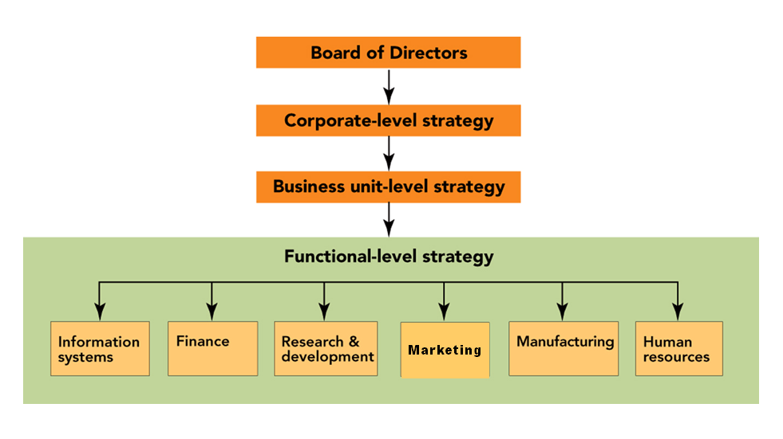
(see text page 27, Figure 2-1, The board of directors oversees the three levels of strategy in organizations: corporate, business unit, and functional)
  - The “ “ level
  - The “ “ level
  - The Functional or Departmental level

- Organizational Structure
  - Corporate
    - The “C” level; ____________, _______________, ____________
    - Top management sets and ________________ the overall strategy for the firm
- How does this work for our entrepreneurs?
  - Tim Apel, AAA Homes
  - Rob Felber, Felber & Felber Marketing
  - Gary Trinetti, Garick
- Which of our guest faculty are at the “C” level?
  - Dan Muller, Timken?

  - Strategic Business Units ( SBU’s )
    - A division, _____________________, or profit center
    - Selling a distinct set of _______________________________
to a specific __________________________________
against well-defined _______________________.
    - SBU’s operate in markets that have ____________________ sizes, growth rates, opportunities/threats, competition, and profit potential
    - So, planners must be ________________________ about these in doing planning, in allocating resources, and in performing evaluations
- Functional/Department Level
- Strategy can be made at three different level:
  - The Corporate Level
  - The Strategic Business Unit level
  - The functional or department level
    - Department input and role:

- Levels of Strategic Market Planning
CORE _________
____________(vision)

Your CORE VALUES must DRIVE your mission and your goals and your plans!!

- Mission Statement
  - The mission statement should be a clear and succinct representation of the enterprise's purpose for existence. It should incorporate criteria addressing concepts such as the moral/ethical position of the enterprise, public image, the target market, products/services, the geographic domain and expectations of growth and profitability.
  - The _________________ of the Mission Statement should be the first consideration for any employee who is evaluating a strategic decision.

  - Example – Mission/Vision at Timken

    - WAS the “____________________________________________”
    - BUT that put them in a “__________________________________”
    - NEW: ________________________________________ --Allows “out of the box thinking!”
    - For customers who are WILLING TO PAY for the ___________________ we create.
    - REMEMBER: “_____________________________________?”

  - Valerie on Mission
Our ___________ GUIDES our business activities and what ______________ we will take on.

- Goals or Objectives—Be “S.M.A.R.T.”

      - Time Warner Business Services Goal is to “Keep our business ___________________ 25% per year”

Time Warner video:
- Types of Goals
  - Profit
  - Sales Targets
    - In Dollars
    - In Unit Sales
  - Market Share (our percent of the market)
  - Quality
    - High? Acceptable?
  - Customer Satisfaction
  - Efficiency
  - Employee Welfare
  - Social Responsibility
    - Example—Portage County Health Services:

- Setting Strategic Directions
  - Understanding where we are NOW (“Three and ½ C’s”)
    - Our _____________
      - _____________________________________
    - Our _____________
    - Our _________________
  - Where do we want to go? Do we want to:

    - Use Portfolio Analysis to help figure it out

- Product Portfolio Models – The Boston Consulting Group
Market Growth Rate
Market Dominance

  - Cash Cows
    - Dominant in Low Growth Market
      - Low __________________________
      - Strong _________________________
      - Generate _____________________________
      - Do NOT require ______________________________
      - Profits flow to ________________________________

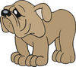
  - Dogs
    - Low Market Share in Low Growth Market
      - Low ____________________________
      - Weak ___________________________
      - Typically, generate ______________________________________
      - Not a good candidate for ______________________________

  - Problem Children
    - Low Market Share in High Growth Market
      - High ___________________
      - Weak __________________________
      - Typically, require _____________________________________


  - Star
    - Dominant in High Growth Market
      - High ____________________________
      - Profitable, but _______________________________
      - Requires ___________________________________
      - Will be __________________________________

Example -- The BCG MODEL and Coca-Cola

STAR PROBLEM CHILD

CASH COW DOG

Market Growth Rate
Market Dominance

- Product Portfolio Models – The Directional Policy Matrix

Market Attractiveness | Competitive Position
Market Attractiveness |  | STRONG | Medium | weak
Market Attractiveness | HIGH | Maintain Leadership | Challenge the Leader | Overcome, Niche, or Quit
Market Attractiveness | Medium | Challenge the Leader | Manage for Earnings | Harvest
Market Attractiveness | low | Cash Generator | Harvest | Divest

- Tracking Strategic Directions with Marketing Dashboards
  - What are they?
    - the visual display on a single computer screen of the essential information related to achieving a marketing objective.

Example – Jim Wise -- Marketing Dashboards at Don Joseph Toyota
    - We can actually get ______________________________ information.
    - But, with good _________________________ we can get the information we need!
    - How many ___________________________________
    - Where are they in the _____________________________
    - Did they _________________
    - Did we get ______________
    - Dashboards make it easy to ____________________________

  - iDashboards – Driving Business Decisions (http://www.idashboards.com/)

Example – Using Dashboards at Don Joseph Toyota for Media Effectiveness
i). One use is to measure ____________________________.

ii). What ________________ of media influenced the customer?

  - Using data to take _______________________________________

- The Strategic Marketing Process
  - Situation Analysis with _________________
    - Internal Factors

    - External Factors

Example: Fred Hunt on the Importance of SWOT
    - Few ______________ from the ________ are used more than the SWOT analysis
    - When you talk strategy, you go back to ____________ to ask the deep ____________________________!
    - From the analysis you can develop appropriate ________________

  - ACTIONS based on SWOT:

 | Type of Factor
Location of Factor | FAVORABLE | UNFAVORABLE
Internal | Strength | Weakness
External | Opportunity | Threat

  - Market-Product Focus and Goal Setting
    - _____________________________
      - IDENTIFY groups of buyers who (a) have common needs and (b) will respond differently to a marketing effort

    - _________________________
      - SELECTION of one or more segments and developing a marketing plan to serve them

    - Jumbo Shrimp Marketing Example (the video)
- Most Big Businesses began small;
- Nike, Dell, Starbucks,
- Is Bigger Always Better?
- Get Bigger by ACTING smaller!

Marketing Rules for How to get BIG by acting smaller!

#1 Be the
#2 LOVE
#3 Passion
#4 Treat
#5 Redefine

View “Jumbo Shrimp Marketing” at http://www.youtube.com/watch?v=UApCcRqu_Xo

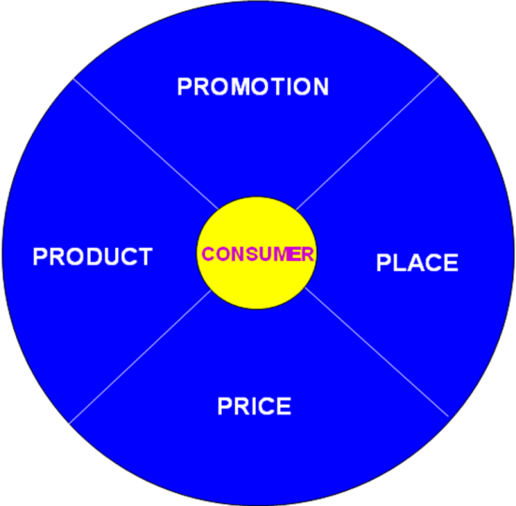
  - The Marketing Program (the 4 P’s of the _____________________)

    - Product Strategy
    - Price Strategy
    - Promotion Strategy
    - Place (Distribution) Strategy

  - See Text page 41, Figure 2-8 The Elements of the Marketing Mix MUST be blended to produce a COHESIVE marketing program!

- Implementing the Marketing Plan
  - Obtain Resources
  - Design the Marketing Organization
  - Develop the Schedules
  - Execute the Marketing Program

- Evaluating the Results – Muller at Timken
- ______________________ used to create communities of interest on Key Performance Indicators
- Available _______________________
- Reviewed in Monthly _______________________________
- Everyone goes through the ______________________________
- People pay attention to _____________________________________!!
Chapter 3: Scanning the Marketing Environment

- Environmental Scanning
  - The process of continually acquiring information on events occurring outside the organization to identify and interpret potential trends.
    - Requires ______________________________________________ and
    - Intelligent _____________________ and ___________________ of the information

- Environmental Factors Affecting the Organization (CREST)

PROMOTION

PLACE
PRODUCT

PRICE

- Social Forces
  - Factors in a society that bring about changes in attitudes, beliefs, norms, customs and lifestyles.
    - These affect how people live AND ___________, _______________, and ___________________ they buy.

- Demographics (a social force)
  - A population’s characteristics such as age, gender, ethnicity, income, and occupation.
    - World POPClock http://www.census.gov/population/popclockworld.html
    - U.S. Population http://www.census.gov/population/www/popclockus.html

  - Generational Cohorts (from the text)
    - Baby Boomers: 1946-1964
    - Generation X: 1965-1976
    - Generation Y: 1977-1994
    - Millennials: 1995+
    - ADD Generation Z: Mid 2002’s to today?? (dates not yet agreed on)
    - Generational Marketing

- Social Forces
  - Marital Status
  - Cohabitation
  - Blended Family
  - All Brought together in…..The Lifestage Analytic Matrix
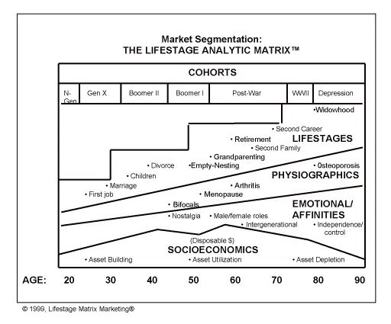
http://www.lifestagemarketing.com/

- The Seven American Cohorts
source: http://www.lifestagemarketing.com/overview.swf

Basic idea: Evoking strategic cohort words, symbols, and memories can bring substantial rewards for marketers.

  - Depression Cohort -- Aged 93+ in 2014.

  - World War II Cohort -- Aged 87-92 in 2014.

  - Post-War Cohort -- Aged 69-86 in 2014.

  - Leading-Edge Baby-Boomer Cohort -- Aged 60-68 in 2014.

  - Trailing-Edge Baby Boomer Cohort -- Aged 49-59 in 2014.

--Engage Boomers

  - Generation X Cohort -- Aged 37-48 in 2014.

  - The Millennial Generation Cohort (Gen Y) -- Aged 19-36 in 2014.

Best Car example:

Video: Don Kosec – The Impact of Generation Preferences (and Technology)

  - PLUS the newest cohort – Generation Z --Aged new born to 18 in 2014.

- Racial and Ethnic Diversity

- Cultural Trends
  - Green Marketing!
  - And…
“Healthy Living”
“Do-it-yourselfers”
“Adventurers”
“Cocooning” (stay home more with “creature comforts” – home networks, home theatres)
Patriotism

- Economic Forces
  - Economy
    - The factors relating to ______________________, expenditures, and resources that affect the _____________of running a business and a household
  - Macroeconomic Conditions
  - Consumer Income
    - Gross Income (amount earned in a year)
    - Disposable Income (after taxes)
    - Discretionary Income (after necessities)
    - Marketing use of the data…ESRI Communities http://www.esri.com/data/esri_data

  - Audio Example ECONOMIC FORCES: The response of FORD to the economic slowdown

Video: Rob Felber, Felber & Felber’s Response to Economic Forces

- We have been through _______________________
- This one is hitting _________________________!
- We learn if it affects our _______________ it affects us…so we need to find ways to ______________________________
- And we need foresight for the next change to ______________ the change.
- Technological Forces
  - Technology’s Impact on Customer Choices and Their Views of “Value”
    - Reduced costs = customers focus on other attributes
    - Introduction of new products
    - Changes to production (e.g. increased use of recycling)
  - Time Warner – Consistent Leader in Innovation
  - Electronic Business Technology
    - Marketspace
an information and communication based electronic exchange environment, where physical boundaries no longer interfere with buy/sell decisions.
In a marketspace, information and/or physical goods are exchanged, and transactions take place through computers and networks
    - Electronic Commerce
    - Intranet
    - Extranets

Video Example: An expert manager’s reaction to the impact of technological changes on a traditional business

  - How have _______________________________________
  - Recognize the fact then
  - _______________________????
  - Teaching Point:
This is _______________ what some _________________ DO!

- Competitive Forces
  - Competition
Other firms/organizations/people that want to take your customers/clients from you by providing better need satisfaction than you do, can, or care to.

NOTE: Your success will come from finding a better way to ____________________ ________________ (i.e., from a “competitive advantage”). NOT from your “need” to __________________ (which is the wrong focus)

  - Alternative Forms of Competition
    - Pure Competition
      - Large number of sellers
      - Similar Products
      - Distribution is very important
Example:
    - Monopolistic Competition
      - Large number of sellers
      - Products are unique, but substitution can occur
      - Pricing is important
Examples:
    - Oligopoly
      - A few large competitors
      - Products are relatively similar
      - Promotion is the key to demonstrate product differences
Examples:
    - Pure Monopoly
      - A single producer
      - A unique and unsubstitutable product
      - The marketing mix is not an important factor
Examples:

  - Types of Competition
- Consumers have ___________________________________
- Companies compete for _____________________________

    - At the Brand level -- Brand Competition
Selling the same type of product that you do (e.g., Colgate or Crest?)

    - At the Product level -- Substitute Product Competition
Offers consumers a choice of how to spend their dollars within a broad product category (________________or ________________?)

    - At the Company level -- Every Company/Spending Opportunity
Given limited discretionary income, consumers must decide whether to save, donate, or spend on a variety of possible products/services

    - HOW does a firm successfully compete?
      - YOUR goal is to find a ________________________
___________________________________
“If you _______________________________, would anyone ___________ you?”

      - Having gained it, you must ________________________

  - Response to Competitive Trend
Audio Example -- Italy “allows” wine in boxes!! What changed their minds?

      - Realization that they would NOT be able to _______________ in a global market without _______________ some traditional restrictions.
      - Boxed wine is the __________________________________
      - NOT for the _________________________________________
      - Northern Europe is ____________________ of the market!
      - In the U.S. ____________ to _____________of market.
      - It is ____________________ to produce

- Political and Legal Forces (see the textbook)
  - Monetary and Fiscal Policies
    - e.g., Government Spending
  - Social Legislation and Regulation
    - e.g., Antipollution Laws
  - To Regulate Competition
    - e.g., Rules on monopolies and restraint of trade
  - To Protect Consumer
    - e.g., Regulation of Food and Drug Labels

Chapter 4: Ethical and Social Responsibility in Marketing

- Ethics
  - The _________________ and ________________ that guide the actions and decisions of an individual or a group
- Business Ethics
  - involves what is right and wrong in the workplace...and doing right.
- Unethical business behavior can get you investigated, fired or _______________!

- Business Ethics: WHO NEEDS IT?
  - “NO ONE” Because:
    - It’s religion, not business.
    - Our people ARE ethical.
    - It’s for philosophers.
    - It’s Obvious--”Do Good”
    - It’s preaching
    - It’s just a recent fad.
    - Ethics can’t be managed.
    - It’s the same as “social responsibility.”
    - If a firm is not in legal trouble, it’s ethical.
    - Managing ethics has little practical relevance.
  - Well, maybe….BUT
    - Nestle’s -- Infant formula
    - Beech-Nut -- watered apple juice
    - Manville -- asbestos & employees
    - E.F. Hutton -- kiting scheme
    - Union Carbide -- Bhopal, India
    - Enron – Conflicts of Interest
    - Worldcom/MCI – Inflated Accounting Reports
    - Martha Steward – Insider Trading
    - Bernie Madoff -- First Jail, Then Bankruptcy for Madoff
    - Nike – Questionable Hiring Practices
      - The Background
        - Nike has been heavily criticized for NOT being __________________________________
        - Accusation: use of sweatshops and child labor overseas, and __________________________________________.
        - Accusation: targeting ___________________________ by making shoes an expensive status symbol for poor urban street kids.
      - Nike’s Corrective Behavior
        - __________________________ and six-point plan ensures more socially responsible labor practices & commissioned an independent study of Nike factories abroad.
        - Created a huge _____________________ department and publishes a Corporate Responsibility Report.
        - The Nike Foundation works to unleash the unique potential of adolescent girls to end poverty for themselves and for the world.

- Figure 4-1 (text page 90) Four ways to classify marketing decisions according to ethical and legal relationships

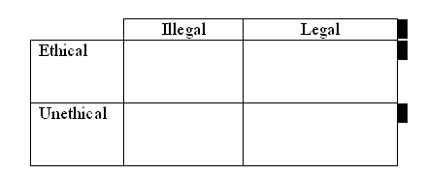
  - Unethical AND Illegal – DUH!
  - Ethical AND Legal – Okay to consider

  - Ethical but Illegal?
  - Unethical but Legal?
- Criticism of Marketing
  - High prices
  - Deceptive practices
  - High-pressure selling
  - Shoddy, harmful, or unsafe products
  - Planned obsolescence
  - Poor service to disadvantaged consumers
  - WHEN THESE OCCUR, they have impact on

- High Prices
  - Causes:
    - High costs of ________________________ and ________________
- Consumers want convenience, they want lots of assortment, they want easy return privileges, etc.
    - High _______________________ and _____________________ Costs

  - Generic vs. Branded? Why such a difference between generic and branded product prices?
Example:

  - SO, markups that result in high prices often reflect services that customers WANT and are willing to pay for:
    - Convenience
    - Image
    - Safety
    - Service
    - Return privileges, warranties

- Deceptive Practices
  - Deceptive Pricing

  - Deceptive Promotions

  - Deceptive Packaging

  - Deceptive Practices lead to:
    - Legislation
  - Is Puffery Deception?
Puffery as a legal term refers to promotional statements and claims that express subjective rather than objective views, such that no ____________________ would take them literally.

  - Harm Business / Buyer Beware

- High-Pressure Selling
  - Some people are trained to deliver
    - High-pressure selling persuades people to
    - High-pressure selling can occur because
  - It DOES happen
  - BUT, it is not “standard business practice”
    - High-pressure selling is ___________________long-term relationships.

- Unsafe Products
  - Products that are not made well or services that are not performed well.
  - Products that deliver little benefit or that may be harmful
  - Unsafe products come from:

    - Manufacturer ______________
    - Increased _________________________________
    - Poorly trained __________
    - Poor quality _________________________, and
    - Outright ______________ people.

Example -- Wal-Mart Pulling Children's Jewelry With Toxic Metals
Example – Lead Paint on Toys made in China
Example – Salmonella problems in the food supply

  - Consumer Product Safety Commission provides HELP for consumers
    - Mission
“To protect consumers against unreasonable risk of injury by developing voluntary and mandatory standards, banning dangerous consumer products, issuing recalls of products already on the market, and researching potential hazards associated with consumer products.”
http://www.cpsc.gov/
  - Video: Apel on Safe/Quality Products
    - Fix ___________________ and fix them right
    - Get products that provide the little features that consumers WON’T notice at first, but that they ___________________________ later
    - The result is a ______________________________ who will be happy and who will come back and refer others!
- Planned Obsolescence
  - Products needing replacement before they should because they are obsolete
  - Producers who influence consumer concepts of acceptable styles
  - Intentionally holding back attractive functional features, then introducing them later to make old model obsolete.
  - The case of the Apple iPhone

- Poor Service to Disadvantaged Consumers
  - Poor are forced to shop in smaller stores where they _____________ for ________________ goods.
  - “Redlining” by national chain stores occurs in disadvantaged neighborhoods.
    - Redlining charges have also been leveled against insurers, banking, health care providers and others.
  - Poor are targeted for “rapid refunds.”

- Cultural Pollution
  - Mass communication media is ________________ and reaches outside target segment,
  - But, _______________________ keeps the cost of radio and television free and magazines/newspaper down, and
  - Consumers can opt for technologies or media that reduce or eliminate ads

- Questionable Judgments in Advertising
  - Example: Provocative ads for Clearasil upset parents.
  - Are such ads:
    - Over the top?
    - Unethical?
    - Humorous? Funny?
  - Should they be:
    - ________________________?
    - __________________________ ?
    - Or should _____________________________ be the main influence?

  - Clearasil’s Response
Our objective is to inform and entertain, not to __________. We have found that Clearasil consumers see this ad as we intended: a humorous and unrealistic presentation of an awkward family event.

  - GoDaddy.com example:

    - Do you like their Super Bowl ads?
      - Rated on Artistic content __________________
      - Based on personal moral views ____________________
      - But if you’re a marketer ____________________________
      - The bottom line is __________________________________
      - Example results:

- Management’s Response to the need to be ethical
  - Corporate Culture
    - Aveda example: http://www.aveda.com/discover/index.tmpl#section=mission
Our mission at Aveda is to care for the world we live in, from the products we make to the ways in which we give back to society. at aveda, we strive to set an example for environmental leadership and responsibility, not just in the world of beauty, but around the world.
  - Codes of Ethics
  - Behavior of Top Management
    - Ombudsman for Ethics
  - MANAGING the ethical environment of your firm and its employees!
  - Video: Kosec – Ethics begins at the top!
    - If you are not ethical then I can’t ______________ or ___________ you!
    - We want ________________________ in our marketing
    - MCI _______________________ as a result of unethical practices
    - Sarbanse-Oxley
    - Ethics starts at the
  - Video: Hunt on Ethics – It all starts at the top
    - Based on my experience it all ______________________________.
    - At Sherwin-Williams the ___________________ are exemplary and they emphasize this in all areas of the firm

    - As a result, it is a _____________________________________
- Good ethics IS Good Business
  - For shareholders
  - For Employees
  - For business partners
  - For Customers/Clients
  - And for Society!

Patagonia example:
- Patagonia lately has been urging its outdoorsy customers to "_____________________________" and question whether they really need that several-hundred-dollar new parka, even from Patagonia.
- The result? Patagonia's fans and customers are both joining the brand's sustainability cause—and buying more new parkas from Patagonia

- AMA Ethics Statement
http://www.marketingpower.com/AboutAMA/Pages/Statement%20of%20Ethics.aspx

http://www.marketingpower.com/AboutAMA/Pages/Statement%20of%20Ethics.aspx

PREAMBLE
The American Marketing Association commits itself to promoting the highest standard of professional ethical norms and values for its members
(practitioners, academics and students). Norms are established standards of conduct that are expected and maintained by society and/or professional
organizations. Values represent the collective conception of what communities find desirable, important and morally proper. Values also serve as the criteria for evaluating our own personal actions and the actions of others. As marketers, we recognize that we not only serve our organizations but also act as stewards of society in creating, facilitating and executing the transactions that are part of the greater economy. In this role, marketers are expected to embrace the highest professional ethical norms and the ethical values implied by our responsibility toward multiple stakeholders (e.g., customers, employees, investors, peers, channel members, regulators and the host community).

ETHICAL NORMS – As Marketers, we must:
1. Do no harm. This means consciously avoiding harmful actions or omissions by embodying high ethical standards and adhering to all applicable
laws and regulations in the choices we make.
2. Foster trust in the marketing system. This means striving for good faith and fair dealing so as to contribute toward the efficacy of the exchange
process as well as avoiding deception in product design, pricing, communication, and delivery of distribution.
3. Embrace ethical values. This means building relationships and enhancing consumer confidence in the integrity of marketing by affirming these
core values: honesty, responsibility, fairness, respect, transparency and citizenship.

ETHICAL VALUES
Honesty – to be forthright in dealings with customers and stakeholders. To this end, we will:

~Strive to be truthful in all situations and at all times.
~Offer products of value that do what we claim in our communications.
~Stand behind our products if they fail to deliver their claimed benefits.
~Honor our explicit and implicit commitments and promises.

Responsibility – to accept the consequences of our marketing decisions and strategies. To this end, we will:

~Strive to serve the needs of customers.
~Avoid using coercion with all stakeholders.
~Acknowledge the social obligations to stakeholders that come with increased marketing and economic power.
~Recognize our special commitments to vulnerable market segments such as children, seniors, the economically impoverished, market illiterates
and others who may be substantially disadvantaged.
~Consider environmental stewardship in our decision-making.

Fairness – to balance justly the needs of the buyer with the interests of the seller. To this end, we will:
~Represent products in a clear way in selling, advertising and other forms of communication; this includes the avoidance of false, misleading and
deceptive promotion.
~Reject manipulations and sales tactics that harm customer trust.
Refuse to engage in price fixing, predatory pricing, price gouging or “bait-and-switch” tactics.
~Avoid knowing participation in conflicts of interest.
Seek to protect the private information of customers, employees and partners.

Respect – to acknowledge the basic human dignity of all stakeholders. To this end, we will:

~Value individual differences and avoid stereotyping customers or depicting demographic groups (e.g., gender, race, sexual orientation) in a
negative or dehumanizing way.
~Listen to the needs of customers and make all reasonable efforts to monitor and improve their satisfaction on an ongoing basis.
~Make every effort to understand and respectfully treat buyers, suppliers, intermediaries and distributors from all cultures.
~Acknowledge the contributions of others, such as consultants, employees and coworkers, to marketing endeavors.
~Treat everyone, including our competitors, as we would wish to be treated.

Transparency – to create a spirit of openness in marketing operations. To this end, we will:

~Strive to communicate clearly with all constituencies.
~Accept constructive criticism from customers and other stakeholders.
~Explain and take appropriate action regarding significant product or service risks, component substitutions or other foreseeable eventualities that
could affect customers or their perception of the purchase decision.
~Disclose list prices and terms of financing as well as available price deals and adjustments.

Citizenship – to fulfill the economic, legal, philanthropic and societal responsibilities that serve stakeholders. To this end, we will:

~Strive to protect the ecological environment in the execution of marketing campaigns.
~Give back to the community through volunteerism and charitable donations.
Contribute to the overall betterment of marketing and its reputation.
~Urge supply chain members to ensure that trade is fair for all participants, including producers in developing countries.

IMPLEMENTATION
We expect AMA members to be courageous and proactive in leading and/or aiding their organizations in the fulfillment of the explicit and implicit promises made to those stakeholders. We recognize that every industry sector and marketing sub-discipline (e.g., marketing research, e-commerce, Internet selling, direct marketing, and advertising) has its own specific ethical issues that require policies and commentary. An array of such codes can be accessed through links on the AMA Web site. Consistent with the principle of subsidiarity (solving issues at the level where the expertise resides), we encourage all such groups to develop and/or refine their industry and discipline-specific codes of ethics to supplement these guiding ethical norms and values.

Chapter 5: Understanding Consumer Behavior

- Video: Michele Skinn, on the importance of understanding consumers’ motivations
  - Learning the motivation is ________________________________
  - Understand WHY the consumer _____________________________
  - or your _____________________________________
  - Understand their motivation and then _________________________

- A Model of Consumer Behavior, Adapted from Engle, Kollat, and Blackwell

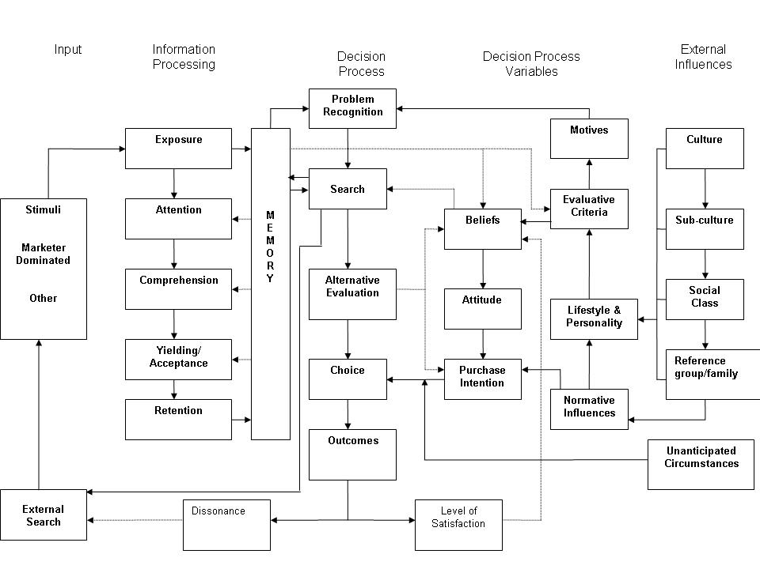

Comments:
- The Purchase Decision Process Consists of Five Stages

  - Problem Recognition Perceiving a _________________
  - Search Seeking _________________
  - Alternative Evaluation Assessing _________________
  - Choice Buying _________________
  - Outcomes Value in ________________ or ______
- Purchase Decision Process Stages – Problem Recognition
  - A perception that there is a _________________ between the _______________ situation and the _______________ situation.
  - Influenced by:
    - Internal needs and _____________, and by
    - ____________, which can activate Problem Recognition through marketing communications which highlight
      - the limitations of _________________________, or
      - limitations of _____________________________
- Purchase Decision Process Stages – Information Search
  - First, we search ____________________________
    - What types of things do we recall?

  - Then, we may do an _______________________ , including:

- Purchase Decision Process Stages – Alternative Evaluation
  - HOW will the consumer decide __________________________________
  - __________________________________________are the Factors that represent the brand’s characteristics (as perceived by the consumer). They are used to compare the possible brand choices.
  - Marketers attempt to _________________________________ ________________________________
Video Example: Windows vs. iPad commercial
  - Consumers use their ____________________ to compare the alternatives in their CONSIDERATION SET (also called the __________________ )
  - Purchase Decision Process Stages – Alternative Evaluation – Understanding the CONSIDERATION SET of brands
    - Consumers’ information search should result in a __________________________
    - Brands that consumers actually CONSIDER before making a purchase decision are known as ________________________ or __________________ (___________________________________)
All Brands
Unknown
Brands
Unacceptable Brands
Overlooked Brands
Rejected
Brands

Evoked
Set

- Purchase Decision Process Stages – Alternative Evaluation – Belief, Attitudes, and Purchase Intention
  - As they evaluate the brand choices, consumers form ______________ about the brands, and _____________ or ________________ attitudes.
  - The result is an ____________________ to make a purchase including which Brand to buy, where to buy, when to buy, how to pay, etc.

- Purchase Decision Process Stages – Post-Purchase Behavior
  - Consumers make the purchase (choice) based on their evaluations and their purchase intentions….and then they
  - Consumers’ Level of Satisfaction is based on their _______________ and their _______________________
    - If Perceived Performance is BELOW Expectations then consumers are _____________________
    - If Perceived Performance EQUALS Expectations then consumers are ______________________
    - If Perceived Performance EXCEEDS Expectations then consumers are _____________________
    - SO, Marketers should promise what ________________________
    - Some marketers will _____________________________

  - __________________________ is the feeling of anxiety consumers often experience when they must choose between attractive alternatives
    - It can occur REGARDLESS of the _________________________
Example:
  - Marketers help MINIMIZE dissonance by:
    - Reassuring consumers they made the right choice and minimizing product misuse through _______________________________
    - Offering ways for _____________________________________
    - Being RESPONSIVE to _______________________________
- Consumers’ Decision Making is Influenced by how INVOLVED they are with the decision (the following details are from the chart shown in the lecture):
  - When consumers’ involvement is _________, they engaged in Routine decision making.
    - Typically, such decisions take a _______________ time to make
    - The cost of the product is usually ______________
    - Consumers will only search _________________
    - And they consider ______________ brand or alternative
  - When consumers’ involvement is MODERATE, they engage in _________________ decision making.
    - Typically, such decisions take a ________________ time to make
    - The cost of the product is usually _________________
    - Consumers will search mostly ___________________
    - And they consider _______________ brands or alternatives
  - When consumers’ involvement is HIGH, they engage in _________ decision making.
    - Typically, such decisions take a ___________ time to make
    - The cost of the product is usually __________________
    - Consumers will search _________________
    - And they consider _______________ brands or alternatives
  - Examples:
- Psychological Influences on Consumers’ Purchase Decisions
  - Motivation – the energizing force that stimulates behavior to satisfy a need
  - Personality–A person’s tendency to respond in a consistent way to situations
  - Perception– the processes by which people select, organize, and interpret information
  - Learning–behaviors resulting from repeated experiences and from reasoning
  - Values, Beliefs, and Attitudes
  - Lifestyle–A person’s “mode of living”
- Psychological Influences Consumer Decision Making – Motivation
- Link to our model of Consumer Behavior
  - Maslow’s Hierarch of Needs (see Figure 5-5, text page 117)
    - Physiological Needs: Food, water, oxygen
Ad Example:
    - Safety Needs: Freedom from physical harm; financial security
Ad Example:
    - Social Needs: Friendship, belonging, love
Ad Example:
    - Personal Needs: Status, respect, prestige
Ad Example:
    - Self-actualization needs: Self-fulfillment
Ad Example:
- Psychological Influences Consumer Decision Making – Personality
  - Personality is a person’s ______________________ that influence their behaviors
    - If a person is confident, dependent, fearful, or sexual in their everyday life, these same traits likely will influence them in their style of __________________________________________
- Psychological Influences Consumer Decision Making – Perception
  - ________________________ is the process of receiving, organizing, and giving meaning to stimuli detected by one of our five senses.
  - However, not everyone gets the same meaning from the same stimuli due, in part, to:
    - Selective Perception
    - Selective Exposure
    - Selective Comprehension
    - Selective Retention
    - Subliminal Perception???
  - Selective Perception
    - Is the process which we use to determine “________________” to perceive.
    - Due to this selective process, we may omit items, add, or even change what we see, feel, or hear.
    - Selective perception doesn’t happen all at once but occurs in various stages including exposure, comprehension, and retention
- Male vs. Female – Differences in Perception example:

  - Selective Exposure
    - From the variety of communication available to them, people _________________________________________________
    - They tend to view communication (e.g., ads) that reaffirm preexisting ideas and attitudes, thereby bolstering their image of themselves and what they "know“.
    - Marketers need to find ways to “____________________” barriers to perception!
    - Example:
    - People rarely read Web pages, instead they _______________________
  - Selective Comprehension
    - This involves interpreting discrepant information so that it is ___________ with beliefs and attitudes.
      - It was once reported in a study that ________________ of non-smokers believed the link between smoking and lung cancer was proven;
      - yet only _______________ of heavy smokers accepted the link!!
- Example
  - Selective Retention
    - People remember more accurately messages that are favorable to their ____________ than messages that are unfavorable.
    - People remember the good things and forget the bad. Selective retention thus reinforces one’s _____________.
    - Marketers need to find ways to help consumers to ____________ their message.
  - Subliminal Perception???

  - SO, consumers perceive marketing stimuli _____________because each individual is unique in the combination of his or her needs, attitudes, experiences, and personal characteristics.
    - AND, identical advertisements, packages, or products may be perceived __________________ by consumers
- Psychological Influences Consumer Decision Making – Perceived Risk
  - Perceived risk involves the perceptions of the riskiness of the purchase. There are several types that marketers must understand, including:
    - _____________________ Risk
    - _____________________ Risk
    - _____________________ Risk
    - _____________________ Risk
  - Marketers must understand their consumers’ perceptions of risk and address them
  - Video Example – Reducing Financial Risk

- Psychological Influences Consumer Decision Making – Learning
  - Learning involves changes in behavior resulting from observation and experience.
    - ______________Conditioning
_____________ and his _______________
    - ______________ Conditioning
_____________ and his _______________
    - ______________ Learning
    - ______________ Learning
  - Brand Loyalty
    - Consumers can _____________ to ________________ a brand over all others….this is rather important to marketers!

- Psychological Influences Consumer Decision Making – Attitudes and Beliefs
  - Based on what they have learned from processing information, evaluating alternatives, making a choice, and evaluating the choice consumers
  - form ____________ about the stores, products, decision processes, and
  - form attitudes ( _________________________ ) about these
  - When attitudes are POSITIVE they ____________________________
  - When attitudes don’t exist (e.g., for a new or for an unknown brand) or when they are NEGATIVE they _______________________________
  - Marketers attempt to Change Unfavorable Attitudes (using _____________________________) by:
    - Changing Beliefs About a Brand’s _________________
    - Changing the Consumer’s Perception of the Importance of the Brand’s ________________
    - Adding New Product ________________
- Body Wash & masculine nail polish example:

- Psychological Influences Consumer Decision Making – Lifestyles
  - __________________ -- Individual patterns of living as reflected by interests, opinions, spending habits, and activities.
  - _______________ -- A technique of measuring lifestyle and VALS
http://www.strategicbusinessinsights.com/vals/ustypes.shtml
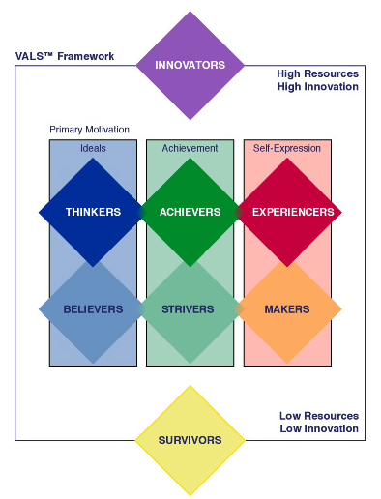
- Influences on Consumers’ Purchase Decisions – Sociocultural
High Resources
High Innovation
  - Sociocultural Influences (link to our model of Consumer Behavior)
    - Personal Influence
    - Reference Groups
    - Family
    - Social Class
    - Subculture
    - Culture
  - Personal Influence
    - Product Trial, Brand Evaluation, Purchase Decisions, and Satisfaction can be influenced by the attitudes of “others.”
      - Opinion Leaders
      - Word of Mouth
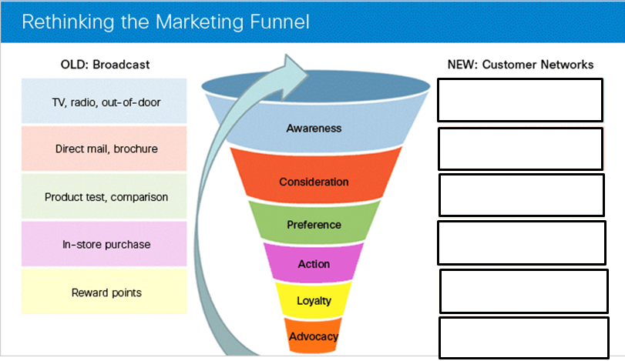
        - Buzz

- The IMPACT of WOM “buzz” -- Philips Sonicare Essence Example:
    - Sent a $70 Sonicare Essence toothbrush to _________________
_________________________________________
    - The 30,000 agents each told _________________________
    - THOSE ______________ people told an average of ___________ more people, for a total of _______________ people
    - Representing a ____________________________________
- Example: You Lookin’ at Me?

  - Family Influence
    - Consumer Socialization
      - The process by which people acquire the skills, knowledge, and attitudes necessary to function as consumers
      - The _____________ is a key factor in consumer socialization of children
        - Marketers are aware of this and create commercials to target this family influence
        - Ad Example:

    - Family Decision Making
      - Family can BE ______________________
      - Often involves ___________________ and __________________
    - Family Life Cycle (see Figure 5-6 from the textbook page 127).
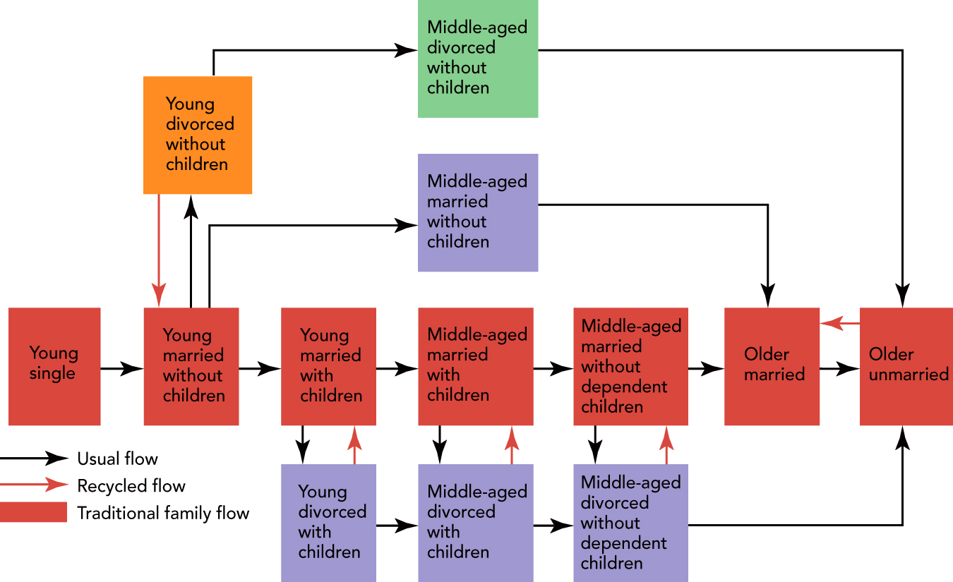
      - Roles in Family Decision Making
        - _________________
        - _________________
        - _________________
        - __________________
        - __________________
    - Marketers must know ___________ plays these roles for their products and whether/how to reach them!
  - Social Class
      - Social Class
      - Upper Class
      - Middle Class
      - Worker/Lower Class
    - A very strong influence on ________________________, attitudes, activities, social interactions, AND your consumer behavior (e.g., where you shop, what you buy, how you save/invest)
  - Subculture -- the subgroups within the larger, or national, culture with unique values, ideas, and attitudes
    - Hispanic
    - African American
    - Asian American
    - And more
  - Culture
  - Video example: American vs. Others--“Similar language, but what does that MEAN?”
- Other influences on Consumers’ Purchase Decisions
  - Situational Influences = five aspects of the purchase situation that impacts the consumer:
    - Purchase task
    - Social Surroundings
    - Physical Surroundings
    - Time (temporal) Effects
    - Antecedent (pre-existing) States

- IN CONCLUSION
Understanding what influences consumers to buy or not buy your product is
  - EXTREMELY ___________________________, and
  - EXTREMELY ____________________________!
Chapter 6: Understanding Organizations as Customers

- The Nature and Size of Organizational Markets
  - ___________________________________ involves the marketing of goods and services to companies, governments, or not-for-profit organizations for use in the creation of goods and services that they can produce and market to others.
  - Business Markets include ___________________ that buy goods and services to:
    - Make ________ goods and services (e.g., ______________________)
    - _____________ that product to others (e.g., wholesalers and distributors)
    - Conduct the organization’s ___________________________
    - In the past, business markets were called ____________________.
  - Six Components of the Business Market
    - Agriculture – The Challenge: ______________________________
    - Resellers who buy and sell products in essentially the same form. However, they create various __________ for other businesses, including:
      - time
      - place
      - Information, and
      - Possession
    - Services, Financial institutions, Ad agencies, trucking firms, warehouses, tax services, etc! which are GROWING rapidly
    - The Government
      - Unique:
    - International Trade
http://www.census.gov/foreign-trade/statistics/highlights/top/top1212yr.html
Total Trade – Jan to Dec -- Data are goods only, in billions of dollars.
Total, All Countries | Exports (Year-to-Date) | Imports (Year-to-Date) | Total Trade (Year-to-Date)
Jan-Dec 2012 | 1,547.1 | 2,275.0 | 3,822.2
Jan-Dec 2011 | 1,480.7 | 2,207.0 | 3,687.6
Total Trade (Goods) Year-to-Date
December 2012
Rank | Country | Exports | Imports | Total Trade | Percent of Total Trade
--- | Total, All Countries | 1,547.1 | 2,275.0 | 3,822.2 | 100.0%
--- | Total, Top 15 Countries | 1,049.0 | 1,703.0 | 2,752.0 | 72.0%
1 | Canada | 292.4 | 324.2 | 616.7 | 16.1%
2 | China | 110.6 | 425.6 | 536.2 | 14.0%
3 | Mexico | 216.3 | 277.7 | 494.0 | 12.9%
4 | Japan | 70.0 | 146.4 | 216.4 | 5.7%
5 | Germany | 48.8 | 108.5 | 157.3 | 4.1%
http://www.census.gov/foreign-trade/statistics/highlights/toppartners.html#total

    - “Non-business” or Not-for-profit Organizations

  - Video: Muller on the Industries Timken serves
    - Growth for Timken
    - Focused on ___________________________________
1. Steel
2. Power Generation
3. Cement Production
4. Aggregate
5. Wind Energy Where they can deliver value…and which are growing. For example:
      - Iron ore
      - Coal
      - Oil
    - Compared to _______________________, which may NOT be a good industry for them in the future.
- Type and Number of Organization Establishments in the U.S.
  - Industrial (business) markets -- Total Number =
  - Reseller markets – Total Number =
  - Government markets – Total Number =
--and Timken’s focus...

- Measuring Domestic And Global Industrial, Reseller, And Government Markets
North American Industry Classification System (NAICS) -- The North American Industry Classification System (NAICS) is the standard used by Federal statistical agencies in classifying business establishments for the purpose of collecting, analyzing, and publishing statistical data related to the U.S. business economy.
http://www.census.gov/eos/www/naics/
  - North American Product Classification System (NAPCS)
A joint multi-phase initiative to develop a comprehensive demand-oriented product classification from the statistical agencies of Canada, Mexico, and the United States. Work to date has focused on the products produced by service industries in 12 NAICS sectors 48-49 through 81. With that work nearing completion, this web page provides an overview of and progress report on the NAPCS initiative and presents the final versions of the product lists developed so far for the service industries included in those 12 sectors.
http://www.census.gov/eos/www/napcs/index.html

- Characteristics Of Organizational Buying
  - Demand Characteristics
    - Derived Demand -- the demand for industrial products and services is driven by, or “derived from,” demand for consumer products and services.
Example:

      - The Implications of Derived Demand:
        - Business Marketers must understand ________________________________
___________________________________________________________
        - Often they need to find ways to ____________________________________

Intel Example:

    - Elasticity of Demand [recall your Microecon course!]
      - The total demand for all of the producers of the product responds very little to changes in its prices. Demand does not change much if price changes.
        - Occurs when Cost is a small percent of the finished product, and
        - When there are no close substitutes
Example

      - Demand is more elastic when
        - A Price Change occurs in a ________________________
        - When demand is viewed from a ________________________
        - If the cost of the business product is a SIGNIFICANT portion of the cost of the finished good

  - Size of the Order or Purchase and the Number of Buying Units
    - Number of Business users =
    - Number of Ultimate Consumers =
    - However, while there are a smaller number of organizations they are ____________________________________________
    - Plus, they are _________________________________
--Goodyear
--Regional Concentration
  - Organizational Buying Objectives
    - Businesses buy from other businesses to help them achieve their objectives, such as:
      - Reduce ______________________
      - Increase _____________________
      - _____________________________________
  - Organizational Buying Criteria (like Consumer’s Evaluative Criteria)
    - In deciding among suppliers, buyers must consider a variety of factors, such as:
      - Price
      - Delivery Schedules
      - Past Performance
      - Production Facilities/Capacity
      - Warranty/Claim Policies
      - Technical Capability
      - Quality Specifications
        - ISO 9000 – standards for registration and certification of a manufacturer’s quality management and assurance system based on an on-site audit of practices and procedures developed by the International Standards Organization (ISO).
    - Why is all of this SO important in B2B Buying?
      - Firms MUST buy the ________________, at the ____________, and at the _______________, because:
        - Companies are making less and buying more from suppliers
        - Firms cannot tolerate ___________________________________
        - SO, firms need to work with fewer suppliers and develop long term relationships with them
          - Work together to develop new products, share information on inventories, production and costs.
  - Buyer-Seller Relationships and Supply Partnerships
    - Supplier development is the deliberate effort by organizational buyers to build relationships that shape suppliers’ products, services, and capabilities to fit a buyer’s needs and those of its customers.

  - The __________________________________________ -- consists of a group of people in an organization who participate in the buying process and share common goals, risks, and knowledge important to a purchase decision.
    - It is a “Cross-Functional” Group
    - People in the Buying Center
    - Roles in the Buying Center
      - Gatekeepers --
      - Influencers --
      - Users --
      - Buyers --
      - Deciders --
  - Buy Classes represent the “type” of buying situation (see Text Figure 6-3):
    - ___________________ Rebuy
    - ___________________ Rebuy
    - _________________ Buy
    - See Figure 6-3, text page 147, for the ways in which the buying situation affects the buying center

    - Stages in the Organizational Purchase Decision Process (See Figure 6-4, text page 149),
      - Problem Recognition
      - Information Search
      - Alternative Evaluation
      - Purchase Decision
      - Postpurchase Behavior
    - The Hershey’s Example:
      - Problem Recognition
      - Information Search
      - Evaluation of Alternatives
      - Purchase Decision
      - Post-purchase evaluation

- ONLINE BUYING IN ORGANIZATIONAL MARKETS
    - Prominence of Online Buying in Organizational Markets
    - E-marketplaces
      - Online Auctions in Organizational Markets
a) Traditional Auctions
      - A Seller puts an item up for sale
      - Various Buyers ______________________.
      - As bidders increase, there is ________________ on price.
      - The Auction ends when ___________________________
b) Reverse Auction
- A Buyer communicates a need for a product or service
- Various ________________ bid in competition
- As the number of suppliers increase there is ___________________ on price
- The Auction ends when _____________________________
Chapter 7: Understanding and Reaching Global Consumers and Markets

- The Nature and Size of Organizational Markets
  - Why International Trade?
    - To get access to materials, products, and services which are___________________________________________

    - To get access to markets which______________________

    - Because of _____________________ ____________________
      - Some countries have unique national or human resources that give them ______________________, internationally

    - Market Saturation ________________
    - Potential Demand
    - Customer Expectations
  - What does it mean to US?
    - Balance of Trade
- The difference between the monetary value of a nation’s exports and imports
- US Balance of Trade….

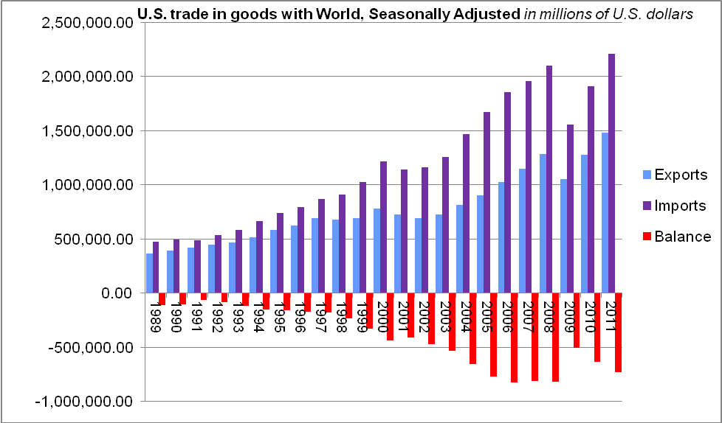

    - Impact of the DHL (Germany) decision for Ohio
    - INVITING FIRMS TO COME TO OHIO ( Desire to HAVE foreign investment locally)

- Dynamics of World Trade – The Competitive Advantage of Nations
  - Porter’s “Diamond” -- WHY do some industries and firms become world leaders and others lose ground or fail?

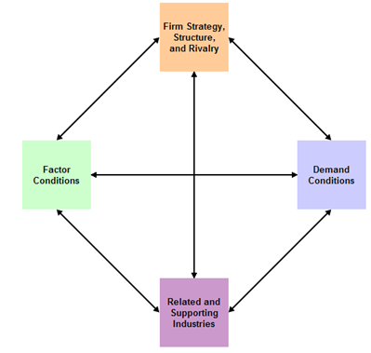
- Factor Conditions
  - Natural Resources
  - Education and skill levels
  - Wage Rates
    - Examples:
  - AND, the question for OUR FIRM – Can we __________ ______________________________________
- Demand Conditions
- Size of Market
- Sophistication of Consumers
- Media Exposure of Products
    - Example

- AND, the question for OUR FIRM – Is there ____________ ________________________________

- Related and Supporting Industries
- Existence of Supplier Clusters
- Examples

- AND, the question for OUR FIRM – Can we ____________ ________________________________
- Company Strategy, Structure, and Rivalry
- Number of Companies in an Industry
- Intensity of Competition
- Public or Private Ownership
  - Example
- AND, the question for OUR FIRM --Can we ____________ ________________________________
- CONCLUSION:
Firms that succeed in global markets have succeeded first in intense domestic competition through:

- Marketing In A Borderless Economic World
- Trend 1—Decline of Economic Protectionism
    - Today we have an _______________________________

    - Should Congress create more Protectionism?
      - Some argue that the benefits of today’s free trade systems go unfairly and primarily to low-wage countries, which take jobs away from Americans.
      - These arguments are not supported by the facts.
    - Reagan said:
      - “A creative, competitive America is the answer to a changing world, not trade wars that would close doors, create greater barriers, and destroy millions of jobs. We should always remember: Protectionism is destructionism.”
  - G20 Trade Barriers 2009.
  - U.S. Slaps High Tariffs on Chinese Solar Panels
- America's economy, over the past few decades, has proved that __________________________ flexibility makes the economic pie much bigger and that the benefits can be widely shared.
- Over the past 10 years, open trade has boosted job growth by more than 13 percent and has helped to raise U.S. GDP by nearly __________________________.
- Protectionism in World Trade (see textbook Figure 7-3)

PROTECTIONISM

- General Agreement on Tariffs and Trade (GATT)
- A treaty, NOT an _______________________
- Focus:
- NO _______________________________
- World Trade Organization (WTO) Goals:
- Trade Without _______________________
(Exceptions: e.g., Regional Trade Agreements)
- Predictable and Growing Access to _________________ (Example: binding tariffs)
- Promoting ___________________________
- Encouraging _____________________ and Economic Reform (Over 3/4 of its members are developing countries)
- Patrick Low – Chief Economist WTO (retired 2013)
        - The WTO is an International ___________________
        - [Including] ______________ nations.
        - The WTO needs to get _____________ and _____________ from all nations.
        - Regional Trade Agreements have exploded and these are a challenge to trade without _______________________
        - The WTO agreements create an environment of ___________, continuity, and predictability.
        - They seek to create ____________ and _________ in trade.

- An aside…how many countries ARE there in the world today?
- Trend 2 – A Rise of Economic Integration
- European Union
- Consisting of __________ countries with more than
_________________________ consumers
- North American Free Trade Agreement (NAFTA), Canada, U.S., Mexico
- Consisting of ________________________________
- Asian Free Trade Agreements
- South Asian Free Trade Area-
a framework for the creation of a free trade zone covering 1.4 billion people in India, Pakistan, Nepal, Sri Lanka, Bangladesh, Bhutan and the Maldives.

- East Asian Free Trade Agreement on Services
- TREND 3 — Global Competition—Who are we up against? How might we compete?
  - __________________________________________-- agreements among two or more independent firms to cooperate for the purpose of achieving common goals.
- Example

  - _______________________________________ – International marketing done in the same way as domestic marketing
- Example

  - __________________________________________ – Varies its Marketing Strategy for each country

- Example

  - ____________________________________ – Use a “Global Marketing Strategy” to keep the mix the same where there are similarities and CHANGE the mix when cultures differ.
- A goal of _________________ is to create and maintain a balanced portfolio of global AND local brands, to:
- Take advantages of ____________________ where possible, by sharing R&D, technical features, manufacturing, etc. across brands
- Grow _______________________ where possible
- Obtain __________________________ though ______ _________________________ locally, when necessary

Henkel Example
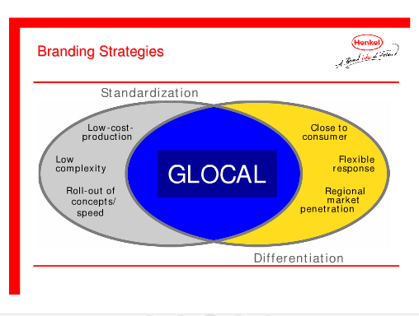

Global Marketing and G.M. (Video)
- _______________ to play a bigger role in G.M.’s future
- It is G.M.’s _________________________________
- ___________ new cars in the next 2 year.

- In 2010 GM sold _____________________ than in the U.S.!!!

- A Global Environmental Scan – What do we need to “know before we go?”
- Cultural Diversity
- Social and Cultural Environment
  - Family
  - Customs and Behavior
  - Education
  - Language
  - Impediments to understanding foreign markets:
    - ______________________________________ -- an unconscious reference to one’s own values, experiences and knowledge as a basis for making certain decisions
- Can result in a __________________ an open attitude and a cultural sensitivity enabling managers to look carefully at the foreign market and understand the _______________needs there (and not simply transfer the needs of the domestic market)
    - Ethnocentrism -- The belief that one's culture is ________________________________
    - Examples

- Economic Environment
- _______________________ – can the country provide communications, transportation, energy, etc.?
- Level of Economic Development
- A general indicator of the market’s attractiveness
- Indicator of the types of products that will be in demand
- Gross National Income (GNI) Per Capita
- Competition
- The __________________ is often overlooked
- You MUST have a ____________________
_______________________________________
- Political Stability -- when the country is not politically stable, business risks losses!
- Examples:
Best Performers
Worst Performers

- Global Market Entry Strategies
- Exporting
- _______________ Exporting
- _______________ Exporting
- Licensing
- _________________ Manufacturing
- _________________ Assembly
- Franchising
- Joint Venture
- Direct Investment
- Global Market Entry Strategies

Exporting Directly, or through Import-Export Middlemen | Company Sales Branches | Licensing Foreign Producers | Contract Manufacturing by Foreign Producers | Joint Ventures and Strategic Alliances | Wholly Owned Subsidiaries | Multinational Corporations

- Examples
  - Coca Cola ( __________________________)

  - Goodyear Tire & Rubber (_____________________)

  - Saint-Gobain (______________________________)

- Product Strategies
- Product Extension -- No change __________________________
- Product Adaptation (Modification) -- Change the product to match the customers’ _________________needs, wants, desires in that country
- Product Invention – Create an entirely ______________________ to satisfy needs, wants, and desires that are not being met by any current product
Video Example: McDonald’s Goes to China

- Promotion Strategies
- Same Promotion Globally
- Adapt Promotions to Local Tastes
- Create Entirely NEW promotions
- Bringing together Product and Promotion Strategies for Global Marketing
(Figure 7-6, textbook page 184)
 |  | Product Emphasis
Promotion emphasis |  | SAME Product | ADAPT Product | Create NEW Product
Promotion emphasis | Same Promotion as Domestically | Product extension strategy | Product adaptation strategy | Product Invention Strategy
Promotion emphasis | Adapt Promotion to Foreign Culture | Communication adaptation strategy | DUAL adaption strategy | Product Invention Strategy

- Distribution and Pricing
- Channels Usually Long and Complex
- Countries May Impose Pricing Constraints
Muller – Understanding Cultural Difference in Pricing
- Timken tends to ______________ who understand the culture.
- But, in ___________________ misunderstandings can occur.
- They had _______________________ than they could supply.
- So, they felt they need to ______________________(because of demand and because of increasing cost).
- In China, increasing price was seen as “___________________.” But, initially, management did not understand this.
- They needed to _______________________________________.
Chapter 8 -- Marketing Research: From Customer Insights to Actions

- The Role of Marketing Research
  - Important Factors that Marketers NEED information about (CREST):

- What is Marketing Research?
  - It is the process of defining a marketing problem and opportunity, systematically collecting and analyzing information, and recommending actions.
  - Implications
    - Marketing Research is used for
      - Planning ______________________________________
      - In the Implementation ____________________________
      - In their _______________________________________

    - Marketing Researchers are responsible for collecting and interpreting data that supports decision making

- Marketing Research/Program Failures
  - New Coke
  - Crystal Pepsi
  - Sony Betamax lost to
  - Sega Dreamcast
  - Colgate Kitchen Entrees
- The Five-step Marketing Research approach for better Actions
  - Step 1: ________________________________
    - Set Objectives
      - The specific, measureable goals for the research (and for the decision maker)
    - Possible Objectives:
      - To ____________________ the issues better (Exploratory Research)
      - To understand the ___________________ better (Descriptive Research)
      - To determine how to ________________ an element of interest (Causal Research)

  - Step 2: ______________________________________
    - Specify Constraints
      - Financial, Time
    - Identify _____________________ needed for Marketing Actions
      - What do we NEED to know to?

    - Determine _______________________________________
      - Sampling
        - Probability Sampling (i.e., Random Sampling)
        - Nonprobability Sampling
        - The difference? The ability to make _________________

  - Step 3: Collect Relevant Information

    - Types of Data
      - Secondary Data

      - Primary Data

Figure 8-2, Types of Marketing Information (text page, 196)
Data
Facts and figures pertinent to the problem
_____________
Facts and figures already recorded prior to the project
_____________
Facts and figures collected for the project
______________
Many internal resources

Many organizations
______________
Mechanical
Personal
______________
Interviews and focus groups
Survey
Type of Data
Source of Data

- Video: Muller on Marketing Research at Timken
- Timken does Marketing Research “both ways” (using internal marketing managers and outside firms)
- They use research to understand their ___________ and to find __________________________________________
- Outside firms for really big jobs
- e.g. Wind Energy Market
- Faster, Global
- Results suggest future role for Timken

- Secondary Data
  - Advantages
    - _______________
    - Inexpensive
    - May provide a “________________________________” solution
    - May point the direction for primary research
  - Disadvantages
    - ____________________________________________
    - Sample/Definitions/Categories not appropriate
    - __________________________________________
- Primary Data
  - Advantages
    - Focuses on the specific problem at hand
    - Is under control of the current researchers
  - Disadvantages
    - __________________________________________
    - _________________________________________

- Syndicated Services – A source of Secondary Data
  - Syndicated research is conducted by a market research firm in an area that may be of interest to multiple companies or organizations within a particular industry.

  - Benefits of Syndicated Research
    - Cost efficiency:
    - Overview of the Market
    - Identifies Industry Trends:
    - Measures Brand Awareness, Strength, and Perceptions:
    - Offers Competitive Intelligence:

  - Syndicated sources can be classified based on the unit of measurement (_____________________________or _______________________).
  - Household/consumer data can be obtained from surveys, diary panels, or electronic scanner services.
  - Institutional data is obtained from retailers, wholesalers, or industrial firms.

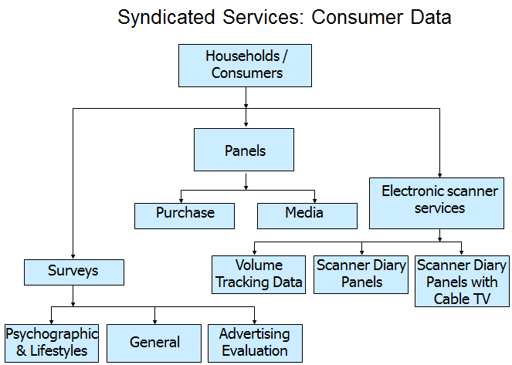

    - Syndicated Services: Institutional Data
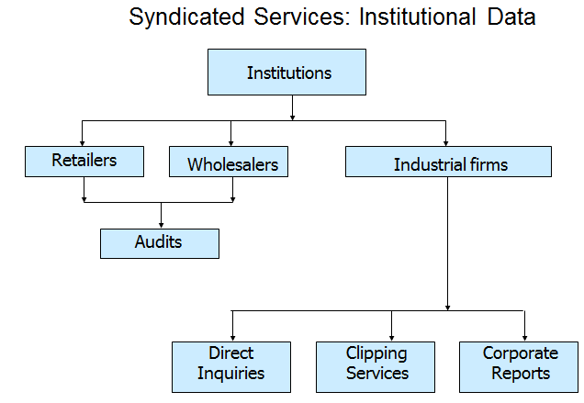

http://www.productscan.com/
….and some internet databases useful to marketers
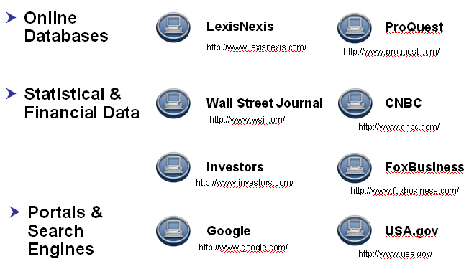
- Primary Data examples
  - ______________________________
    - Observational Data
      - Nielsen
      - TIVO
      - Web Cookies
  - _____________________________
    - Mystery Shopper
    - Videotaping
    - Ethnographic Research
      - MTV visits teens in “The Merchants of Cool”
    - Field Agent – A consumer app for Primary Data Collection!
      - Make money with your iPhone by completing _________ with Field Agent
      - What is it?

      - We’ve made it our mission to

  - Questionnaire/Survey Data (Questioning Consumers)
    - __________________________________
      - Individual Interviews
      - In-depth Interviews
      - Focus Groups
      - Fuzzy Front End techniques
        - “Unusual” ways to identify new, cool trends
    - __________________________________:
      - Personal Interview Surveys
      - Telephone Surveys
      - Mail/Fax Surveys
      - E-Mail/Internet Surveys
      - Mall Intercept Surveys
  - Question Formats
    - Open-ended
    - Closed-ended or Fixed Alternative
    - Dichotomous
    - Semantic Differential -- The response is give on a set of “____________ ___________________”:

    - Likert Scale -- Respondents rate their degree of ____________with a statement:

--All can be useful; the format needs to match the goal.
--Writing the question can be an “art” that critically influences the result!!
See http://knowledge-base.supersurvey.com/glossary.htm#loaded_question
  - Collecting Primary Data
    - ________________________________
      - An ongoing group of consumers or stores who agree to provide information
    - _________________________
      - Carefully control the “cause” (the “stimulus”, e.g., the ad, the price, the packaging, etc.) and measure the important “results” (the “dependent variable,” e.g., attention, beliefs, attitude, sales).
    - __________________________

  - Using information for ACTION – issues
    - Navigating information overload
      - New ways to govern, measure, and ___________________________ in the extended enterprise
      - Information Systems…On-going, organized procedure to generate, analyze, disseminate, store, and retrieve information for use in making marketing decisions.
    - Data Mining
      - Data warehouses can be analyzed the same way as databases (looking for predetermined patterns).
      - However, due to size, it would be a slow and cumbersome process
      - More advanced statistical and artificial intelligence techniques (called data mining) allow marketers to identify patterns and meaningful relationships!
      - Harrah’s Example:

- Step 4: Develop Findings
  - Analyze the Data
    - Using the appropriate techniques
  - Present the Finding
    - Communicated in a clear manner for ACTION

- Step 5: Take Marketing Action
  - Make Action Recommendations
  - Implement the Actions Recommended
  - Evaluate the Results

Video EXAMPLE – Frontline from PBS
MTV Using Marketing Research for Action!
- VIACOM’s crown jewel is MTV earning _____________________ in profits
- MTV’s Problem – _____________________________
  - No longer seen as cool or creative
- MTV’s Objectives:
  - How to get closer to the audience
  - How to learn what kids want and get closer to them
- The “data plan”-- Immerse themselves in ___________________________
- Learn what the consumer wants and deliver it to them!
  - To ensure the bond, MTV depends on Market Research!
  - Research to understand ___________________________________
- Collect RELEVANT INFORMATION --TECHNIQUES:
  - Ethnography study (Collection of Primary Data with Personal Observation)
    - Visit the fan in his home
      - Gain insight into the teenaged male
      - What issues are important them?
      - Dating
      - Parents
      - Stressors?
- Develop and Present the findings.
  - Captured on video and shown to the MTV insiders
- What happens with the research? What portrait emerges?
  - The _________________________..???!!!!
  - He is crude, loud, obnoxious, and in your face.
- And the ACTION…he influences a great deal of programming!
  - Tom Green
  - Daredevils
  - Spring Break
  - Comedy Central South Park
  - The Man Show
- Criticism -- Are we capturing the “person?”
  - Revenues depend on being ahead of the curve!
  - Professional Wrestling
- Huge with the audience

Chapter 9 -- Market Segmentation, Targeting, and Positioning (STP)

- Hewlett Packard – Printers (and more)
  - HP's Imaging and Printing Group (IPG) is "the leading imaging and printing systems provider in the world for printer hardware, printing supplies and scanning devices, providing solutions across ____________________ from individual consumers to small and medium businesses to large enterprises.“
  - How has it obtained this position?
  - History
    - The 1980’s
    - The 1990’s
    - The 2000’s
  - HP has been successful by finding _____________________________ them with appropriate products and services!!
  - FUTURE CHALLENGES:

- Markets
  - _______________________________________ -- Groups of customers with different wants, buying preferences or product-use behavior
    - For example, what do YOU look for in a vacation?

  - _______________________________________ – A market segment for which the seller chooses to design a marketing mix
  - Market Segmentation – The PROCESS of identifying and describing ___________________________ target markets
    - Market Segmentation involves ______________________________ _____________ into groups, or segments, that:
      - Have common needs, and
      - Will respond similarly to a marketing action.
    - We need to target our market segment by “positioning” our offer; BUT first we need to define and describe the target market in detail.
- Market Segmentation (another view)
  - The process of dividing the total market for a good or service into several smaller, internally homogenous (i.e., _________________) groups.
    - Members of each group are similar with respect to the factors that influence demand
      - For example 3 types of cars:

  - Segmentation Benefits and Challenges
    - More efficient use of marketing resources
      - Example
    - Can help to create rapid growth
      - Example
    - Challenges – Be Careful
      - Too much complexity can frustrate consumers
        - Example:
- Process of Market Segmentation
  - Identify _______________________ within a _________________
    - Market research is used to explore this with CURRENT and POTENTIAL consumers.

    - Cell phone Example -- What do people want in a cell phone?
      - Texting?

      - Web access
      - Gaming Apps
      - Camera (or video?)
      - Music
      - Fashion
      - Simple, low-tech
      - “Don’t Care”
      - Business Users
(10) For _________________________!

  - Identify the Characteristics that define the segment (what do prospective segments share that make them different from other segments with different needs/wants/desires?)
Example:

  - Determine the ____________________ of the segment and how well they are being ________________________ by current offerings
    - How large is the segment in terms of numbers, demand, and dollars (i.e., potential sales)?
    - How _________________ is their need (how dissatisfied are they with their current options)?
    - How __________________ is the existing competition?
    - FORECASTS can help to determine which segments are worth pursuing!
    - Note: See the textbook for “sales forecasting techniques” that may be very valuable here.
  - This should allow us to determine the size of the segment, the urgency of the need, and the strength of the competition…so, ____________ _________________ help determine whether or not this segment seems to be appealing for us
- Market Segmentation Conditions that indicate a useful segment
  - The segment is Measurable and we can ____________________ data about the segment
Example:

  - Is the segment ______________________________?
e.g., The Cleveland Plain Dealer:
  - Is the segment _______________________ to be profitable for us?

    - Creating a new product/service, advertising it, distributing it, facing down competition is all ______________________________.
    - Is there enough size, demand, and sales to provide the ________________ we will need?
    - In some cases, we can be successful by treating EACH customer as a separate segment through __________________________________.
Examples:

- Market Segmentation – Grouping Buyers into Segments
  - Based on the Customer’s reason for __________________________?
    - _______________________ -- For personal use = Final Consumer
    - _________________________________ -- To use in the organization, to resell, or to make other products
--Black and Decker and DeWalt Example:

Video: Felber on Market Segmentation at Felber & Felber
        - Felber & Felber has focused on the _____________ segment
        - There are many manufacturing companies doing well
        - Felber & Felber only needs a few of these to FOCUS on with their specialties
        - Green Marketing and Early Stage Clients
        - They apply what they learned from other clients to this segment
However, while useful, this is too broad…so look at Consumer Market segmenation….
  - Bases for Segmenting Consumer Markets (from the figure):
    - Geographics (Region, Size, Urban-rural, Climate)
    - Demographic (Income, age, gender, family life cycle, social class, education, occupation, ethnic background)
    - Psychographics (e.g., VALS)
    - Behavioral segmentation (Benefits desired, usage rates)
    - Usage Rate
Examples:
      - ___________________________________________ (by Age )

      - Psychographic Segmentation
        - As the American population becomes more diverse and affluent, demographic researchers are changing the way they define segments of American society.
        - _____________________ has defined 14 distinct groups of consumers based on recent Census and consumer data that emphasize income, age, and lifestyles. Segments of each group buy the same types of cars, read the same magazines, and watch the same television shows.

L I F E S T Y L E

URBAN  I  N  C  O  M  E | SUBURBAN | SECOND CITY | TOWN & COUNTRY
Urban Uptown | Elite Suburbs | Second City Society | Landed Gentry
Midtown Mix | The Affluentials | City Centers | Country Comfort
Midtown Mix | Middle-burbs | City Centers | Middle America
Urban Cores | Inner Suburbs | Micro-City Blues | Rustic Living

- Claritas’ 14 segments are divided into 66 smaller clusters.

For more, see: USA Today – Who We Are: Redefining our demographics
http://www.usatoday.com/news/graphics/whoweare/flash.htm
http://www.claritas.com/MyBestSegments/Default.jsp

        - Useful for direct-mail promotions, retail outlet selection, decisions about the mix of products/brands to offer in the area.

      - Behavioral Segmentation
        - ___________________ is an “ideal” approach, but often hard to measure
          - Example: What are the benefits of wearing clothing that has label on the outside?
          - Citicard example:

      - Usage Rate
        - Non-users
        - Light users, medium users, heavy users
          - Example:

- “Traditional” Target Market Strategies
  - ___________________________________________ (mass-market, undifferentiated market, one size fits all)
    - Use a ___________________________________ for everyone – A “shotgun” approach…. VERY UNCOMMON; perhaps some _________ ___________
    - Potential Advantages;
      - Lower ______________________________________, and
      - Easy to _________________________________________
  - ________________________________ Strategy
    - Product differentiation involves using different elements of the marketing mix to help consumers see the product as being different from the competition, and “better” for the consumer
    - Apple example:

  - Single-Segment Strategy (_____________________________)
    - Create a single marketing mix which targets a single, well defined group
    - Can be a good way to __________________ in the broader market
      - Examples

    - The marketer can earn a reputation as an _________________ or a _________________________ in this ____________________ market
    - Niche markets are often (though not always) relatively ________________________________

        - Example:

    - So, this is one way for a firm with ______________________ ___________________ to be competitive!

    - CAUTION: A danger of this approach is that you are ______________ __________________ ______________________
      - Example
  - _____________________________________
    - Identify MULTIPLE segments, and develop, market, and manage MULTIPLE marketing mix offering attempting to satisfy the needs, wants, and desires of EACH segment with a “_______________” marketing mix.
e.g., Bayer HealthCare Products
    - Advantages:
      - Eliminate or reduce _______________________________
      - Become _________________________________________
_____________________________________________________
    - Disadvantages:
      - Higher ____________________________________________
      - Higher ___________________________________________
      - Higher __________________________________________
      - SO,
For example it is estimated that _________________________
_____________________________________
Examples: Gap Clothing Segmentation and Jeans segmentation

  - Example: Muller on Segmentation at Timken
    - Primarily by industry
      - Primary metals
      - Wind energy
      - Power generation
      - Cement
      - Automotive
      - Off highway construction vehicles
    - And then further with micro segmentation
      - Short lead time
      - Longer life
      - More productivity
    - Challenge to discover the segment’s needs and to create a mix for each
- Example: Bayer Consumer Products Example (http://www.consumercare.bayer.com/scripts/pages/en/our_brands/index.php)
    - Background
        - Employees: 6,600
        - Activities in more than 100 countries
        - Sales: Over EUR 2 billion
        - More than 170 brands worldwide
        - Global Headquarters: Morristown, NJ
        - Bayer HealthCare's OTC brands are manufactured around the globe in Europe, North America and Latin America, as well as in Asia.
      - _______________Major Segments
        - Analgesics: Bayer Aspirin, Aleve, Aktren, and Midol
        - Gastrointestinal: Alka-Seltzer, Lefax, Phillips Milk of Magnesia, Rennie, and Talcid
        - Dermatological: Bepanthen, Bepanthol, Canesten
        - Cough and cold remedies: Alka-Seltzer Plus, Aleve Cold & Sinus, and Tabcin
        - Multivitamins and dietary supplements: Berocca, One-A-Day, Flintstones (complete, gummies, plus, my first Flintstones)
      - Two Major Segments within ___________________________________
        - Aspirin Regimen
        - Aspirin for Pain Relief
http://www.bayeraspirin.com/products/products.htm
        - Multiple offerings within each segment
- Selecting a Target Market – Guidelines
  - BEFORE selecting a segmentation strategy, determine the __________________ of the segments.
  - Is the segment’s needs ____________________ with the company’s goals
    - Example:
  - A good ______________ with the company’s resources
    - Example:
  - ___________________ that justify the investment
    - The segment must be _____________________________
    - The segments should be expected to ________________________
    - We can reach the segment at a ___________________________
      - Example:

  - Competitors are _____________________________________

- Positioning the Product
  - Creating and maintaining in the minds of target market consumers a particular image relative to competing products
    - Example:
      - The NAME
      - Its ads
      - The dentist recommendations

  - Consumers often form mental “____________________” for brands that will simplify their decision making – we want to _________________________
  - Three steps to Positioning a product
    - Select a ____________________________________ based on what is important to the target consumers.
-- Answer the question, “What will you do for me that ____________ ______________________________?”
Dove:
    - Design the ______________________________ that conveys the position

--Done well, this embodies your “__________________________” (USP).
--Your USP __________________________ your product from the competitors, on a feature that is ______________ to consumers.
--Examples are having the lowest cost, the highest quality or being the first-ever product of its kind.
--A USP could be thought of as “what you have that ________________ don’t” (that is of importance to your consumers).
    - Coordinate ALL ___________________________ to convey the position to the target consumers
Examples:
___________________: "You get fresh, hot pizza delivered to your door in 30-minutes or less…or it's free."
______________________: "Expect more. Pay less."
U.S. __________________: "The toughest job you'll ever love."
______________________: "Melts in your mouth, not in your hand."
______________________: "When your package absolutely, positively has to get there overnight."
____________________ Jewelers: Open Hearts collection

  - The Perceptual Map as a product positioning tool
    - Step 1 -- Analyze the Map and select the ______________________
    - Step 2 -- Design the dimension or the product feature that most effectively conveys the ____________
    - Step 3 -- Coordinate the marketing mix components to convey a consistent position to the target audience
    - Of course, this can only work if it is a “good” segment and all the segmentation criteria are met!
- Positioning Errors
  - __________________________
    - Failing to position the brand very well.
      - Examples:
  - _____________________________
    - Giving buyers too narrow a picture of the company.
      - Example
  - _____________________________
      - Claiming two or more contradicting benefits OR changing positions often
      - Leaving buyers with a confused image of a company.
        - Example
- Basic Positioning Platforms (and examples)
  - Premium Positioning or status symbol
  - Value for money
  - Friend / family values /warmth
  - Problem Solver
  - “Fun”
  - Trendy / stylish
  - Role model/ user imagery (reliability, trust, quality, premium); Celebrity endorsements
  - Anti-establishment / rebel
  - Technology leader / Innovation
  - Service Leader
- NOTE: It would be simplistic to look at these platforms as independent and exclusive. Many brands can (and do) span more than one platform.

Chapter 10 -- Developing New Products and Services

PROMOTION
PRODUCT
PLACE
PRICE
CONSUMER

- New Products? Who needs ‘em?
Examples:

- Great New Ideas are the cornerstone of business success
  - Price Waterhouse Coopers
    - 50% or more of plausible business ideas come from customers, competitors, and suppliers.
    - The rest? ____________________________________
    - The Challenge!
  - How can we stimulate ______________ to make suggestions? and,
  - How can we _______________________ to find promising ideas?

  - Imaginatik – Idea Central

- Understanding the terms
  - What is a “product”?
    - A set of ____________________________________________
    - May be a __________________________________________
    - Which provide satisfaction of ______________________________ in the form of ___________________________ .
    - And is exchanged for ___________________ (or some other unit of value).
  - The “Total Product”
    - A Broad spectrum [bundle] of tangible and intangible benefits
    - Primary Characteristics:
      - Basic features of the ________________________
    - Auxiliary Dimensions ________________________
      - Example: Crest Complete

- 
Core Product – Crest Toothpaste
Understanding the terms
  - Product Line
    - A group of closely related products that _________________:
      - a class of needs,
      - are used together,
      - are sold to the same customer group,
      - are distributed through the same type of outlets,
      - or fall within a given price
    - EXAMPLE: Product Lines at Church & Dwight Co. Inc.
      - Personal Care lines:
        - Antiperspirants & Deodorant
        - Eye Care
        - Fertility
        - Hair Removal
        - Nasal Care
        - Oral Care Products
        - Ovulation
        - Wound Wash
      - Household Product lines:
        - Baking Soda
        - Deodorization
        - Fabric Care
        - Household Cleaners
        - Pet Care Products
        - Wood Care
  - Product Mix
    - The number of _______________________ offered by a company.
  - Width of Product Mix
    - The number of product lines carried (Church & Dwight is broad; Spyder Paintball is narrower)
  - Depth of Product Mix
    - Average Number of Products in __________________________.
  - Consistency of Product Mix
    - How similar are our product lines?
    - PRODUCT MIX EXAMPLE:

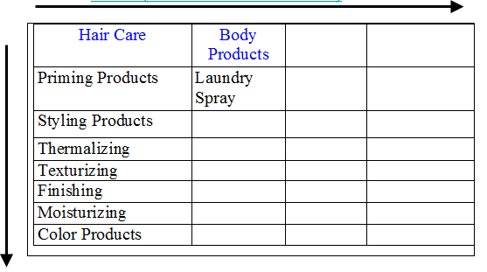

Hair Care | Salty Snacks | Dental Care | Soft Drinks
Shampoo | Chips | Toothbrush | Colas
Conditioner | Nuts | Toothpaste | Ginger Ale
Hair Spray | Crackers | Dental Floss | Root Beer
Comb

- Classifying Products
  - Consumer Goods
    - products purchased by the _______________________ consumer.
    - Based on Durability/Tangibility Classification (goods-services continuum)

    - Based on CONSUMER’S Interest
Willingness to Expend Effort for the Product
LOW
HIGH

    - CONVENIENCE PRODUCTS
      - Characteristics:
        - Relatively Inexpensive
        - Purchase is regular and recurring
        - Little Thinking Involved
        - Minimal Shopping Effort
        - Bought a most convenient location
        - “Staple” products, like groceries, and
        - Impulse purchases (candy bar?)
      - STRATEGY:
        - Make available in every possible place
        - Must be visible inside the store
        - Distribution is a major marketing mix factor
        - Easy substitution by similar brands (consumer will accept another brand)
        - Extensive advertising is used
    - Shopping Products
      - CHARACTERISTICS:
        - Product comparisons occur
        - Consumer seek information
        - Decisions are based on thought
        - Relatively higher prices
        - Often technology or fashion oriented
        - Monetary & social risks
        - Brand loyalty may be found
      - STRATEGY:
        - Selective distribution
        - Consumers will seek products in less visible locations
        - Product attributes and Quality are important
        - Product differentiation is possible
    - Specialty Products
      - CHARACTERISTICS:
        - Substitutes are not accepted
        - Infrequently purchased
        - Extensive Search
        - Brand loyalty may be strong
        - Loyalty to retailer may be as important as brand selection
        - May travel great distances to acquire
      - STRATEGY:
        - Limited distribution
        - Consumers will seek products regardless of location
        - Extensive product and price differentiation
        - Strong brand image
    - Unsought Products
      - CHARACTERISTICS:
        - Consumer does not know about or does not want the product (initially)
        - Interest is likely caused by a “sudden or unexpected problem” (rain = umbrella; death = funeral plot)
        - The consumer is not likely to be loyal and will accept substitutes
      - STRATEGY:
        - Limited distribution
        - Need to advertise so consumers are aware when the need arises
        - May require persistent and aggressive advertising and selling approach
Example: Spectrum Brands Segmented based on Consumer Markets

  - _______________________________
    - Products that assist directly or indirectly in providing products for resale. Also called B2B goods, industrial goods, or organizational goods.
      - Manufactured materials and component parts: (electrical resistors, screws, electric motors, computer chips, spark plug)
      - Process materials (raw materials): used in production, become part of finished product (chemicals, wood, wheat, cotton)
      - Installations: primary production equipment and major capital items (buildings, computer hardware, assembly lines, oil drilling rig)
      - Accessory equipment: (Copiers, office equipment, cell phone, hand tools)
      - Maintenance, Repair, and Operating Supplies: facilitate routine operations (writing paper, staples, tape, Post-it notes)
      - Services: intangible product provided by others to facilitate the firm’s production and operation (maintenance, repairs, trucking, security service, legal advice, consulting)
- Product Development
  - The development of _______________________
  - The continuous improvement of ___________________________
  - WHY bother?
    - Any company that does not innovate will eventually be crushed by competition or abandoned by its consumers
    - “____________________________________________________!”
    - EXAMPLE: Innovation at two very different companies
      - GOOGLE
        - Ideas come from everyone in the company – even the finance team.
        - Open information on every project – every idea, every deadline.
        - Favor intelligence over experience.
        - Employees get a free day each week to innovate – 50 percent of new products come from this time.
        - Don't politic for your idea, use data – eliminate ‘I like' for real data.
        - Give people a vision, rules how to get there and deadlines – creativity loves constraints.
        - Simple to use and easy to love – the money will follow this.
      - Whirlpool
        - Stick with it – it can take up to six years to attain a big payback.
        - Innovation alone is not enough – need operational excellence as well.
        - Be highly practical – inventions have to be something someone will buy.
        - At Whirlpool, sales from new product ideas less than 5 years old were less than $30 million; today they are more than $1.2 billion!!
- Differing Perspectives of New Products
  - Newness Compared with Existing Products – “_______________________________________”
  - Newness in Legal Terms—for ____________________________ ________after “regular distribution”
  - Management perspective:
    - New-to-the-world products (true innovation)
      - High Risk
    - Product category extensions
      - Diversification into an established market for an existing product--BUT, ____________________________________ _______________________________________
    - Product line extensions
      - Additions to _________________________
  - Consumer Perspective:
    - ______________________ innovations
      - Variations of existing products
      - No behavior changes or new learning
    - ___________________ innovations
      - Improvement of existing products
      - Minor behavior changes, some new learning
    - _____________________ innovations
      - New function
      - Major behavior changes and education needed

- What it takes to launch ONE commercially successful new product

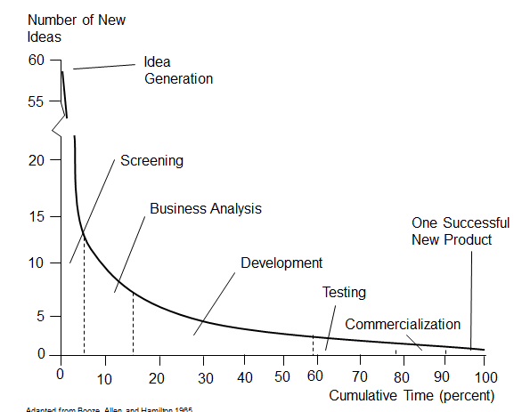

- Characteristics of Success for a New Product
  - _______________________________
    - An enhanced bundle of benefits
  - __________________________
    - Similar usage or consumption, patterns, and values
  - _______________________
    - Opportunity for buyer testing through sampling or divisibility
  - ________________________
    - Buyers see the newness
  - ____________________________________
    - Complexity is a disadvantage which slows diffusion
  - A good marketing mix, well executed

- Stages in the New-Product Development Process

Salespeople
Dealers
Customers
Engineers
R&D
Competitors
Trade Shows
Ad agencies
Market Research
U.S. Dept of
Commerce
Patent Office
Licenses
Private Labs
Independent
Inventors
University Labs
Stage 1

Search for
New Product
Ideas
(idea generation)

To Stage 2

Video: Fred Hunt on a New Product Idea for at Sherman-Williams
  - Marketing is very much focused on the ______________________
  - At Sherwin-Willams we ___________________________________
  - How the conversation resulted in _____________________________
  - We know that our “do-it-yourself consumer is mostly _________________
  - She knows what she wants and she makes _____________________________
  - She was doing the actual ___________________________________________
  - BUT, she has a few things that she was __________________________________
  - SO, we did some ___________________________________ to watch what she was doing when she got the product home.
  - We found that she had problems with (a) ________________________________ (b) _________________________________ and (c) _______________________
  - We thought about the innovative idea of making the process ___________________.
  - From this came the _________________________________ paint can.
  - It has a Wide handle, a Twist Off Top, and a Spout!!
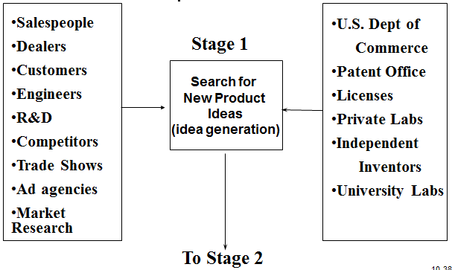
  - A Classic Story of

INTERNAL

- Initial Evaluation of Market Potential
- Initial Evaluation of Market Potential
- Check product fit in company mission and competencies
- Consider Effects on other products
INTERNAL

- Raw materials supply
- Patent position

EXTERNAL
- Concept Tests

Screening and Evaluation

Stage 2
To Stage 3
INTERNAL

- Check against customer needs
- Establish target market
- Check competition’s position
- Develop target position

- Develop initial product specifications
- Perform economic analysis
- Revise and refine as needed

Business Analysis

Stage 3
To Stage 4
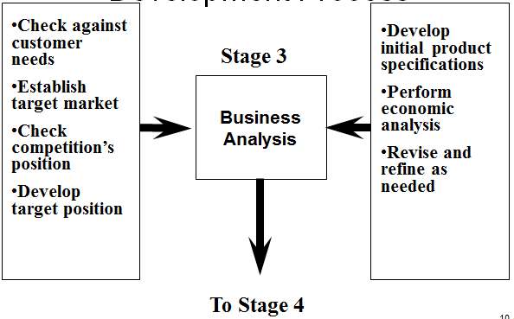

Supply chain process
Manufacturing process
Manufacturing Control system process
Marketing programs

Update costs and financial plans
Ensure target costs are met

Development

Stage 4

To Stage 5

Create Prototype
Lab Testing
Customer Use Tests
Customer reaction to planned marketing mix

Feedback and Revision
Re-test by customers
Re-evaluation against competition

Development
&
Testing

Stage 5
To Stage 6a
Test Market
To Stage 6
Commercialization

Test promotion methods
Check repurchase rate
Test media mix
Measure Trade Acceptance
Test prices

Build product inventories
Develop additional distribution channels
Revise as needed
OR
Simulated Test Marketing

Market
Testing

Stage 6z
To Stage 6

Ramp up Production
Ramp up purchasing
Activate Quality focused control systems

Mass training of sales or service personnel
Dealer meetings
Trade and customer ads
Press conference

Launch
(Commercial-iziation)

Stage 6
To Stage 7

Analyze sales data
Analyze profits
Revise promotion mix

Adjust product specs
Reallocate sales force
Phase out weak items

Evaluation

Stage 7
Continuous Improvement

- Why New Products Fail
  - No Competitive ___________________
  - ________________________ Reaction
  - Badly ________________
  - Poor Quality
  - Does Not Deliver Promised ___________________
  - Too Little Marketing Support (SYNERGY!)
  - Low Perceived _____________________
  - Bad Estimates of Market Potential (or other marketing research errors)
    - --Forecasts are dangerous, especially those about the future!!!
  - Poor estimates of Production &/or Marketing Costs
  - Poor Selection of Marketing Channels
  - Rapid Change in the Marketing Environment
- ..so Research, Research, RESEARCH!!
- Thinking about research and sample size…
  - http://www.robertniles.com/stats/sample.shtml

Chapter 11 -- Managing Successful Products, Services, and Brands

- Introduction – Starbucks
  - The Early Years
  - Growth
  - Managing the product and brand extensions.
  - Starbucks Logos
  - Starbucks Competition

- The POINT: Changing __________________ AND _________________ REQUIRE marketers to actively and successfully ________________ their products and brands!

- Product Life Cycle
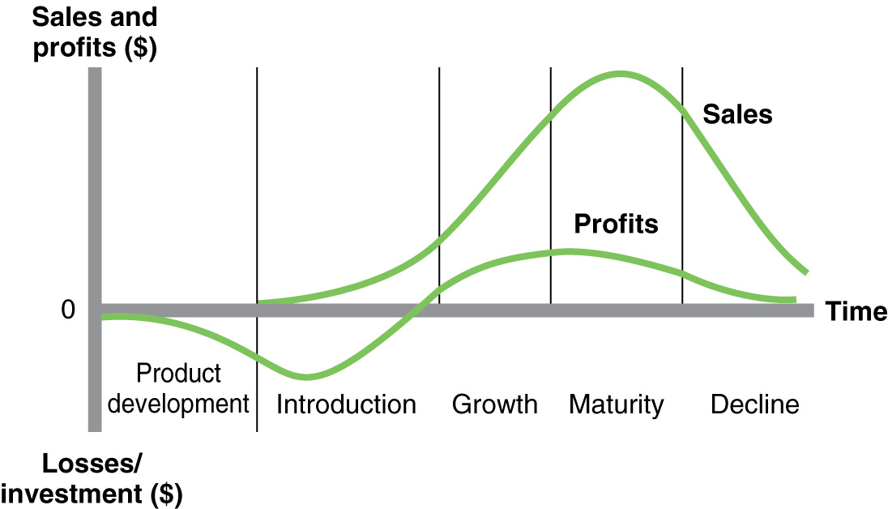
  - The PLC shows the ___________________________ over an extended period of time for all brands comprising a generic product category.
  - PLC and profit curves varies from product category to another, but above is the __________________________ that we often see.
  - Note the ________________ profits. Sales are needed to offset product development costs
  - As we move through the PLC, we must increase advertising and selling efforts and cut prices in face of __________________________.
  - Deciding when to enter a market can IMPACT __________________.

- PLC Characteristics and Implications

  - Characteristics Introduction Growth
  - Customers Innovators To the masses
  - Competition Little Increasing
  - Sales Low Rapid Growth
  - Profits None Strong & then peak

  - Marketing Implications
  - Overall Strategy Market
Development Penetration
  - Costs High per unit Declining
  - Product Strategy Undifferentiated Improved features
  - Pricing Strategy High Lower over time
  - Distribution Strategy Scattered Intensive
  - Promotional Strategy Awareness Brand Preference

  - Characteristics Maturity Decline
  - Customers Mass market Loyal Customers
  - Competition Intense Decreasing
  - Sales Slow Declining
  - Profits Declining Low/none

  - Marketing Implications
Overall Strategy Defensive Efficient or exit
  - Costs Stable Low
  - Product Strategy Differentiated Pruned line
  - Pricing Strategy Lowest Increasing
  - Distribution Strategy Intensive Selective
  - Promotional Strategy Brand Loyalty Reinforcement

  - WHY do brands decline?

    - Better or ______________________________________
    - The need ______________________________________
    - Most competitors abandon the market, BUT
    - Some can develop small successful niche businesses.

- Length of Product Life-Cycle
  - The PLC diagram suggests that stages are of _____________ length (this may not be accurate)…certainly ______________________________
Examples

  - Extended introduction stage
  - Fad
  - Indefinite Maturity stage

  - The Product Life Cycle is getting shorter for most products due to:
    - ________________ (“me-too”)
    - Technology advances
  - The Product Life Cycle can be affected by
    - The Product Category and __________________
      - Example

    - Differences in _________________________________________
      - Example
- Product Life-Cycle Management
Successful marketers need to do well at:
  - ________________________the PLC for their product, and
  - Recognize what stage they are in and ________________________ to it.
    - ISSUES: When to enter?
  - Entry Strategies
    - When is there a Pioneering Advantage?
    - An imitation strategy may be better!
  - Managing on the Rise

  - Managing During Maturity

  - Surviving the Decline

      - During the decline stage firms may:
        - Ensure that marketing and production programs are _____________________ as possible,
        - Prune _____________________ sizes and models which decreases sales but increases profits,
        - Run out the product to squeeze out final profits, or
        - _________________________ (best and toughest route)
- Brands
  - The word “brand” is comprehensive
  - Brands are used both to _________________ the seller and to __________________ the product from competition.
  - Brand Name --Words, letters, numbers that can be vocalized
    - Examples
  - Brand Mark – Symbol, design, color, lettering
    - Examples

  - Trade Mark – The Legal Protection of a brand
Companies Protect their Brands
    - Example
  - Leading Brands
    - Examples

--Why Brand?
  - Reason for Branding from the consumer perspective
    - Brands make it easy to ___________ goods or service
    - Brands help assure consumers of __________________.
    - Brands make shopping ____________________________.
  - Reason for Branding from the marketer’s (seller’s) perspective
    - Brands provide a ________________ for promotion.
    - Brands allow for recognition and ___________________
    - Brands help to reduce the importance of _________________
  - Are the benefits worth it??
      - Example
  - BusinessWeek’s -- Top Global Brands
(also see Best Global Brands Summit 2009 http://www.youtube.com/watch?v=8f2crqqTglI )

Top Global Brands 2011 | Top Global Brands 2012
1. Coca Cola | 1. Coca Cola
2. IBM | 2. Apple
3. Microsoft | 3. IBM
4. Google | 4. Google
5. GE | 5. Microsoft

  - Why aren’t ALL products branded?
    - Branding brings responsibilities that some companies do not want:
      - Brands require expensive ____________________
      - Brands require maintenance of _________________________
      - Branding does not make sense if the product cannot be physically _____________________
- Selecting a Brand Name
  - Good Brand name
    - Contributes to the product’s success
  - The Challenge
    - Finding a _____________________________
    - Running out of name possibilities as ___________________ products are launched a year!
    - Many dictionaries only have 50,00 words
  - Solutions?
    - Combine _________________________________
    - Use ______________________________________________
  - A Good Brand name should suggest the _______________ or use of the product
      - Example:
    - Should be ____________ to pronounce, spell, and remember
      - Example:
    - Should be _________________
      - Example:
    - Should be adaptable to product line _________________
      - Example
    - Can be registered and legally protected
- Protecting a Brand Name
  - Product counterfeiting
    - Intellectual Property Theft costs companies ____________________ and costs 750,000 jobs in the U.S.
Examples:

    - Product Counterfeit Example:

  - Generic Use of the name
    - Becoming generic
Examples

      - No simple __________________________________, and

    - Protect by:
      - Indicate _________________________
      - Use brand with ________________________, and
      - ___________________________
  - Online Brand Monitoring

    - Warning signs of Brand Counterfeiting behavior:
      - _______________below acceptable levels
      - Lack of good contact information
      - ______________ service and warranty information
      - Inaccurate product descriptions
      - Products sold on sites not registered to the seller
      - Sites with unsecured transactions

- Producer’s Branding Strategies
  - Producer’s Own Brand
    - Done by _________, well financed, and well _____________ firms
Examples:
  - Branding of Fabricating Parts and Materials
    - The producer attempts to develop a market preference for its branded parts or materials
      - Works when the product is also a _____________________________ that is bought for replacement.
      - OR when the part is ______________________________
  - Producing Middlemen’s Brands (Private Label)
    - A widespread strategy _________________________________
    - The hope is that the _________________ brands will appeal to loyal customers, while the cost conscious will buy the less expensive __________________________________________________
- Middlemen’s Branding Strategies
    - The middleman may choose to only carry only the _____________ Brands
      - Avoids the Branding Responsibilities
    - May choose to carry BOTH the Producer and ___________________________ brands.
Example:
      - The hope is to create _______________ and to create better profit margins!
      - _______________ say they plan to place more emphasis on private label brands.
    - Manufacturer Responses:
      - Cutting prices
      - Convincing consumers of their brand superiority
      - Pruning product lines
      - This sets up the “Battle of the Brands”
- Strategies Used by both Producers and Middlemen
  - Branding within a product mix
    - A _____________________________ for each product
    - ______________________________ The company name combined with a product .
  - Branding for Market Saturation

Example
  - Co-branding
    - Two or more brand names on _______________________
    - Dangers
      - Overexposure
      - Risk to both brands if ___________________________
- Brand Equity
  - The value a brand adds to a product over __________________________________________________
    - Examples:
  - Brand Equity provides a number of benefits:
    - It provides a _______________________to buy
    - It is a ______________________ to competition
    - Facilitates international _______________________
    - Helps product survive a crises
  - Brand Equity does have limits
Example:
- Trademark or Brand Licensing
  - Owner grants permission to other firm to use the brand name and brand mark on products
    - Benefits to owner
      - ___________________ and
      - Brand _____________________
    - Benefits to Licensee
      - Improved likelihood of new product success
      - Reduced marketing costs
- Packaging – CNBC “The Entrepreneurs” example
  - Jason Osborn and Jason Wright
    - “If the next guy can do it, I can do it better!”
  - The “back story”
  - The product needs a name
    - They came up with 20 or 25 names
    - They pick “FEED.”
      - It describes the product.
      - It is simple.
      - It stands out from the 1000’s of other products.
  - The beginnings of a new brand are born
  - The product gets “rave reviews.”
  - Now, growing their business involves several steps:
    - Writing a business plan,
    - Getting a loan,
    - Incorporating
    - AND
    - More sophisticated packaging
  - Now it is time to give the brand a STRONGER IDENTITY
    - You have 1 second to get the customer’s attention
    - You want your brand BIG and MEMORABLE.
    - Goal: To SIMPLIFY the packaging
  - Consult a “Branding and Identity Expert”
    - What is working and what is not?
    - Problems:
      - Hard to read
      - Busy
      - Image is vague
    - It IS legible
  - The NEW package:
    - Simple.
    - Keeps true to the product idea.
    - It showcases the product well.
  - NOMINATED FOR AN AWARD FOR THE PACKAGING!
  - And the WHOLE FOODS chain becomes interested!!

Chapter 12 -- Services Marketing

Introduction

“Ruby Tuesday Blows up Wrong Restaurant”

The Point
In SERVICES marketing, the “casual dining segment” HAS become a “sea of sameness!”

The industry is not longer providing customers with “Value.”

- Services are a Major Factor in the U.S. economy in dollars and in jobs
  - Over ______________________ and _______________ million jobs!
See Figure 12-1 page 296.
- SERVICES Defined
  - Services are the __________________________ or ________________ that an organization provides to consumers in exchange money or something else of value.
- Increase in Services Influenced by:
  - Organizations’ focus on productivity and profits

  - Consumers’ ______________________________
    - Personal Shoppers
    - Take out food
    - House and lawn care
- Affecting virtually all industries:
  - Location--ATMs, branch outlets, branch warehouses, JIT delivery
  - Longer Business Hours
  - Better trained sales and service people
  - One-stop shopping
  - Improved customer service systems (personal, phone, on-line)
  - More information available--before, during, and after the sale
  - ADDS VALUE beyond issues of price and product quality
- THE UNIQUENESS OF SERVICES
  - Four I’s of Services
    - _____________________
      - Services cannot be
      - SO it is harder to
      - Communications must make these
      - Setting Price can be hard
    - _______________________
      - Lack of standardization;
      - inconsistent delivery and quality depending
      - Minimize by employee selection, training, and
      - service performance standards.

    - ______________________
      - Simultaneous production and consumption means
        - consumers are a part of the service process;
        - We must manage the interaction for customer satisfaction;
        - educate consumers about the service process and their role in it.
    - ________________________
      - Services cannot be inventoried, so it is hard to balance capacity and demand;
      - cannot return service for credit or exchange;
      - need to manage demand in peak periods; use capacity in off-periods
      - Idle production capacity

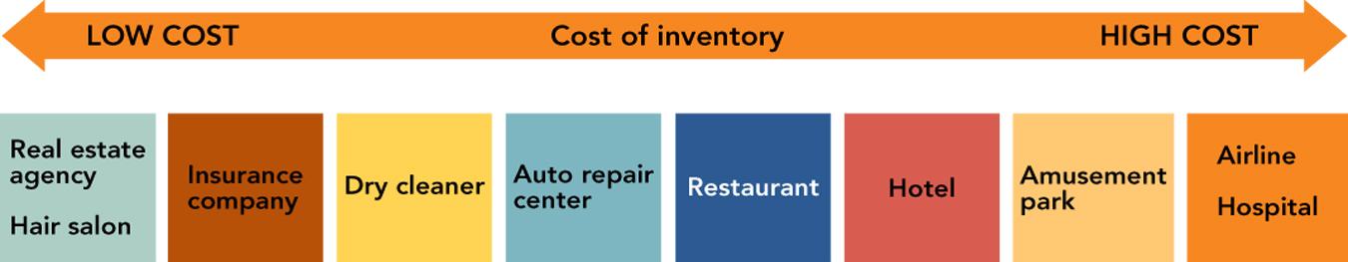
- Inventory carrying costs of services depend on the cost of employees and equipment

- Levels of Service
  - Core/Primary Services
    - The major activity of a business (or nonprofit organization).
      - Example: Investment Services provide the use of a brokerage account to buy and sell stocks

  - Ancillary Services
    - Expected or optional supplements to the primary purchase.

    - Ancillary Services expected in B2B marketing

- Service as Value
  - Consumers & Organizational Buyers want:
    - Quality products
    - Right price
    - Qualified Sales/Service personnel
    - Maximum benefits
    - Minimum effort
    - Low wait times
    - In other words, they demand _____________________!
        - Example: The Casual Dining Industry stopped providing “value”
        - Casual Dining restaurants provide full-service, alcoholic beverages, and CHECK AVERAGES from $10 to $23 per person.
        - COMPETITION from “fast-casual” chains are stealing customers
        - Fast-casual chains have no waiters and higher quality food than fast food chains.

- VALUE...
  - …an intangible concept often defined in terms of
    - exceptional _______________________________
    - exceptional ______________________________
    - value-based ________________________
        - Example: Casual chains learn from recession
          - During the recession many consumers pulled back on their discretionary spending, which meant eating out at restaurants less frequently if at all.
          - While economic conditions have begun to improve in the U.S., many consumers are still watching their wallets - preferring to eat at less expensive casual dining chains over pricier upscale restaurants.
          - Restaurant operators were poorly positioned heading into the recession in 2008 because they had too restaurants.
          - But the dining chains learned. 30,000 restaurants have closed since then and companies focused more on improving their menus, service and the atmosphere at their storefronts.
          - In 2007, the industry's mentality was “build it and they will come,” but today successful restaurant companies are driven by a guest-centric planning process.
          - That is, casual chains are returning to a “value service proposition.”
- Competitive Positioning
  - Service Image is conveyed by the firm’s “service products.”
    - The dimensions used should be those valued by the customers.
      - Example: What DO consumers want in Casual Dining?
        - Stand for something UNIQUE
          - Cheesecake Factory

          - Outback

          - Olive Garden

        - Lower Prices
        - BETTER FOOD
          - Casual dining was initially successful because it provided better food quality than fast food, at a very reasonable price
          - Recently, fast food’s quality has gone UP with prices rising only slowly
          - BUT, casual dining’s price have risen while food quality and innovation has stagnated!
          - RUBY TUESDAY is upgrading its food, but it prices are still pretty high.
        - IMPROVED SERVICE
            - Slow service
            - Discourteous staff
            - Are NOT what consumers are looking for!!
              - Chili’s is trying to cut 15 minutes from its 45-minute lunch by testing BlackBerry’s that connect directly from the server to the kitchen.
              - Chili’s is also improving its employee hiring practices
              - And the staff is wearing more professional looking aprons
        - Better looking stores
            - Most stores are 20-years old!
              - Ruby Tuesday has redesigned all of its company-owned stores with contemporary designs and lighter colors.
              - Lone Star is replacing concrete floor with wood and is installing oak tables.
            - Get kid-friendly
              - Families are a big part of the casual dining industry’s market
              - Could restaurants have kid playgrounds? Loaner hand held video games?

- Service Leadership or Follow the Leader?
  - Will you set the service standard or wait for competitors to set the standard and then follow their lead?
    - Example:
- Benefits of Exceptional Customer Service
  - Exceptional Customer Service can _______________________ from Competitors
    - Services attract & keep customers
    - Services and recover lost sales
    - Service quality is related to customer satisfaction
    - Customer Service usually leads to a profitable ROI in the long term
- HOW CONSUMERS PURCHASE/EVALUATE SERVICES
  - The Purchase Process
    - ________________ Properties
      - What consumers can judge prior to the purchase
        - Price, location, appearance of physical facilities, paperwork, interactions with the service provider’s staff
    - __________________ Properties
      - Attributes discernable only during or after the service experience
        - Physical comfort; staff concern
    - _________________ Properties
      - Attributes inferred from a subjective evaluation of the entire process.

- Consumers use search, experience, and credence properties to evaluate services (Figure 12-5)
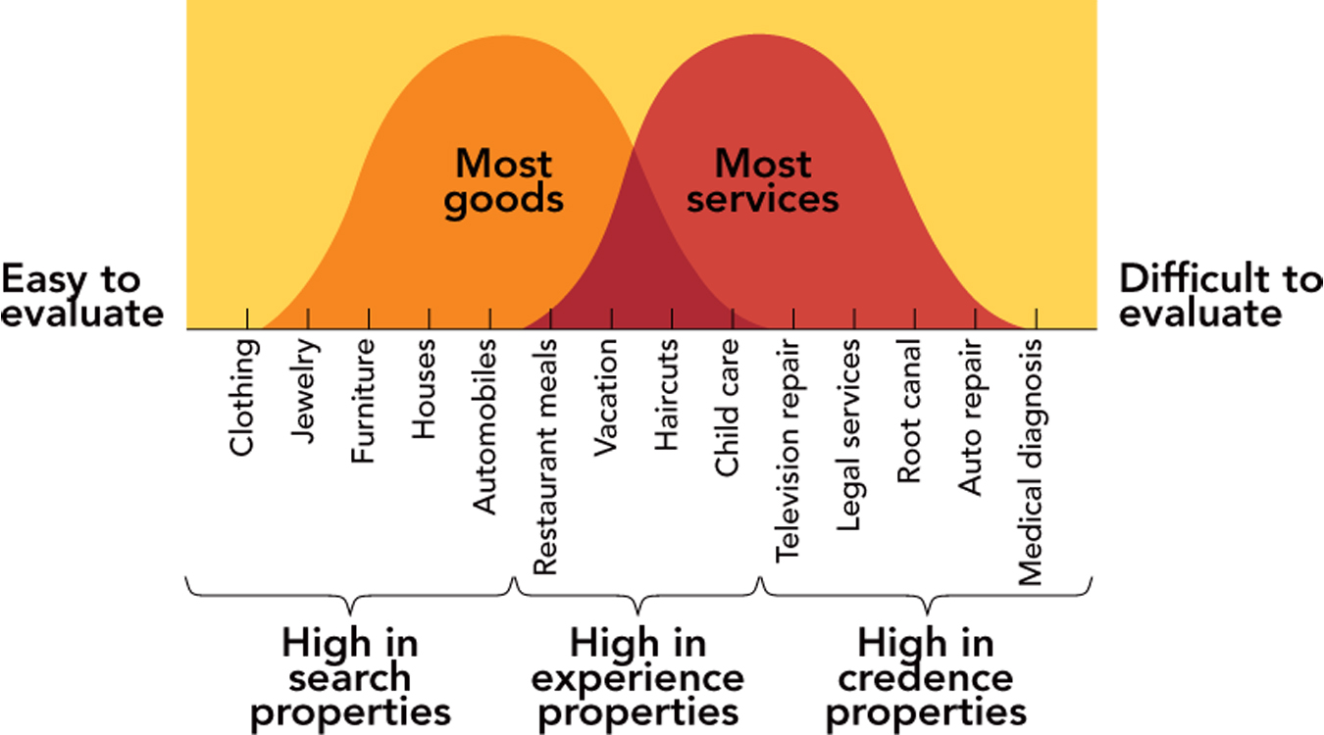

- The Service Design Process
  - Customer Targets
    - What do they want?
  - Nature of the Service
    - Complex (medicine, investments) = substantial support services and highly qualified customer contact people
  - Pricing?
    - Who is the target?
      - How much and how often do they buy?
    - What is the type of service?
    - Can a fee be “justified?”
  - Pricing--Costs
    - Wages
    - Physical facilities
    - Technology & Equipment
    - Honoring warranties and guarantees
  - Degree of Complexity/Uncertainty
    - When complex, customers may need extensive sales assistance, demonstrations, service guarantees, after sale assistance, pre-purchase information
  - Marketer’s Resources
    - Smaller marketers may need to outsource some customer services to save costs (pros and cons to this).
    - When to use customer service outsourcing (http://www.buyerzone.com/marketing/call_center/tmm-customer-service-outsourcing.html)
      - Significant growth
      - Save money
      - Testing and learning
      - Variable volume
      - Business model shifts
  - Number of Services
    - Focus on services which make a difference in consumers’ purchase decisions
    - Remember, customers may be willing to pay some or all of the cost of desired services
  - Level of Service
    - Full service to self-serve?
      - What does your market/target customer call for?
      - What can you support?
- Service Delivery
  - Top-management commitment
  - Treat EMPLOYEES as Internal Customers
  - View Service as a “Performance”
  - Ensure Service Recovery
    - When errors occur---fix ‘em!
- Successful Service Recovery
  - Know the costs of _____________________________
    - For every customer who bothers to complain, there are ________________________________
    - The average “wronged” customer will tell _________________________
    - 91% of unhappy customers will never purchase services from you again.
    - It costs about __________________________ as much to attract a new customer as it costs to keep an old one.
    - Each one of your customers has a circle of influence of 250 people or potential customers who hear bad things about you!
      - Example: Two Outback Steakhouse EX-customers have not been back since a server and a manager argued with them very publically about how a steak was cooked!!
  - Listen to the customer--get them to talk
  - Anticipate potential failures
  - Act fast
  - Train employees
  - Empower the front line
  - Close the Loop--get back to the customer
Video: Chef Ramsey’s Cardinal Rule
- Chef Ramsey helps a restaurant by revamping the menu and the layout.
- The owners book TWO seatings for mother’s day.
  - A table of 19, 15, 14 all coming at the same time!
  - The Kitchen is overwhelmed!
- The owner’s must learn a “______________________________:”
- Put the ________________________________, make them feel really special, and build a sense of _________________________!
- These customers have waited 1.5 hours!
- Remember, “Unhappy customers ________________________________!!”
- An excellent lesson whether selling a Service OR a product!!

