1. | Find the class with the least number of data values.  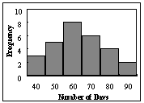
 | A) 70 B) 90 C) 60 D) 40

2. | Thirty students recorded the colors of their eyes, choosing from the colors brown, blue, green, hazel, and black. This data can be appropriately summarized in a
 | A) | Open-ended distribution | C) | Grouped frequency distribution
 | B) | Categorical frequency distribution | D) | Upper boundary

3. | A Pareto chart does not have which of the following properties?
 | A) | It is a bar chart
 | B) | The frequencies are arranged from highest to lowest
 | C) | The frequencies are arranged from lowest to highest
 | D) | It is used to represent categorical data

4. | A time series graph is useful for which of the following purposes?
 | A) | Representing relative frequencies of categories in a specific year
 | B) | Representing the cumulative frequencies of the data in a specific year
 | C) | Representing the frequencies of the data, sorted from largest to smallest
 | D) | Representing the frequencies of a data category over a period of several years

5. | The graphs that have their distributions as proportions instead of raw data as frequencies are called
 | A) | relative frequency graphs. | C) | histograms.
 | B) | ogive graphs. | D) | frequency polygons.

6. | The total frequency of the data whose ogive shown below  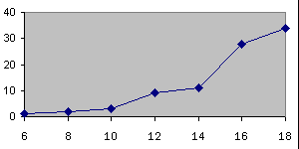  is approximately
 | A) 12 B) 18 C) 34 D) 90

7. | What are the boundaries of the class 1.87–3.43?
 | A) 1.9–3.4 B) 1.87–3.43 C) 1.879–3.439 D) 1.865–3.435

8. | The total frequency of the data whose histogram is shown below  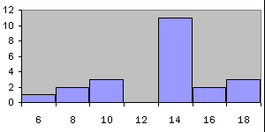  is approximately
 | A) 11 B) 20 C) 50 D) 100

9. | An automobile dealer wants to construct a pie graph to represent types of cars sold in July. He sold 72 cars; 16 of which were convertibles. The convertibles will represent how many degrees in the circle?
 | A) 60° B) 80° C) 100° D) 50°

10. | A scatter plot would be useful for
 | A) Showing the relative number of sales of four different brands of blank DVDs
 | B) Showing the trend of sales, over time, of five different brands of blank DVDs
 | C) Showing the relationship between the sales of blank CDs and blank DVDs
 | D) Showing the top selling brands of blank DVDs

11. | What kind of relationship does the scatter plot show between x and y?  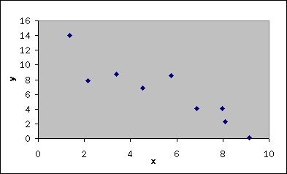
 | A) A positive linear relationship
 | B) A negative linear relationship
 | C) No linear relationship
 | D) This is not a scatter plot

12. | Exaggerating a one-dimensional increase by showing it in two dimensions is an example of a(n)
 | A) pictograph. B) pie graph. C) ogive. D) misleading graph.

13. | A weatherman records the amount of rain that has fallen in Portland, Oregon during each day. What type of graph should he use?
 | A) pie graph B) pictograph C) time series graph D) ogive

14. | Which of the following could be a cumulative frequency graph?
 | A) | 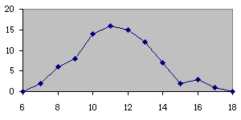
 | B) | 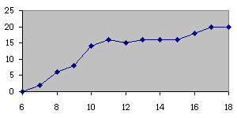
 | C) | 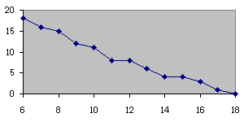
 | D) | 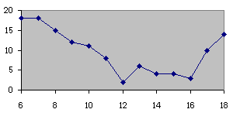

15. | Which of the following graphs is the scatter plot for the data given below?
  x values | 9 | 9 | 12 | 5 | 1
  y values | 4 | 2 | 9 | 6 | 6
 | A) 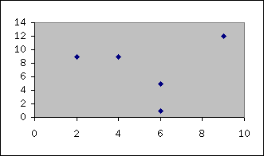
 | B) 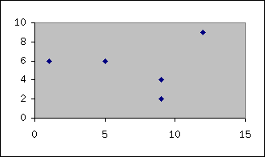
 | C) 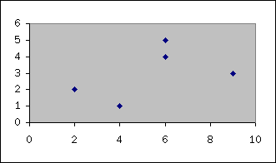
 | D) 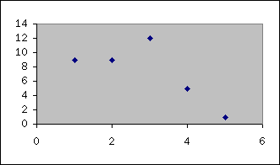

16. | Which of the following is a frequency polygon?
 | A) | 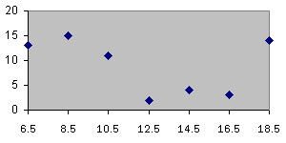
 | B) | 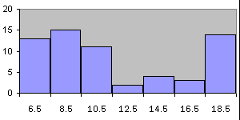
 | C)
 | D) | 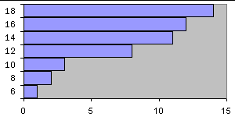

17. | What type of graph is the figure below?  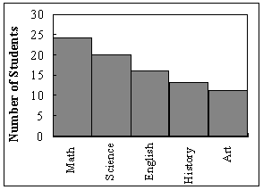
 | A) Pareto chart B) pictograph C) ogive D) pie graph

18. | In a pie graph, if pepperoni pizza were 24/72 of the distribution, how many degrees would be needed to represent pepperoni?
 | A) 90° B) 120° C) 60° D) 150°

19. | Karen is constructing a pie graph to represent the number of hours her classmates do homework each day. She found that 8/24 did homework for three hours each day. In her pie graph, this would represent how many degrees?
 | A) 135° B) 45° C) 120° D) 240°

20. | What is the midpoint of the class 1-17?
 | A) 1 B) 9 C) 1 and 17 D) 9 and 16

1. | If the mean of a set of data is 23.00, and 12.60 has a z-score of –1.30, then the standard deviation must be:
 | A) 4.00 B) 32.00 C) 64.00 D) 8.00

2. | What is the median of the following numbers?  3, 5, 8, 10, 14
 | A) 9 B) 5 C) 7 D) 8

3. | Find the z score for each student and indicate which one is higher.
  Art Major
  Theater Major
 | A) | Both students have the same score.
 | B) | Neither student received a positive score; therefore, the higher score cannot be determined.
 | C) | The theater major has a higher score than the art major.
 | D) | The art major has a higher score than the theater major.

4. | Which of the following is the correct mean for the given data?  7, 8, 13, 9, 10, 11
 | A) 9.7 B) 9.67 C) 9 D) 10

5. | The minimum of the set of numbers {–3, 17, -5, 11, 5} is
 | A) 20 B) 10 C) –3 D) 17 E) none of the above

6. | The maximum of the set of numbers {8, 18, -5, 11, 5} is
 | A) 15 B) -5 C) 18 D) 10.5

7. | If the mean of a set of data is 23.00, and 30.50 has a z-score of 0.75, then the standard deviation must be:
 | A) 100.00 B) 5.00 C) 50.00 D) 10.00

8. | If the five number summary for a set of data is 0, 3, 6, 7, and 16, then the mean of this set of data is
 | A) 6 B) there is insufficient information to calculate the mean C) 8 D) 5

9. | Find , , and for the following data set.  7, 21, 32, 38.
 | A) | , , and | C) | , , and
 | B) | , , and | D) | , , and

10. | Find the median for the following data.  6, 7, 4, 5, 3, 7, 4
 | A) 5 B) 3 C) 7 D) 4

11. | All the values in a dataset are between 9 and 11, except for one value of 84. That value 84 is likely to be
 | A) the boxplot B) the mean C) the range D) an outlier

12. | A student received the following grades: An A in Statistics (4 credits), a F in Physics II (5 credits), a B in Sociology (3 credits), a B in a Literature seminar (2 credits), and a D in Tennis (1 credit). Assuming A = 4 grade points, B = 3 grade points, C = 2 grade points, D = 1 grade point, and F = 0 grade points, the student's grade point average is:
 | A) 2.47 B) 2.24 C) 2.52 D) 2.40 E) 2.13

13. | Given that the variance for a data set is 1.20, what would be the standard deviation?
 | A) 0.60 B) 1.20 C) 1.10 D) 1.44

14. | In a unimodal, symmetrical distribution as shown in the figure below.  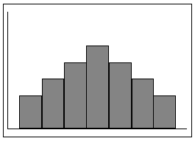
 | A) | The median and the mode are the same, but the mean can be different.
 | B) | The mean is the same as the median, but the mode can be different.
 | C) | The mean, the median, and the mode are different.
 | D) | The mean, the median, and the mode are the same.

15. | If a set of 25 numbers has standard deviation 9, then it's variance is
 | A) 45.00 B) 16.20 C) 81.00 D) 1.80

16. | Which of the following is true?
 | A) B) C) D)

17. | Determine the range for this data: 4, 7, 3, 16, 5, 22, and 8.
 | A) 14 B) 19 C) 3 D) 4

18. | What is the range of the numbers –6, 2, –8, 3, 11
 | A) 19 B) –6 C) 2 D) 3

19. | The range of the set of numbers {8, 17, 3, 10, 5} is
 | A) 10 B) 14 C) 17 D) 3

20. | What is the term for a characteristic or measure obtained by using all the data values for a specific population?
 | A) mode B) statistic C) parameter D) variable

