RELIABILITY OF WIRELESS NETWORKS

Abstract ⎯
The world is becoming more dependent on wireless and mobile services, but the ability of wireless network infrastructures to handle the growing demand is questionable. As wireless and mobile services grow, weaknesses in network infrastructures become clearer. Failures not only affect current voice and data use but could also limit emerging wireless applications such as e-commerce and high-bandwidth Internet access. As wireless and mobile systems play greater roles in emergency response, including 911 and enhanced 911 services, network failures take on life-or-death significance. Therefore, in addition to directing some attention to designing survivable wireless and mobile networks, developers must also keep in mind that increasingly pervasive and demanding services will further escalate the importance of reliability and survivability requirements. The authors explain several options providers must consider to decrease the number of network failures and to cope with failures when they do occur.

INTRODUCTION
“A wireless network is a flexible data communications system, which uses wireless media such as radio frequency technology to transmit and receive data over the air, minimizing the need for wired connections.Wireless networks are used to augment rather than replace wired networks and are most commonly used to provide last few stages of connectivity between a mobile user and a wired network.
Wireless networks use electromagnetic waves to communicate information from one point to another without relying on any physical connection. Radio waves are often referred to as radio carriers because they simply perform the function of delivering energy to a remote receiver. The data being transmitted is superimposed on the radio carrier so that it can be accurately extracted at the receiving end. Once data is modulated onto the radio carrier, the radio signal occupies more than a single frequency, since the frequency or bit rate of the modulating information adds to the carrier. Multiple radio carriers can exist in the same space at the same time without interfering with each other if the radio waves are transmitted on different radio frequencies. To extract data, a radio receiver tunes in one radio frequency while rejecting all other frequencies. The modulated signal thus received is then demodulated and the data is extracted from the signal.”
WIRELESS NETWORK TYPES
There are three main types of networks and manufacturers with different costs associated with each type. They are the referred to by their IEEE (Institute of Electrical and Electronic Engineers) specification designations: 802.11a, 802.11b, and 802.11g. The all operate by transmission of the data stream using radio frequencies in a transceiver pair of transmitting and receiving device. The data is sent in a fashion similar to human conversation, with the first one talking while the second one listens and then they switch and the second one talk while the first one listens. The conversation is intended to be private between the two communicating, but can be overheard by anyone near enough.
The different wireless types are based around similar descriptions as human speech, Frequency (is the voice high like a woman’s’ or low like mans’), Speed (how fast is the talking) and Language (or dialect). For Wireless these description equate to Frequencies in the Giga Hertz or billions of cycles per second (versus human speak in the 100s to 1000 cycles per second) and Speed in the millions of impulses per seconds (versus human words in the range of 2 to 25 per minute) and Language in coding format of the data (versus human dialects where we can understand each other mostly, and language barriers where we cannot communicate due to no common underlying construct between communicating parties).
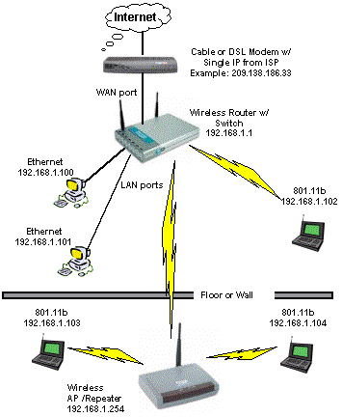
FIGURE 1: Network Diagram with Wireless and Hard Wired components
Source: D-Link, http://www.dlink.com
The Following chart displays the differences of the three wireless communication types.
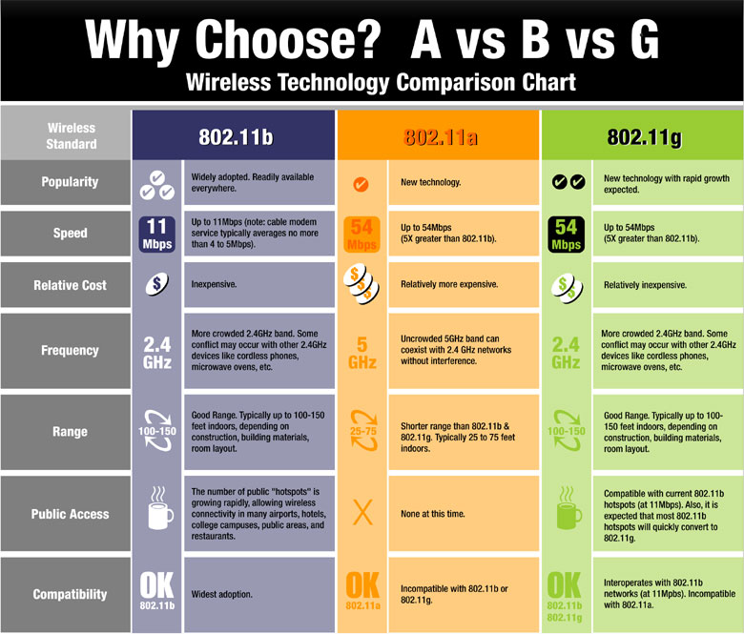
Properties comparison of Wireless Types
Source: Linksys, http://www.linksys.com/edu/wirelessstandards.asp

HOW IS INFORMATION SENT OVER A WIRELESS CONNECTION?
When your computer sends data over a wireless connection, your wireless adapter card or device converts data from a digital signal (bits) into an analog signal (radio waves). This process is similar to the way in which modems convert data into signals that can travel over phone lines, except that wireless data travels over radio waves instead of copper lines. Slight frequency differences in the analog waves are used to represent the binary states of one and zero.
Next, the radio waves travel through the air to an access point, a piece of hardware that converts the radio signals back into digital data. Even though the strength of the analog signal may have faded during its journey, it is easily converted back into a digital signal by the receiver. The receiver reads the frequency of the analog wave and matches the closes binary value (one or zero).
Finally, the binary data signals are sent normally over traditional, land-based lines or retransmitted as radio waves to another access point as the data travels to its destination.
Because interference is a common problem with radio waves, the technology used to send data over radio waves uses a wide band of the frequency spectrum. This is known as spread spectrum radio technology, and it supports several different transmission methods. Two of them are Direct Sequence Spread Spectrum (DSSS) and Frequency Hopping Spread Spectrum (FHSS). Because of the way that they transmit data, both methods require more bandwidth than is necessary for the actual size of the data being sent. This marks the main difference between spread spectrum and other radio technologies. Traditional narrow-band signals, like radio station broadcasts, concentrate a high-powered signal in a much smaller area of bandwidth (which we know as its frequency). They are more subject to interference because the data comprises most of the signal. Even minor signal losses can cause loss of performance.
SPREAD SPECTURUM RADIO TECHNOLOGY
In addition to satisfying regulatory requirements, spread spectrum techniques increase reliability, boost throughput, and allow many unrelated products (e.g., microwave ovens and wireless devices) to share the spectrum without explicit cooperation and with minimal interference. Both of the spread spectrum radio techniques — frequency hopping spread spectrum (FHSS) and direct sequence spread spectrum (DSSS) — operate within the 2.4-gigahertz (GHz) ISM band.
FHSS. FHSS uses frequency-shift keying (FSK) technology, meaning that the signal jumps from frequency to frequency within the ISM band to avoid interference. Devices using FHSS send a short burst of data, shift frequencies (hop) and then send another short burst of data. FHSS techniques allow for a relatively simple radio design, but are limited to speeds under 2 Mbps. This limitation is driven primarily by FCC regulations that restrict subchannel bandwidth to 1 megahertz (1 MHz). These regulations force FHSS systems to spread their usage across the entire 2.4-GHz band, meaning they must hop often. This leads to a high amount of overhead, since FHSS requires the transmitter and receiver to resynchronize after each frequency hop.
DSSS. By contrast, devices using DSSS communicate within a fixed frequency band, but split each byte of data into several parts. Each part is encoded to create encrypted "pseudo-noise," and multiple copies of the signal (usually 10 or more) are sent concurrently at offset frequencies. Only one signal needs to arrive intact in order for the original message to be decrypted. This makes DSSS very redundant and nearly immune to complete data loss. Also, because DSSS spreads the signal out over a wide frequency range at low power, any interference is diluted on the receiver end when the signal is decrypted. While DSSS consumes more available bandwidth than FHSS (about 22 megahertz), it is capable of much greater speeds and can send more data at once.
CONSIDERATIONS
Range: The range of the wireless network is an important consideration when using a wireless network. Access point and station adapters have a range of 3280 ft in open space and 200 ft-650 ft indoors. PCMCIA adapters have an open space range of 2200 ft and an indoor range of 300 ft. These ranges are affected by interferences such as microwaves and other radio interferences, as well as interference for structures such as walls and doors.
Throughput: The amount of data transferable using wireless devices is important. The amount will not be as great as a standard wired LAN, but will be greater than using a using wireless modems or other such devices. The access point, PCMCIA adapter, and station adapter have a data rate of 3mb. This data rate, however, is not throughput. When data is being transferred via wireless networking it requires a certain amount of overhead which is also included in the data rate. Most networks do not require more throughput than provided by the devices.
Integrity: The wireless network is a generally stable form of communication. The robust designs of proven wireless technology and the limited distance over which signals travel result in connections that are far more robust than cellular phone connections and provide data integrity performance equal to or better than wired networking.
Interoperability: Wireless device provide the ability to connect to wired LAN with ease. Adapters and access points work like a wired connection, except that no wires are necessary. The computer connects to other computers just as it would for a wired connection, because wireless devices use a "transparent protocol". These devices are compatible with IEEE 802.11 standards, which is the industry standard for wireless devices. Although industry standards are being set, most devices do not work with devices made by another manufacturer. In the future more interoperability will function as industry standards are polished and device become completely interchangeable.
Scalability: Wireless networks can be designed to be extremely simple or quite complex. Wireless networks can support large numbers of nodes and/or large physical areas by adding access points to boost or extend coverage.
Simplicity of installation and use: Users need very little new information to take advantage of wireless LANs. Because of the nature of a wireless LAN is transparent to a user's network operating system, applications work the same as they do on wired LANs. Wireless devices incorporate a variety of diagnostic tools to address issues associated with the wireless elements of the system; however, products are designed so that most users rarely need these tools.
Security: Because wireless technology has roots in military applications, security has long been a design criteria for wireless devices. Security provisions are typically built into wireless LANs, making them more secure than most wired LANs. It is extremely difficult for unintended receivers (eavesdroppers) to listen in on wireless LAN traffic. Complex encryption techniques make it impossible for all but the most sophisticated to gain unauthorized access to network traffic. In general, individual nodes must be security-enabled before they are allowed to participate in network traffic.
Battery Life for Mobile Platforms: End-user wireless products are designed to run off the AC or battery power from their host notebook or hand-held computer, since they have no direct wire connectivity of their own. WLAN vendors typically employ special design techniques to maximize the host computer's energy usage and battery life.
Safety: The output power of wireless LAN systems is very low, much less than that of a hand-held cellular phone. Since radio waves fade rapidly over distance, very little exposure to RF energy is provided to those in the area of a wireless LAN system. Wireless LANs must meet stringent government and industry regulations for safety. No adverse health affects have ever been attributed to wireless LANs.

Reliability Analysis
A reliability analysis predicts the operational performance of a link or system of links. Statistical models are used to predict the annual outage time, unavailability percentage, and reliability percentage. The analysis provides critical verification that the selected link budget parameters are sufficient to support the intended communications.
Microwave paths are often designed for "five nines" reliability, or a reliability of 99.999%. This reliability corresponds to an annual outage time of only about 315.5 seconds. Depending on the requirements of your system's application, however, the required reliability could be higher or lower than 99.999%.
Service outages can be caused by multipath conditions and rain. Multipath propagation occurs when copies of a signal arrive at a receiver at different times as a result of having followed different paths through the atmosphere. If they are out of phase, these signals may cancel at the receiver causing an outage. Rain outages occur when raindrops attenuate the microwave signal power below a usable level. The attenuation becomes significant as the size of the raindrops becomes comparable to the wavelength of the signal. Rain attenuation increases as raindrops become larger, rain becomes more frequent, and the frequency of the link becomes higher (the wavelength becomes smaller). Typically, rain outages are only a concern in frequency bands above 10 GHz.
Multipath outage, which occurs independently in each direction of a path, is calculated for each direction, and the two results are added to produce the two-way outage. Rain outage, which affects both directions of a path at the same time and is therefore already a two-way result, is calculated once for the path direction with the lower fade margin.

RELIABILITY AND PERFORMANCE

Reliability and performance are inseparable in this case. If the performance is not satisfactory the product will not be reliable, this is described in the following excerpt from Atheros Corporation White Paper. “Even though the maximum throughput, or data rate, may be attainable at relatively short distances with well-engineered WLAN products, actual performance will decrease as the distance between wireless stations is increased.”
“Many factors that actually do affect radio range and performance, on the other hand, include antenna efficiency, RF component performance, and absorption through and scattering around objects. While these factors do depend upon frequency, the actual differences between operating performance at 2.4 GHz or 5 GHz are small compared to differences between radio design in areas such as signal-processing algorithms, RF component capabilities, and the amount of electrical noise generated within RF electronics. For example, an 802.11a system with high signal integrity will likely have superior range, coverage, and performance compared with an 802.11b or 802.11g design with weaker signal integrity.

Environmental variables also have an impact on range and throughput:

Outdoor: typically a direct line of sight between the access point (AP) and the client station. Examples include outdoor campus coverage, public areas, or even large, open buildings like airport concourses or convention halls.

Open office: no longer a direct line of sight between the AP and the client station, but typically with at most two or three obstructions (such as walls). Examples are buildings with open areas such as offices occupied by cubicles, lobbies, meeting areas or warehouses.

Closed office or home: no direct line of sight between AP and client station with many obstructions. Examples are buildings with regular offices or residential homes.

In these different environments the total coverage range will be significantly different. The outdoor environments will provide the longest ranges and the closed office environments will provide the shortest ranges. In general, the relative performance and throughput for different products under test should be similar across the different environments. So if Vendor #1’s product is significantly better than Vendor #2’s in an open office environment, it is highly likely, although not guaranteed, that Vendor #1’s product will perform better in other environments as well. “
-Atheros White Paper: 802.11 Wireless LAN Performance p.2
Atheros Communications

As shown in Figure 1, the throughput (data transmitted per second) decreases as distance from the source increases. Please note deviations from a linear graph are due to the aforementioned interior obstructions in the test environment (walls, windows, doors, cubicles, filing cabinets etc.).
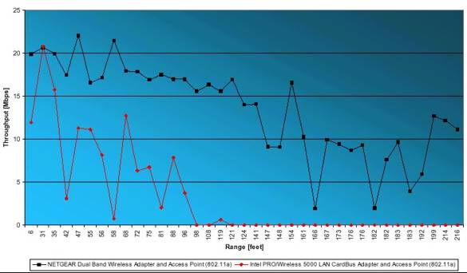
Figure 2: Wireless LAN Performance
Source: Atheros Communications White Paper: 802.11 Wireless LAN Performance.

The last set of criteria to be assessed is the user-friendliness and administrative ease of each option to prevent the installation of a time-consuming product.
CONCLUSION
Flexibility and mobility make wireless LANs both effective extensions and attractive alternatives to wired networks. Wireless LANs provide all the functionality of wired LANs,
without the physical constraints of the wire itself. Wireless LAN configurations range from simple peer-to-peer topologies to complex networks offering distributed data connectivity and roaming. Besides offering end-user mobility within a networked environment, wireless LANs enable portable networks, allowing LANs to move with the knowledge workers that use them.

REFERENCES
http://aspin.asu.edu/projects/wireless/introduction.html
http://www.tutorial-reports.com/wireless/introduction.php

