Title:

Date of Submission: May 1, 2006

Submitting Organization: Smart Intercom Systems

Desired start date: January 15, 2006

Duration: 24 months

Principal investigator: Cagatay Bozturk
Student of School of Technology

Total Amount Requested: $79,025

ABSTRACT

Smart Intercom Systems Inc was found for trying to change the classical structure of the Intercom System with new inventions. Company is trying to develop new generation Intercom Systems that converting this voice messages into text messages and informing the residences via sms. Company is using the latest technology in their works like wireless devices, open source software.
INTRODUCTION
Smart Intercom Systems Inc. is a company that well-known with their innovative Intercom Systems. Company is more focused on how to develop new generation intercom devices and how to make people’s life easier.
This research is more related with programming and wireless technologies. We can think this project as a resident informing system for houses. If you are not at home when your visitors come to your houses they just leave message to the intercom and system is starting in this point and process goes on. In the end system informs you about visitors via sms.

TABLE OF CONTENTS
Project Detaıls

Nature of the problem
Importance of Smart Intercom Systems started to increase in the today’s market because of decreasing cost of electronics regarding to advancing technology, public interest for advanced technology and necessity of inventions in the intercom market. Today’s intercom systems are lack of enough advanced properties. They are generally composed of fixed microphone/speaker units which connect to a central control panel and generally it provides electronic communication within a building or group of buildings.

Measurable Objectives
Smart Intercom Systems Inc. should consider this new market and take the advantage with a new product. Our new system should include wireless communication and text messaging. Beside that system should be produced easily and low cost. It is important that company should continue to stay just behind the cutting edge, where the proven technologies meet the demands of forward-looking companies worldwide.
Procedures for Implementation
There are some procedures that we should understand very well. Use of special software is one of them because this software is going to help us to make a conversion between speech and text. Another important issue is that to understand the working principles of SMS-OPC Gateways which integrate IP networks with the Short Message Service (SMS).Finally, it is really important to understand the implementation of Wireless Intercom System.

Significance
If we develop an intercom system with features such as wireless and informing via SMS, it will be the first intercom system with these features in the market .Besides our company will gain the competitive advantage and consolidate its prestige in the intercom market. Other intercom systems don’t provide any significant features to their customer except electronic communication. However smart intercom systems is carrying the idea of intercom one step further.

Unique Components of This Research
Short Messaging Service (SMS) gateways are going to be used first time in the intercom systems. Besides that we are going to use special software that converts the voice messages into text messages. With this project, wireless technology will take importance place in our intercom system.

Introduction

Goal of the project
Thanks to new intercom system, company is trying to inform the residences with a text message when residences are not available at home. This new system is going to present the both low cost and high technology with a secure and reliable information infrastructure. Company wants to become a pioneer institution in the intercom market with its innovator products and system.

Project relationship to funding source
Background as to why the company will participate
1. Wireless technology is the new trend in the intercom market
2. Company wants to control the big part of intercom systems in the market.
Statement of the Problem

Analysis of problem
An intercom is an electronic communications system within a building or group of buildings. They are generally composed of fixed microphone/speaker units which connect to a central control panel. But we can’t instantly reach our guests messages without a service which provides text messaging. New intercom system is going to help us to reach the messages of our guests instantly. However some negligible exterior factors (interference, walls etc.) could affect wireless network performance.

Validation of problem--review of literature to substantiate critical thinking need
i. OPC-SMS: a wireless gateway to OPC-based data sources by Vassilis Kapsalis, Stavros Koubias, and George Papadopoulos, Computer Standards & Interfaces 24 (2002) 437–451
ii. Voice recognition software programs: are they right for you by Mohsen Attaran, Information Management & Computer Security 8/1 [2000] 42±44
iii. Speech-as-data technologies for personal information devices by Roger C. F. Tucker, Marianne Hickey, Nick Haddock, Springer-Verlag London Limited 2003
iv. Speech recognition in the human-computer interface by Carl M. Rebman Jr. ,Milam W. Aiken, Casey G. Cegielski, Information and Management Vol: 40, Issue: 6, July, 2003 pp. 509-519

How this project builds upon past works
Complaints of costumer about today’s intercom systems are analyzed so according to their feedbacks, we will be avoid of doing the same mistakes again. Weak points of wired and wireless intercom systems are determined so efficient and reliable method will used. Patent research helped us to see various intercom ideas and understand the weak and strong sides of the intercom

Objectives

The anticipated questions of this work are as follows:
i. How interference affects the wireless performance in the house?
ii. How accurately your software will covert the receiving speech into text message?
iii. How this new system will effect position of your company in the intercom market?
Evaluation and measures
i. System will be tested in company’s test labs.
ii. Prototype of the system will sent to chosen customers of company. Then we will evaluate our system according to costumer feedbacks.

Methodology

Case for selected methodology

The first part of the research will focus on three main issues. These are;
Defining and developing the most suitable software which converts the voice messages into text messages. It is important to use the most reliable wireless system for decreasing the interference effect in house environment. Finally, determining the reliable and secure SMS gateway host which transmits the converted text messages to the customers
Time tables
Phase 1: Fist system will be tested in company’s lab and if it is successful, samples of the system will be sent to chosen costumers for testing in a more realistic environment.
Phase 2: Chosen customers will send us their feedback about the system. Then we will decide to sell the product in the market or run new tests respect to their feedbacks.

Facilities
The testing will be conducted in the companies lab

Evaluation
After the testing stage, product we will send the system to chosen customers and receive their feedbacks. According to their feedbacks, we will decide further process.

Budget
a. Direct costs
i. Personnel
1. Principal investigator
2. Researchers
a. Researchers from universities
b. Researchers from inside of the company
3. Developers
4. Testers
a. Company’s professional testers
b. Chosen customers
ii. Materials & Supplies
1. Hardware and Electronics
a. Network equipment
b. Basic computer
c. 3 Channel wireless intercom system
2. Software
a. Special Software that provides conversion between speech and text
b. User Interface
c. SMS gateway

3. Other
a. Prototypes for customers who are chosen for testing
a. Postage (sending these prototypes to chosen customers)
b. Indirect Costs
i. Maintenance
ii. SMS gateway back-up
X. List of references

a. OPC-SMS: a wireless gateway to OPC-based data sources by Vassilis Kapsalis, Stavros Koubias, and George Papadopoulos, Computer Standards & Interfaces 24 (2002) 437–451
b. Design and Analysis of Wireless Networks by Yi Pan and Yang Xiao, Nova Science Publishers, Inc. New York 2005
c. Voice recognition software programs: are they right for you by Mohsen Attaran, Information Management & Computer Security 8/1 [2000] 42±44
d. Speech-as-data technologies for personal information devices by Roger C. F. Tucker, Marianne Hickey, Nick Haddock, Springer-Verlag London Limited 2003

e. Speech recognition in the human-computer interface by Carl M. Rebman Jr. ,Milam W. Aiken, Casey G. Cegielski, Information and Management Vol: 40, Issue: 6, July, 2003 pp. 509-519
PROJECT BUDGET
PERSONNEL

Principal Investigator:

The Principle Investigator, Cagatay Bozturk, is responsible for the overall project progress. He is responsible for determining the budget of the project, ensuring the budget and timetable targets, selecting the Researchers and Programmers that will develop the system, analyzing process, making the appropriate changes in project phases if necessary, working with evaluation consultant to develop the project. The Principle Investigator will work 40% of the time for 24 months. Based on an annual salary of $15,000, the cost to the project will be $12,000.
Researchers:
The Researchers will be responsible for making necessary researches and they will work corporately with developers.2 Researchers will take place in this project and they will be assigned 50% of the time to the project for the 12 months. Based on an annual salary of $20,000, the total project cost of the Researchers will be $20,000.
Developers (Programmers):
The Programmers will design and develop software that will convert the incoming voice messages into text messages. 2 Programmer will take place in this project and they will be assigned 50% of the time to the project for 7 months. Because during the first 6 months of the project, the Programmers will not be needed Based on an annual salary of $24,000, the total project cost of the Programmers will be $14,000, and will be provided as matching funds.
Testers:
The Tester will test the system and according to results, they will play important role in the development step of the project.2 Testers will take place in this project and they will be assigned 50% of the time to the project for 10 months. Because during the first 12 months of the project, the Testers will not be needed Based on an annual salary of $15,000, the total project cost of the Programmers will be $25,000.
Total Personnel Costs: $71,000

EQUIPMENT
Personnel Computers:
The Principle Investigator, Researchers, Programmers and Testers will use the computers in this project. 7 PCs will be used by personnel and 1 computer will be necessary for system. One of these computers is going to be laptop which will used by Principle Investigator. Each computer will be equipped with a high-speed modem and a CD-ROM drive. Cost of each computer is $600 and laptop cost is $1,000. Totally 7 computers and 1 laptop will cost $5200.
Hardware and Electronics
3 Channel wireless intercom system is $64.99
150-Foot Computer Network RJ45 350MHz (CAT 5) Cable is $ 21.99

Linksys Wireless-G WRT54G Broadband Router is $49.99
Motorola cell phone is $49.99
Total Equipment Costs: $5.385.00
SOFTWARE:
We will use open source software with a GPL license, so we won’t pay any charge for software expense.
Total Software Costs: $0.00
SERVICES:
SMS Gateway connection:
No Setup Fee,
No Minimum Purchase Required,
No Monthly Volume Requirement,
No Port Fees.
For a standard text message of 160 characters, the price is 1 credit per message.
SMS Pricing:
Credits : Cost per credit in Euro
1 - 9,999 : € 0.044
10,000 - 49,999 : € 0.042
50,000 - 99,999 : € 0.039
100,000 - 249,999 : € 0.037
250,000 - 499,999 : € 0.034
500,000+ - Price on application

MATERIALS & SUPPLIES

Postage and Telephone:

It includes the postage and telephone use for mailing flyers and communication with companies, organizations and team members. The estimated telephone cost for one month is calculated as $80, which means $1920 for two years. The total postage cost estimated for two year is $120.

Miscellaneous:

These supplies include paper, pens, toner cartridges, computer diskettes, laser, printer cartridges, file folders, and other items which will be required for various administrative requirements, researches and reports. The estimated project cost for paper, toner, envelopes, letterhead, forms, tags, etc is $600 for two years.

Total Materials & Supplies Costs: $2640

Total Personnel Costs: $71,000
Total Equipment Costs: $5,385
Total Software Costs: $0, 00
Total Materials & Supplies Costs: $2,640
TOTAL PROJECT COSTS: $79,025

Literature Review

Introduction
This project is thought for changing the classical structure of the Intercom System with new inventions. I am going to develop new generation Intercom Systems that converting this voice messages into text messages and informing the residences via Short Message Service (SMS).
This project is more related with software development, working principles of intercoms, structure of sms gateways and wireless technologies. We can think this project as a resident informing system for houses. For example, if you are not at home when your visitors come to your houses, they just leave message to the intercom and system is receiving this speech and converting to text message via special software. Then it sends this text message to the residents via sms gateway.
Although there are too many intercom systems in the market, most of them are only interested in their own limited areas. These are mostly focused on the voice and display systems. But this system is not only transmitting voice but also converting this voice messages into text messages and informing the residences via sms.
The main advantage of this system is to inform the residences with a text messages when the residences are not at home. If we investigate the system in detail, first of all, wireless digital intercom device receives the audio and delivers to the main system which is connected to the internet 24 hours and also one special software that runs on it, receives the voice messages that delivered by the wireless digital intercom system. Then it converts the voice messages into the text messages. Following by this text messages are delivered to the residences cell phones via sms gateway. Another important point is that we can add some people’s names that are important for us or some key words like “alert” or “emergency” to the software which converts the voice messages into text messages. So the system sends messages to the whole residence quicker and more detailed (like name, history, hour etc.)

Respect to the article that I received form Kent Link electronic database named OPC-SMS: a wireless gateway to OPC-based data sources by Vassilis Kapsalis, Stavros Koubias, George Papadopoulos, Computer Standards & Interfaces 24 (2002) 437–451

The author describes OPC-SMS gateway, a platform that integrates IP networks with the Short Message Service (SMS), in order to deliver an integrated service for access to data sources conforming to Object Linking and Embedding for Process Control (OPC) standard specifications, through SMS-enabled mobile devices. The gateway supports pull and push services in order to support both request-based and alarm/scheduled-based notifications, respectively. The proposed architecture is based entirely on the ubiquitous Hypertext Transport Protocol (HTTP), Simple Object Access Protocol (SOAP), Extensible Markup Language (XML) protocols, and the Global System for Mobile communication (GSM) network and thus exploits the network infrastructure already in place. The capability of accessing different types of OPC data sources (real-time and historical) by any SMS-enabled device consists of a highly flexible service, supporting mobility and event-based notification. A pilot implementation of this approach has been tested in a large-scale installation for accessing OPC data sources of several automation subsystems in a hospital.
General description of OPC-SMS
OPS-SMS gateway will play important role in my project. Because it is an intermediate entity, which enables the communication between GSM networks and the Internet for accessing OPC data sources through SMS-enabled devices. It consists of two parts:
- the main part residing in the gateway, which contains the communication module for the GSM network and the modules for the information access from OPC data sources, through the Internet
- the parts residing in the remote DCOM-based networks, which act as OPC clients, both for Data Access and Historical Data Access servers.
Article shows that, in most existing implementations, SMS and IP networks are integrated through an SMS Center (SM-SC). In this case, a gateway interconnects the SM-SC to the IP network based on a specific protocol for communication between the SM-SC and gateway. Since the SM-SC is not part of the GSM specifications and its implementation is vendor-specific, the SM-SC-based SMS-IP integration solution heavily depends on SM-SC vendors. Furthermore, the SMS-IP gateway is maintained and controlled by GSM operators, and thus requires the close cooperation with them in order to deploy new services. To address these issues and further support an environment for quick prototyping and hosting wireless data services, a solution transparent to the existing SM-SC and GSM network is proposed. In this architecture, a GSM-compliant modem that provides wireless access to the GSM network is connected through the RS-232 port to the OPC-SMS PC-based gateway (in this implementation a PC running Windows 98/Me/2000/XP or NT).
V. Kapsalis et al. / Computer Standards & Interfaces 24 (2002) 437–451
Fig. 1. System architecture.

Services of OPC-SMS gateway
There are several types of services provided by the gateway, including request-based access by a user sending SMS requesting specific information, event-based (push) notification based on predefined customized events, and time-scheduled transmission of information.
- In the request-based access, a mobile phone operator sends a short message (SM) to initiate the reading or writing of some values from/to the corresponding OPC server(s).
- In the case of event-based (push) mode, an alarm condition or a predefined combination of events initiates a short message to the appropriate mobile phone.
- In the time-scheduled mode, the transmission of specific information about critical process parameters (e.g., transmission of a summary report once per day) is sent periodically to authorize personnel.

OPC-SMS gateway modules
This section presents a detailed description of the functionality of each module, as well as specific implementation details (Fig. 2).

V. Kapsalis et al. / Computer Standards & Interfaces 24 (2002) 437–451

Short Message Driver (SMD)
This module is responsible for the communication task between the GSM network and SMS-OPC gateway, dealing with all the details of sending/receiving short messages to/from the GSM modem. This communication is taking place through a protocol, implemented using the SMS Attention (AT) command set. In effect, Short Message Driver (SMD) acts as an interface between the Agent Dispatcher (AD), which is part of the Proxy Server, and GSM modem. It receives incoming short messages from the COM port and passes these messages to the Agent Dispatcher. On the outgoing direction, it receives messages from the Agent Dispatcher and, after transforming them into short message format, forwards them to the GSM modem through the COM port. Another operation performed by the Short Message Driver is the segmentation of the messages received from the Agent Dispatcher in order to assure that the maximum SMS length is less than 160 octets. Thus, a message greater than 160 octets is segmented to a number of SMS packets, which are fed to a First-In, First-Out (FIFO) queue for sequential transmission.

Proxy server
This is the main module of the OPC-SMS gateway, which consists of two functionally separated types of modules. The first is the Agent Dispatcher, which acts as the interface with the Short Message Driver, and the second consists of one or more Agents with each one implementing a different service. Each Agent communicates through the Internet with the corresponding server module, which implements the actual data access. As mentioned above, two types of Agents have been developed: Web- and SOAP-based.

Agent Dispatcher (AD)
This module dispatches the received SMS message (command) from the Short Message Driver to the appropriate Agent based on the SMS content. The Mobile Station ISDN number (MSISDN) of the mobile device (caller ID) is used to identify the user, providing a level of security in order to reject unauthorized access. An added level of security is implemented in the application level by using a password for access to specific parameter information.
An SMS message for real-time access is of the form:
where, “Command” is a string that corresponds to one of the actions (services) supported by the OPC DA and/or HDA servers, “{Item}” can be an automation point or a database parameter and the “{Parameter 1}”–“{Parameter N}” can be a list of specific parameters for each service. The Agent Dispatcher invokes the appropriate Agent (resides within the Proxy server) corresponding to the SMS message and passes to it the message parameters. The mapping of SMS messages to the services (each service is implemented by a separate Agent) takes place in a mapping table. Developing new services is implemented by adding new entries in this table. At the end of the processing (that was initiated by an SMS message) performed by the appropriate Agent, the Agent Dispatcher receives the results and, subsequently, sends them back to the Short Message Driver.

Consequently, understanding the structure of OPC-SMS gateway is critically important to complete the project. Because it will play important role in the transmission of sms that is send by system. So this article helped me to understand the structure of gateways and their working principles.

Respect to the book that sent from the Cleveland State University named Design and Analysis of Wireless Networks by Yi Pan and Yang Xiao, Nova Science Publishers, Inc. New York 2005

The goal of the book is to serve as a reference for current design methodology and analytical models that can be used to design and analyze various wireless network systems. Also author reviewed important reliable wireless networks. Important features and limitations of methods were identified.
The book is basically dividend into three main parts.
Part I: Location Management
Authors describe the Application Level Gateway (ALG) to support IPv6-IPv4 interworking for Session Initial Protocol (SIP) applications. They also discuss 3rd-generation wireless networks and mobile IP networks. They explain the design and performance study of both the static and dynamic movement-based locating management wit the HLR/VLR architecture.

Part II: Admission Control, Resource, Allocation and Scheduling
The authors discuss call admission control (CAC) in mobile wireless networks. They address the resource management issues in DS-CDMA cellular networks. They introduce the concept of fair queuing in wireline networks; discuss the problems and difficulties to apply them to wireless networks. Broadcast scheduling algorithms for wireless data dissemination have been introduced by the authors.
They also adopt matrix approach to analyze a general wireless and mobile system.
Part III: Emerging Protocols and Performance
The authors provide an overview of the feasible interconnection technologies and architectural solution between UMTS and 802.11(e) based networks. Also they compares different power allocation algorithms of downlink soft handoff in the wideband code division multiple access system from both outage performance and power efficiency perspectives. Transport layer design issues is discussed in mobile wireless networks

The important point of this book for my project is that the authors mentioned the gateway applications and design of wireless network. These two issues are critically important for my project. But the author were more focused on Application Level Gateway (ALG) to support IPv6-IPv4 interworking for Session Initial Protocol (SIP) applications and SIP based VoIPv6 applications instead of OPC-SMS gateway applications that will used in my project. However this book was inspired me in point of wireless network design.
In the abstract, this book was only showed the way for design of wireless networks and generally informed me about the gateways. But it didn’t help me to solve the problem exactly in my project.

Respect to the article that I received form Kent Link electronic database named Voice recognition software programs: are they right for you by Mohsen Attaran, Information Management & Computer Security 8/1 [2000] 42±44
One of the long-standing goals of artificial intelligence is the creation of programs that are capable of understanding human languages. Not only does the ability to understand natural languages seem to be one of the most fundamental aspects of human intelligence, but also its successful automation would have an incredible impact on the usability and effectiveness of computers themselves. He also mentions that the use of speech recognition falls into two general categories: telephony applications and continuous speech recognition or dictation applications. The telephony technology demands that the computer recognizes a relatively limited range of words. The dictation technology demands that the computer recognizes a much wider range of words or commands to parallel more closely conversational speech.

In today’s world, there are new generation of voice recognition software programs developed by IBM, Microsoft, General Magic, Dragon Systems and others are hitting the market, allowing people to talk to their machines. These programs are able to understand spoken word and you don't have to speak slowly for the computer to comprehend what you are saying. After proper training and overtime, theses software programs learn to understand how you pronounce regular words and pick up special words that you use even though they are not part of their built-in vocabulary.
There are several varieties of voice recognition software programs from which you can choose. Each package available is one or all of the three types summarized in Table I. This table also describes the benefits of each method.

This article was inspired me about decision of what type of voice recognition software that I am going to used in my project. Author was explained the all types of voice recognition software in detail. He also pointed out the advantages and disadvantages of each type of voice recognition software.
Consequently this article informed me about the types or voice recognition software and how depth of market than appeal. But it didn’t give me any clue about how this software work and how applied to the any systems likes intercom phones or etc. Author was only mentioned to how speech recognized. He also didn’t talk about the speech-to-text conversion that is very important for my project.
Respect to the article that I received form Kent Link electronic database named Speech-as-data technologies for personal information devices by Roger C. F. Tucker, Marianne Hickey, Nick Haddock, Springer-Verlag London Limited 2003
The authors discussed about the small, portable devices, speech input has the advantages of low-cost and small hardware, can be used on the move or whilst the eyes & hands are busy, and is natural and quick. Rather than rely on imperfect speech recognition we propose that information entered as speech is kept as speech and suitable tools are provided to allow quick and easy access to the speech-as data records. This paper summarizes technologies needed for these tools – for organizing, browsing, searching and compressing the stored speech. These technologies go a long way towards giving stored speech the characteristics of text without the associated input problems.
This article was inspired me about organization of speech, if the speech can be broken down into short segments only a few seconds long. It helps the system that makes speech recognition to increase the accuracy of texts. As we see rates below, long records increase the error rates.
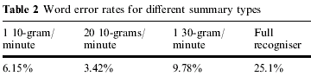

.

Respect to the article that I received form Ohio Link electronic database named Speech recognition in the human-computer interface by Carl M. Rebman Jr. ,Milam W. Aiken, Casey G. Cegielski, Information and Management Vol: 40, Issue: 6, July, 2003 pp. 509-519
This paper discusses the results of an experiment investigating word generation rates, word error rates, and user acceptance of a speech recognition program as compared to typing.
SR technology digitizes spoken words, identifies individual sounds (phonemes), and uses mathematical models to select discrete words or complete phrases. When used for dictation, SR can automatically transcribe the selected text into word processors, reducing or eliminating the need to type and increasing the productivity of office work.
SR technology can be categorized in terms of speaker dependency and speech mode

Speaker dependent or independent
Speaker-dependent SR technology requires a user to train the program to recognize his or her voice (the process is referred to as –enrollment-). This type of SR is better for those with non-standard speaking patterns, dialects, or foreign accents. Speaker-independent programs are designed to interpret any user’s voice with no enrollment, but this type of software is usually less accurate. If the software is speaker independent, a default set of discrete sounds or phonemes is provided, otherwise user enrollment creates a personalized set of phonemes for improved accuracy.

Continuous or discrete speech
Continuous-speech SR allows the user to talk normally in complete sentences while discrete-speech SR requires the user to pause after each word. Continuous speech is usually considered to be more natural, less frustrating, and faster. In addition, being more complex, continuous-speech SR can recognize individual words (discrete speech) as well as entire phrases. Although some studies have suggested that discrete-speech SR is more accurate, others have shown the opposite to be true.

The SR process
Author specified the five steps of the speech recognition:
- Audio input: The human voice is transmitted through a microphone connected to a PC with a standard sound card.
- Acoustic processor: The acoustic processor filters out background noise and converts the captured audio into a series of phonemes.
- Word matching: The software attempts to match the sounds to the most-likely words in two ways. First, it uses acoustical analysis to build a list of possible matches that contain similar sounds. Then, it uses language modeling (the likelihood that a given word appears between those coming before and after it) to narrow the list to the best candidates. In addition, the word-matching process draws on the user-defined domain (the set of vocabularies, pronunciations, and word-usage models, as well as a model of the user´s speech and words). The user can extend the domain by adding new words and can create multiple domains for different applications. Finally, continuous-speech SR examines contextual information to predict what words should come next in the current phrase. This also helps the system to distinguish among homonyms.
- Decoder: The decoder selects the most-likely word based on the rankings assigned during word matching and assembles the word along with those selected earlier into the most-likely sentence combination.
- Text output: Some SR programs include their own word processors, but many also allow text transcription directly into a separate word processing program or a text box in an application, such as a web browser or e-mail program.
In my opinion, using discrete speech in my project could be more efficient and reliable. Because informing the residents with a correct message is our main goal. So with the way of discrete speech SR, residents will be informed with high rate accuracy.
Conclusion
It is clear that producing a lower cost resident informing system is not a difficult process. The important point is using the suitable devices and producing cost effective systems. If we remember 10 years ago, producing this kind of devices and systems were so difficult and expensive because of the insufficient software infrastructure. In this direction, these articles helped me to understand the various systems. Thanks to these articles I have found change to analyze and compare the systems that are used in today’s world. Some of these articles were more related with my project than others and pointed good solutions.
References
- OPC-SMS: a wireless gateway to OPC-based data sources by Vassilis Kapsalis, Stavros Koubias, George Papadopoulos, Computer Standards & Interfaces 24 (2002) 437–451
- Design and Analysis of Wireless Networks by Yi Pan and Yang Xiao, Nova Science Publishers, Inc. New York 2005
- Voice recognition software programs: are they right for you by Mohsen Attaran, Information Management & Computer Security 8/1 [2000] 42±44

- Speech-as-data technologies for personal information devices by Roger C. F. Tucker, Marianne Hickey, Nick Haddock, Springer-Verlag London Limited 2003

Speech recognition in the human-computer interface by Carl M. Rebman Jr. ,Milam W. Aiken, Casey G. Cegielski, Information and Management Vol: 40, Issue: 6, July, 2003 pp. 509-519

GANTT CHART
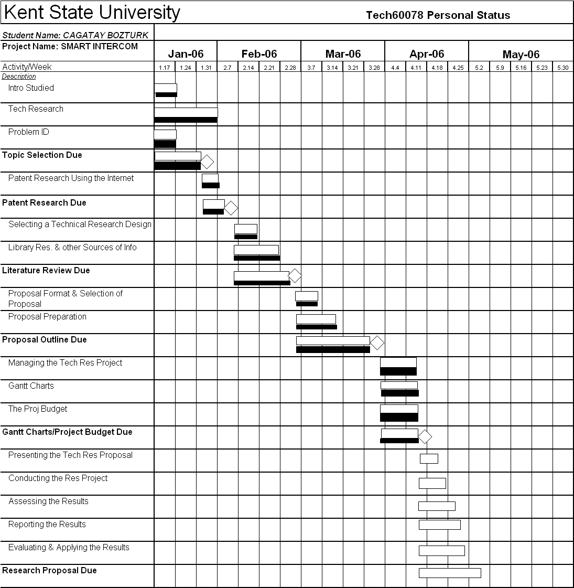
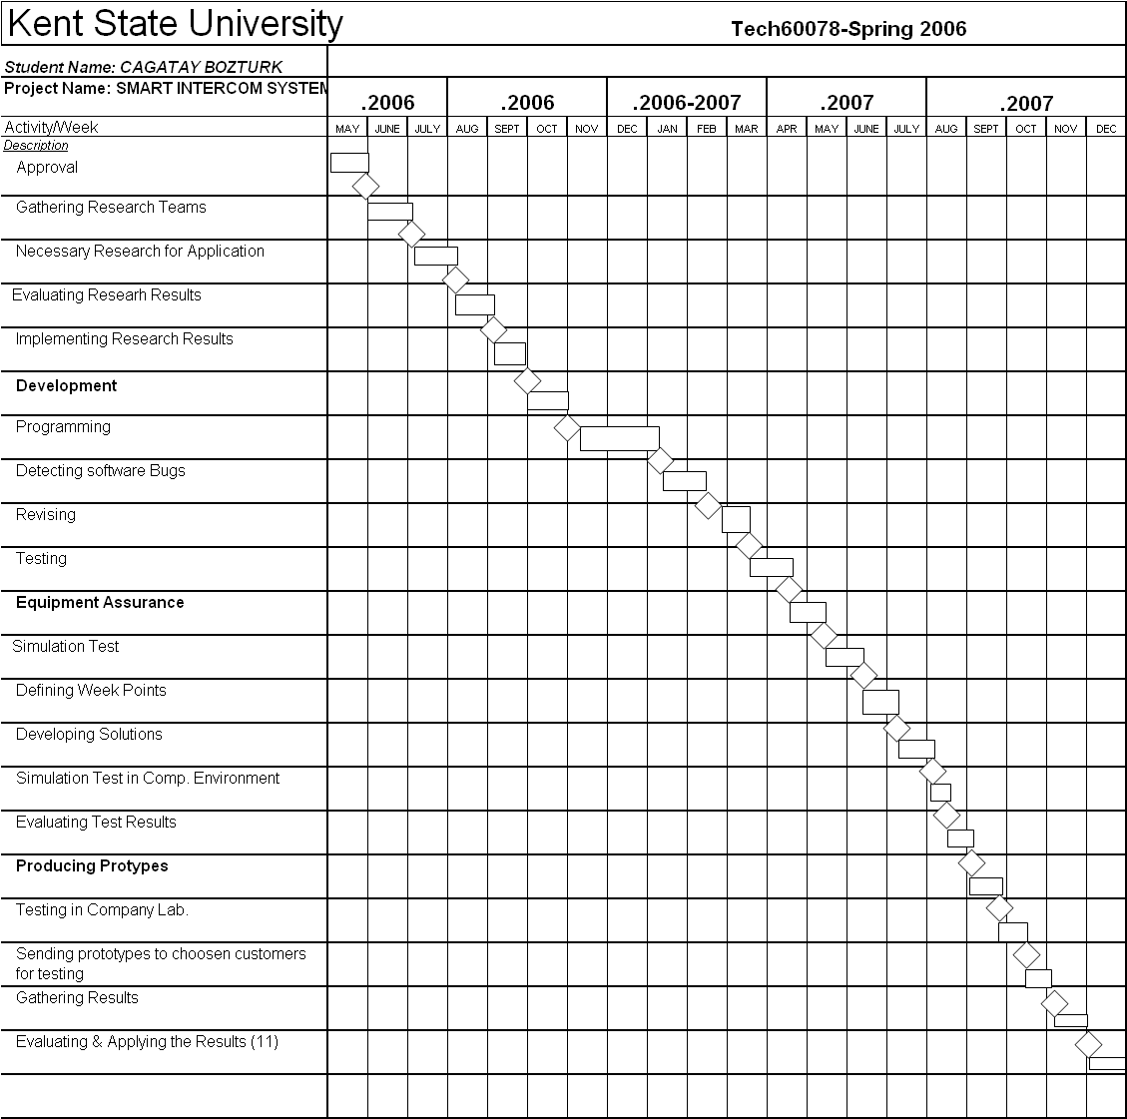
Incomplete task
Complete task

a wireless gateway to OPC-based data sources by Vassilis Kapsalis, Stavros Koubias, George Papadopoulos, Computer Standards & Interfaces 24 (2002) 437–451
a wireless gateway to OPC-based data sources by Vassilis Kapsalis, Stavros Koubias, George Papadopoulos, Computer Standards & Interfaces 24 (2002) 437–451
a wireless gateway to OPC-based data sources by Vassilis Kapsalis, Stavros Koubias, George Papadopoulos, Computer Standards & Interfaces 24 (2002) 437–451
a wireless gateway to OPC-based data sources by Vassilis Kapsalis, Stavros Koubias, George Papadopoulos, Computer Standards & Interfaces 24 (2002) 437–451
a wireless gateway to OPC-based data sources by Vassilis Kapsalis, Stavros Koubias, George Papadopoulos, Computer Standards & Interfaces 24 (2002) 437–451
Voice recognition software programs: are they right for you by Mohsen Attaran, Information Management & Computer Security 8/1 [2000] 42±44
Speech-as-data technologies for personal information devices by Roger C. F. Tucker, Marianne Hickey, Nick Haddock, Springer-Verlag London Limited 2003
Speech recognition in the human-computer interface by Carl M. Rebman Jr. ,Milam W. Aiken, Casey G. Cegielski, Information and Management Vol: 40, Issue: 6, July, 2003 pp. 509-519

