2 - Roman Numeral Analysis
We will be using Roman Numerals to analyze the function of the harmonies in popular music songs. For the most part we will be using the same symbols as used in Theory I and II.

Differences:
In “classical music” the major tonic chord is indicated with I⁷ in popular music I⁷ indicated a Dominant harmony on the tonic. The major seventh on the tonic will be indicated with: I^{maj7}

Key and Modulations
Indicate the ken and modulations with the key followed by a colon:

C: d: (or dm:) Gb: B: e:

Altered Chords
In popular music some chord are not built on diatonic scale degrees.
The most common are chords built on the flatted seventh scale degree (TE). Other possibilities are the flatted 3d and 6th (ME and LE)

Added Tone Chords
In absolute chord symbols C⁶ does not refer to a first inversion triad but to a C triad with an added sixth. Why is it different from an Am7/C?
When using Roman Numerals Added Tone Chords are indicated with add6, add2, add9
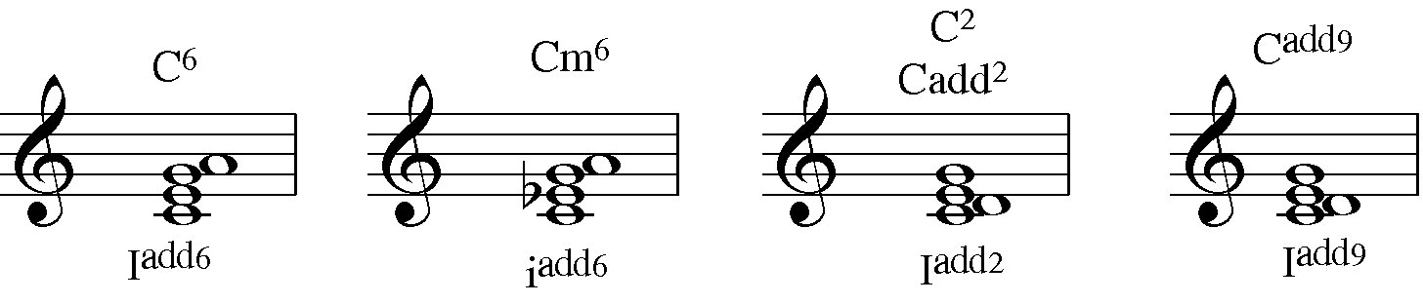
Figure 1: Added Tone Chord Symbols
Replaced Tone Chords
A note in the chord has been moved to an adjacent pitch. The most common are the sus chords.
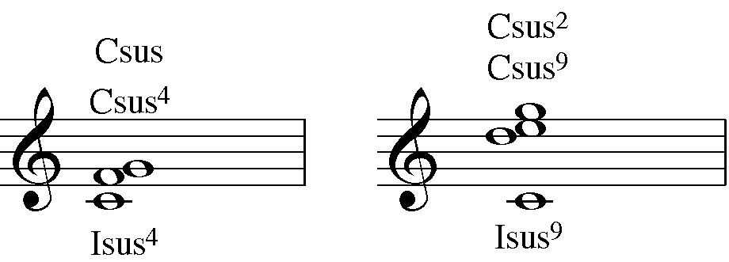
Figure 2: Sus Chords

A sus chord implies that a note of the chord has been moved up a step to a dissonance and should (but does not always) resolve down by step.
In a C^{sus4} the 3^{d} has been moved to the 4th. In a C^{sus2} it the tonic has been moved up a step. In a sus9 the octave has been moved up a step.
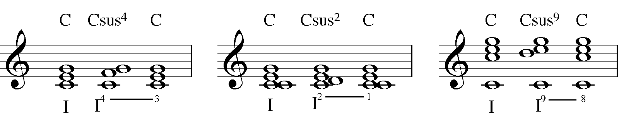
Figure 3: Sus (suspension) Chords

SLASH ANALYSIS
This is an expansion of the system used for Secondary Dominants: instead of just a dominant chord in a diatonic key a chord progression is related to a diatonic key.
A diatonic key is a key in which the tonic chord can be analyzed with a roman numeral from the original key.
Major | ii=i | iii=i | IV=I | V=I | vi=I
Minor | III=I | iv=i | v=I (V=I) | VI=I | VII=I

This system can be expanded with the use of non-diatonic chords such as:

The following chord progression can be analyzed with roman numerals in two different ways: 1) using slash notation (notice how the slash can apply to each chord or to the entire progression) and 2) with a modulation.
