Lab 4 – Active Directory

The objective of this lab is to explore the role of a Windows 2008 server as an Active Directory Domain Controller. Windows 2008 has been installed on a virtual machine and it has been promoted to be a domain controller for the domain named college.us You will copy this virtual machine to your computer and use it to manage the college.us domain using Virtual PC. This Lab will entail joining a Windows XP client virtual machine (used in previous labs) to the domain, setting up domain user accounts and logging on to the XP computer using one of the newly created domain accounts.

Remember the steps to start a virtual machine, from Lab2 http://www.personal.kent.edu/~sschindl/nm/labs/Lab2VPC.doc, especially remember to enable the loopback adapter on the host computer.

Start the 2008DC virtual machine and the XP virtual machine. When the XP machine boots up open a command window and enter the ipconfig /all command. What is the ip address of it’s DNS server? Go to the properties of the XP machine’s “My Network Places” and goto the Internet Protocol Properties (of the Local Area Network properties). Change the DNS server to the IP address of the domain controller, 192.168.0.115 (if this doesn’t seem to be the servers address, skip ahead, login to the server and find it using ipconfig) (Active Directory uses DNS to locate resources, so the Domain Controller has been setup to run a DNS server) Again enter the ipconfig /all command. What is the ip address of it’s DNS server now? Ping the DNS server’s ip address to make sure it is running. Enter a command like ping www.kent.edu to make sure you are getting name resolution, better yet enter the command nslookup www.kent.edu (there may be some errors)

To join the XP computer to the domain, right-click on its “my computer” and select properties. Under the “computer name” tab, click on the change button. Change the name of the computer to whatever you want to call it, change the domain to college.us and click OK. Enter the domain account “administrator” and password “Password1234” when asked.
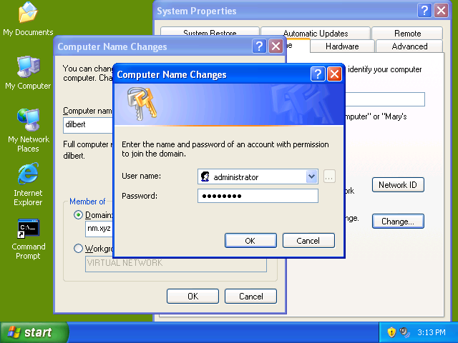

While the XP virtual computer is restarting go to the domain controller, (select the command from the VirtualPC action menu to send a ctrl-alt-del to the virtual pc ). Logon as user “administrator” password “Password1234” and open the “Active Directory Users and Computers” program on the start button. Click on the Computer folder under the college.us domain. See if your computer is there, if so you have joined it to the domain.

Open a command window on the Server. Enter the commands:

Dsquery user
Dsquery computer
Dsquery group

Do hands on project 9-1 and 9-2 starting on page 477 in the textbook. In addition to the accounts in the project, setup an account with your user name and add it to the Faculty group.

Use your new domain account to log the XP client computer on to the domain. Make sure you are logging on to the domain, not just the local machine. (click the options button on the Log On window and select the domain under “Log on to:”

