Lab 1 Virtual PC

Virtual PC is installed on the computers in the College of Business Computer Lab.

Copy Virtual Machine configurations to your computer
Open the “My Computer” window and select “Map Network Drive” from the “Tools” menu. .

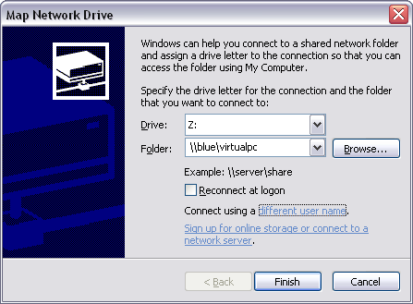
Click on “different user name” and type in “virtualpc” for the user and “vpc123” for the password.
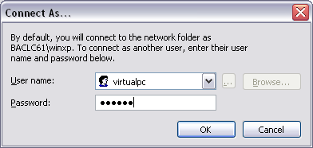Click “ok” Enter \\blue\virtualpc for folder and click “finish”. A window should open with the contents of a folder on the blue server. Right click on “my virtual machines” and select “send to” “my documents” (click “yes to all”) This should copy the virtual computer configuration information to your computer. Close the window showing the contents of the folder on the \\blue\ server-- so you don’t accidentally try to run the virtual machines directly from the server.

Enable loopback adapter

For the virtual networking to work you must enable the loopback adapter on the host computer. Click on Start, Network Connections, right click on Virtual PC, click on enable.

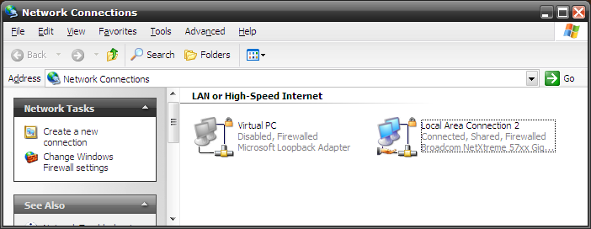

Part 1, Run Virtual PC
Open “My Documents” and drill down into the VISTA directory as shown in the figure below. Double click the VISTA.vmc icon (Virtual Machine Setting File) and wait for the virtual computer to boot.
.

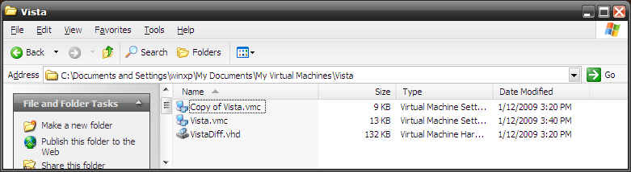

Login to the user1 account with the password “password” (all lower case).

Try to duplicate the examples in the textbook (not the lab manual) start with “Using the windows Vistat Interface” at the bottom of page 16, through the end of the chapter. Then skip to Lesson 3 in the textbook and again duplicate the examples up trough page 79. Periodically take screen images, ctrl-PrintScreen and save them to a file. Make note of anything that doesn’t work. This will be the basis of your lab report.

