MUSIC PRODUCTION-II
Dr. Birch
Project 2:
Goal:
Enter the drum, bass, piano/guitar/ and melody part of a 12 bar blues using step MIDI recording in the various editors

Reading:.
- Error! Not a valid link.
Create a New Project
- Start a new project in a new folder in your folder on the D drive
- Name the Folder: <Yourname> MP-II Project 1
- Create an empty project
Entering the Drum part
- Create an instrument track and select an acoustic drum kit
- Right Click on the Inspector and select Show All. This will be a good habit to start at the beginning of all MIDI projects.
- Create a one measure clip
- Open the drum editor and enter the following one measure pattern
- Set the Independent Track loop to one measure

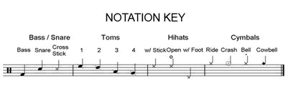

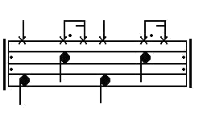
Entering the Bass part using the List Editor
- Create a Bass instrument
- Create a 12 measure clip
- Enter the list editor
- Turn on Step Input and turn off Insert and on and off velocity
- Enter the following pattern using the step editor
- Use Quantize to set the note value (the right arrow does not seem to enter rests in the list editor!!!!)
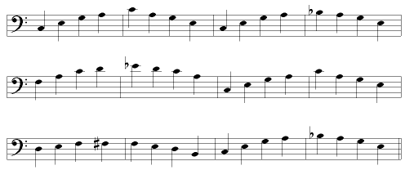
Entering the Piano Part\
Same as above but
- Use the score editor
- Use the right arrow to insert rests

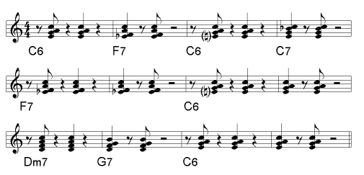

Entering the Guitar Part

Same as above but use the Key Editor
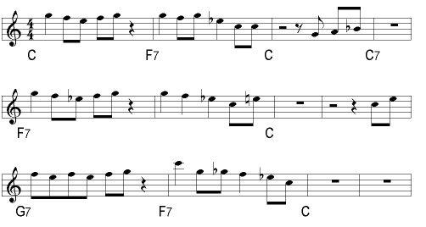

When you are done entering all of the parts, open the mixer and set the levels and the pan for each track.
Mixing Procedure
- Set the L and R locators and turn on Cycle
- Set the Pan for each track
- Turn the volume down for each track
- Turn the Bass up to unity
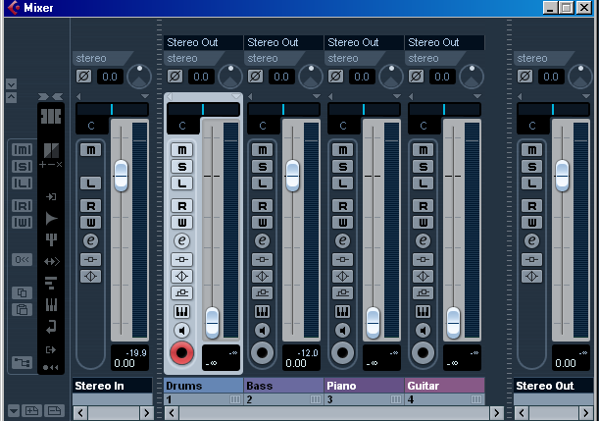
- While listening, raise the volume of the drums, then the piano then the melody.

You can temporarily save to your folder on the I Drive.

When you are finished: From Cubase go to File>Backup Project, navigate to the M: Drive, Create a new folder called <yourname> Project 2 and on the M Drive, give the project the name <yourname> Project 2 and click ok
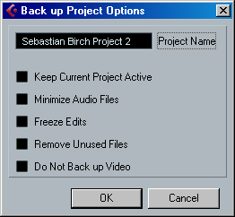

Name the folder and the project <Yourname> MP-II Project 2

