Message from ALEKS after taking the initial assessment:

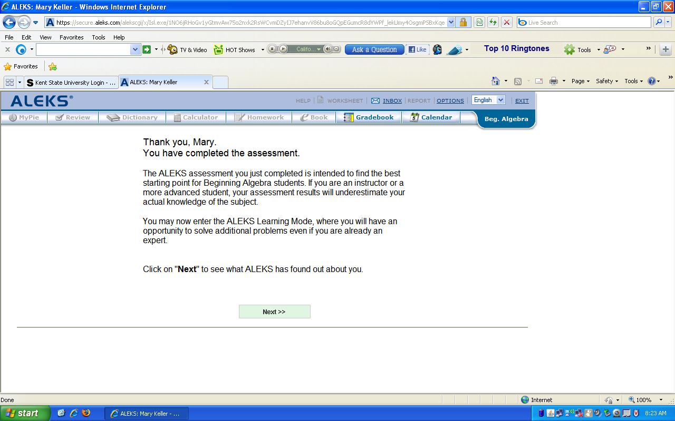

Message from ALEKS after finishing all the topics of the course: (Just before the final assessment)

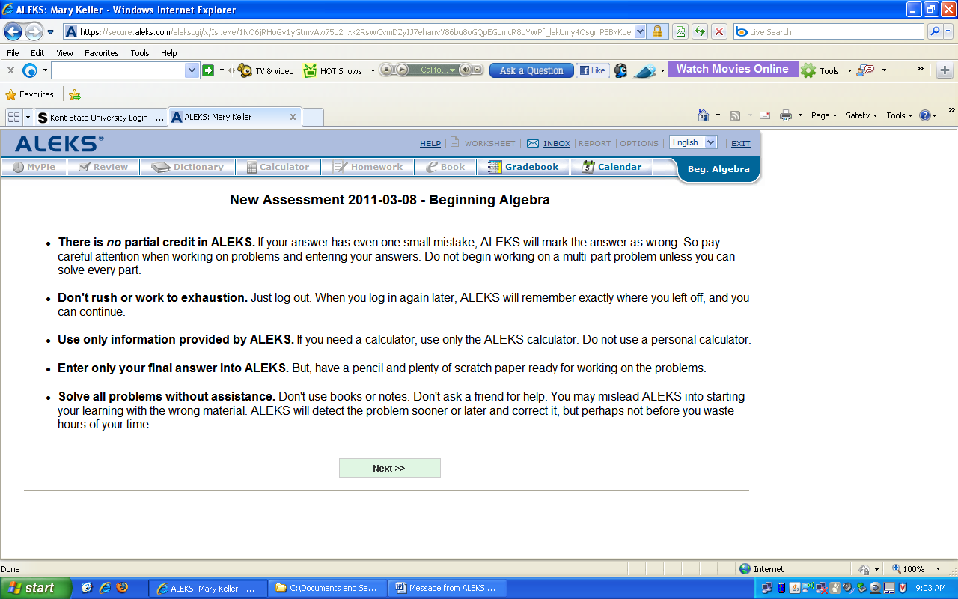
Message from ALEKS after finishing a generated auto assessment: (Just before the final assessment)

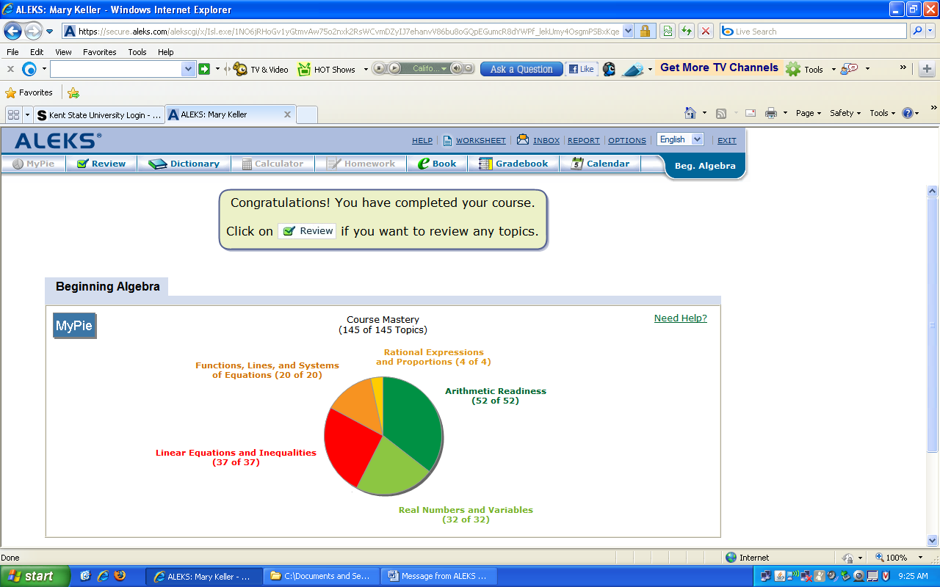

The auto assessment was 11 questions. Now the instructor must assign the comprehensive assessment.

Message just before the final comprehensive assessment:

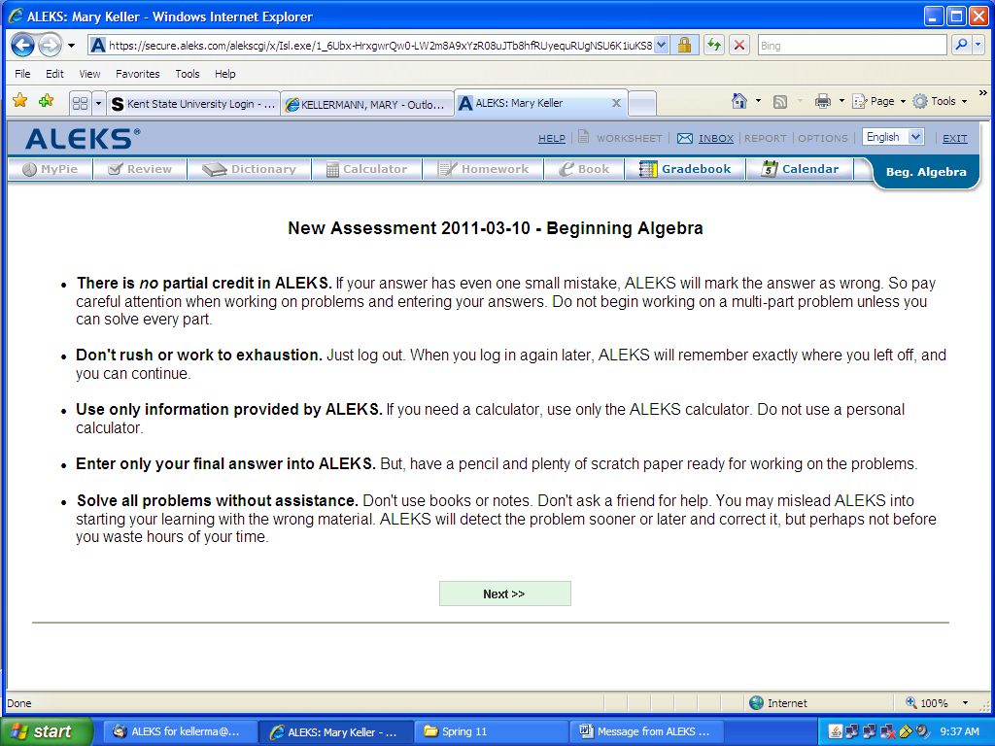

Messages after final assessment:

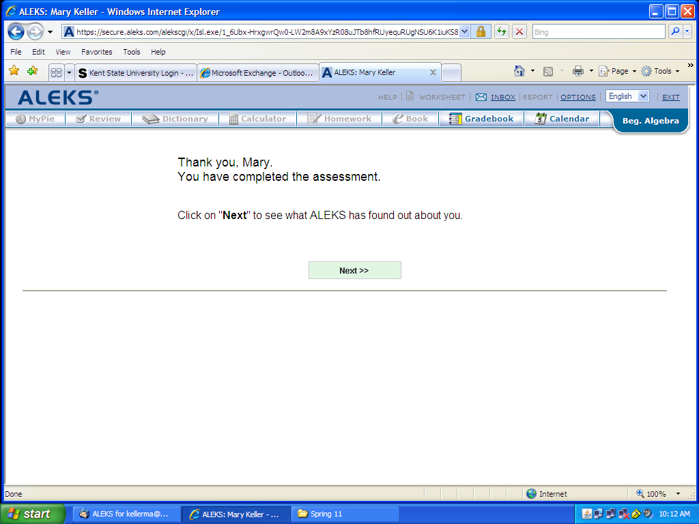
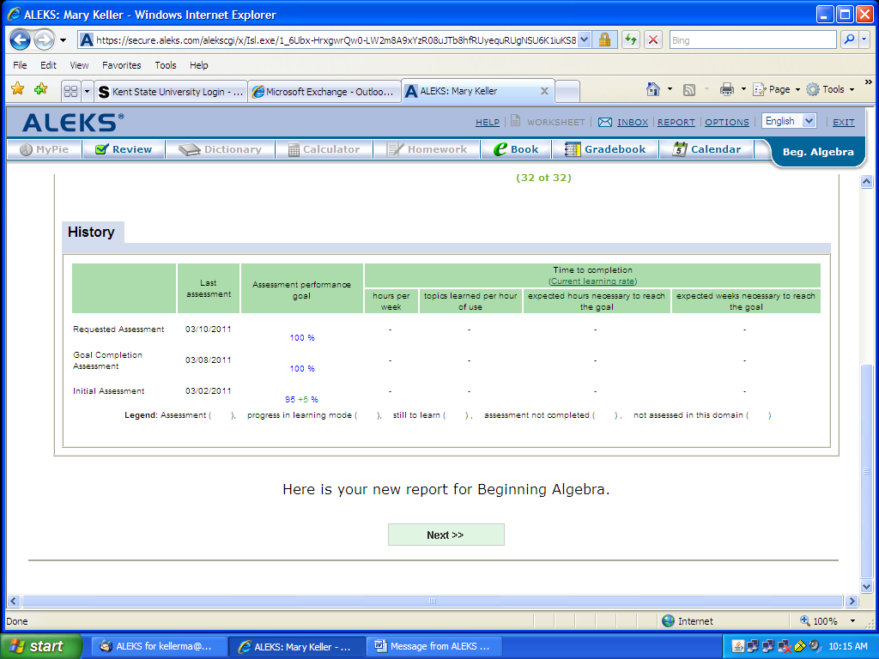

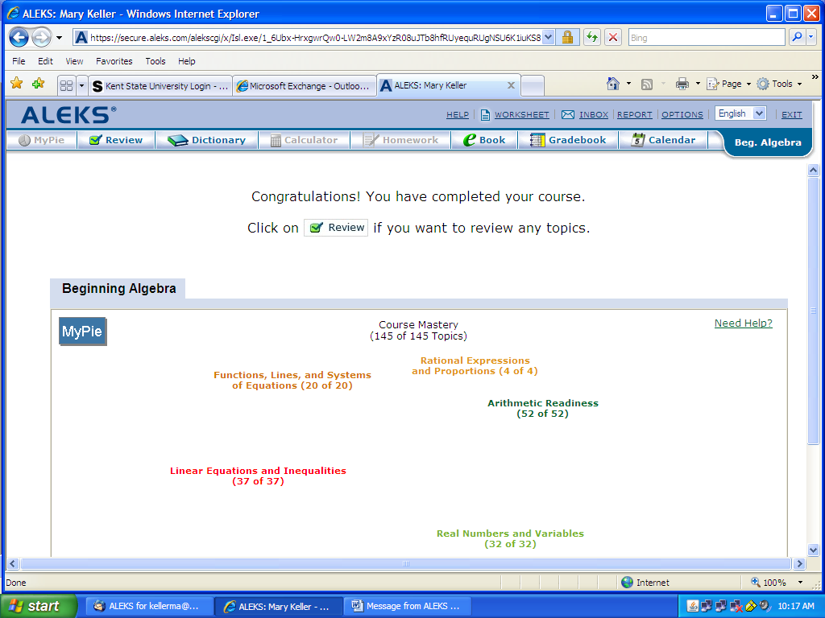

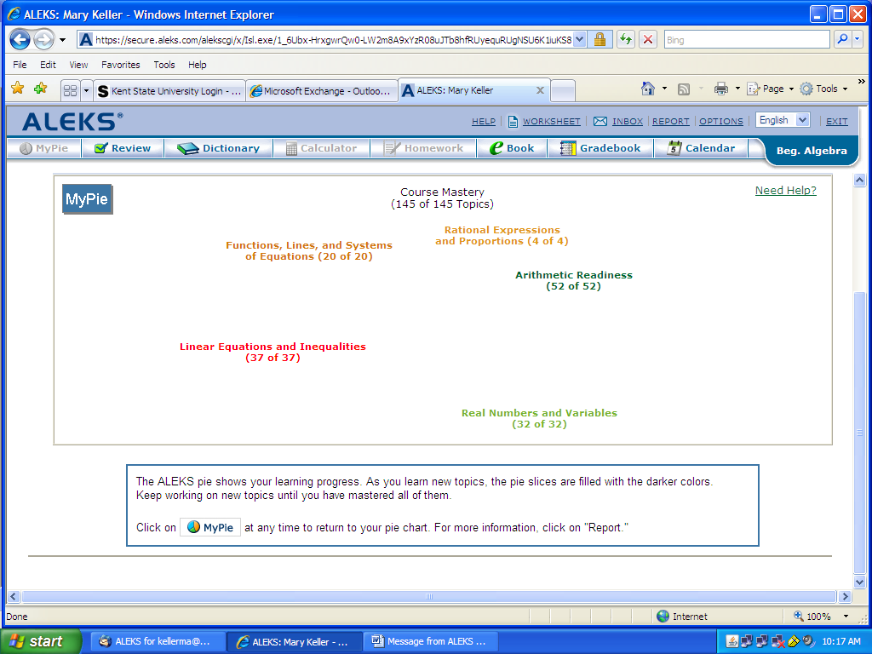

Student clicks on report (upper right, not a tab):

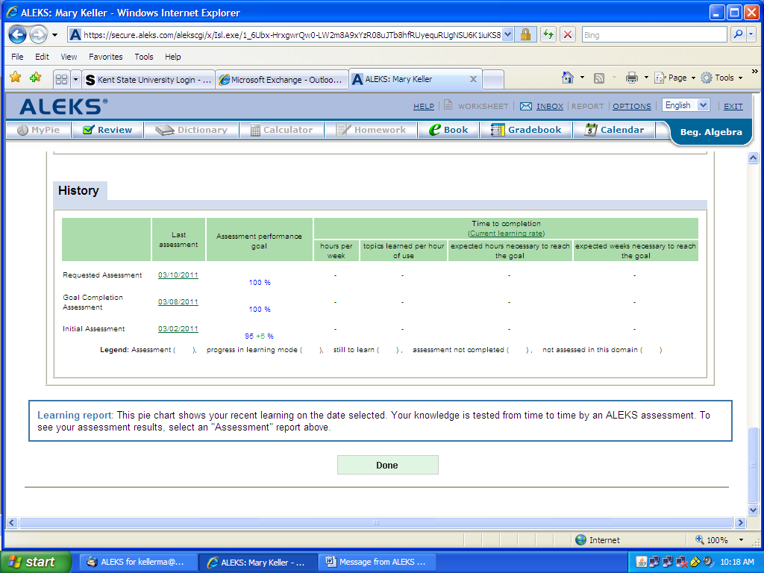

Student ready for 10022!

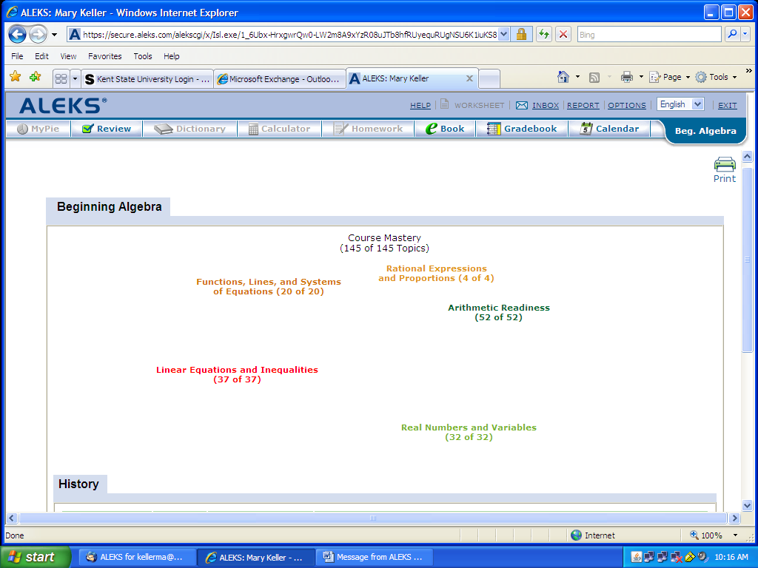
Student mkeller108 now moved to 10022, student logs in and sees:

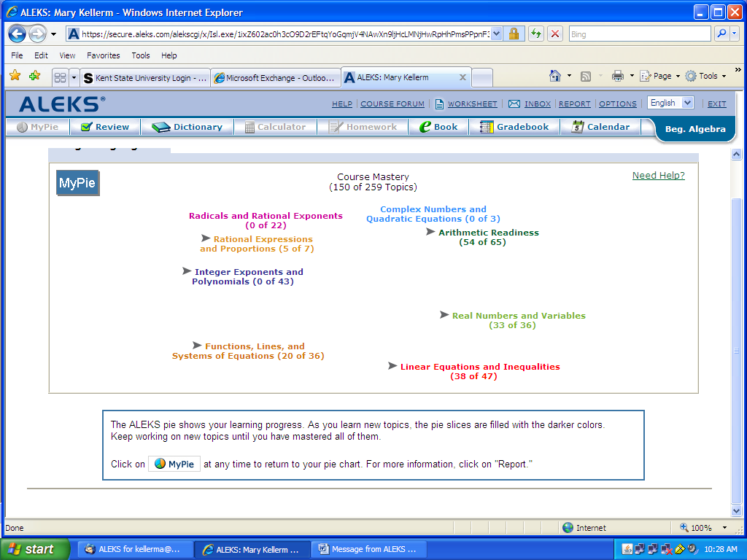

Student clicks on report:

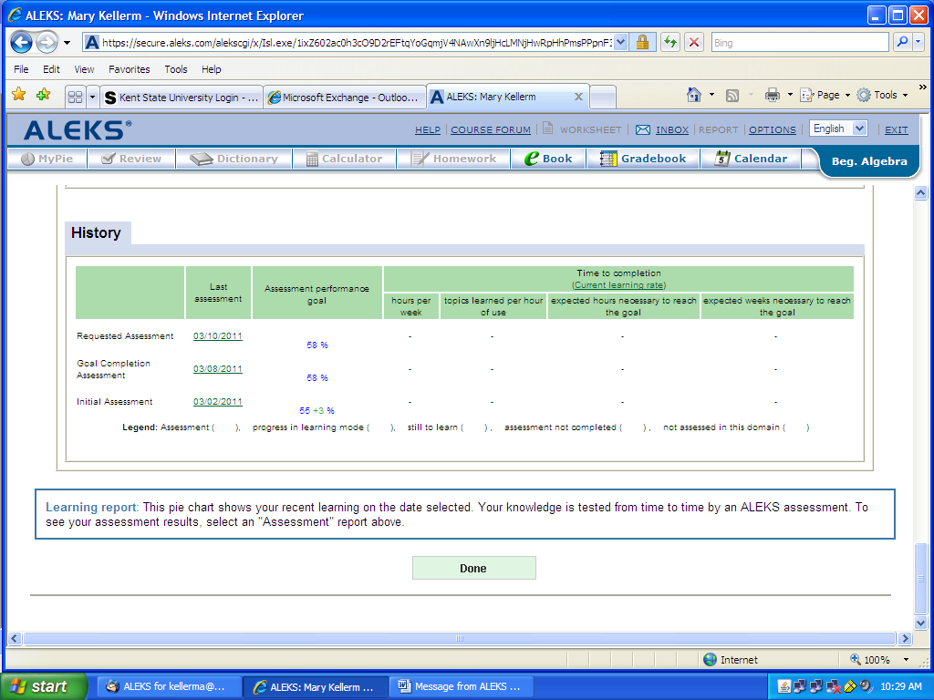

Student did not get the auto initial assessment. Student works on topics. After doing a few, here is the report. Scroll down please.

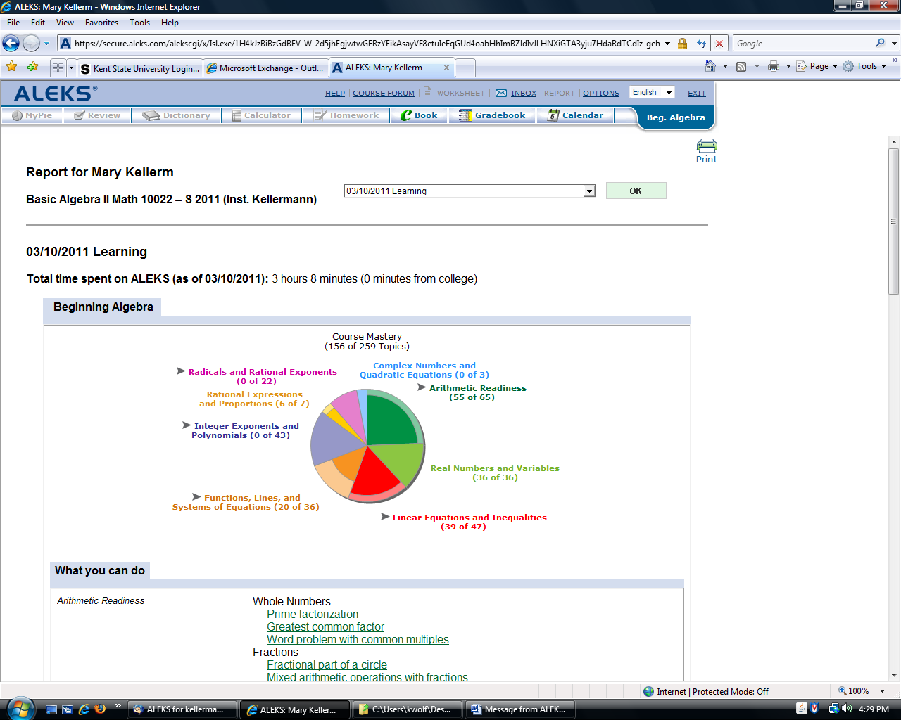

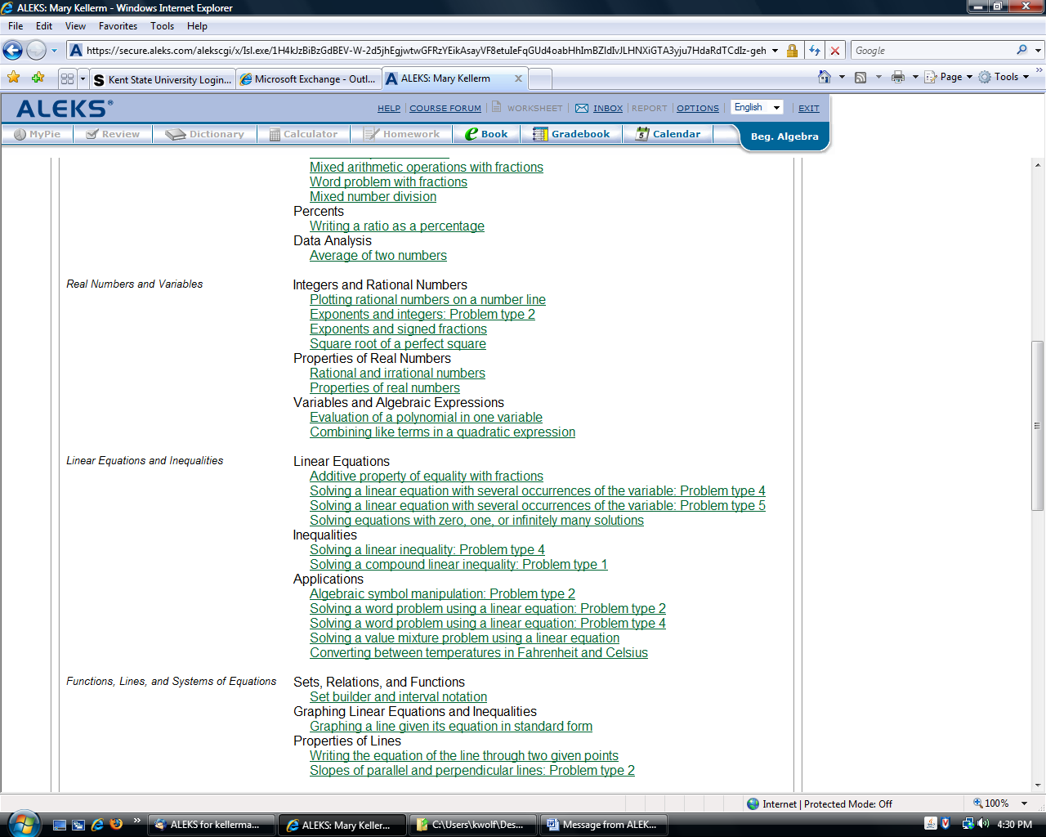

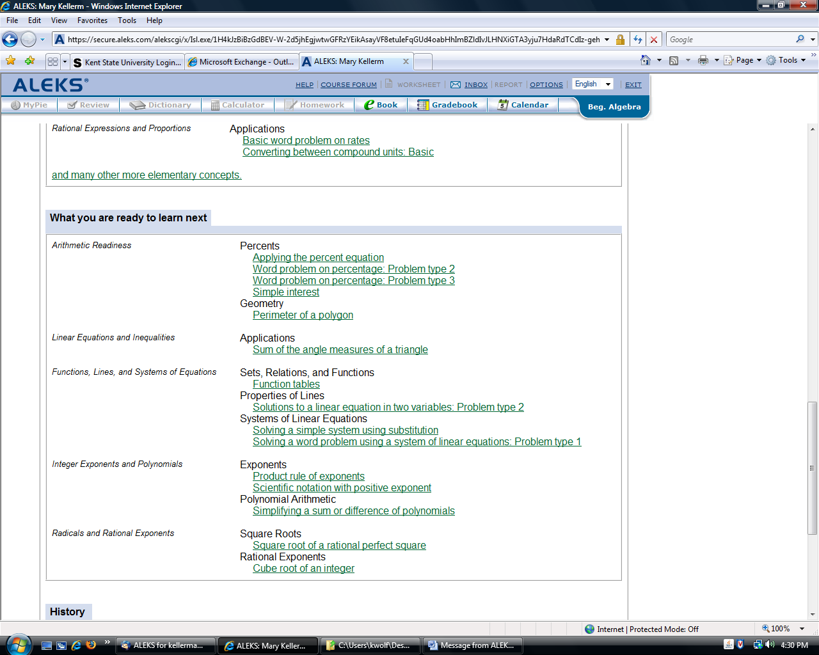

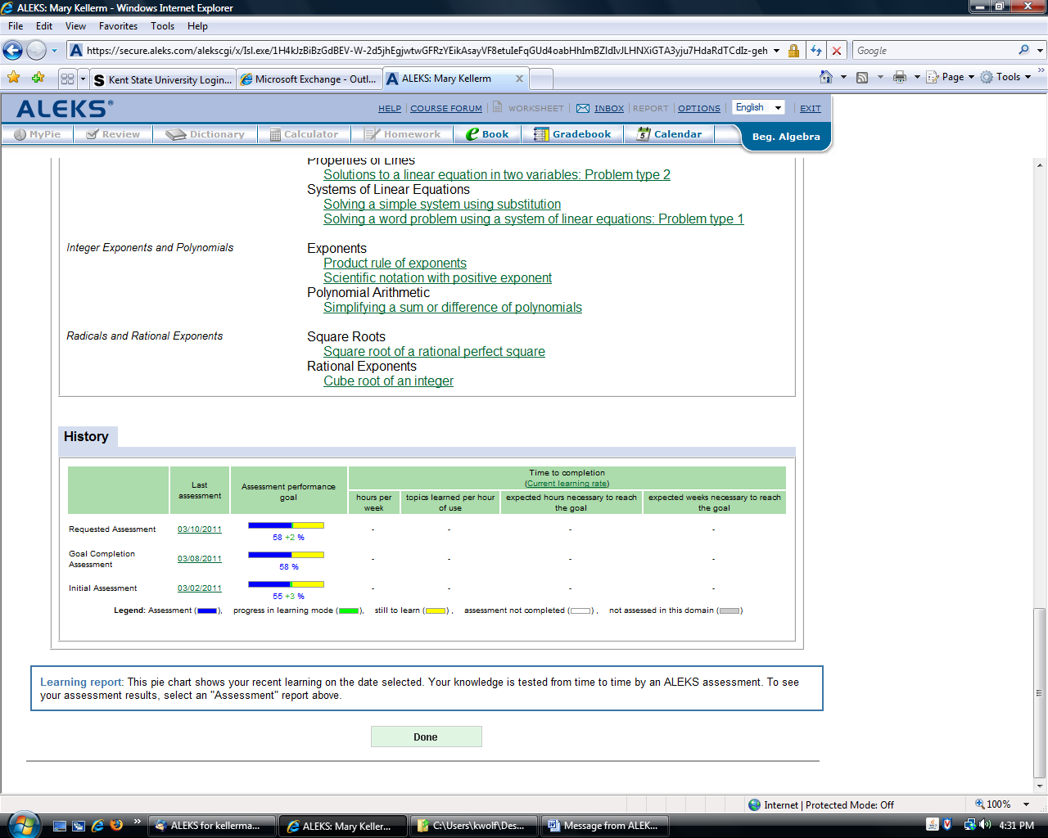

Still, no auto assessment.

163/259 topics report:

