Aleks Instructor Module – Reports -Use Basic – IM2 View-

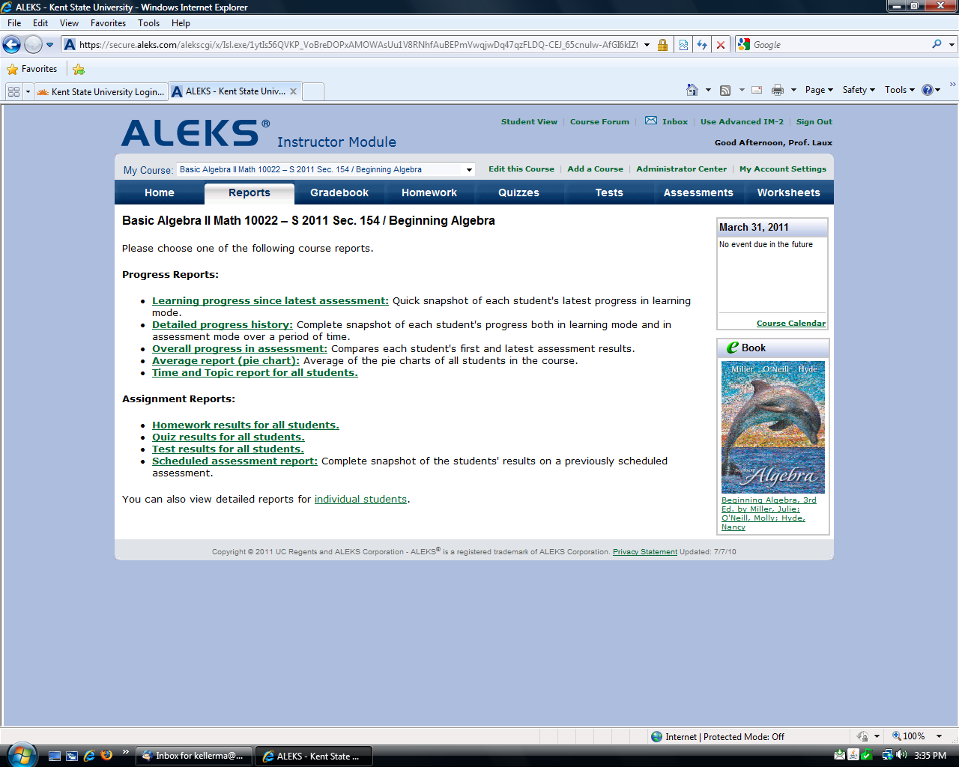

Home Tab

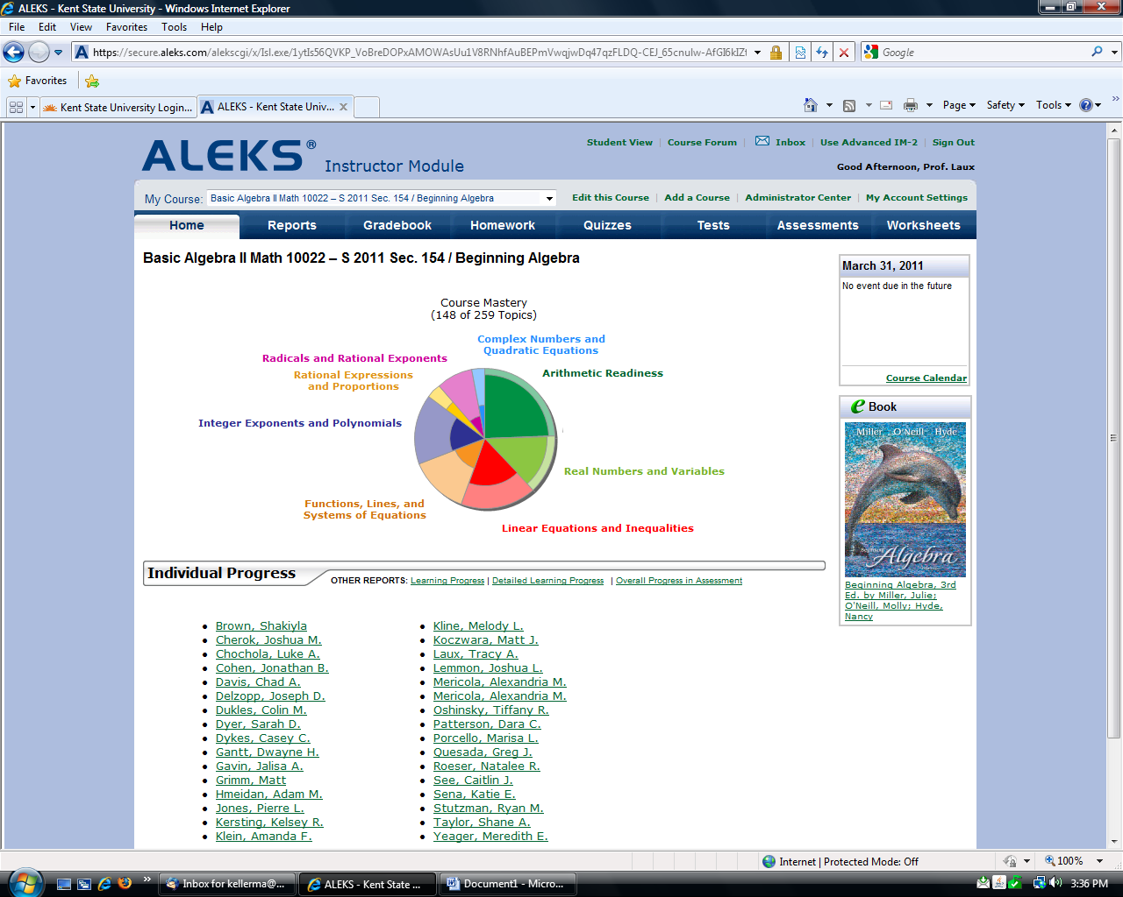

How to assign to entire class In Basic – IM2 View 1) Click- Assessments tab 2) Click- Add Assessment Button

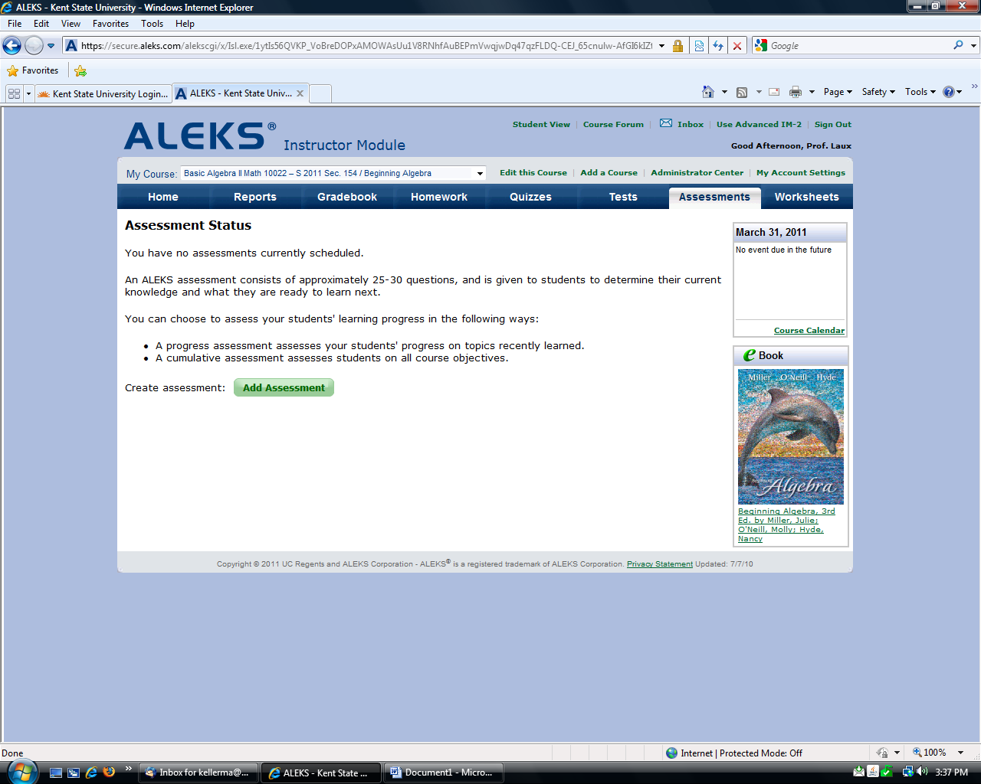

3) Select- Comprehensive Assessment 4) Check- To be Taken at School Only 5) Check- Prevent automatic assessment – drop down arrow- same day or up to 7 days 6) Select- Assign to entire Class (see below if assigned to specific student)

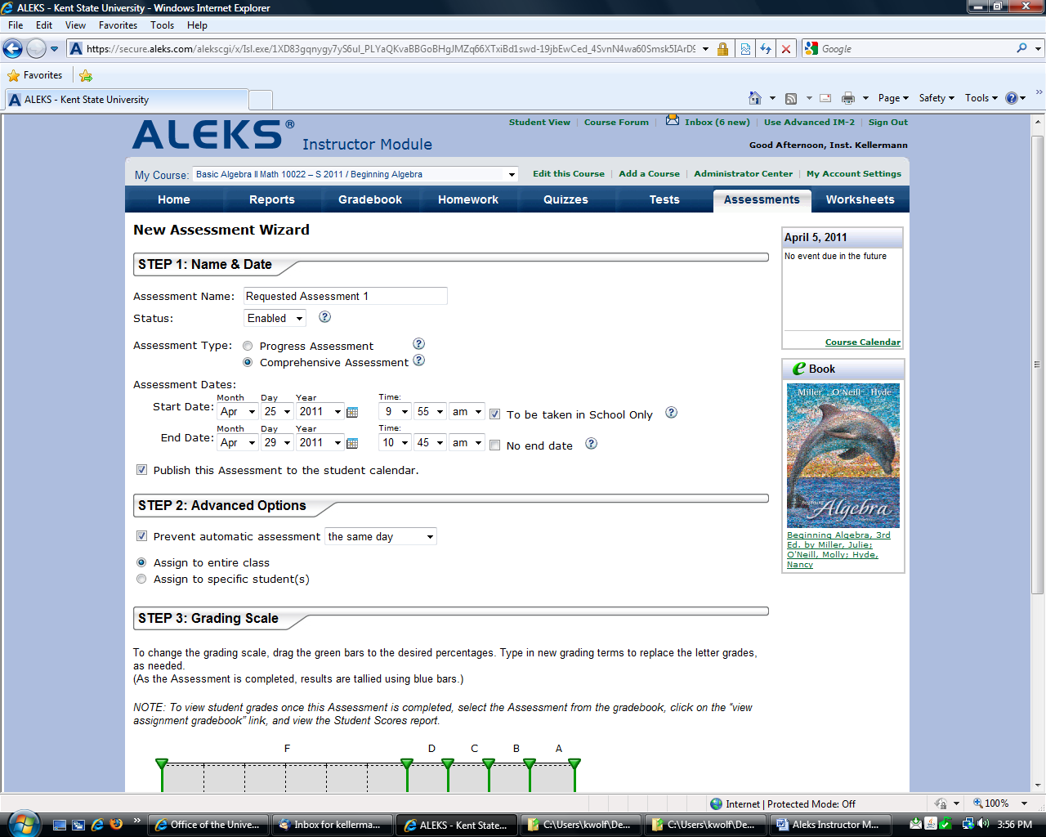

6) If assigned to specific student: Select student

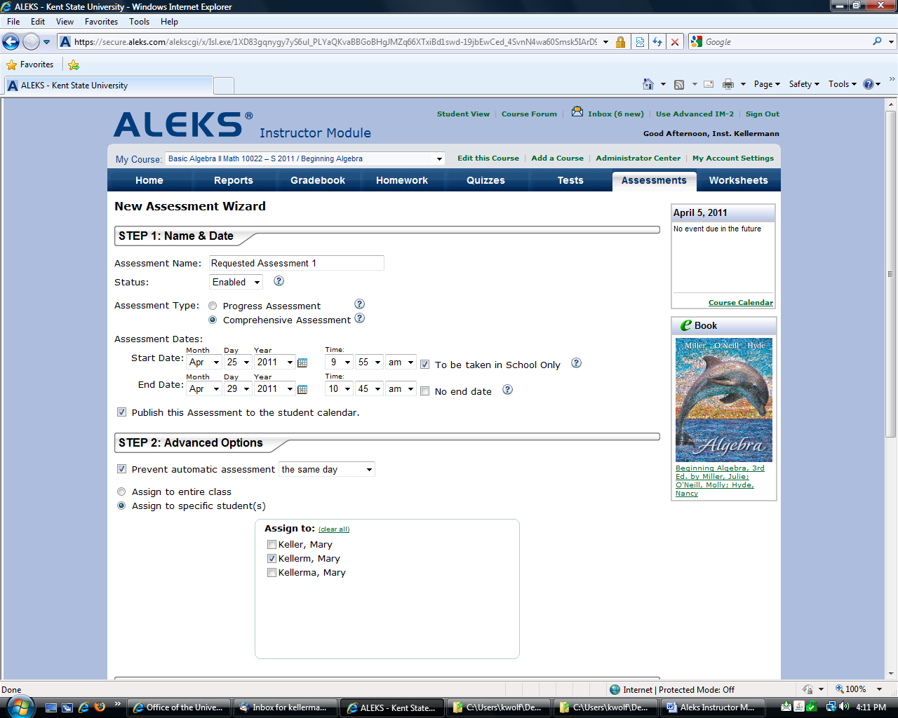

7) Select- Do not show letter grades on reports 8) Click on Next

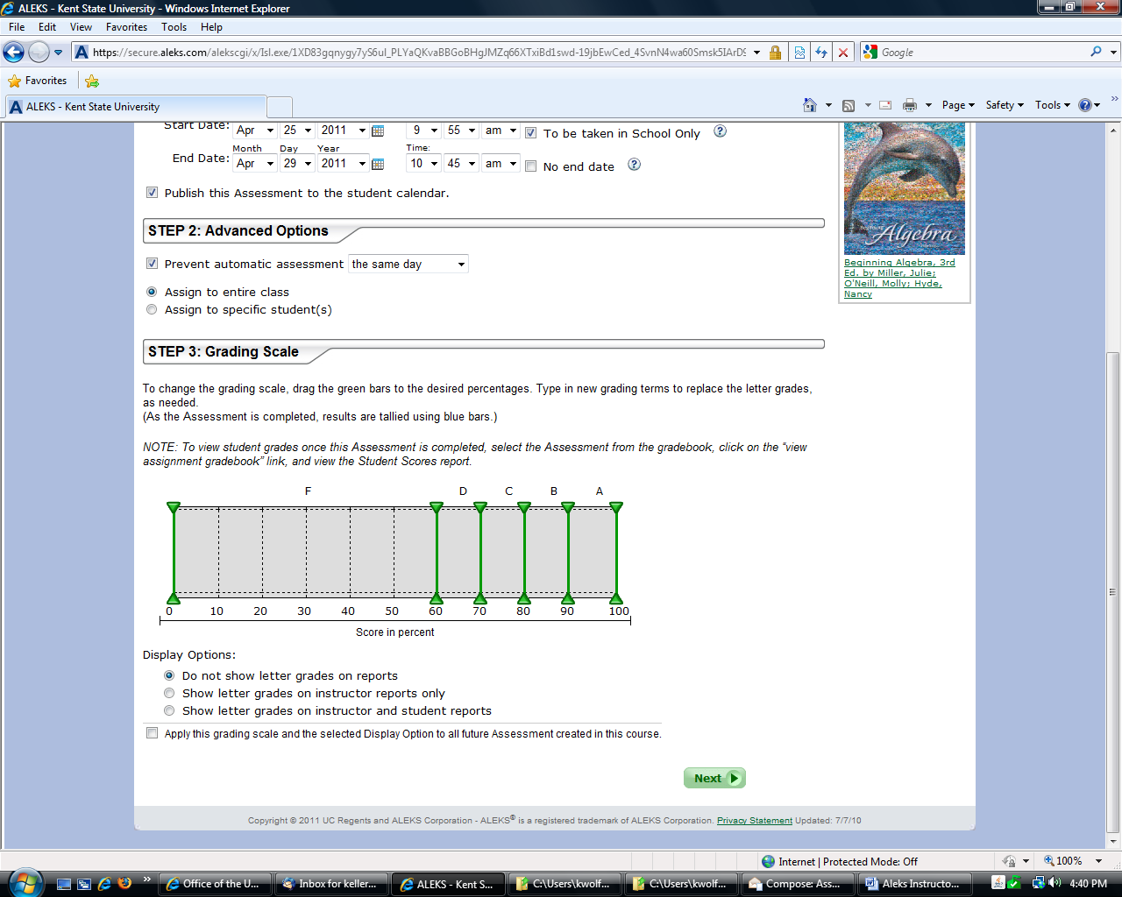

9) Click on Save

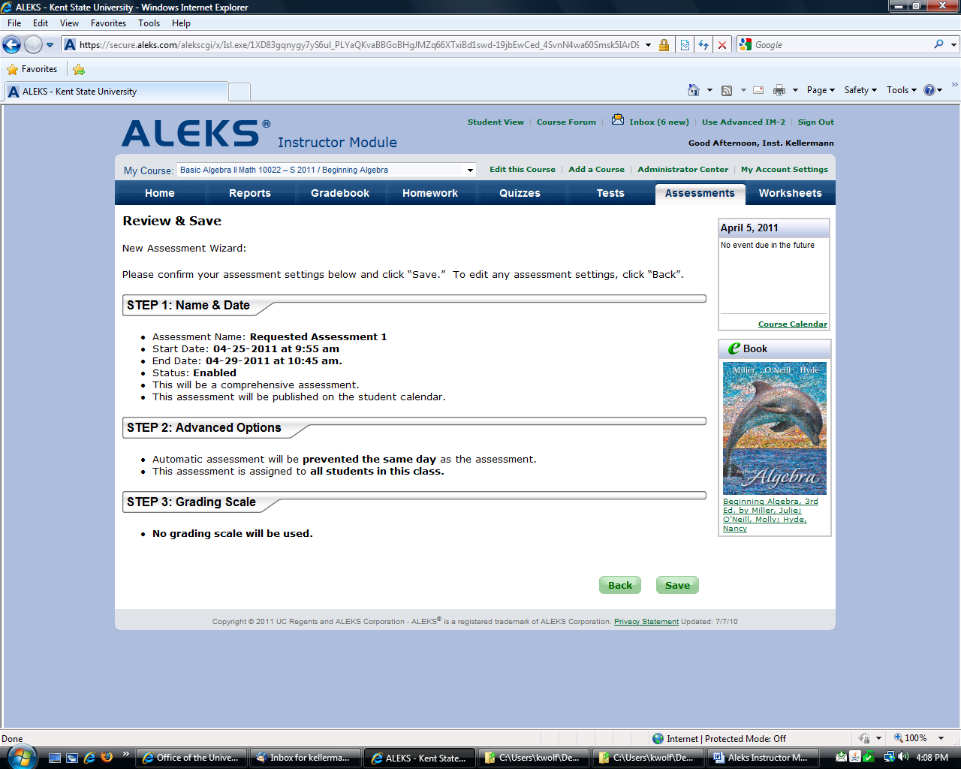

There are other ways to do this in the Used Advance IM – 2 View.

