Student Enrolls in a new ALEKS Course having an existing account

- Student logs in
2) Student selects options- upper right of screen

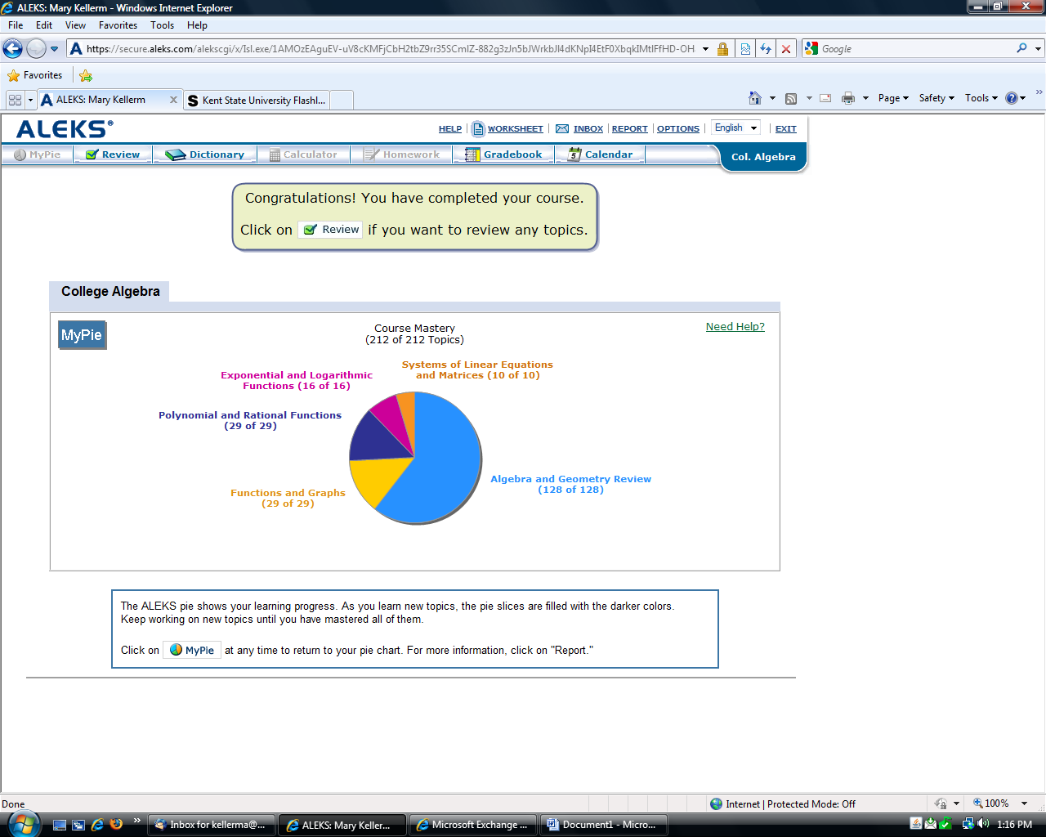

After selecting the options link:

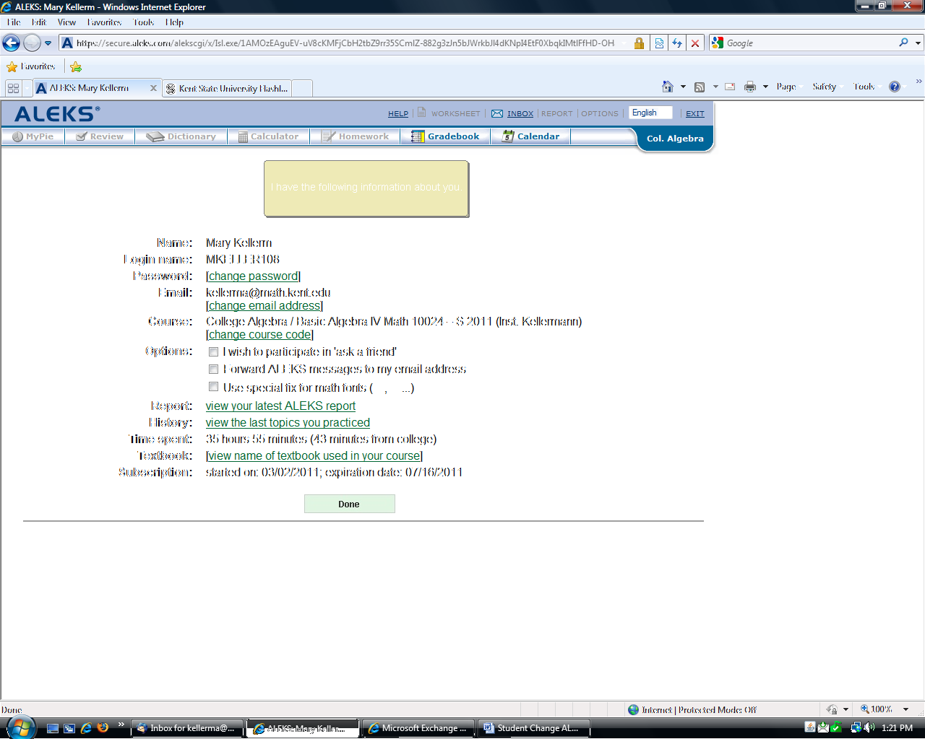

3) Go to Course: Change Course Code:

Course:
  College Algebra / Basic Algebra IV Math 10024 – S 2011 (Inst. Kellermann)
  [change course code]

4) Now student enters the new 10 digit course code:

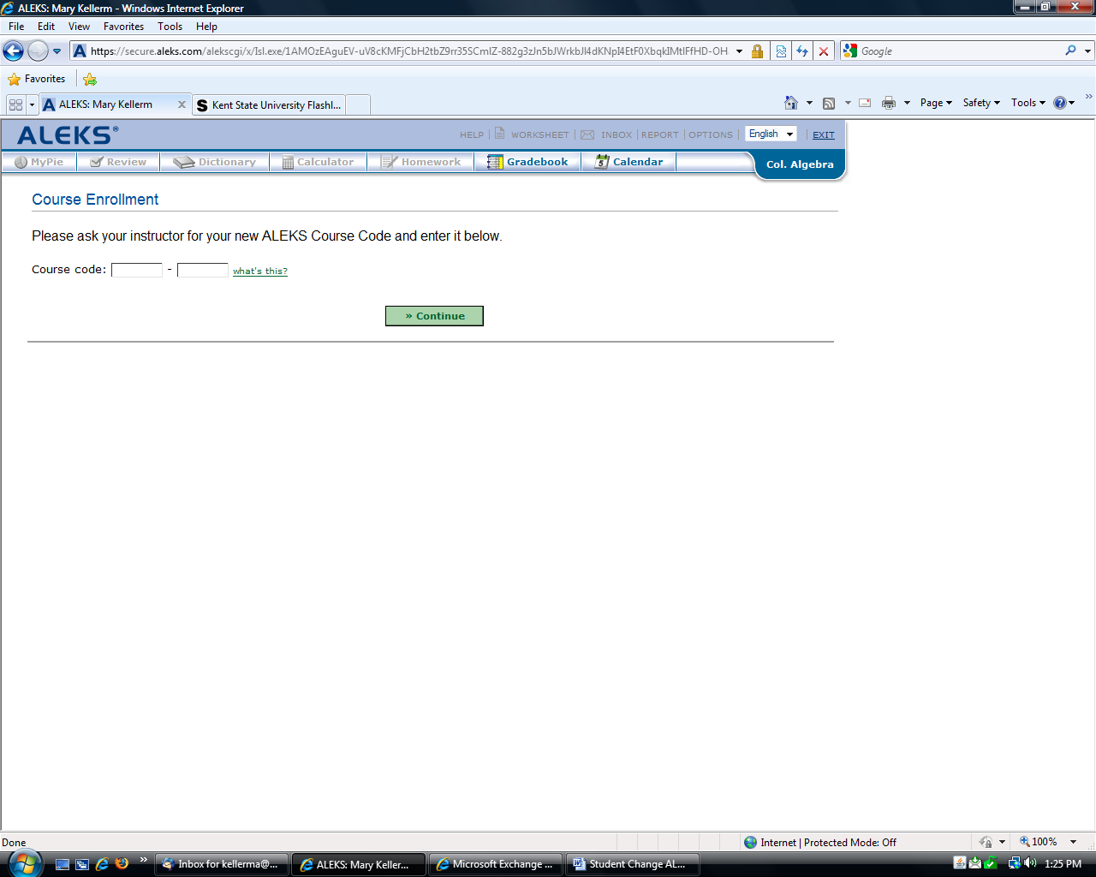

Click Continue:
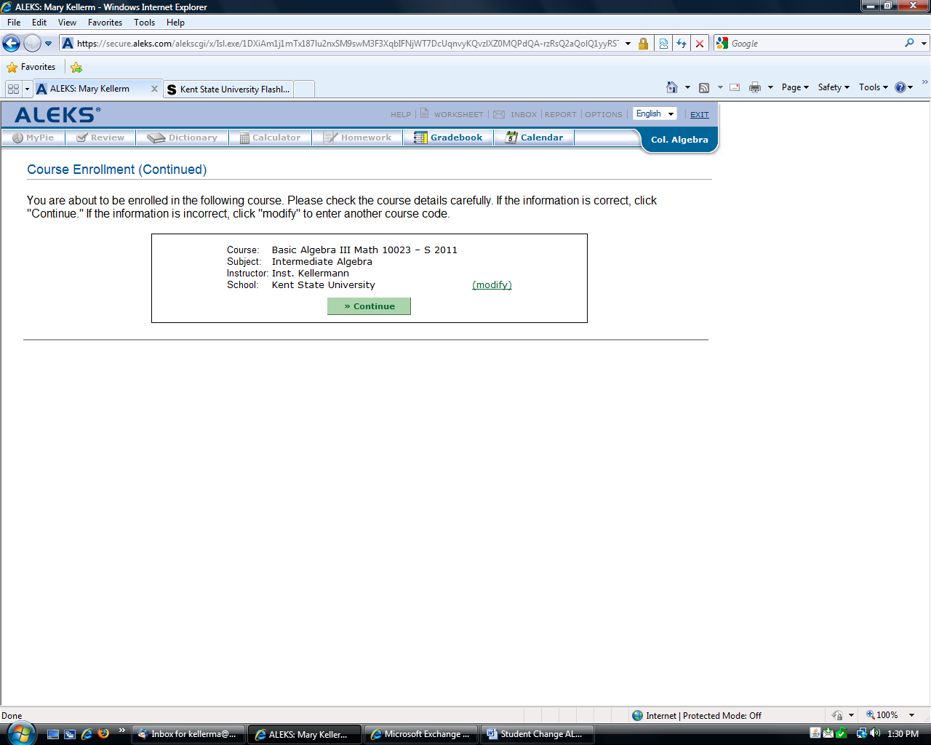
Click Continue Again. Use the modify link to re-enter 10 code if there was a mistake.

If the student is starting a different ALEKS course, like Beginning Algebra to Intermediate Algebra, an initial assessment will begin:

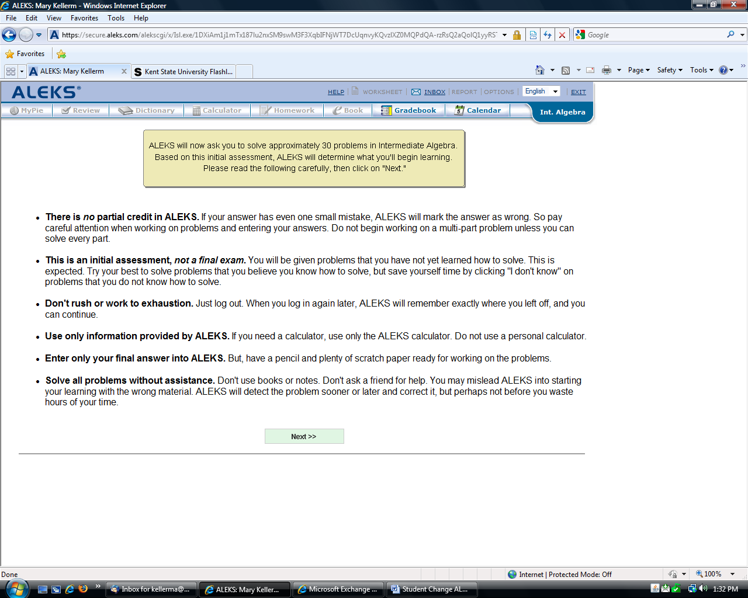

Student is now enrolled in the new course!

