Hudson Middle School
Physical Education Assessment
Floor Hockey

Name: ______________________ Date: _____________________ Period: ________________

Score: _________ / 10

- Think back to our first day of Floor Hockey. We went over safety and the rules of Hockey. Circle the picture that shows TRIPPING (1 pt)

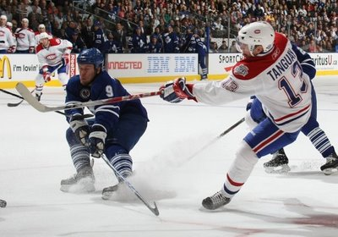 | 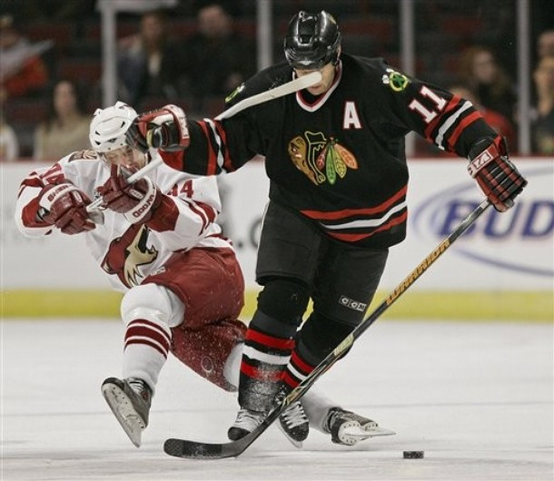 | 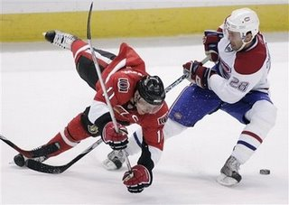

- Circle the picture that shows HIGH STICKING. (1 pt)

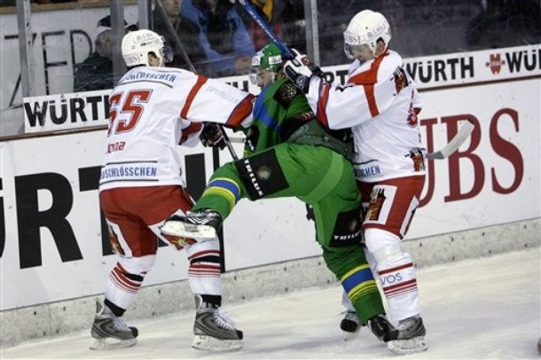

- Next, we learned how to keep control of the puck with our stick. What did you have to do with your stick to keep the puck under control? (1 pt)

- While you were playing at your home court, what did you do to make sure your team always had the puck? Finish the sentences. (2 pts)

Made ___________________ and ___________________ passes.

Moved to ______________________________________ space.

You
Your teammate
You have just made a pass to your teammate. You are trying to score a goal.

5. Draw an arrow on the court to show where you would move to next. (1 pt)

6. Then, draw an X where your teammate should pass it to you. (What are they aiming for? Where should you get the ball back?) (1 pt)

- Why do we use the give-and-go? (1 pt)

- We also learned two types of shots. Fill in the sentences below. (2 pts)

The wrist shot is when you ________________ the puck with the blade of the stick.

The _____________________ is when you strike the puck with your stick from 1-2 inches away. (like putting a golf ball but faster)

* BONUS *

What is my name? 

Miss ________________

