Iceland
Capital city: Reykjavik
Political system: Republic
Population: 0.3 million
Total area: 103 000 km²
Currency: Icelandic króna
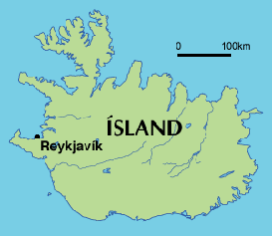

Iceland is famous for its natural beauty and extensive unspoilt landscapes. Volcanoes and
glaciers combine to create a stunning and unique natural environment. Natural geothermal
springs are popular as open-air swimming pools and spas, and are a major attraction for tourists.
The first settlers came to Iceland in the 8th century. Fishing, river rafting and 4x4 off-road tours also attract crowds of tourists every year.
They were from Norway or Celtic people from the British Isles. They thrived as an independent community for several centuries and described their adventures in history books which they called 'sagas'. Iceland can perhaps boast the world’s oldest parliamentary democracy as its
parliament was established in 930.
Known as the 'Althingi', the parliament’s 63 members are elected every four years. The economy is based on fishing, industry that can exploit the renewable energy from the hot springs or modern IT-based services.
Much of Iceland’s visual art has been influenced by the country’s landscape Folk music remains popular, along with pop. Famous exports include Björk, The Sugarcubes and Sugur Rós.

Useful links
Iceland's official tourism portal presents various information on activities and tours organised in the country, downloadable brochures and transport tips.
The official website of the Icelandic Government serves as a portal to all ministry sites. Each
ministry
has
an independent entry and webpage containing information on its portfolio, responsibilities and activities, as well as pertinent laws and regulations. The website also presents the political programme of the current government.

