Aluminum Worksheet
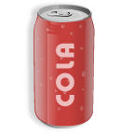

Name: ____________________________________________

Directions: Write the word Aluminum in the space below.

Directions: In the first square draw examples of recyclable aluminum. Please leave the second square empty.

