Loading Approval Materials from YBP and OCLC PromptCAT Via Millennium

- Login to the Millennium Acquisitions Mode.

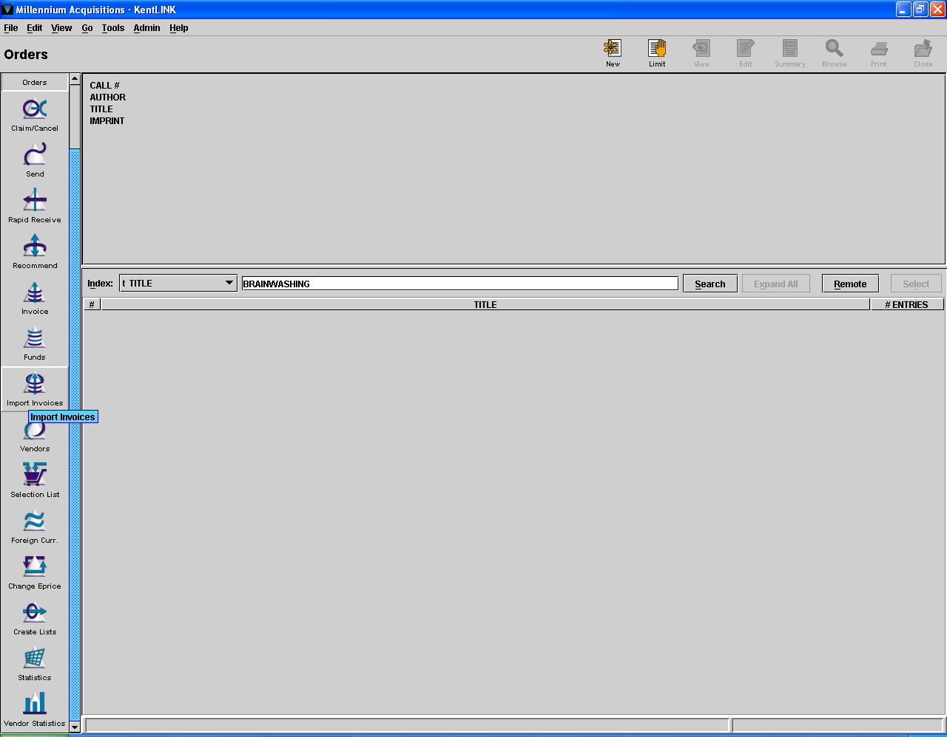

- Click on Import Invoice mode located on the left side of the screen.

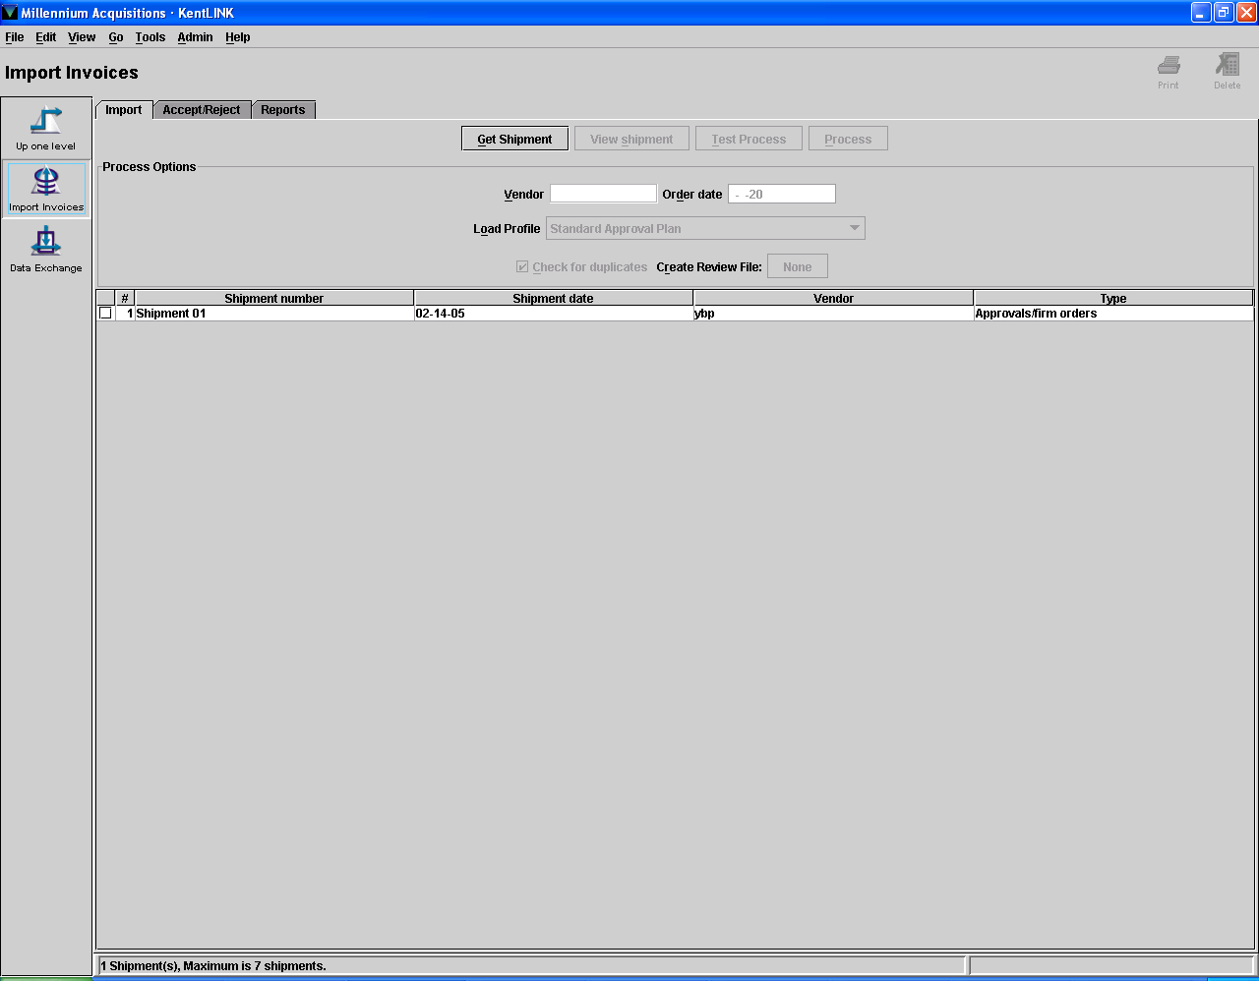

- Click on the Get Shipment Button located in the upper middle of the screen.

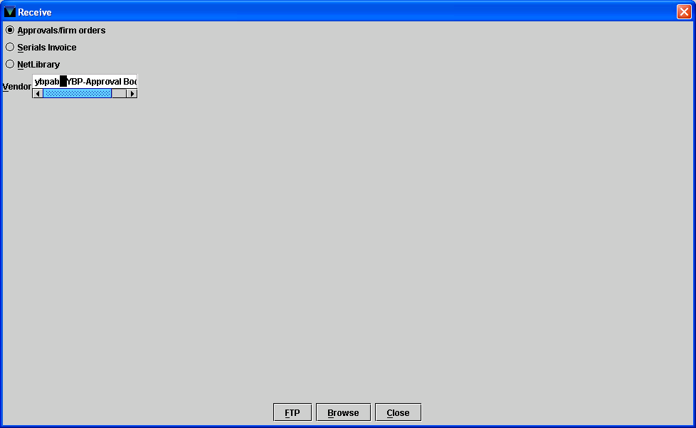

- Make sure approval/firm orders radio button is selected.

- Start typing “ybpab” in the vendor field.

- Click on the FTP button located at the bottom of the screen.

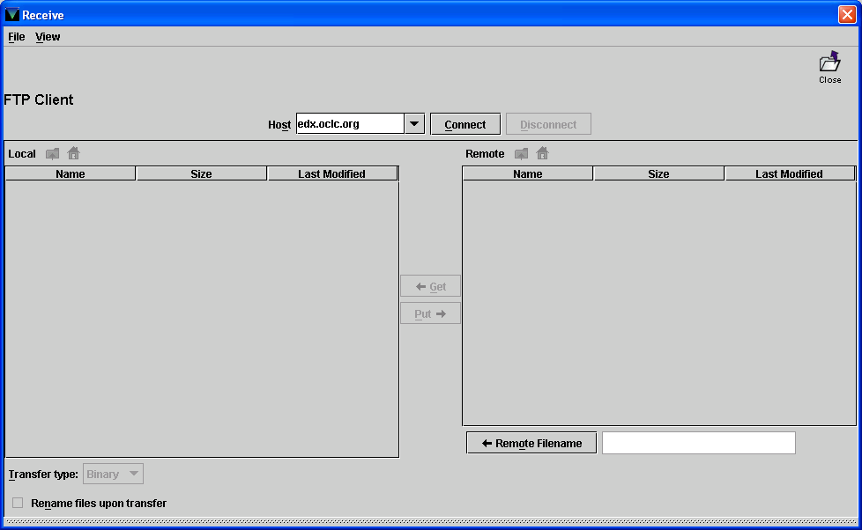

- In the pull down area of the Host field located in the upper center of the screen, select the host “edx.oclc.org” by clicking on that line.

- Click on the Connect button located in the upper center of the screen.

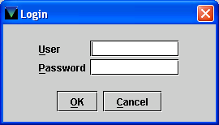

- Type the user name and hit the Enter Key.

- Type the password and Click the OK button or hit the Enter key

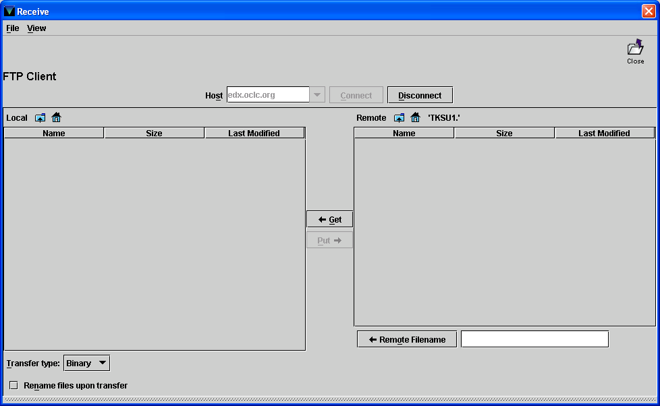

- In the Remote File Name field located in the bottom left of the screen, Type ‘edx.pcat.ksu.rcd’ and Hit the Enter key.

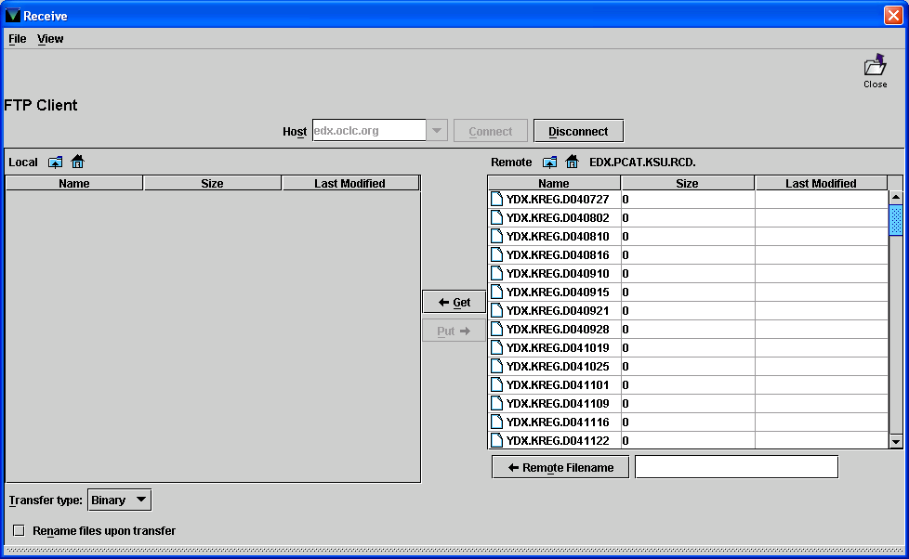

- Using the down arrow key on the Remote Directory located on the right side of the screen look for the next approval book file to be loaded into KentLINK.

- When you locate the file click on line.

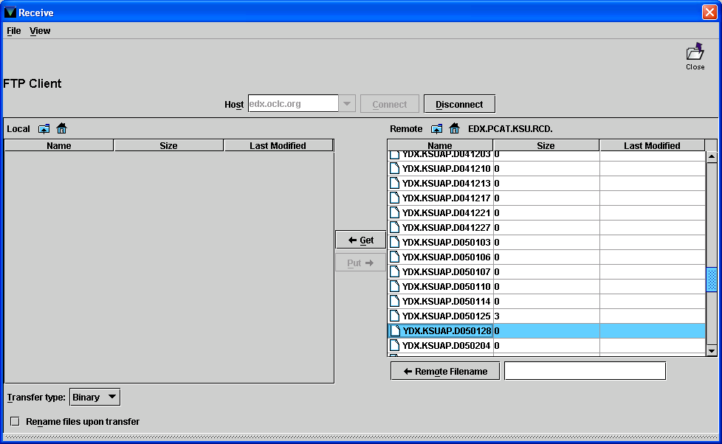

- Click on the Get Button located in the center of the screen.

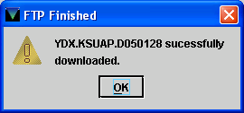

- You should see the above box when you have successfully downloaded file into KentLINK.

- Hit the Enter key or Click on the OK button.

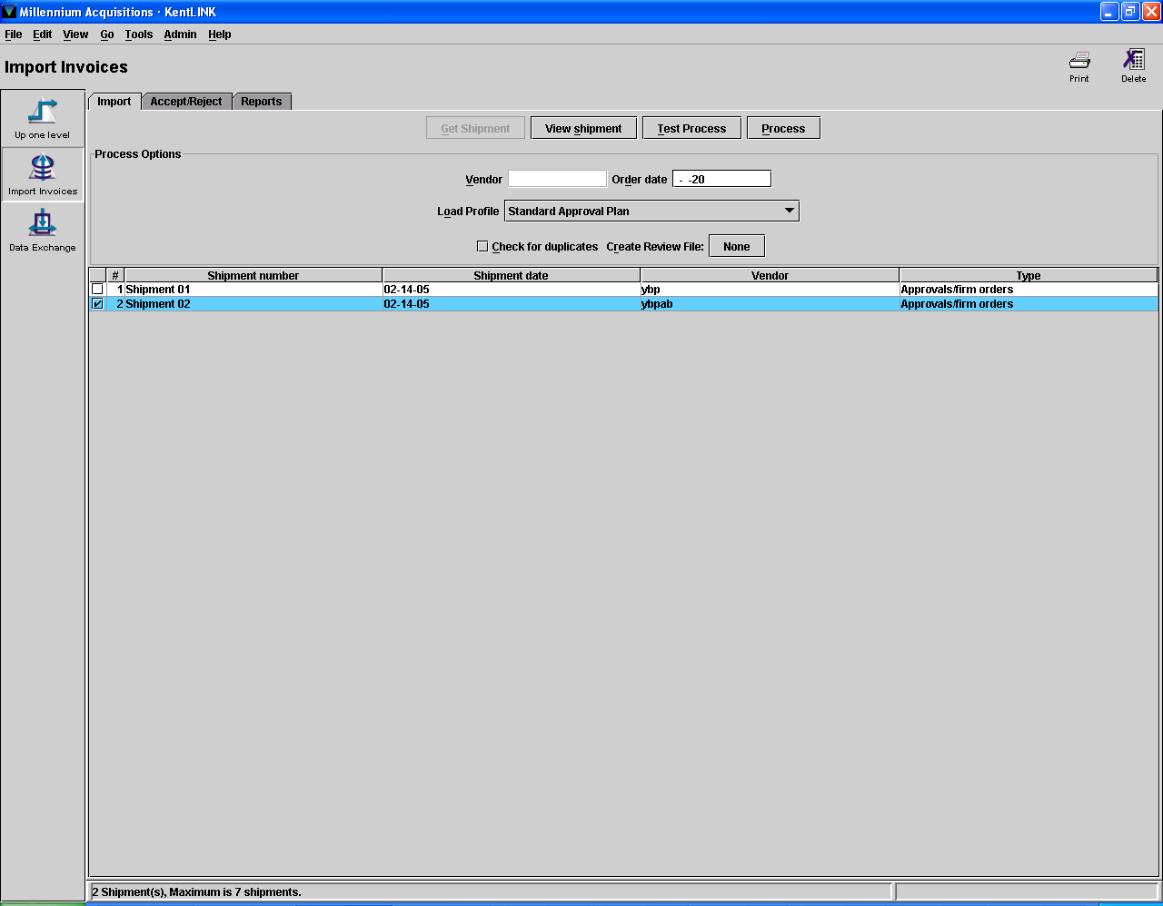

- Click on the appropriate Shipment Number (the shipment you just FTP’d).

- Click on Create Review File None Button

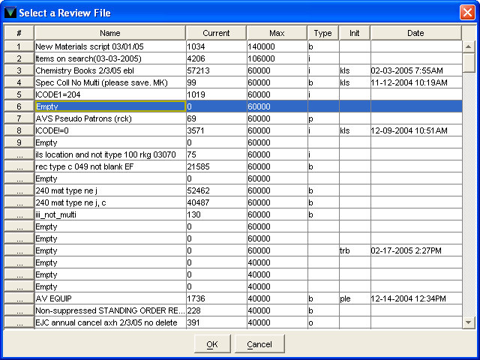

- Using the down arrow key on right side of screen select assigned file numbers (Lists 226-229 ). Select one of these list numbers that say “Empty” and Click the OK button located on the bottom of the screen.

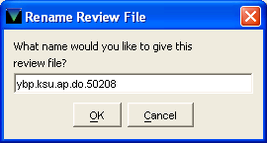

20. Type the name of the file you just FTP’d into KentLINK and Click on the OK button.

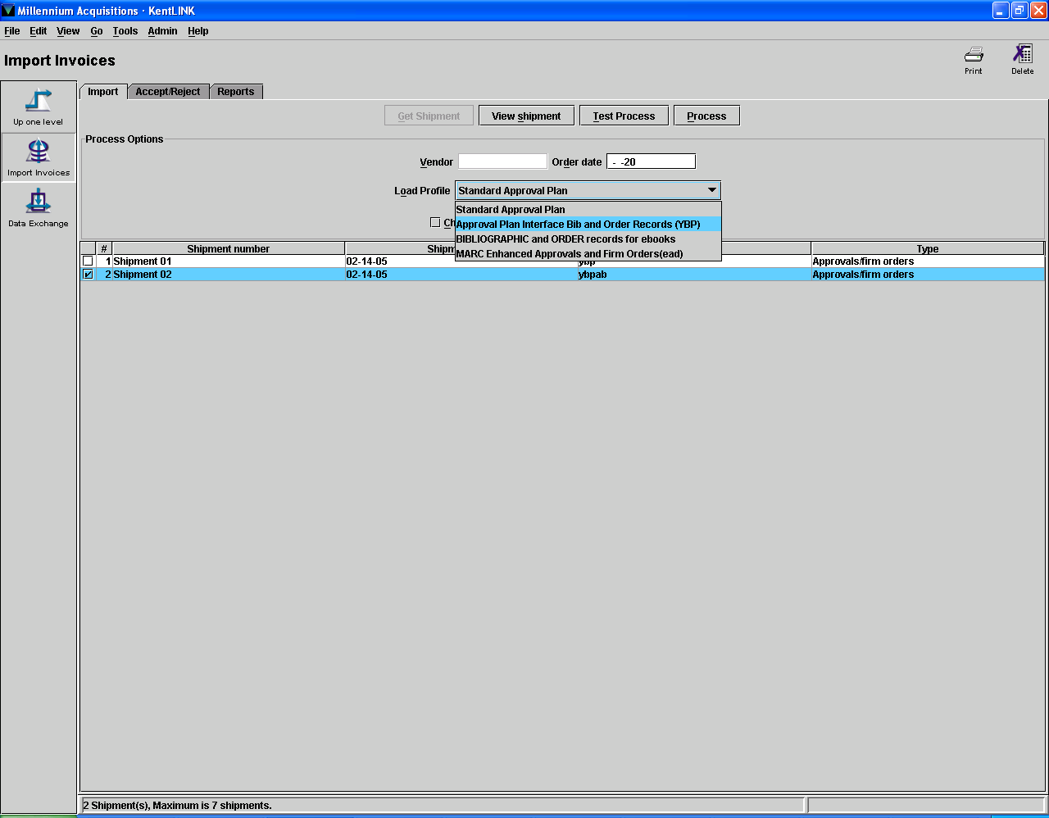

- In the Load Profile field located in the upper center of the screen use the drop down menu and select Approval Plan Interface Bib and Order Records (YBP).

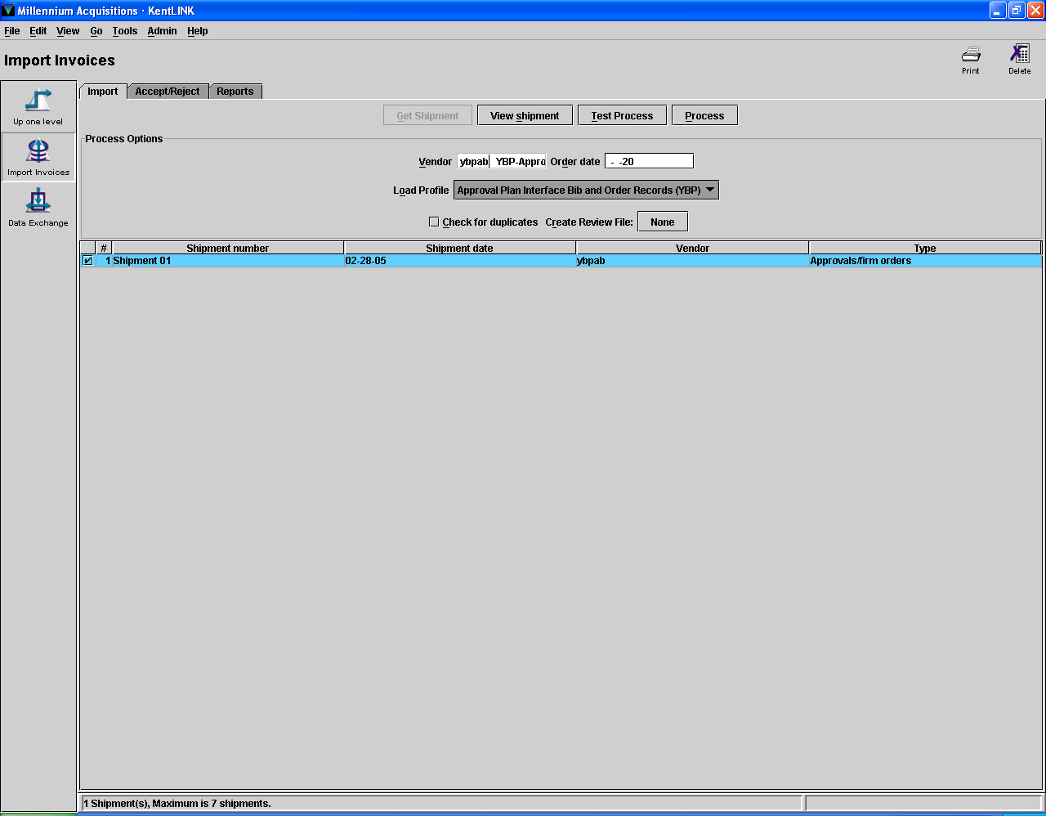

- Type “ybpab” in the Vendor field located in the upper center of the screen.

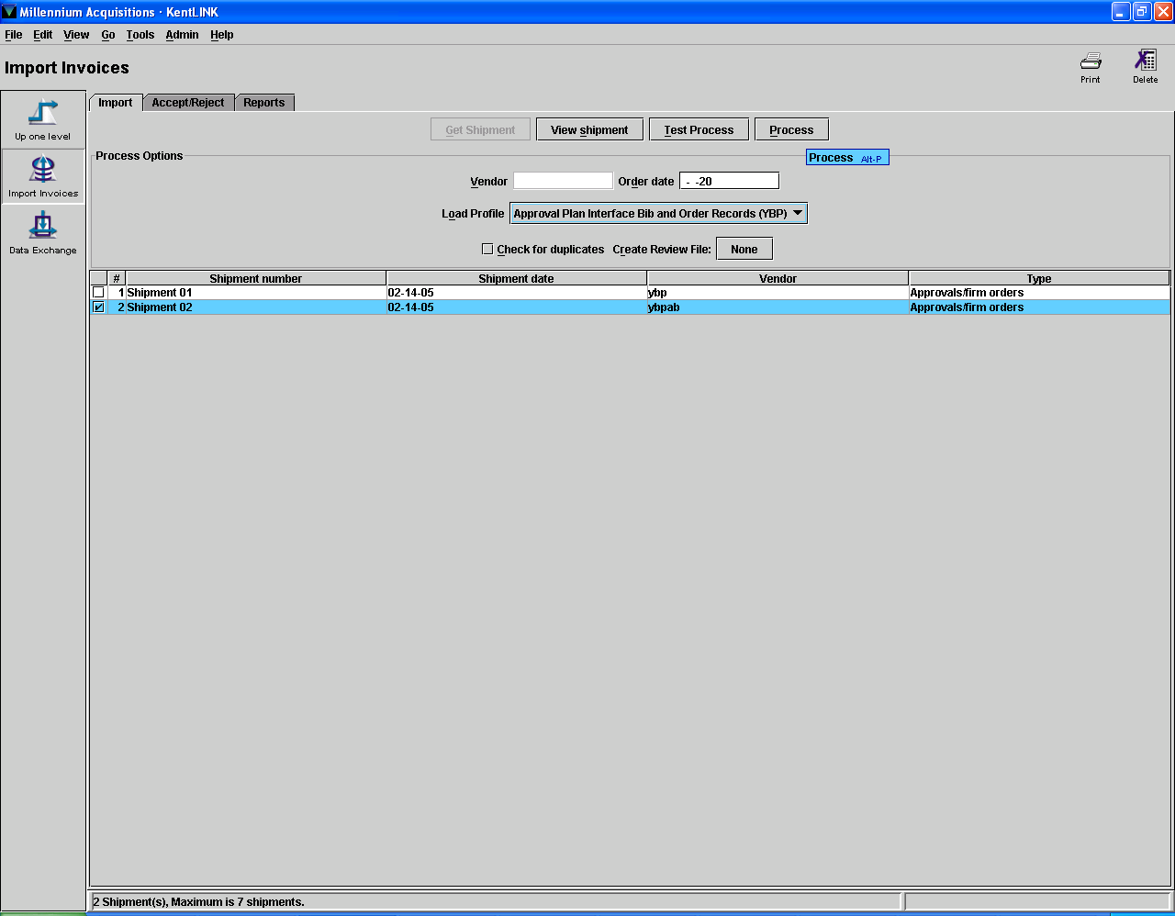

- Click on the Process button located in the upper center of the screen.

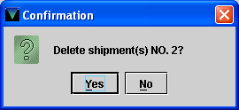

- Click on the Yes button or Hit the Enter key.

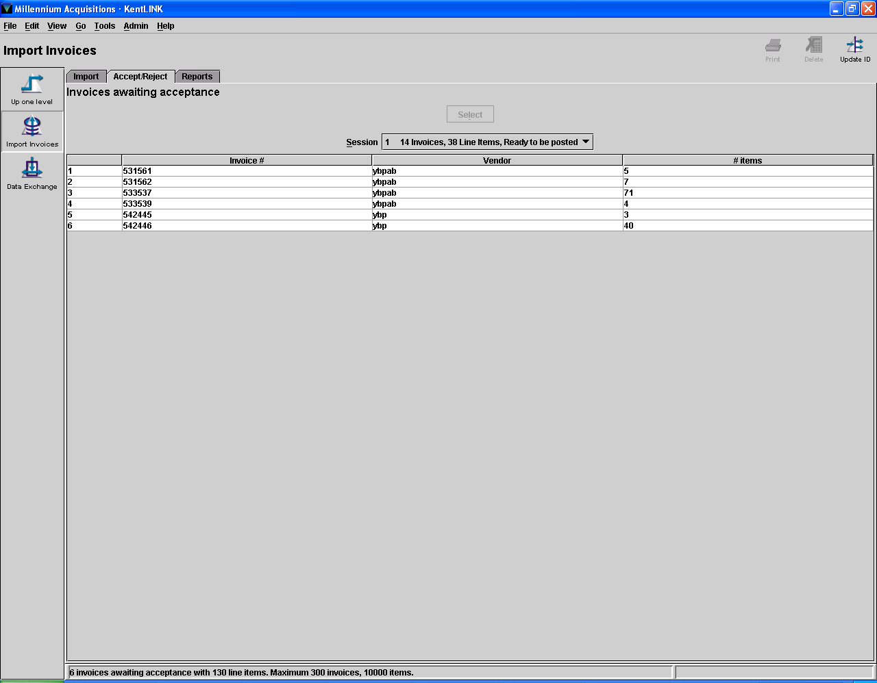

- Click on the Accept/Reject tab located on upper left of the screen.

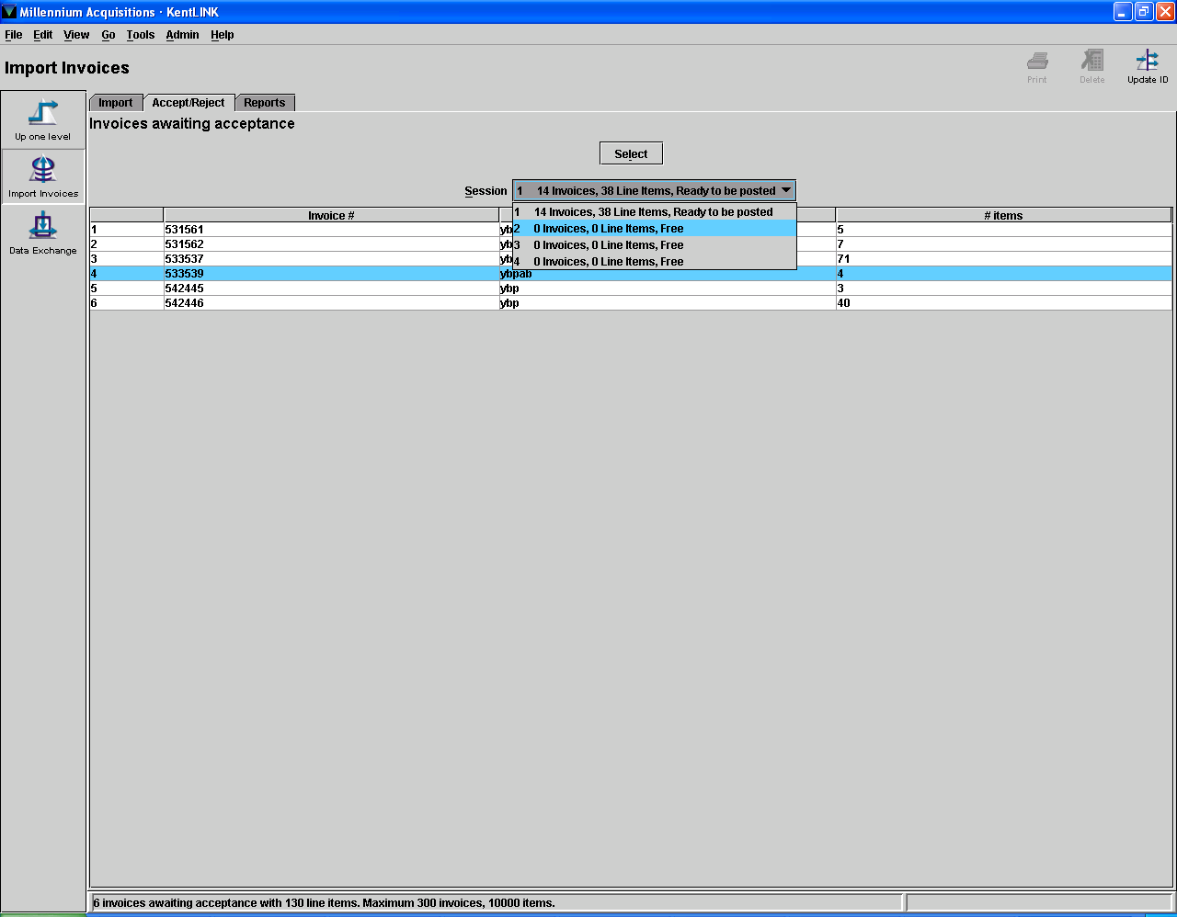

- From the Session drop down menu located in the upper center of the screen, select an Empty pay file.

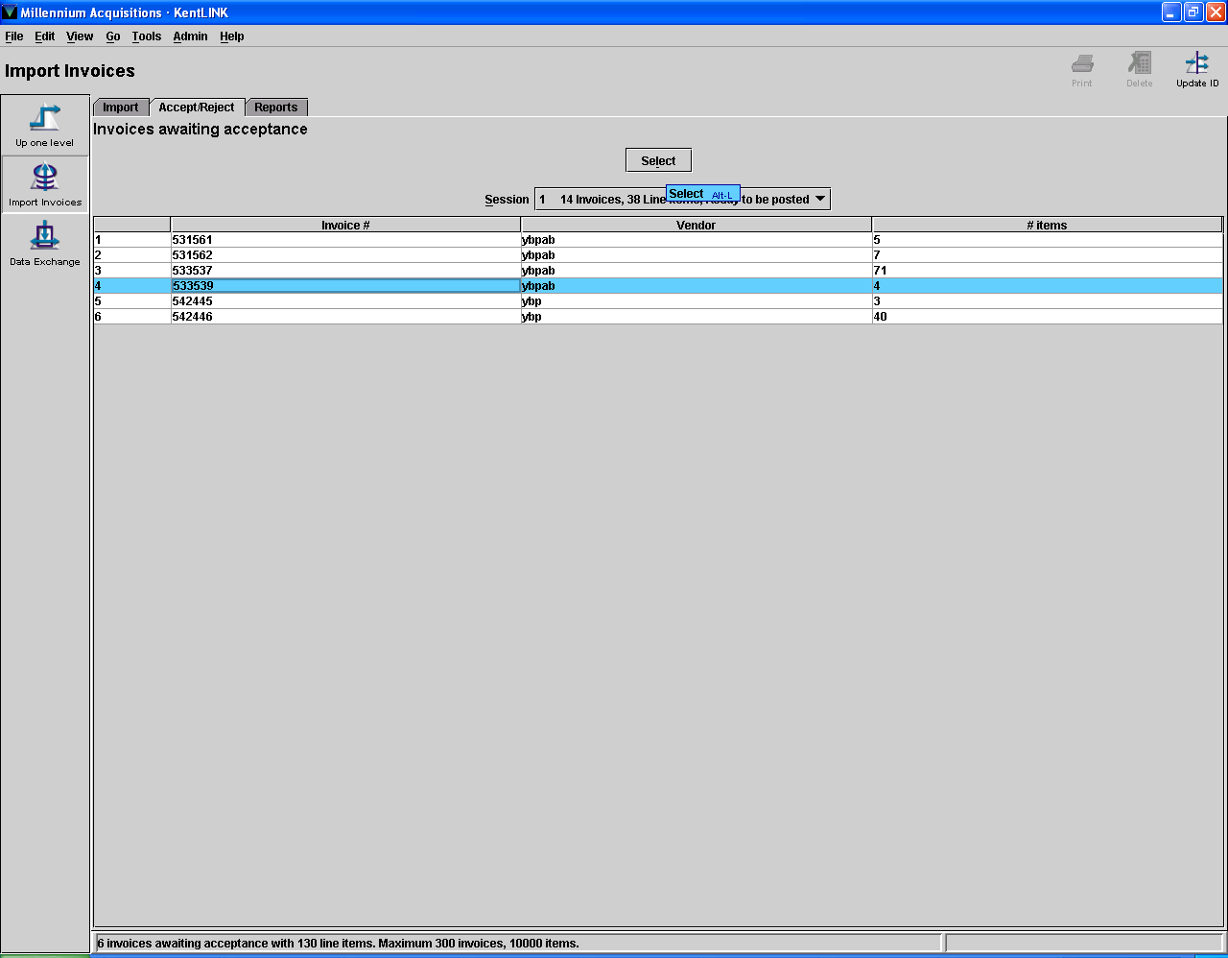

- Select the invoice line you want to process and Hit the Select button located in the upper center of the screen.

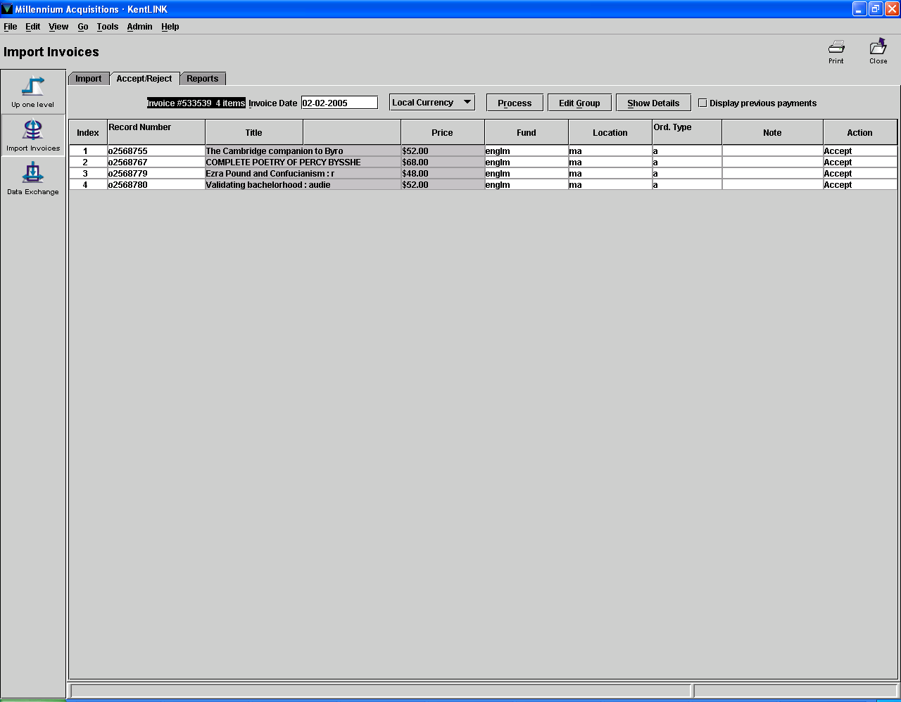

- If items need to be rejected, in the action column click on the lines of the items you want to reject and the action will change from accept to reject.

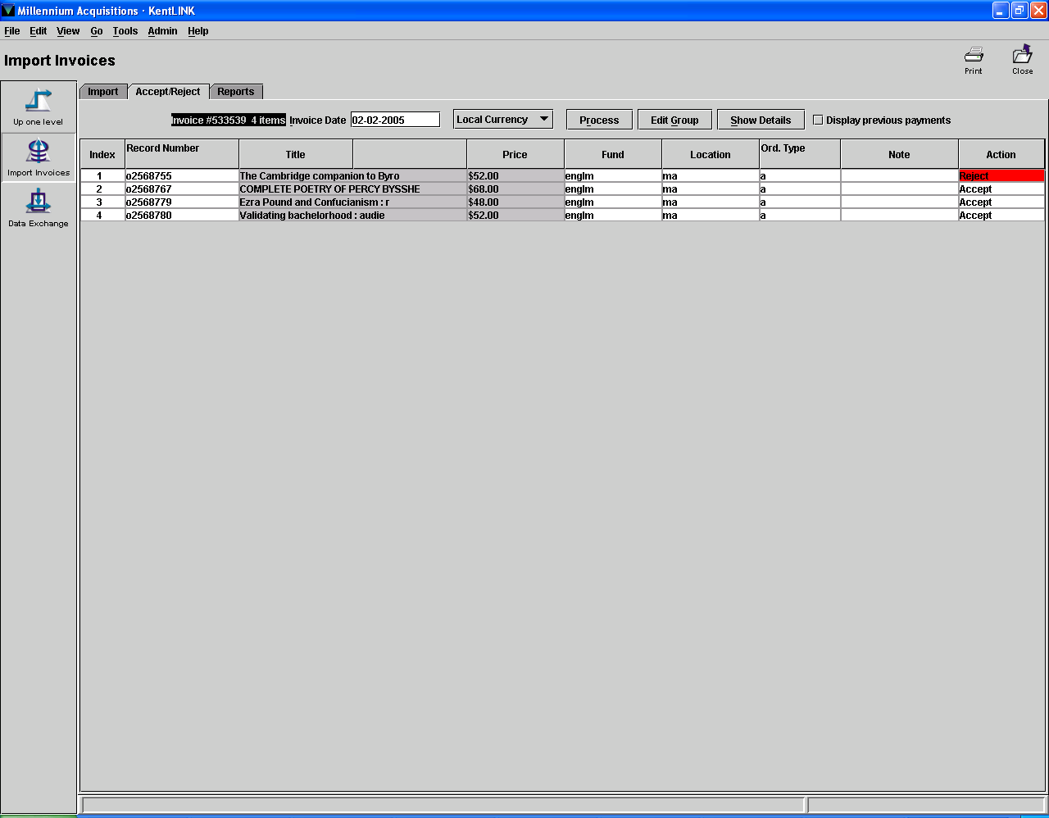

29. When you are done rejecting and accepting items. Click the Process button located in the upper center of the screen.

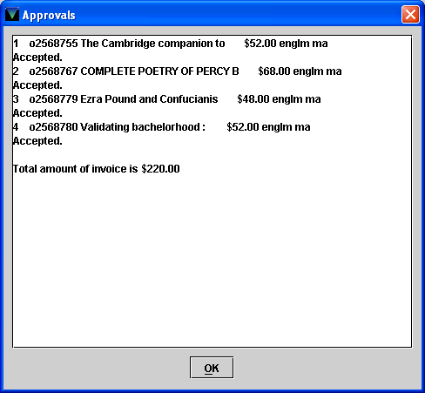

- Click on the OK button or Hit the Enter key.

