MUSIC PRODUCTION I
Dr. Birch

PROJECT 6:

OBJECTIVE: Create a project using audio files
- Import the audio files
- Rename the audio files
- Create a pattern (at least 32 measures long) using the loops

Directions:
Download the loops from the web site and save them in a folder called “project 6 loops”
You can also import the Audio files from the S: Drive
- Open Cubase
- Create a new empty project
- Select your directory on the I Drive: I>MP-I>yourname>yournameProject 6
- Click on PROJECT>ADD TRACK>MARKER – This will help visualize the project
- Click on FILE>IMPORT>AUDIO FILE
- On the S (Shared Drive) Find the folder “MP-I Project 6 Loops”.
- Open the folder, select all of the files (ctrl-a) and select OPEN – Each file will open to a separate track. Make sure to select Copy to Directory.
- In the Transport Panel Deselect TEMPO (it will change from Tempo Track to Tempo Fixed) – Set the tempo to 95 beats per minute
- Adjust the horizontal Zoom until the loops fill the window

MAKE SURE THAT SNAP IS ON
- Move the right locator to the beginning of the third measure by either:
  - Dragging the right locator
  - Entering 3 in the right locator position
  - Highlight a two measure clip and press “P”
- Select Cycle in the Transport Panel
- Audition each loop by pressing the SOLO key on each track – Just let the sequencer loop while soloing different tracks – (You may adjust the cycle loop by pressing P with the clip selected)
- Label all of the clips with more appropriate names
  - When you click on a clip the EVENT INFOLINE appears on the black bar at the top of the screen
  - Click on File and rename
Create an interesting pattern using most of the samples (at least 32 bars long)
- Move the samples around as necessary by dragging and dropping them with the mouse.
- To keep things simple you should keep the loops in their own tracks
- To move a clip, click and drag
- To make copies of a sample drag and drop while holding the ALT key
- Play back the loop and listen carefully if the pattern is satisfactory.
- When you are finished enter markers that indicate what is happening (drums start, bass enters, end etc)
  - Select the marker track
  - Place the project cursor where you want the enter the marker
  - Click on Add Marker
  - Name the Marker in the EVENT INFOLINE
- Save the File in your Folder as<your name> Project 6
- SAVE THE PROJECT TO NEW FOLDER on the M Drive
  - File>Save Project to New Folder
  - Navigate to your M drive
  - Click on CREATE and name the new folder: <yourname> Project 6
  - Press OK twice
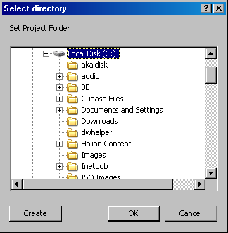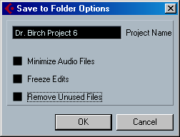

  - At the Save to Folder Options screen do not select anything and press OK
  - You are done. Your project is ready for grading.

