MUSIC PRODUCTION I
Dr. Birch

Project 9

Goal
Create a Drum pattern to go with a loop from the Beatle song A day in a life
The first verse of the song has no rhythm section and the tempo is a little free.
We will first notice how setting the tempo to the entire clip does not give good results.
The workaround is to divide the loop into parts and with the Time Warp feature make each section similar in tempo.

READING:
- Sample Editor
- Drum Editor
- Time Stretch
- Halion One

- Start a new Project in your folder
- Import all of the WAV files from the WEB page
- Solo the Entire Beatles Track and listen to it.
- With the solo feature listen to the other tracks – They are the same file cut into 4 measure segments (32 beats)

CREATE A MIDI DRUM TRACK
Open the VST Instruments panel (F11) and add the sampler HALION ONE
  - Click on an empty slot in the VST Instrument list
  - Set Synth>Halion One
  - When Cubase asks you:
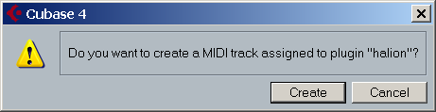
Select Create
- In the inspector select program and you will see the Browser
- Select “Drum & Percussion” in the left pane and a drum set in the right pane.
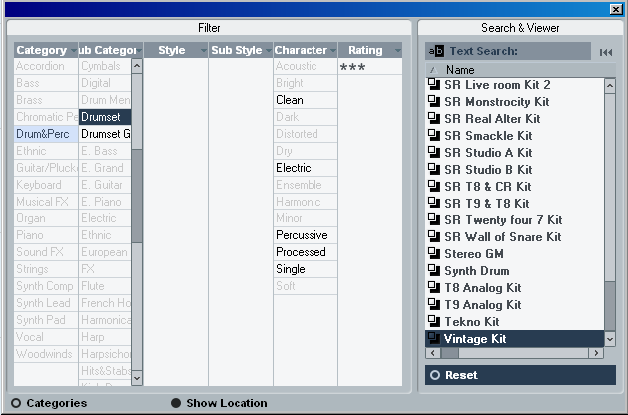
- With the pencil tool create a 4 measure loop (1 to 5)
  - Click and drag in the event display over the MIDI track
- Go to the DRUM EDITOR and create a SIMPLE four measure drum loop with the Drum Editor
  - Ctrl Right click on the clip and select MIDI>Open Drum Editor
- Bass Drum on 1 and 2 , Snare on 3 , High Hat on 1 2 3 4
(Feel free to improve on this simple recipe!!!!!!!)
- Close the Drum Editor and rename the drum clip
- The entire Beatles Clip is 20 measures long so we will need 5 copies of the Drum Loop
- Right click on the new loop and select EDIT>REPEAT – Enter 4 and select SHARED COPIES. (Or Alt+Drag to copy once)
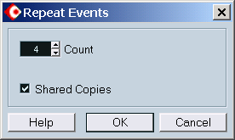

- Select the Entire Beatles Track clip and with the Beat calculator set the correct tempo – (there are 80 beats)
- Solo the Entire Beatles Track and the Drum track and Listen
- Close right? But the drummer and the rest of the band do drift off…

Now using the five four measure segments lets see if we can do better
We will set TIME WARP FOR EACH CLIP all 5 files to be exactly 4 measures long
- Double Click on the first clip to open the SAMPLE EDITOR
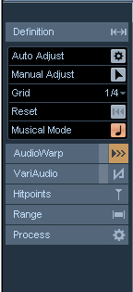 | 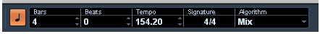  - Open the Definition menu  - Select 4/4 as the time signature  - Assign 4 bars to the clip  - Select Straighten Up (the little note)  - Now the Clip will WARP to match the tempo of the song  - Repeat these steps for each clip.  - Repeat the same procedure for the Drum Clips as well  - The Drum clips have different lengths – Count how many measures are in each one of them  - Some of the Drum loops play back twice as fast. To slow the loop down you will need to change the imbedded information that tells the loop how many measures long it is.  - Open Sample Editor of the drum loop (double click on the loop)  - Turn off Musical Mode  - Double the amount of bars (this effectively halves the tempo)  - Turn Musical Mode back on

- Once you have created something you like:
Move the Beatles track over by at least 4 measures
- Copy over the drum loop to fill out the track
- Create a fade in with the volume
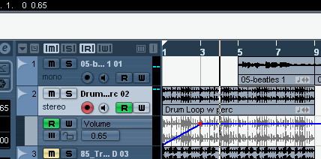
- Click on the + under the track number – A volume controller track will appear
- Click on the R and the W to allow writing and reading
- Click on the blue line and drag the red handle to the bottom left – No volume at the beginning.
- Click on the line again and drag it ¾ of the way up were the vocals begin

Now be creative and add to the project.
Some suggestions:
- Copy and paste some of the vocals to a new track and with SNAP OFF move it so slightly to the right(the echo effect)
- Add an instrumental MIDI track
- Add some GOOD MIDI drums
- Create a collage with different drum loops and repetitions of the vocal tracks
- Add more volume controls
- Add Pan controllers by clicking on the + below the Volume Controller track and changing it from MUTE to PAN
Save the project in your folder as <YOURNAME> Project 9
Save to new folder on the M drive

