MUSIC PRODUCTION I
Dr. Birch

Project 14
MIDI

Objective:
Assign synthesizer patches to a MIDI file
For this project we will be using the sample playback unit: Halion ONE (you may use other synthesizers if you whish)

Before starting:
Download one of the MIDI files from WEEK 11

Start Cubase
- Import the MIDI file
  - File<Import<MIDI file
  - If you have already created a New Project click on “No” (do not create new project)
Now you have a set of MIDI tracks that are already labeled (not MIDI 4)
If you press play you will hear nothing as there are no synthesizers connected to the midi tracks.

This template is valid for the file named “MIDI 1”. Small changes will make it work for the other tracks.

Let’s start with the Drum Track
- Load the Halion One into the VST-Instruments panes (F11)
- When Halion asks if you want to create a new MIDI track enter Cancel
- In the inspector assign each drum track to the Halion One.
- In the inspector choose a drum program from the Browser
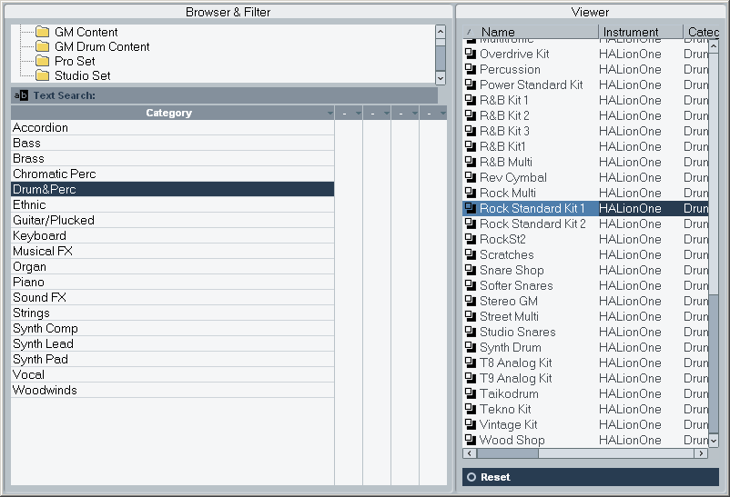

Now you can hear the Drums

- Now another instance of Halion One and assign it to the Bass.
  - Assign the Bass track to – 2-Halion One (as the first one is now called 1-HalionOne)
  - Pick the best sound patch from the Browser drop down menu
- Repeat step six for all of the remaining tracks.

You will need to load one instance of Halion for the drums and one for each other instrument.

- When you are done assigning patches to all of the tracks
  - Open the Mixer
  - Set the levels to your liking
- You can also use controllers to change volume and pan
- When you are satisfied with your project, export the audio.
  - Set the locators to the beginning and end of the project – It is better place the right locator a few bars past the end to avoid clicks or chopped off effects at the end
  - Go to File>Export>Audio Mixdown

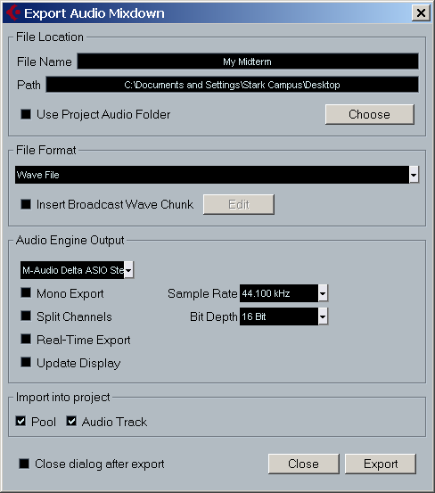

Select:
- Wave File
- Stereo Interleave Out (stereo)
- Sample Rate 44.1
- Bit Depth 16 bit
- Import to Pool and Audio Track – This will load the resulting file into the project
- Select Close dialogue after export
- Click on Export
  - Save the file in your folder as <your name> Project 10a

Save the finished project as <yourname>Project 11 to the M drive.

Acoustics and Technology students:

- Use a classical MIDI file of a work for piano and “YOUR INSTRUMENT” that you have found on the internet.
- You might have to remove the program changes: Open the LIST EDITOR and remove the program changes.
- Use the Halion One for both instruments.
Create and re-import two audio files: 1) of the complete work and 2) of the accompaniment alone.

Save the finished project as <yourname>Project 14

