Music Production I
Dr. Birch

Saving a Cubase Project to a new folder
Moving a Cubase Project to another computer

This procedure is necessary when the project needs to be moved to a different:
- location on the drive
for example
  - From “My Documents” to the Desktop
- storage device
for example:
  - From the C Drive to the I drive
  - From the I drive to the M drive or anywhere else
  - To the S drive
- computer
for example
  - From the computer at school to your computer and vice versa

- Open your project
- Make sure that it sounds right
  - Proper tracks are enabled
  - Tracks you want to hear are not muted
  - Etc.
- When you are finished with the project go to File>Backup project
- From the file menu navigate to the location you want to save the file (usb drive, M drive, s drive etc) then click on Make a New Folder and name the new folder. Cubase projects have to be backed up to an empty folder.
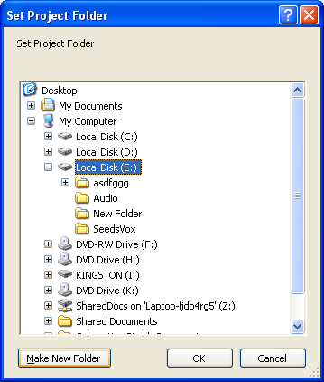
- Click OK and the following window will appear

- Make the necessary selections

Option Description
Project Name | Enter a project name if you want to change it from the default  (the current name of the project).
Keep Current Project Active | When this option is activated, the current project will still  be the active project after clicking OK. If you wish to  switch to the new backup project instead, you need to  deactivate this option
Minimize Audio Files | If this is activated, only the audio file portions that are actually  used in the project will be included. This can significantly  reduce the size of the project folder (if you are  using small sections of large files), but it also means you  cannot use other portions of the audio files if you continue  working with the project in its new folder.
Freeze Edits | This will perform a Freeze Edits operation, making all processing  and applied effects permanent to each clip in the  Pool,
Remove Unused Files | When this is activated, only files in the Pool that are actually  used in the project will be stored in the new folder.
Do Not Back up Video | When this is activated, any video clips on the video track  or in the pool of the current project will not be included in  the backup project.

