MUSIC PRODUCTION I
Dr. Birch

Project 8
OBJECTIVES:

Grabbing sound from a CD – Creating usable clips from this audio file.
You will need: A CD with a track of music you will not mind listening to OVER and OVER AGAIN!
This project will work better if you choose a (not too long) track with a steady beat.

Project 8:
- Grab one or more tracks from a CD
- Create at least 3 different loops.
- Find number of beats of each loop
- Set the grid to one of the loops
  - Use the beat calculator
- Bounce each loop
  - Right click on the loop and select Audio>Bounce Selection
  - When asked enter Replace
- Open each loop in the audio editor
- Turn on the Audio Tempo Definition Tool
- Insert the number of beats (There are 4 beats to a measure)
- Turn on Musical Mode

Create something “Artistic” with the loops you have created:

Suggestions
- Import one of the audio loops we have used in previous projects
- Split the loops into smaller sections using snap and the scissors tool
- Create an interesting project at least 32 bars long:
Possible suggestions:
  - Make a collage of bits and parts of the piece
  - Use the Process>Pitch Transpose to create new loops
  - Layer audio track on top of each other

Directions

- Start a new project
- Click on File>Import>Audio CD
- Select the track you wish to copy
- Click on Change Folder and select your own Folder (Should be there already)
- The file will be copied to the location indicated at the bottom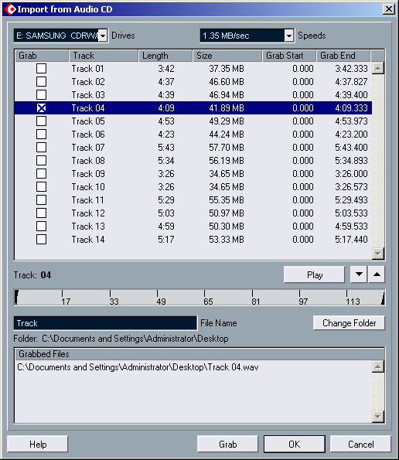

- Now you have one long AUDIO PART
- Save the file
- With the Split tool, practice splitting the file into smaller parts
- Try to isolate some interesting instrumental parts that could be looped – Hint: at first go for loops that are no longer than 4 measures
- When you have found an interesting loopable section, split it and move it to a new track.
- Set the L and R locators to the start and end of the clip (highlight the clip and press P). Turn Cycle on and play the clip. It should repeat smoothly. See Loop Techniques below for help.
- Figure out how many measures the loop is and adjust the tempo so that the Cubase “grid” lines up with the loop. You should be able to “see” the drum pattern in the loop.

Adjusting the tempo and determining the tempo of an audio clip
- Highlight the clip
- find out how many “beats” are in the clip
- Go to Project>beat calculator
- Enter the amount of beats
- Click “At tempo track start” to enter the tempo for the song
- Make sure that the tempo is set to Track in the transport tool bar

Turning on Musical Mode
When the Loop is “perfect”, bounce the clip:
  - Right click and select Audio> Bounce Selection. This creates a “copy of the audio contained in the clip”. You will not be able to enlarge the clip.
- Double-click the audio event to open the Sample Editor.
- Enter the tempo in the audio tempo box
- Bars and beats should now indicate the exact amount of bars and beats you selected in the beat calculator.
- Activate “Musical Mode”
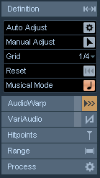
- Now you can change tempo in the transport toolbar (after changing the Tempo to Fixed) and the loop will “warp” to the new tempo.
Loop technique

- If you are having a hard time looping a clip because the transition back to the beginning (the loop) is poor, go back to the original clip and select a slight larger clip on both ends.
- Move this clip to the beginning of measure 2 of a new track and set the R L locators from 2 to the end of the loop.
- Now turn off the SNAP function
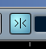
- Now you can move the clip freely and not just from measure to measure.
- Turn cycle on. While playing the loop move the clip slightly to the left or right until the loop is good
- Depending on the loop a slight fade at the start or end might improve the loop.
- When you are done, save the project in the root of your folder as <Your name Project 8>

