MUSIC PRODUCTION-II
Dr. Birch
Project 1:Drum Notation

Goal: Transcribe notated drum parts into Cubase using three different step input methods – Drum Editor - Key Editor – Score Editor -

There are several different types of drum notation
Here are a few examples:

Defined by the Percussive Arts Society as described in Norman Weinberg’s book, Guide To Standardized Drumset Notation. This is the notation recommended by Sibelius
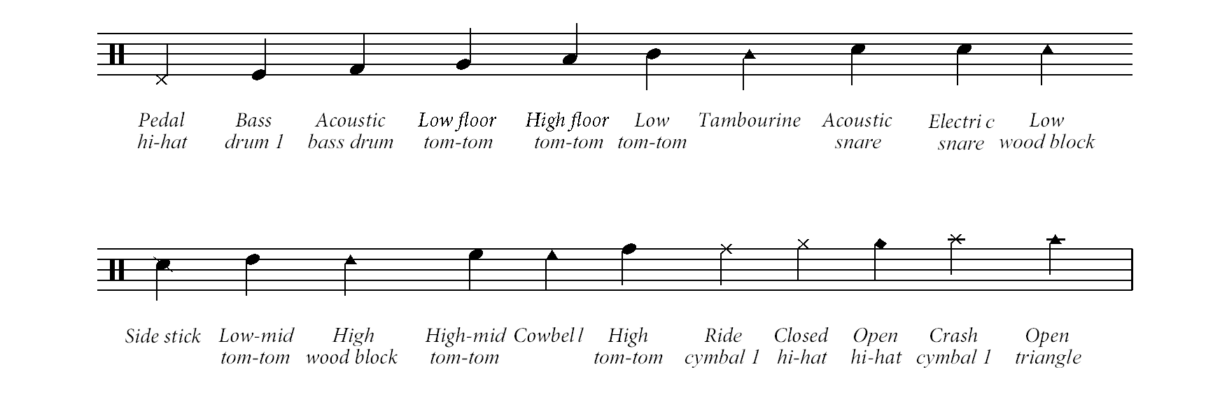
Here are other notation keys that reveals today’s lack of standard
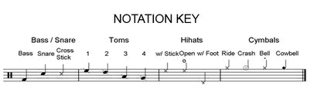

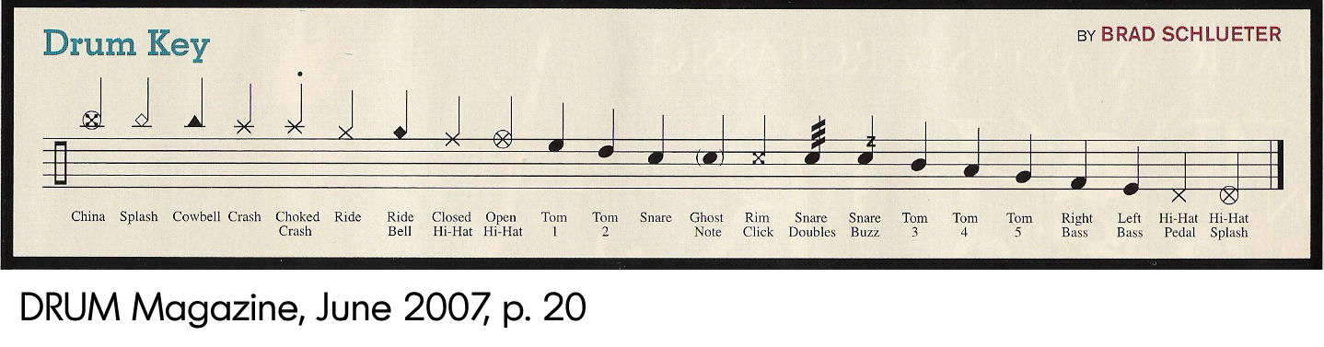
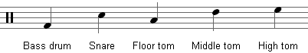
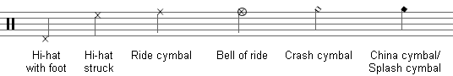

Project 1:
- Transcribe each of the assigned drum patterns into Cubase alternating using the drum editor, the key editor and the score editor.
- Each pattern will be in a separate EVENT
- Place each event on a separate track but keep the events one after the other.
- Insert the indicated tempo’s into the Tempo Track Editor.

Drum Editor
- Create a new Instrument Track with an appropriate drum patch (you can change it later)
- Draw an event the size of your musical example
- Open the event with the drum editor
- Use the drum stick to enter the notes
- You may need to change the quantize setting to enter certain values.

Key Editor
- For this part of the project we will be using the keyboard to input notes.
- Following is a table that describes the General MIDI percussion assignments to the keyboard.
- Since this is a drum part the sounds should all be “one shot” meaning that no matter how long you hold a key the sound is always the same.
- Input all of the notes using the same rhythmic value.

With a drum program both of these measure should sound the same
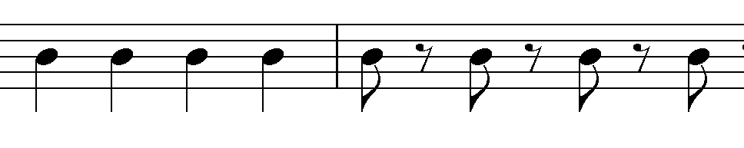
Experiment!

TABLE 2 - General MIDI Percussion Key Map
(assigns drum sounds to note numbers. MIDI Channel 10 is for percussion)
 | Midi Key | DRUM SOUND |  | Midi Key | DRUM SOUND
B0 | 35 | Acoustic Bass Drum |  | 59 | Ride Cymbal 2
C1 | 36 | Bass Drum 1 | C3 | 60 | Hi Bongo
C#1 | 37 | Side Stick |  | 61 | Low Bongo
D1 | 38 | Acoustic Snare |  | 62 | Mute Hi Conga
D#1 | 39 | Hand Clap |  | 63 | Open Hi Conga
E1 | 40 | Electric Snare |  | 64 | Low Conga
F1 | 41 | Low Floor Tom |  | 65 | High Timbale
F#1 | 42 | Closed Hi-Hat |  | 66 | Low Timbale
G1 | 43 | High Floor Tom |  | 67 | High Agogo
G#1 | 44 | Pedal Hi-Hat |  | 68 | Low Agogo
A1 | 45 | Low Tom |  | 69 | Cabasa
A#1 | 46 | Open Hi-Hat |  | 70 | Maracas
B1 | 47 | Low-Mid Tom |  | 71 | Short Whistle
C2 | 48 | Hi-Mid Tom | C4 | 72 | Long Whistle
 | 49 | Crash Cymbal 1 |  | 73 | Short Guiro
 | 50 | High Tom |  | 74 | Long Guiro
 | 51 | Ride Cymbal 1 |  | 75 | Claves
 | 52 | Chinese Cymbal |  | 76 | Hi Wood Block
 | 53 | Ride Bell |  | 77 | Low Wood Block
 | 54 | Tambourine |  | 78 | Mute Cuica
 | 55 | Splash Cymbal |  | 79 | Open Cuica
 | 56 | Cowbell |  | 80 | Mute Triangle
 | 57 | Crash Cymbal 2 |  | 81 | Open Triangle
 | 58 | Vibraslap

- Create an instrument track with a drum patch, and an event
- Open the event with the Key Editor
- Turn on Step Input and turn off Insert and “On and Off Velocity”
- With these setting Cubase will only “listen” to the MIDI pitches and not the velocities. The velocity of all of the notes will be set according to the value selected in the Velocity Insert Pop Up Menu in the toolbar

- Use the right arrow to insert rests

Score Editor

- Start a new Instrument Track, assign it to Groove Agent or another drum program
- Select GM map in the Inspector – Now that track knows that you will be inputting notes with the GM map.
- Open the event in the Score Editor
- Change the clef to Bass Clef by clicking on the clef and selecting the bass clef.
- Turn on MIDI step input and enter the note of the pattern.
- When you are done you can see the pattern notated in Drum Notation by selecting:
Scores>Settings>Polyphonic and choose Jazz+Pop>Drumset
- You should see (yet another) a style of drum notation

When you are done save the project on your M:drive as <yourname> MP-II Project 1

