MUSIC PRODUCTION-II
Dr. Birch
Project 3:
Goal:
Arrange a song from a fake book for small combo using step MIDI recording in the various editors.
A possible combo could be: Drums, bass, guitar(s), piano and melodic line.

Create a New Project
- Start a new project in a new folder in your folder on the I drive
- Name the Folder: <Yourname> MP-II Project 3
- Create an empty project
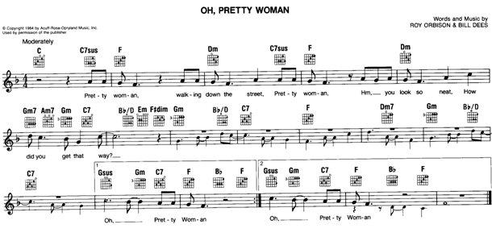
Artistic Considerations
You can either opt to create your own personal and original arrangement or listen to a recording to emulate or for inspiration
Workflow
The following is a possible workflow to enter the project into Cubase. An infinite amount of other possibilities exist!
- Make sure to label each track and each clip.
  - Tracks can be named Bass, Drums, and Guitar 1 etc.
  - Clips can be named: Verse 1, verse 2, chorus, bridge, instrumental, “measures 1-8”, etc
- Indicate either in the track or in the Clip what editor you used to step input the notes. You need to have at least one example of each!
- Using a step editor enter all of the BIG notes of the sheet music – Assign the track to an appropriate melodic instrument

- On a separate track enter the small notes – Assign to an instrument
- Listening to what you have entered set the tempo either as fixed or in the tempo track. Will you need to vary the tempo at any time?
- Create a simple 1 measure drum pattern work with the song. Use Edit>Repeat…>Shared Copies – Copt the pattern many times …. This way you can edit one of the patterns and all of them will match. At a later point you can unlink individual clips for editing: Edit>Convert to Real Copy
  - Do you need fills at the end of phrases?
  - Do you need a variant for each repeat or for the chorus?
- Create the remaining parts
- Create and intro if necessary.
- Arrange the material you have so that the song is between 2 and 3 minutes in duration.

When you are done use File>Backup Project to save a copy of the project on your M Drive.
Name the folder and file: <YourName> MP-II Project 3

