MUSIC PRODUCTION-II
Dr. Birch
PROJECT 6

Goals:
- Creating notes using the pencil and line “line tool”
- Edit MIDI notes using all of the Cubase editors

Project 4a:
- Create a new Cubase project in a folder <yourname> Project 6 and save the projects as <yourname> project 6a
- Create an instrument track with a patch of a pitched sound (not noise, ambient or sfx) and name it Pencil tool
- Create a 2 measure clip and name it Key Editor
  - Open the clip with the Key Editor
  - With snap on enter notes using the pencil tool
    - In the first measure, with SNAP-ON enter notes on different beats and of different durations
    - In the second measure, With SNAP OFF, enter notes on different beats and of different durations
    - When done exit the key editor window
- On the same track enter another 2 measure clip and name it List editor
  - Open the clip with the list editor
  - Enter notes with the pencil tool. What is different?
  - Again enter some notes of differing durations using both snap on and off
- Create another 2 measure clip and name it Score Editor
  - Open the clip with the score editor
  - The pencil tool is now a NOTE tool
  - Enter notes of varying durations using the note tool
  - Does snap-off make sense in the score editor?

- Mute the first track and create another instrument track and name it Line tool
- Create 2 measures, name them Key Editor Line and open them with the key editor.
- With the line tool experiment entering notes with different combinations of:
  - snap on and off
  - Quantize values
  - Horizontal lines
  - Different slopes
- Create 2 more measures and name them Key Editor Parabola
  - Repeat item 3 but use the parabola tool
- Repeat item 4 but use the sine tool
  - Experiment with snap on and the Length Q shorter than the Quantize value. For example Q=1/8 and length Q=16 or 32
- Repeat with the triangle and Square line tool
- Finally create 2 measures with the Paint tool
- Can you think of what these tools could used for?

Save as <yourname>project 6a

Project 4b:
- In the same project 6 folder start a new project and save it as <yourname>project 6b
- Create a piano instrument track
- Create a one measure clip and name it Whole Note Triad
- In the key editor enter a C major chord in whole notes using step input
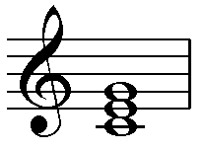
- Copy the clip 3 times rename it :
  - Key Edtor Alberti Bass
  - List Editor Alberti Bass
  - Score Editor Alberti Bass
- Open the Key Editor Alberti bass in the Key Editor and change all of the note values to eight notes using the Object Selection Tool
  - Using the object selection tool move and copy (alt-drag) the 3 notes to create the following pattern:
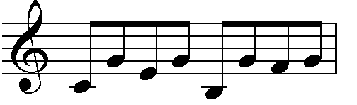
  - Do you need snap on or off? Quantize?
- Repeat step 6 using the List Editor
  - Only use the numerical values to change durations and starting points.
  - Use copy and paste – Notes are pasted at the cursor location
  Note values in Cubase
  Whole note | 1.0.0.0
  Half note | 0.2.0.0
  Quarter | 0.1.0.0
  Eighth | 0.0.2.0
  Sixteenth | 0.0.1.0
  Positioning in Cubase
  Start | 1.1.1.0
  Measure 3 | 3.1.1.0
  Measure 5 beat 3 | 5.3.1.0
  The 8th eighth note in measure 11 | 11.4.3.0
  The fourth Sixteenth note on beat 2 of measure 3 | 3.2.4.0

- Repeat step 6 using the score editor
  - To change note values: highlight the notes to change and ctr-click on the new note value
  - To copy notes highlight and copy
  - To paste place the project cursor where the first not is to be pasted and Ctrl-V
- Save the project as <your name> Project 6b
- When you are done backup both projects to the M drive for grading

