MUSIC PRODUCTION-II
Dr. Birch
PROJECT 7
MIDI PERFORMANCE CONTROLLERS

Read:
- Cubase Operation Manual: MIDI Processing and Quantizing
Other “good” reading:
- http://en.wikipedia.org/wiki/MIDI_controller
- http://en.wikipedia.org/wiki/General_MIDI#Controller_events
- http://www.soundonsound.com/sos/aug07/articles/cubasetech_0807.htm
- http://www.indiana.edu/~emusic/etext/MIDI/chapter3_MIDI.shtml

We will be dealing with MIDI data that “controls” performance parameters:
The most common controllers are:

Velocity
Pitch Bend
Program Change
MIDI Controllers:
Most Common MIDI Controllers
1 | Modulation (triggered by the mod wheel on the keyboard controller” associated with VIBRATO
7 | Volume
10 | Pan
11 | Expression – a confusing controller often associated with some type of “dynamic”
64 | Sustain

Project 7

Goals:
Creating MIDI controller data in Cubase
- Create a new project in a folder: <yourname> Project 7
- Save the file as <yourname> Project 7

Changing Programs
- Load the VST instrument MiniMogue and associate it with a MIDI track.
  - Create a 1 measure clip
  - Open the Clip with the LIST EDITOR
  - Using step input enter a one measure pattern
  - From the INSERT TYPE pull down menu select Program Change
  - Using the pencil tool enter a Program Change at the beginning of the measure
- In the project screen copy the clip 5 more times
  - Select the 6 clips and open them in the List Editor
- In the list editor FILTER NOTES
  - You will be left with 6 program changes
  - Change the DATA 1 Values to any number between 1 and 128
  - Listen to the six measure. You should hear a different Program for each measure.
- This feature does not work with Halion. Why? Why is it not important?
How many discreet numbers does Program Change have in MIDI?

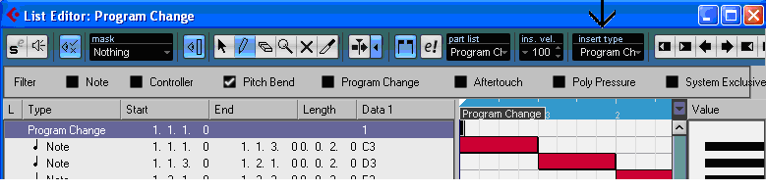

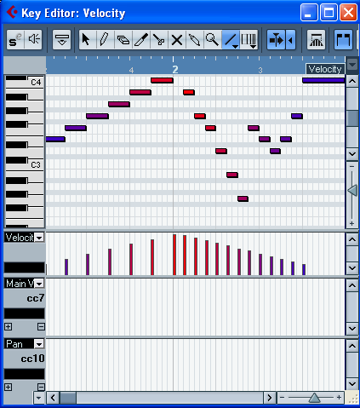
CHANGING VELOCITY, PAN AND VOLUME
- Create an instrument track using the HalionOne program Ethnic Flute
  - Name the track Controlers
- Create a 2 measure clip
  - assign the L and R markers to the clip
  - turn on cycle
- Open the clip in the Key Editor
  - turn on snap
  - set quantize to the eighth note
  - Use the line tool to enter a set of repeated eighth notes
- Exit the key editor
  - copy the clip 3 times
  - name the clips: velocity, volume cc7, pan CC10
- Open the Velocity clip in the Key Editor
  - Add two more controller lanes:
    - Set the first to Velocity, the second to Volume CC7 and the third to PAN CC10.
  - In the velocity lane use the LINE tool to draw a velocity curve in the shape of a triangle.
  - Listen to the clip
- Open the volume clip and the key editor and draw a VOLUME curve identical to the Velocity curve.
  - Play back both files: what is the difference?
  - If you can’t hear the first clip you will need to insert a Volume Controller at the beginning of the Velocity Clip set to 100.
- Open the PAN clip and using the SINE tool with snap off draw a line in the PAN lane.
- If you can’t hear the PAN clip add a Volume Controller at the beginning of the clip using the List Editor.
How many discreet numbers do velocity, volume and pan have in MIDI?
PITCH BEND
- Create a new instrument track assigned to a guitar patch and the following pitches:
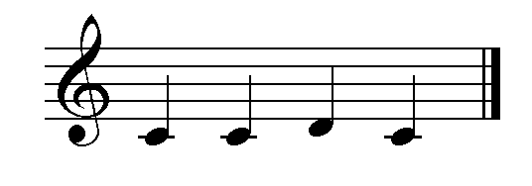
- Open clip in the Key Editor and assign the controller lane to pitch bend.
- Use Pitch Bend to convert the “lick” into:
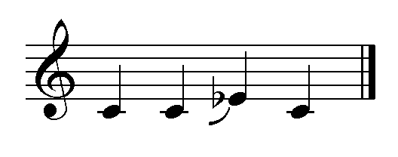
  - What happens if you do not “reset” the pitch bend before the clip loops?
How many discreet numbers does pitch bend have in MIDI?

Using Velocity with a MIDI drum pattern

- Create a new Instrument Track assigned to an acoustic Drum program
- Create a 4 measure clip and open it in the Drum Editor
- Create a drum beat -, with a steady Hi Hat or Ride. Create a Tom fill in bar 4.
- Edit the velocities in both the Drum Editor and in the Key Editor
  - The Drum Editor is best suited to change the velocities one instrument at a time – For example just the HH or the snare
  - The Key Editor is best for editing selections that cover diverse instruments (pitches).
- Save the project as <yourname> Project 7

