MUSIC PRODUCTION-II
Dr. Birch
PROJECT 8
MIDI Modifiers and MIDI Inserts

Reading:
Operation Manual: Page 317
Plugin Reference Manual: MIDI Effects

Project:
- Inspector
  - Create a MIDI Track
  - Explore all of the parameters in the Basic Track Settings
    - Change Volume and Pan. Experiment with Track delay with another track present
    - Change Instrument, Change Patch etc
    - Open VST Instrument
- MIDI Modifiers
  - Create an instruments track assigned to Rockst2 and name it MIDI MODIFIERS
  - Create a one measure clip and enter straight 16th note in the Hi Hat part (F#1) at constant velocity
  - Copy the clip X times and name them
    - Random
    - Triangle velocity
    - Open Closed Hi Hat

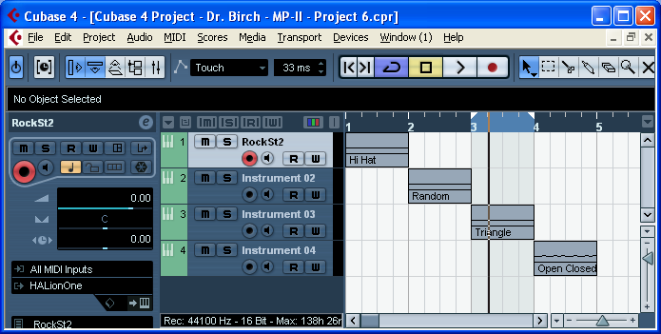 | - Drag the clips vertically down to move them onto new tracks

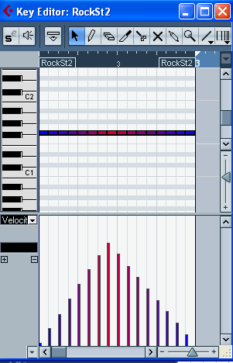 | - In the:  - “Triangle Velocity” clip use the velocity lane and the line tool to enter a triangle shaped curve.  - “Open closed Hi Hat” change some of the F#1 notes to G#2  - x
- In the “Triangle Velocity” clip:
  - Experiment with Transpose and velocity shift

- In the “Random Clip” experiment with:
  - Random Velocity
  - Random Pitch
  - Random Position
- In the “Triangle Clip”:
  - Experiment with:
    - Velocity compression
      - Increase the denominator. What happens?
      - Reset the denominator and increase the numerator. What happens?
    - Velocity limiter
      - Reset Velocity Compression
      - Experiment with Range>Velocity Limit
      - Experiment with Range>Velocity Range

Create a simple MIDI project that uses many MIDI Modifiers
Explain your procedures in the Notepad
Save the Project as: <YourName> Project 8 MIDI Modifiers

MIDI Inserts
Create 2 Instrument Tracks with pitched sounds (Piano will work)
- Learn the operation of the Chorder
- On one track create an Octave and a Global setting
- When you have learned to create an interesting chord progression add the Arpache5/ArpacheSX
- Create a single line pattern that works with your Chord Progression
- Explore:
  - Density
  - MicroTuner
  - MIDI Echo
Create a small project that features MIDI inserts.
Save the Project as: <YourName> Project 8 MIDI Inserts

