MUSIC PRODUCTION-II
Dr. Birch
PROJECT 10
Importing MIDI Files

Reading: Importing and Exporting MIDI Files OM Page 458

Goals:
- DL a MIDI file from the WEB and import it into CUBASE Using pre assigned instruments
- Assign Instruments to a “stripped” MIDI file – Add controller data

Part 1

- Download a MIDI file from the WEB
- Start Cubase
  - Create a new project in a <your name> Project 7 Folder
  - Save the file as <Your Name> Title of Song Project 10 A
  - Under Preferences go to File<Preferences and turn on:
    - Autodissolve
    - Import to Instrument Tracks
    - Click apply and OK
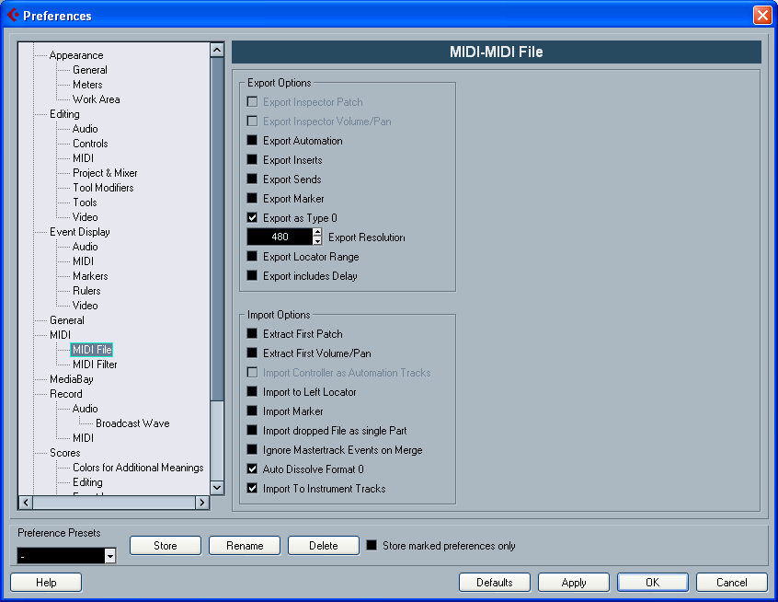
READ IN THE MANUAL WHAT ALL OF THE MIDI IMPORT AND EXPORT OPTIONS ARE
  - Go to File<Import<MIDI file and locate the file you downloaded
  - Listen to the file
  - In the Notepad inside the Inspector comment on:
    - The quality of the file
    - Identify the type of controllers used
    - Try to identify if the notes were inputted in real or step time
    - Analyze the use of velocity

Part 2

- Download a different MIDI file from the WEB
- Start a New Cubase Project in the same <yourname> Project 10 Folder
  - Save the file as <Your Name> Title of Song Project 7B
  - Under Preferences go to File<Preferences and turn OFF:
    - Autodissolve
    - Import to Instrument Tracks
    - Click apply and OK
- If the file opens up into multiple tracks skip to item 5
- If the file opens as one track (it is in format 0) use MIDI> Dissolve Track to separate all of the different MIDI channels into separate tracks
- Remove all non-NOTE MIDI DATA
  - Select ALL of the clips (Ctrl-A)
  - Open all into the List Editor
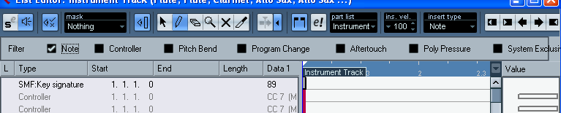
  - Use the SHOW FILTER VIEW to hide the Notes
  - Highlight all of the non-note MIDI events (Ctrl-A) and press delete
  - Un-filter the Note Events
  - Set all the velocities to 100 by highlighting all of the notes in the List Editor (Any Editor will do) and go to MIDI>Logical Presets>Standard Set 1> Set Velocities to 100
- Assign each track to an appropriate VST instrument – Try not to use only HalionOne
- Now that the file has been stripped of all performance controller data add performance data to a small portion of the song. Try to uses as many as possible.
  - Velocity
  - Volume and Pan
  - MIDI Inserts
  - MIDI Modifiers
- When you are done with both projects export both files to the M Drive in a Folder named <yourname> Project 10B

