MUSIC PRODUCTION-II
Dr. Birch
PROJECT 12
THE ARRANGE TRACK

Create an arrangement with the Arrange Track
To practice you will be entering a 12 bar Rock/Blues

- Start a new Cubase Project in the folder: Your Name MP-II Project 12
- Create an Instrument Track with a Bass sound

- Enter the following 1 measure bass line: 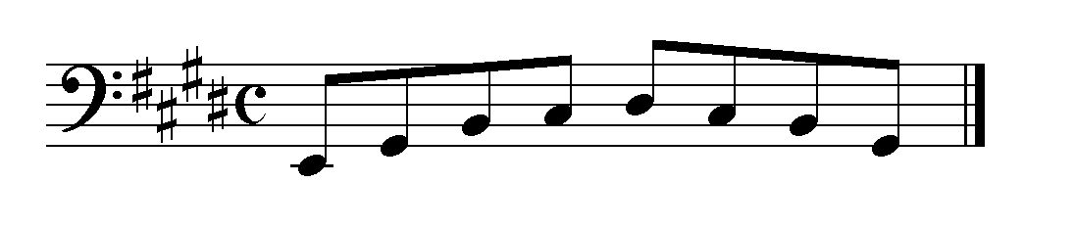
- Copy the clip 4 times and transpose
  - the second up a 4th (sub-dominant)
  - the third up a 5th (dominant)
  - do not transpose the 4th clip (tonic)
  - 5th clip down a fourth (dominant)

- Create an instrument track with a drum sound
  - Create a one measure drum beat and copy it to measures 2 and 3
  - Create a one measure drum fill in measure 4
- Create an Arrange Track
  - Using the pencil tool “draw” 5 arrange events: one for each measure: they will be labeled A, B, C, D, E
  - In the Inspector of the arrange track there are two panes: the top pane lists the order of the events and the bottom pane lists the existing events.
  - Drag the events from the bottom pane in the following order (the number after the letter indicates the number of repeats): A4 B2 A2 C1 B1 A1 D1
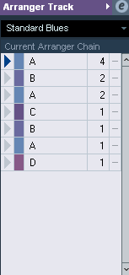
  - Play the song
  - Rename the Chain “Standard Blues”
- Create a new chain and name it “variant 1”
  - Enter the following pattern: A1 B1 A2 B2 A2 C1 B1 A1 E1
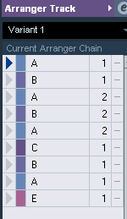
  - Play the song
- Create another Chain and name it “Variant 2”
  - Create your own 12 measure pattern
- Open the Arrange Editor by clicking on the “e”
  - Select Flatten Project (with Options and Preferences)
    - Select
      - All Chains
      - Append Chain Name
      - Open New Projects – Cascade New Projects
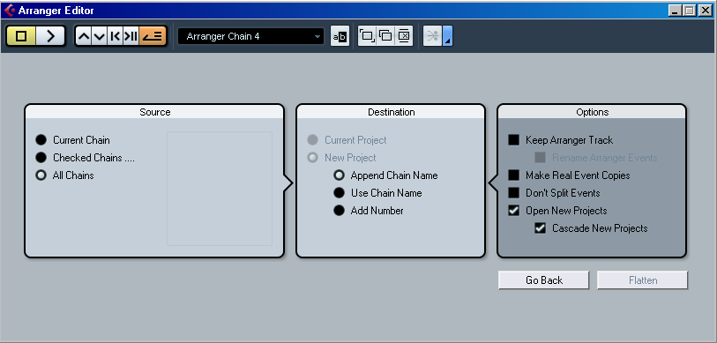
- Save all projects

