Commercial Music Theory

Descending Progressions
Major

Diatonic
I | I/TI | I/La | I/Sol | either repeats or moves on to IV
I | I/TI | vi | vi/sol | either repeats or moves on to IV
I | V/Ti | vi | vi/sol | either repeats or moves on to IV
I | V/Ti | vi | V43/IV | IV

Winter Shade of Pale
Chord | I | iii/Ti | vi | vi/sol | IV | IV/Mi | ii | II/Do
Bass | Do | Ti | La | Sol | Fa | Mi | Re | Do
Chord | V | V42 | iii7 | V64 | I | IV | I | V
Bass | Sol | Fa | Mi | Re | Do | Fa | Do | Sol

Piano Man
Chord | I | iii/Ti | vi | vi/Sol | IV | I⁶ | V7/V | V
Bass | Do | Ti | La | Sol | Fa | Mi | Re | Sol
Chord | I | iii64 | vi | vi42 | IV | V | I | IV64
Bass | Do | Ti | La | Sol | Fa | Sol | Do | Do

Chromatic
I | V/Ti | I/Te(V42/IV) | IV/la | iv/le | I/sol
I | I/Ti | I/Te | IV/La | ¨VI^{7¨5} (Fr⁺⁶) | I/Sol
Do | Ti | Te | La | Le | Sol

Chromatic line I-IV6
I | V6 | ¨VII | IV6
I | V6 | ¨VII | vi
Do | Ti | Te | La

Chromatic line I-V/ii

I | V/Ti | ii4/3/ii (iii | V7ii
Do | Ti | Te | La

Minor
Diatonic

Bass line:
Possible progressions
i | v6 | iv6 | V
i | VII | VI | V
DO | Te | Le | Sol

Minor Chromatic

i | i/Ti | i/Te | i/La (ii^{±7}/v) | VI^{M7} | V⁷
i | V/Ti | v/Te | IV/La | iv/Le | V | V/V/Fi | V7/Fa | I/Mi
Do | Ti | Te | La | Le | Sol | Fi | Fa | Mi

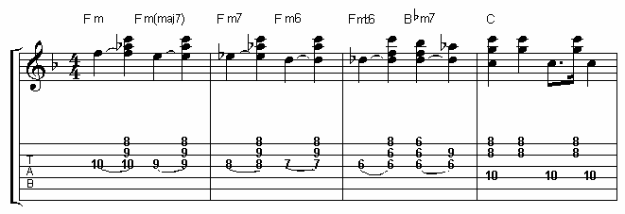

Homework
- Harmonize the following Bass Line. The phrase should conclude.

Do | Ti | La | Sol | Fa | Mi | Re | Sol

- Harmonize the following Bass Line. The phrase should conclude.

Do | Te | Le | Sol | Fa | Me | Re | Sol

- Harmonize the following Bass Line. The phrase should conclude.
Major
Do | Ti | Te | La | Le | Sol | Fi | Fa | Mi | Me | Re | Ra | Do

- Harmonize the following Bass Line. The phrase should conclude.
Minor
Do | Ti | Te | La | Le | Sol | Fi | Fa | Mi | Me | Re | Ra | Do

- Write a 16 bar “song”, melody and rhythm section, with a descending Major line
- Write a 16 bar “song”, melody and rhythm section, with a descending minor line

ONE OF THE TWO PROGRESSIONS NEEDS TO BE CHROMATIC! You only need to be descending for a portion of each phrase.

- Email the Sibelius file and turn in this page. Don’t print the Sibelius file!

